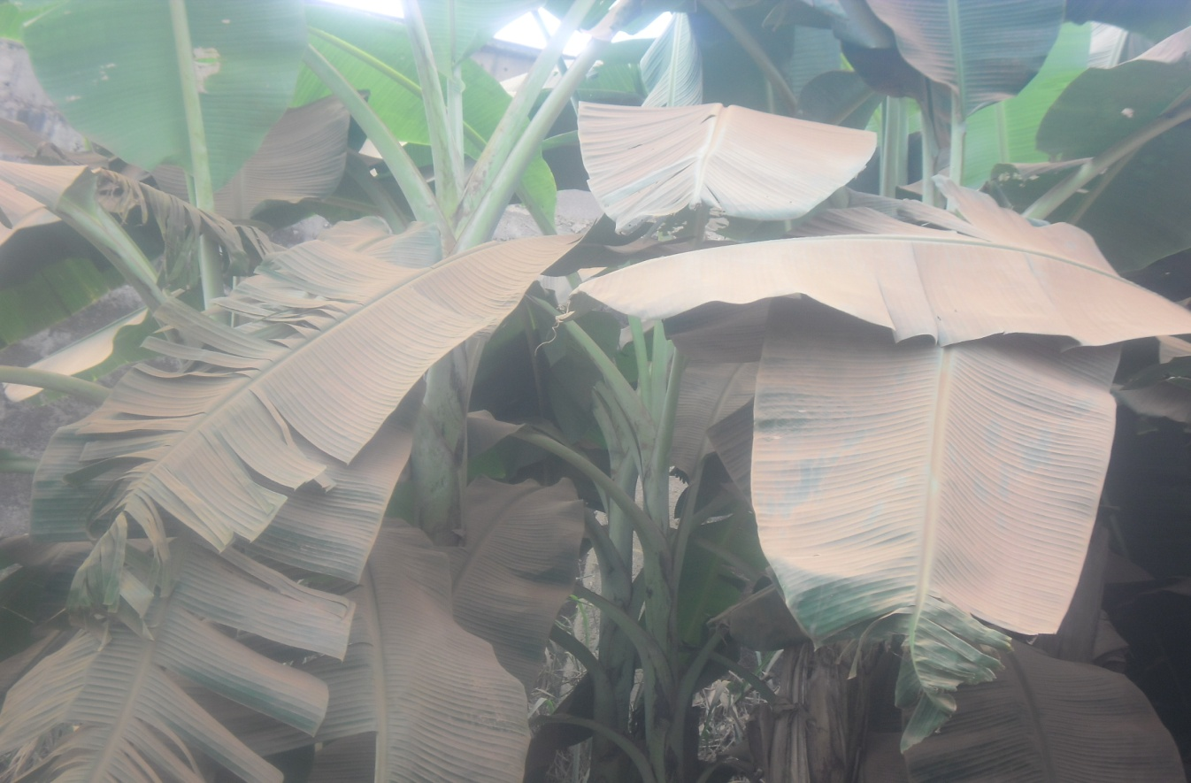

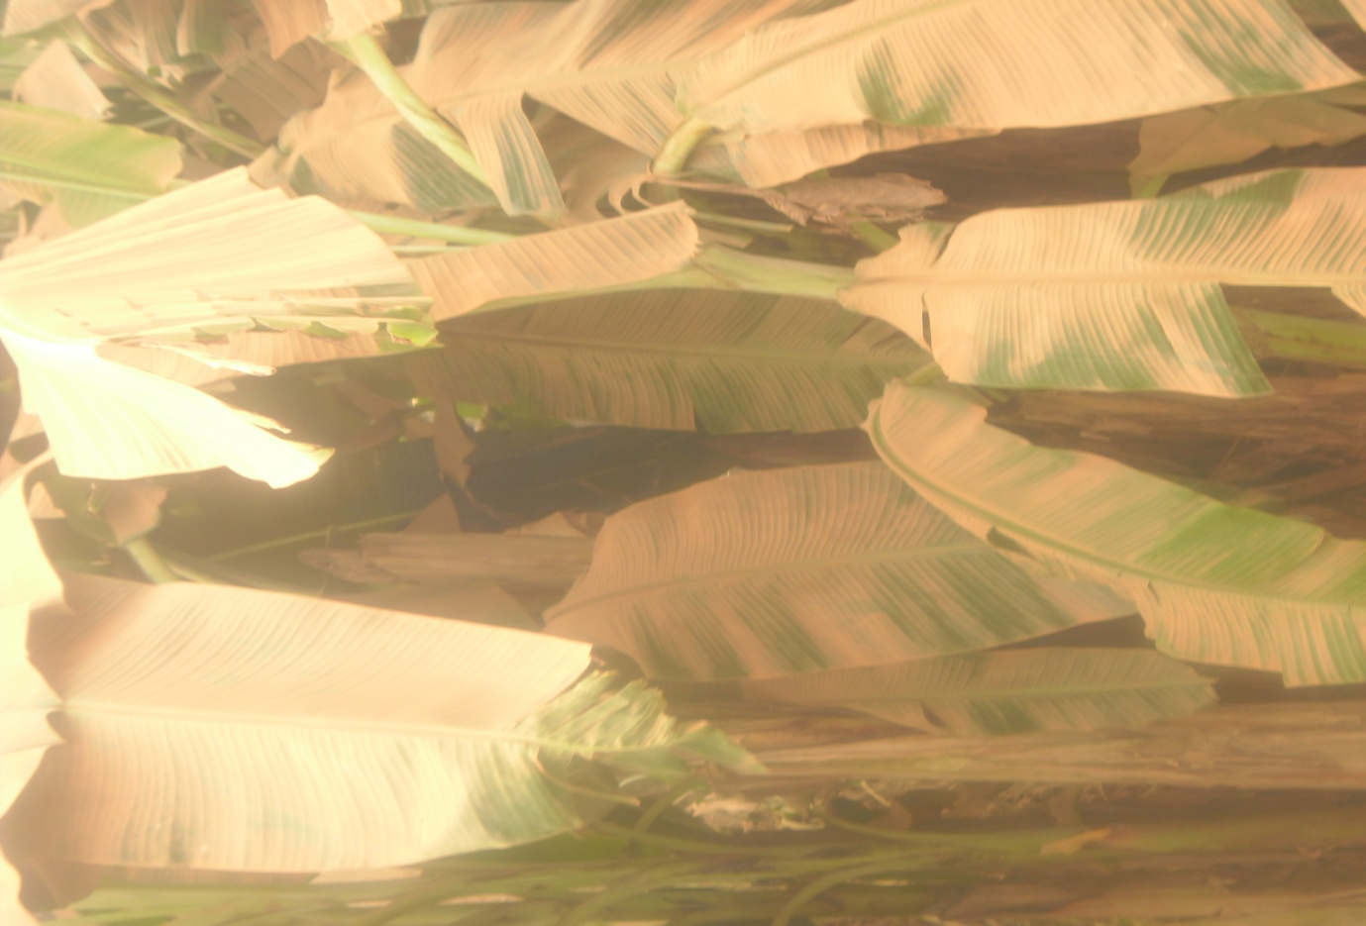
Plate 1: leaves covered with cement dust
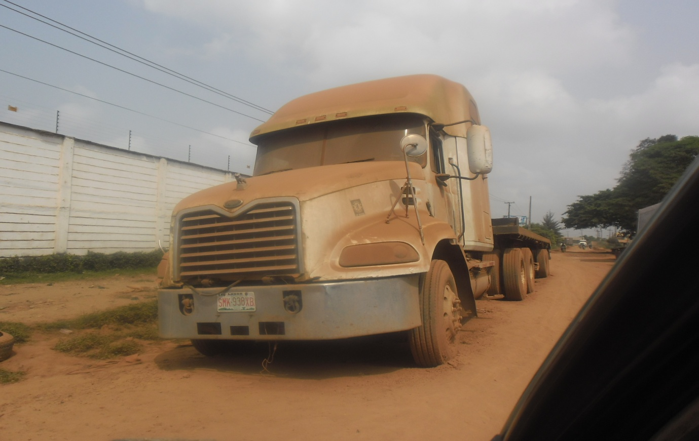

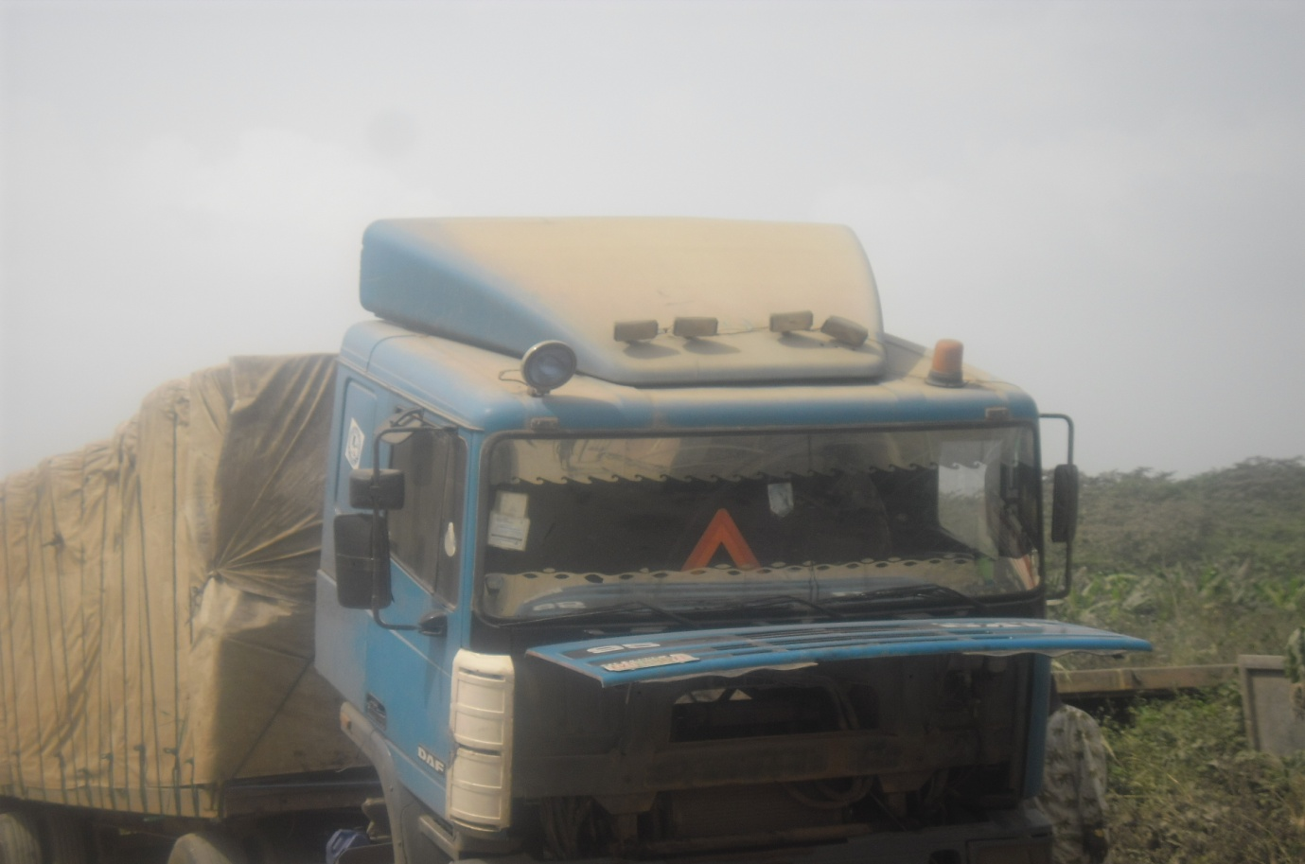
Plate 2: Packed trucks covered with dust
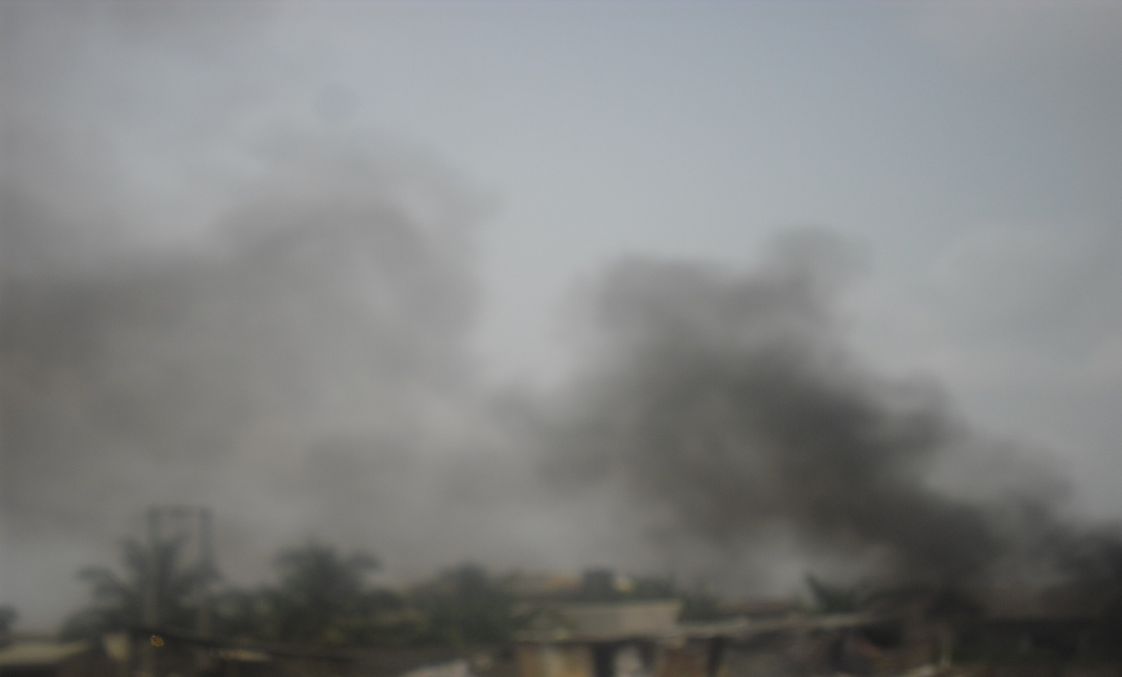
Plate 3: Smoke released into the air from industrial activities in Ota industrial estate
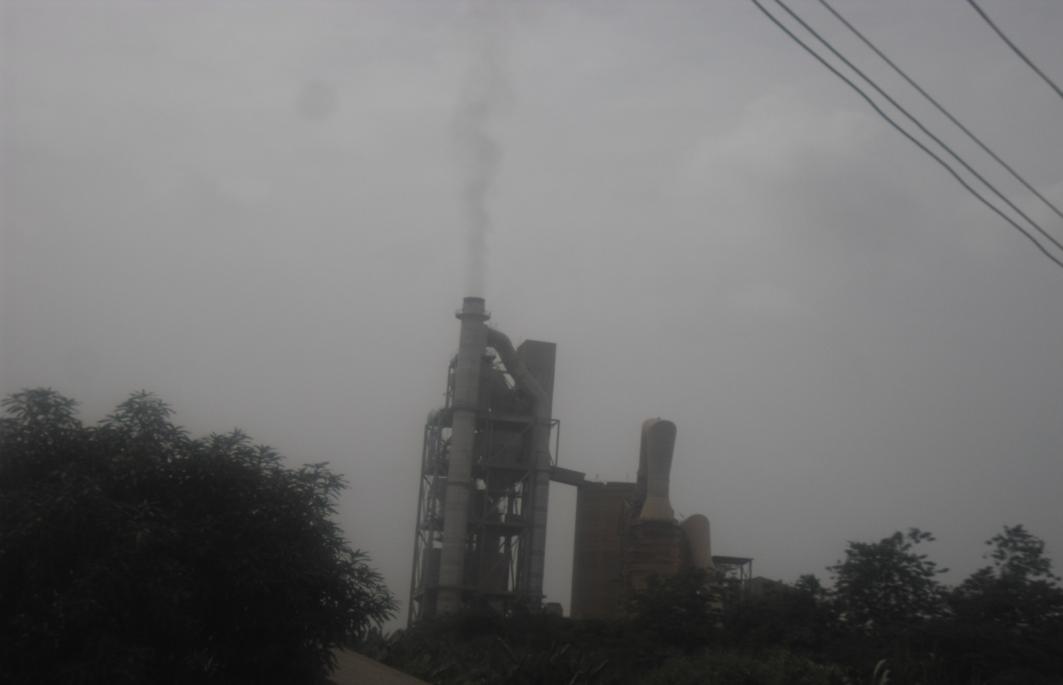
Plate 4: Smoke released into the air from cement processing factory
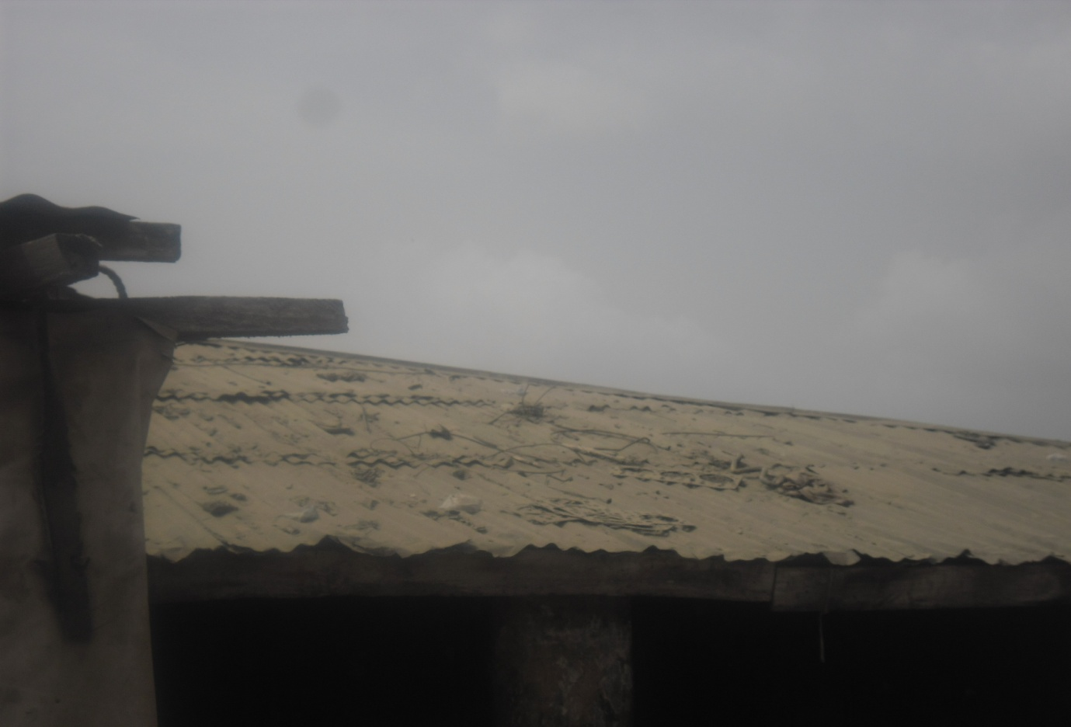
Plate 5: Roof covered with cement dust
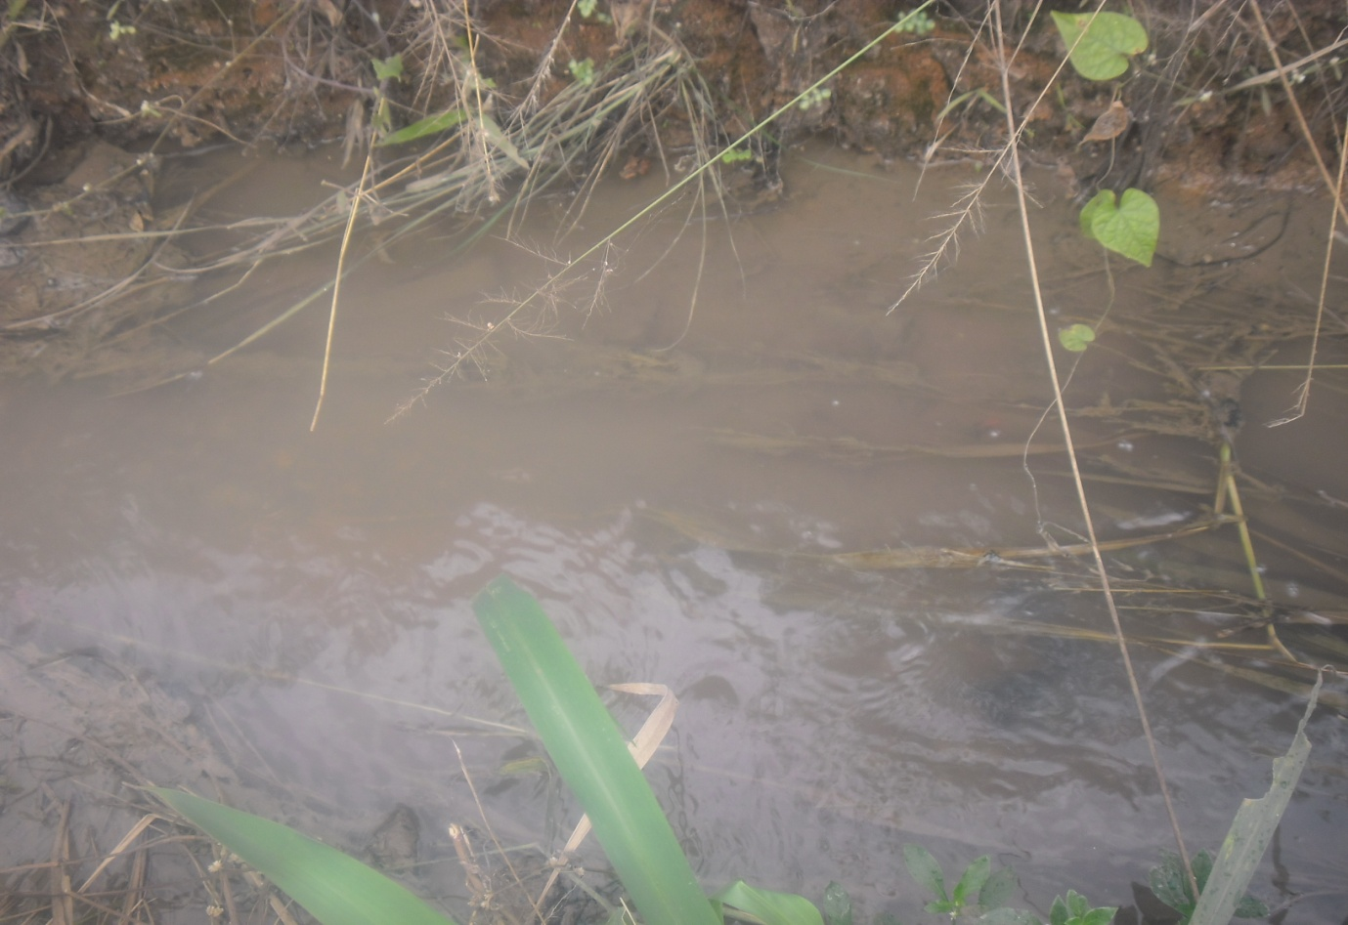
Plate 6: Bad and blocked drainage

