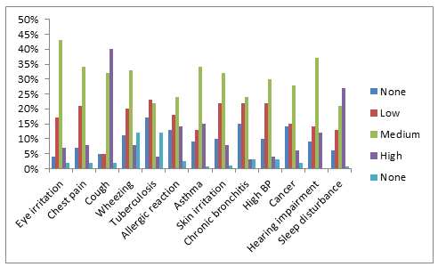
Figure 1: Distribution perception of the rate of health challenges prevalence in Ota

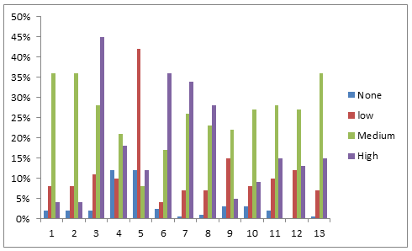

Figure 2: Distribution rate of health challenges prevalence in Ewekoro

