S1. Chamber characteristics
Table S1: Vegetation and distance to nearest trees and ditches. Only living trees growing within 5 m from each chamber are included.
Chamber | Species | Trees (< 5m from chamber) | Distance to ditch
1 | Vaccinum vitis-idea, Carex globularis, Pleurozium schreberi, Hylocomium splendens, Dicranum polysetum | 2.6 m Picea abies, 3.1 m Betula pubescens, 4.8 m Picea Abies | 12 m
2 | Vaccinum myrtillus, Dryopteris carthusiana, Dicranum polysetum, Pleurozium schreberi | Picea abies 3.7 m | 10 m
3 | Sphagnum spp., Trientalis europaea | 3.2 m Picea abies, 4.2 m Betula pubescens, 2.4 m Picea abies, 2.2 m Betula pubescens, 3 m Picea abies, 4.2 m Betula pubescens, 4.4 m Picea abies | 20 m
4 | Pleurozium schreberi, Dicranum polysetum | 2.9 m Picea abies, 2.5 m Betula pubescens, 3.3 m Picea abies, 3.5 m Betula pubescens, 2.4 m Betula pubescens, 2.4 m Picea abies, 2.8 m Picea abies | 5 m
5 | Dryopteris carthusiana, Vaccinum vitis-idae, Vaccinum myrtillus, Pleurozium schreberi, Dicranum polysetum, Hylocomium splendens | 1.9 m Picea abies, 1.6 m Picea abies, 1.2 m Pinus sylvestris, 4.8 m Betula pubescens, 4.5 m Picea abies | 5 m
6 | Trientalis europaea, Pleurozium schreberi, Dicranum polysetum, Hylocomium splendens | 2.8 m Picea abies, 3.4 m Betula pubescens, 4.9 m Picea abies, 1.9 m Picea abies, 3.4 m Betula pubescens, 3.8 m Picea abies, 5 m Picea abies, 3.2 m Picea abies, 2.1 m Picea abies, 2.3 m Betula pubescens, 2.7 m Picea abies | 20 m

S2. N₂O flux histograms

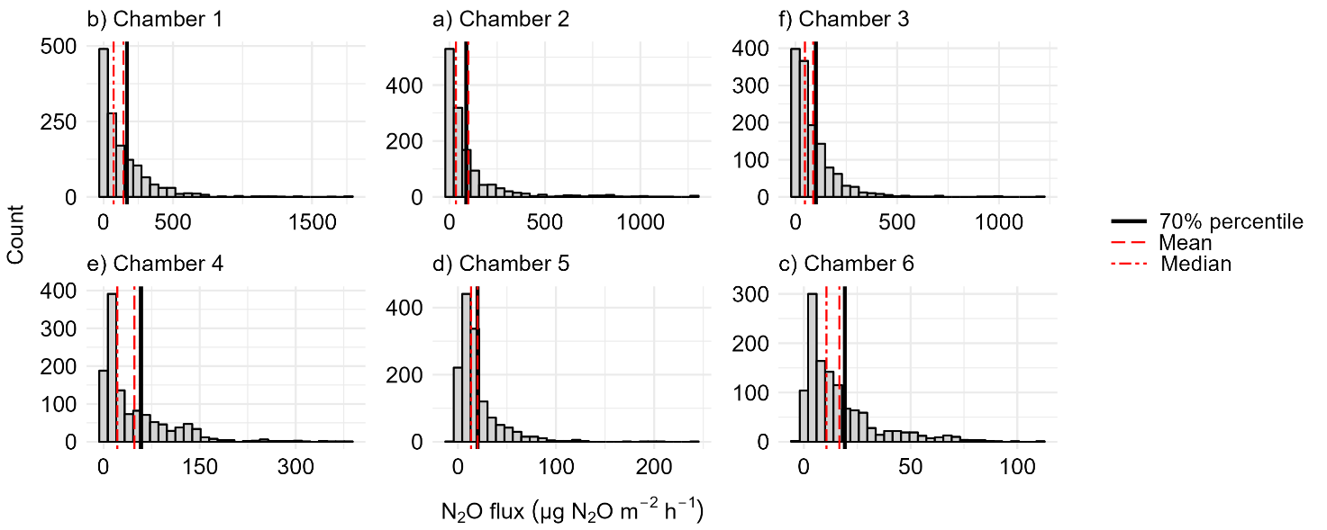
Figure S2: Distribution of daily mean N₂O flux in Chambers 1–6. The chamber-specific mean, median and 70 % percentile that was used to define high-flux days, are shown as vertical lines.

S3. Spatio-temporal variation of N₂O fluxes
Table S3.1: Mean, minimum and maximum N₂O fluxes in different measurement years. Unit of the N₂O flux is µg N₂O m⁻² h⁻¹. Years 2015 and 2019 include only part of the year (*). Measurements in Chamber 6 ended six months earlier in 2019 than in other chambers.
 | 2015* |  |  |  |  | 2016 |  |  |  |  | 2017 |  |  |  |  | 2018 |  |  |  |  | 2019*
Chamber | Mean |  | Min |  | Max | Mean |  | Min |  | Max | Mean |  | Min |  | Max | Mean |  | Min |  | Max | Mean |  | Min |  | Max
1 | 77 | 2 |  | 467 |  | 215 | 26 |  | 1266 |  | 233 | –1 |  | 1761 |  | 43 | 0.1 |  | 322 |  | 131 | 0.5 |  | 717
2 | 63 | 4 |  | 359 |  | 189 | 6 |  | 1272 |  | 145 | –1 |  | 1282 |  | 24 | 0.4 |  | 198 |  | 48 | 0 |  | 294
3 | 61 | –12 |  | 476 |  | 151 | 15 |  | 1192 |  | 130 | 7 |  | 937 |  | 30 | 0.5 |  | 227 |  | 50 | 0 |  | 333
4 | 27 | 2 |  | 85 |  | 71 | 9 |  | 228 |  | 89 | 7 |  | 381 |  | 21 | 1 |  | 110 |  | 18 | –1 |  | 87
5 | 16 | 0 |  | 54 |  | 24 | 3 |  | 118 |  | 27 | –1 |  | 244 |  | 12 | –5 |  | 201 |  | 21 | –2 |  | 103
6 | 16 | 1 |  | 71 |  | 24 | –1 |  | 111 |  | 23 | –1 |  | 74 |  | 7 | –3 |  | 31 |  | 7 | –3 |  | 25

Table S3.2: Mean, minimum and maximum N₂O fluxes (µg N₂O m⁻² h⁻¹) in different thermal seasons. All years are included.
 | Spring |  |  | Summer |  |  |  |  | Autumn |  |  |  |  | Winter
Chamber | Mean | Min | Max | Mean |  | Min |  | Max | Mean |  | Min |  | Max | Mean |  | Min |  | Max
1 | 122 | 0 | 621 | 199 | 0 |  | 1761 |  | 86 | 2 |  | 717 |  | 117 | –1 |  | 1266
2 | 55 | –1 | 298 | 173 | 0 |  | 1282 |  | 45 | 6 |  | 211 |  | 49 | 0 |  | 339
3 | 57 | 1 | 228 | 96 | 3 |  | 937 |  | 44 | –12 |  | 220 |  | 117 | 0 |  | 1192
4 | 71 | 1 | 306 | 47 | –1 |  | 381 |  | 14 | 1 |  | 72 |  | 62 | 1 |  | 184
5 | 15 | 0 | 52 | 20 | –5 |  | 244 |  | 11 | –1 |  | 54 |  | 30 | –3 |  | 201
6 | 9 | –3 | 41 | 20 | –1 |  | 77 |  | 8 | –3 |  | 42 |  | 21 | –1 |  | 112

S4. Time series correlations
Table S4: Correlation of N₂O time series between each pair of chambers. Correlations were statistically significant (p < 0.05).
 | Chamber 1 | Chamber 2 | Chamber 3 | Chamber 4 | Chamber 5 | Chamber 6
Chamber 1 | 1.00 | 0.79 | 0.64 | 0.65 | 0.36 | 0.40
Chamber 2 | 0.79 | 1.00 | 0.75 | 0.55 | 0.29 | 0.47
Chamber 3 | 0.64 | 0.75 | 1.00 | 0.69 | 0.41 | 0.53
Chamber 4 | 0.65 | 0.55 | 0.69 | 1.00 | 0.46 | 0.48
Chamber 5 | 0.36 | 0.29 | 0.41 | 0.46 | 1.00 | 0.49
Chamber 6 | 0.40 | 0.47 | 0.53 | 0.48 | 0.49 | 1.00

S5. Temporal variation of N₂O within a year
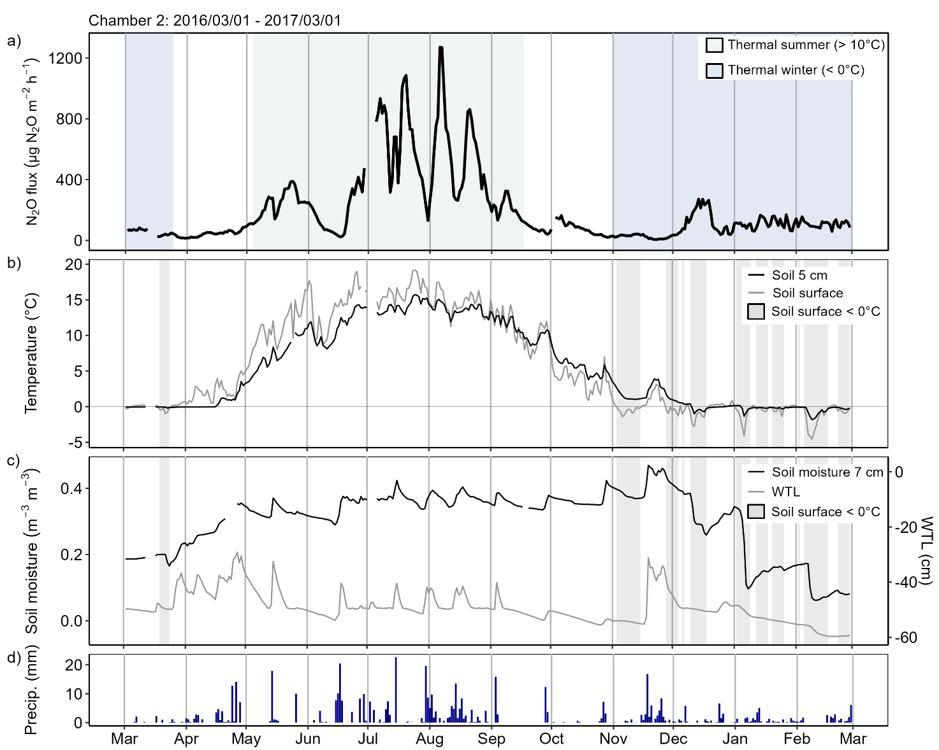
Figure S5.1: a) Daily mean N₂O flux, b) soil surface temperature and temperature at 5 cm depth with highlighted freezing periods (soil surface temperature < 0 °C), c) soil moisture and water table level (WTL), and (d) daily precipitation from March 2016 to March 2017 in Chamber 2. The shown temporal dynamics of N₂O flux were measured in a year with relatively wet summer and warm winter. Data are not gap-filled. Figure for Chamber 1 is presented in the manuscript (Fig. 6).
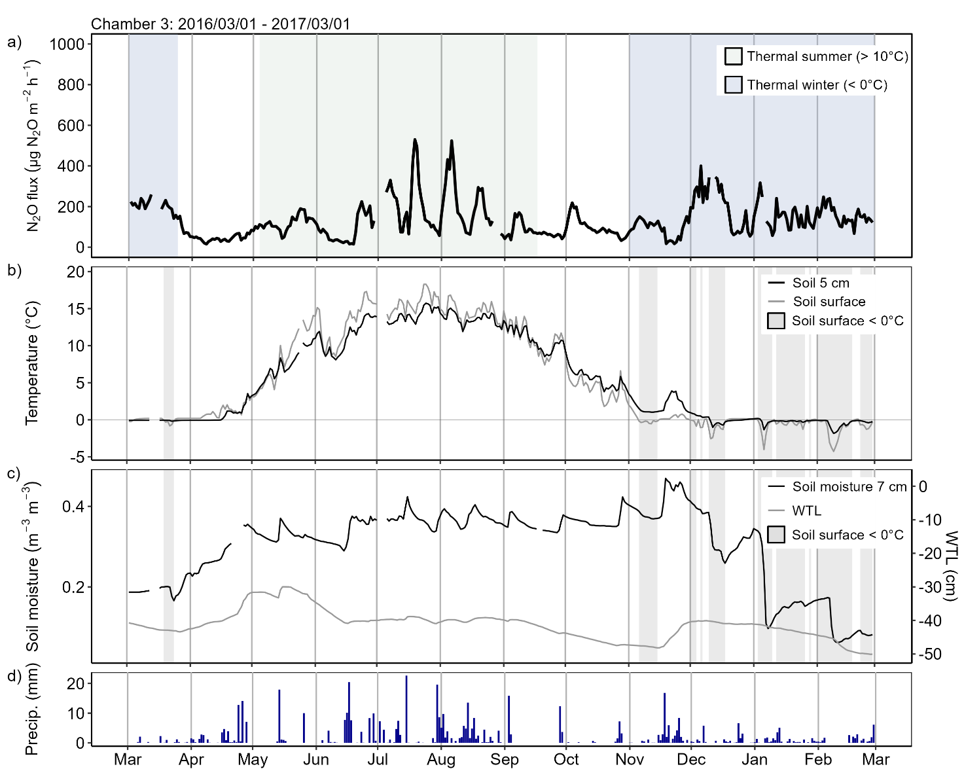
Figure S5.2: a) Daily mean N₂O flux, b) soil surface temperature and temperature at 5 cm depth with highlighted freezing periods (soil surface temperature < 0 °C), c) soil moisture and water table level (WTL), and (d) daily precipitation from March 2016 to March 2017 in Chamber 3. The shown temporal dynamics of N₂O flux were measured in a year with relatively wet summer and warm winter. Data are not gap-filled. Figure for Chamber 1 is presented in the manuscript (Fig. 6).
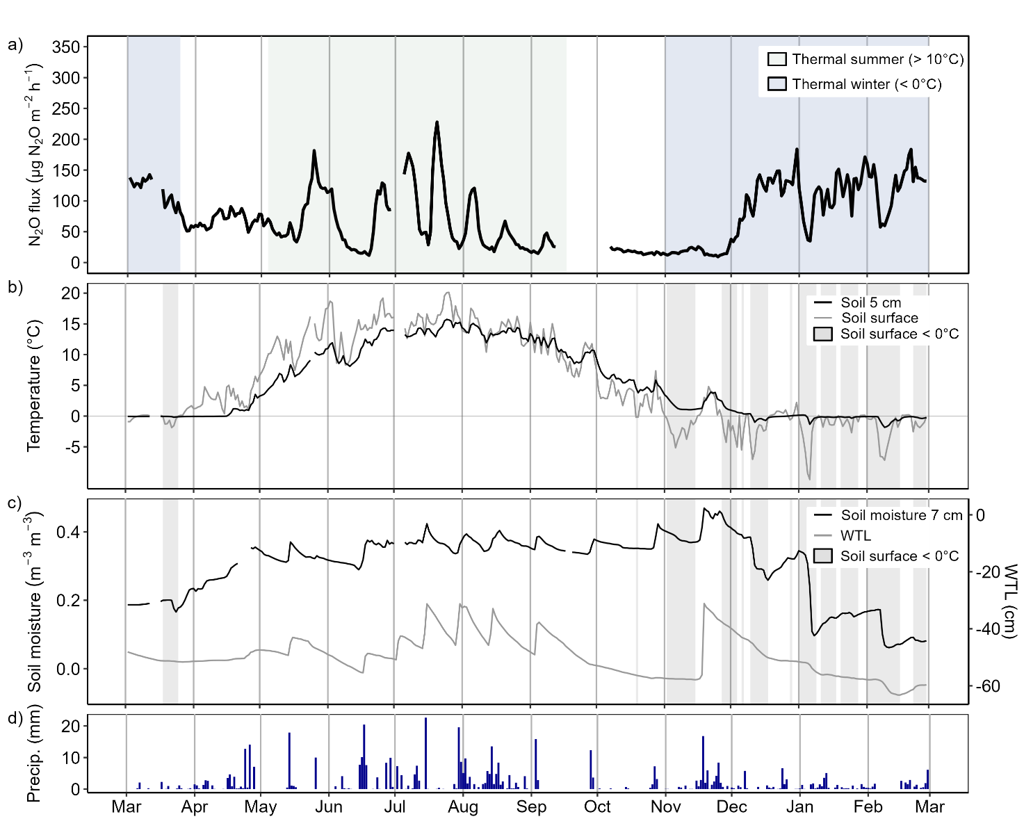
Figure S5.3: a) Daily mean N₂O flux, b) soil surface temperature and temperature at 5 cm depth with highlighted freezing periods (soil surface temperature < 0 °C), c) soil moisture and water table level (WTL), and (d) daily precipitation from March 2016 to March 2017 in Chamber 4. The shown temporal dynamics of N₂O flux were measured in a year with relatively wet summer and warm winter. Data are not gap-filled. Figure for Chamber 1 is presented in the manuscript (Fig. 6).
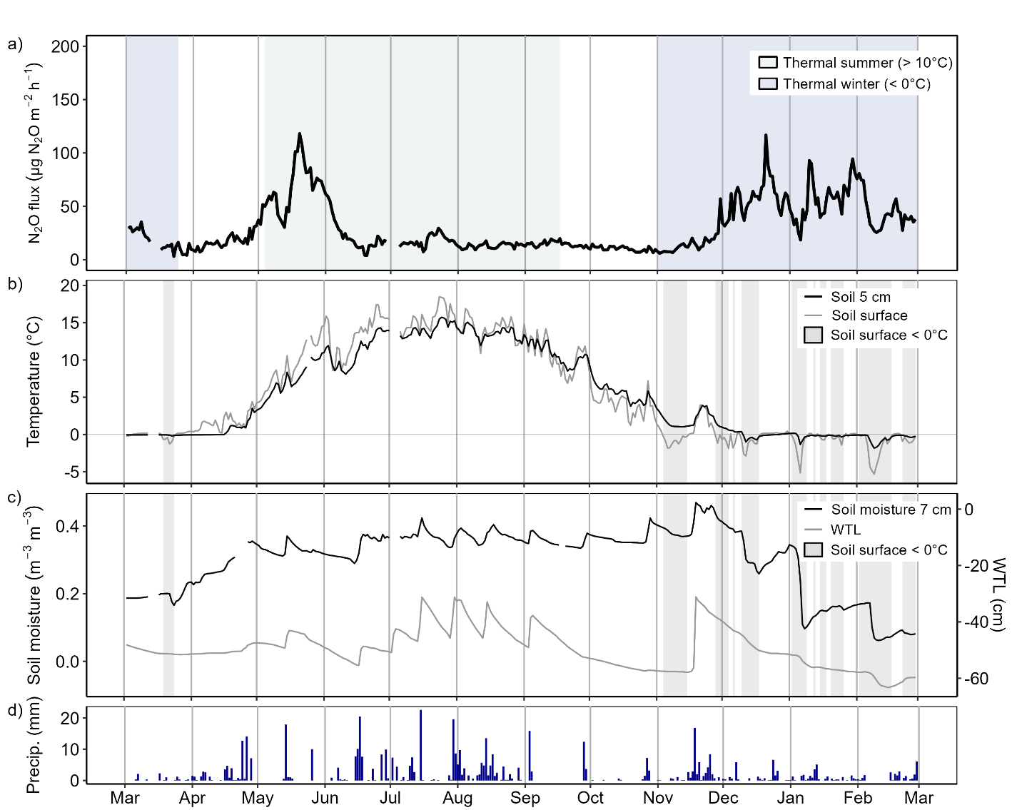
Figure S5.4: a) Daily mean N₂O flux, b) soil surface temperature and temperature at 5 cm depth with highlighted freezing periods (soil surface temperature < 0 °C), c) soil moisture and water table level (WTL), and (d) daily precipitation from March 2016 to March 2017 in Chamber 5. The shown temporal dynamics of N₂O flux were measured in a year with relatively wet summer and warm winter. Data are not gap-filled. Figure for Chamber 1 is presented in the manuscript (Fig. 6).
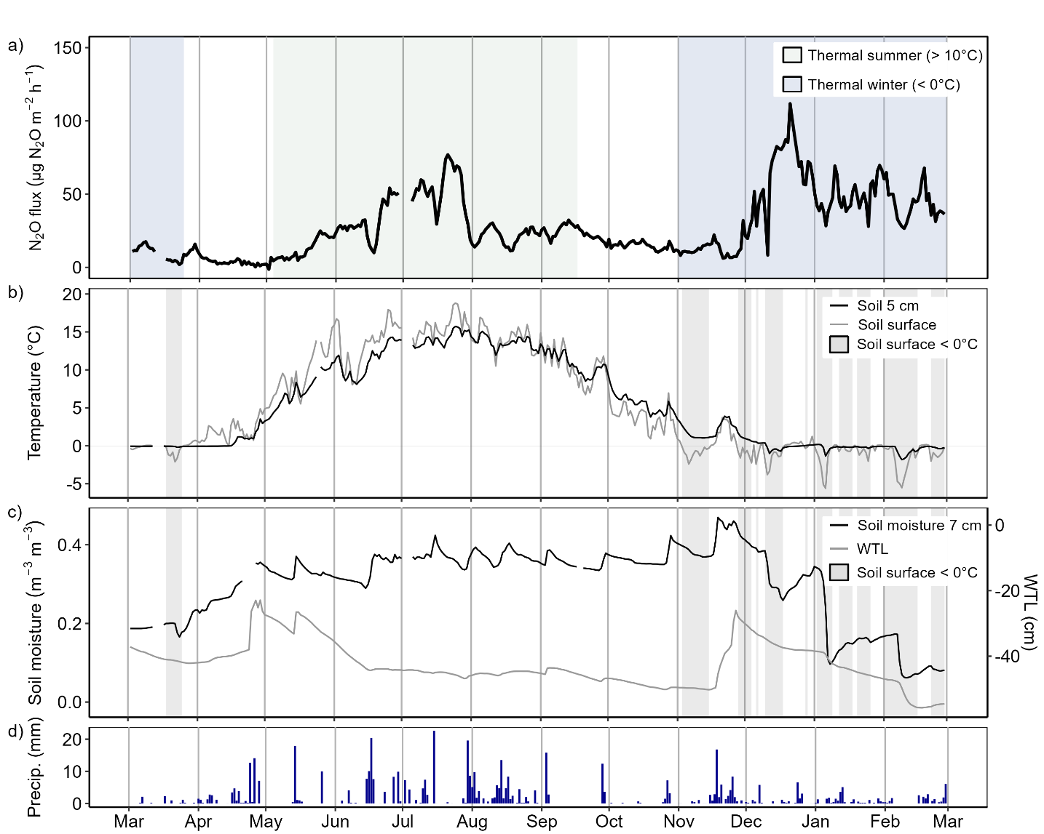
Figure S5.5: a) Daily mean N₂O flux, b) soil surface temperature and temperature at 5 cm depth with highlighted freezing periods (soil surface temperature < 0 °C), c) soil moisture and water table level (WTL), and (d) daily precipitation from March 2016 to March 2017 in Chamber 6. The shown temporal dynamics of N₂O flux were measured in a year with relatively wet summer and warm winter. Data are not gap-filled. Figure for Chamber 1 is presented in the manuscript (Fig. 6).

S6. Lag-specific variable importance
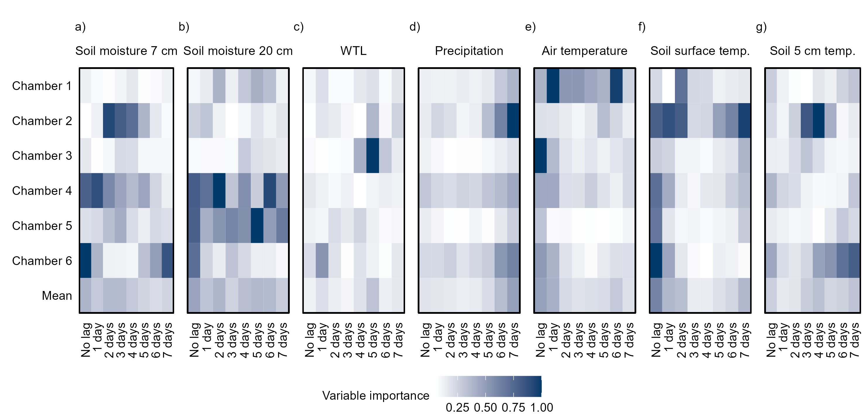
Figure S6: Variable importance (VI) scores of different environmental variables and their lagged versions in explaining the temporal variation of N₂O. The matrix plot shows VI values separately for different chambers (Chambers 1–6) as well as the mean VI across all the chambers (Mean row). VI values are means across 10 runs of Random forest with conditional inference trees. VI scores are scaled between 0 and 1 (0 = lowest importance, 1 = highest importance) per chamber to make VI scores comparable across chambers. Total VIs of each environmental variable are presented in the manuscript (Fig. 8). Comparing VIs of individual lags and unlagged versions of the variables, should be done with care to avoid very data-specific conclusions.

S7. N₂O flux responses to immediate and time-lagged environmental conditions
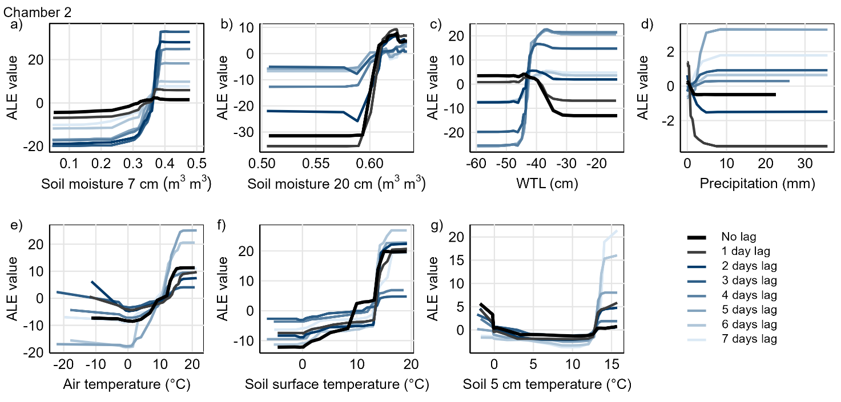
Figure S7.1: Response of predicted N₂O flux to different environmental conditions for Chamber 2 visualized using Accumulated Local Effects (ALE). Figures illustrate how the predicted N₂O flux values deviate from the mean predicted flux (ALE value = 0) along the gradients of a) soil moisture at 7 cm depth, b) soil moisture at 20 cm depth, c) water table level (WTL), d) precipitation, e) air temperature, f) soil surface temperature and g) soil temperature at 5 cm. ALE responses for unlagged and lagged variables (1–7 days) are included. Responses for chamber 1 are presented in the manuscript (Fig. 9).

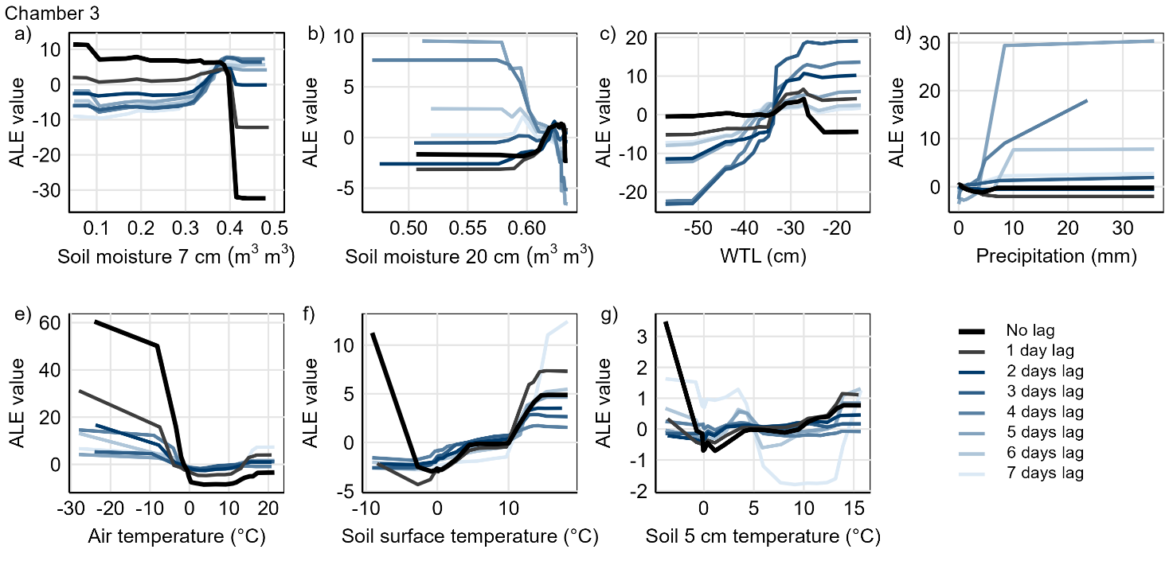
Figure S7.2: Response of predicted N₂O flux to different environmental conditions for Chamber 3 visualized using Accumulated Local Effects (ALE). Figures illustrate how the predicted N₂O flux values deviate from the mean predicted flux (ALE value= 0) along the gradients of a) soil moisture at 7 cm depth, b) soil moisture at 20 cm depth, c) water table level (WTL), d) precipitation, e) air temperature, f) soil surface temperature and g) soil temperature at 5 cm. ALE responses for unlagged and lagged variables (1–7 days) are included. Responses for chamber 1 are presented in the manuscript (Fig. 9).

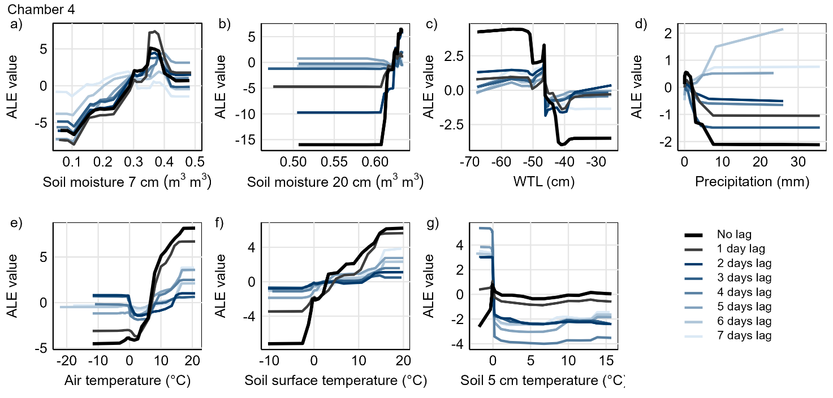
Figure S7.3: Response of predicted N₂O flux to different environmental conditions for Chamber 4 visualized using Accumulated Local Effects (ALE). Figures illustrate how the predicted N₂O flux values deviate from the mean predicted flux (ALE value = 0) along the gradients of a) soil moisture at 7 cm depth, b) soil moisture at 20 cm depth, c) water table level (WTL), d) precipitation, e) air temperature, f) soil surface temperature and g) soil temperature at 5 cm. ALE responses for unlagged and lagged variables (1–7 days) are included. Responses for chamber 1 are presented in the manuscript (Fig. 9).

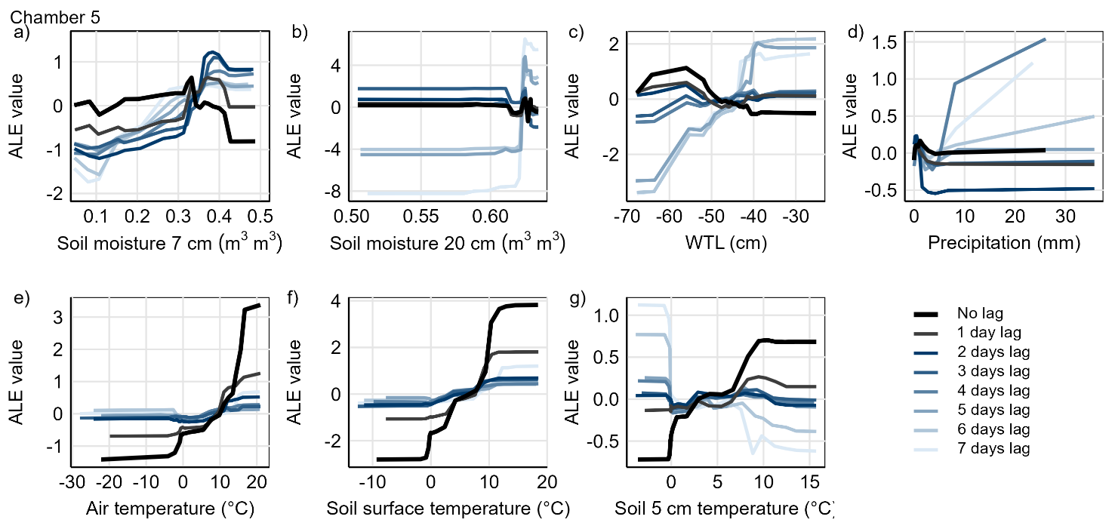
Figure S7.4: Response of predicted N₂O flux to different environmental conditions for Chamber 5 visualized using Accumulated Local Effects (ALE). Figures illustrate how the predicted N₂O flux values deviate from the mean predicted flux (ALE value = 0) along the gradients of a) soil moisture at 7 cm depth, b) soil moisture at 20 cm depth, c) water table level (WTL), d) precipitation, e) air temperature, f) soil surface temperature and g) soil temperature at 5 cm. ALE responses for unlagged and lagged variables (1–7 days) are included. Responses for chamber 1 are presented in the manuscript (Fig. 9).

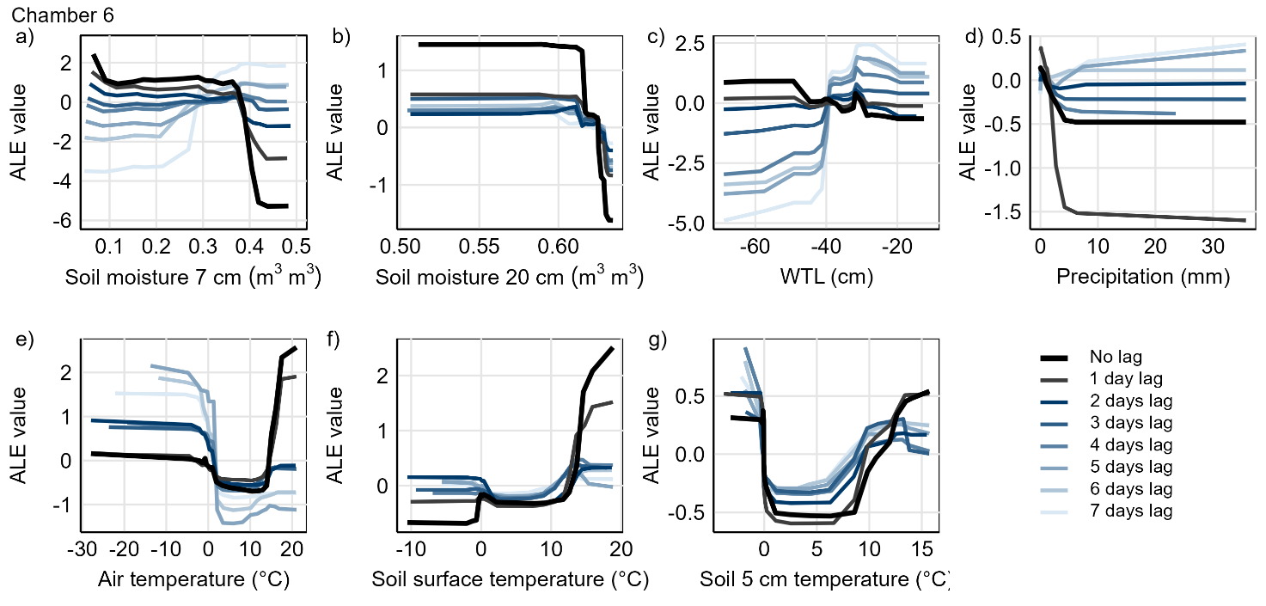
Figure S7.5: Response of predicted N₂O flux to different environmental conditions for Chamber 6 visualized using Accumulated Local Effects (ALE). Figures illustrate how the predicted N₂O flux values deviate from the mean predicted flux (ALE value = 0) along the gradients of a) soil moisture at 7 cm depth, b) soil moisture at 20 cm depth, c) water table level (WTL), d) precipitation, e) air temperature, f) soil surface temperature and g) soil temperature at 5 cm. ALE responses for unlagged and lagged variables (1–7 days) are included. Responses for chamber 1 are presented in the manuscript (Fig. 9).

S8. N₂O budgets and seasonal contributions
Table S8.1: Annual N₂O budgets in different chambers. Unit of N₂O budget is mg N₂O m⁻² y⁻¹. The annual N₂O budget includes only part of the year in 2015 (summer and autumn) and 2019 (spring and summer) (*). Measurements in Chamber 6 ended in early 2019 and the annual budget was not calculated for that year.
Chamber | 2015* | 2016 | 2017 | 2018 | 2019*
1 | 469 | 1886 | 2114 | 399 | 790
2 | 360 | 1613 | 1367 | 222 | 283
3 | 350 | 1340 | 1116 | 281 | 284
4 | 141 | 613 | 743 | 214 | 112
5 | 88 | 210 | 246 | 112 | 155
6 | 87 | 214 | 200 | 59 | -
Mean | 249 | 979 | 964 | 215 | 325

Table S8.2: Contributions of spring fluxes to annual N₂O budgets. Contributions are expressed as percentage (%) of the annual budget. The annual N₂O budget includes only part of the year in 2015 and 2019 (*). Measurements in Chamber 6 ended in early 2019 and the annual N₂O budget was not calculated for that year.
Chamber | 2015* | 2016 | 2017 | 2018 | 2019*
1 | - | 5 | 12 | 9 | 24
2 | - | 3 | 11 | 6 | 19
3 | - | 4 | 14 | 9 | 26
4 | - | 11 | 27 | 13 | 45
5 | - | 8 | 6 | 8 | 21
6 | - | 2 | 12 | 9 | -
Mean | - | 6 | 14 | 9 | 27

Table S8.3: Contributions of summer fluxes to annual N₂O budgets. Contributions are expressed as percentage (%) of the annual budget. The annual N₂O budget includes only part of the year in 2015 and 2019 (*). Measurements in Chamber 6 ended in early 2019 and the annual N₂O budget was not calculated for that year.
Chamber | 2015* | 2016 | 2017 | 2018 | 2019*
1 | 77 | 52 | 61 | 64 | 48
2 | 53 | 79 | 67 | 59 | 64
3 | 63 | 36 | 48 | 41 | 63
4 | 66 | 35 | 39 | 36 | 34
5 | 52 | 44 | 48 | 28 | 15
6 | 66 | 45 | 42 | 42 | -
Mean | 63 | 49 | 51 | 45 | 45

Table S8.4: Contributions of autumn fluxes to annual N₂O budgets. Contributions are expressed as percentage (%) of the annual budget. The annual N₂O budget includes only part of the year in 2015 and 2019 (*).
Chamber | 2015* | 2016 | 2017 | 2018 | 2019*
1 | 18 | 5 | 14 | 7 | -
2 | 37 | 5 | 9 | 12 | -
3 | 24 | 7 | 14 | 13 | -
4 | 30 | 5 | 6 | 5 | -
5 | 41 | 6 | 16 | 8 | -
6 | 25 | 8 | 12 | 6 | -
Mean | 29 | 6 | 12 | 9 | -

Table S8.5: Contributions of winter fluxes to annual N₂O budgets. Contributions are expressed as percentage (%) of the annual budget. The annual N₂O budget includes only part of the year in 2015 and 2019 (*).
Chamber | 2015* | 2016 | 2017 | 2018 | 2019*
1 | - | 37 | 14 | 20 | -
2 | - | 13 | 24 | 23 | -
3 | - | 53 | 27 | 36 | -
4 | - | 49 | 30 | 45 | -
5 | - | 43 | 34 | 56 | -
6 | - | 44 | 20 | 43 | -
Mean | - | 40 | 25 | 37 | -

S9. Model performance
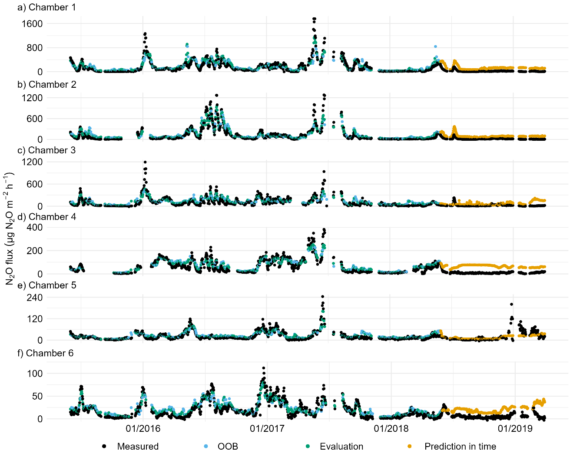
Figure S9: Measured and predicted N₂O fluxes plotted against time. Figures (a–f) show predicted values from random forest with conditional inference trees separately for six chambers. Points are colored by the used data with out-of-bag (OOB) data, evaluation data within training period (30 % of first three years of data) and prediction in time data (outside model training period, fourth year of data) different types of evaluation datasets, and daily means of measured fluxes.

