Supplementary information for
Deposition and Corrosion Performance of Phosphate-Polylactic Acid Composite Coatings on WE43 Magnesium Alloy

Andrei V. Paspelau, Aliaksandr A. Kasach, Jacek Gurgul, Grzegorz Mordarski, Konrad Skowron, Irina I. Kurilo, and Dzmitry S. Kharytonau

XRD measurements
JCPDS cards used for XRD data analysis
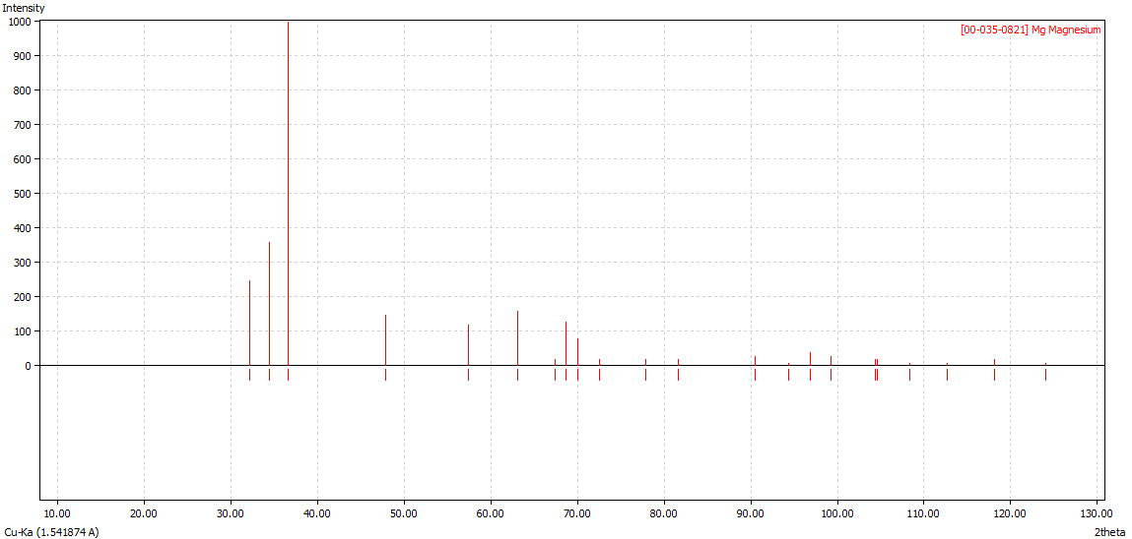
JCPDS card #00-035-0821 – Mg
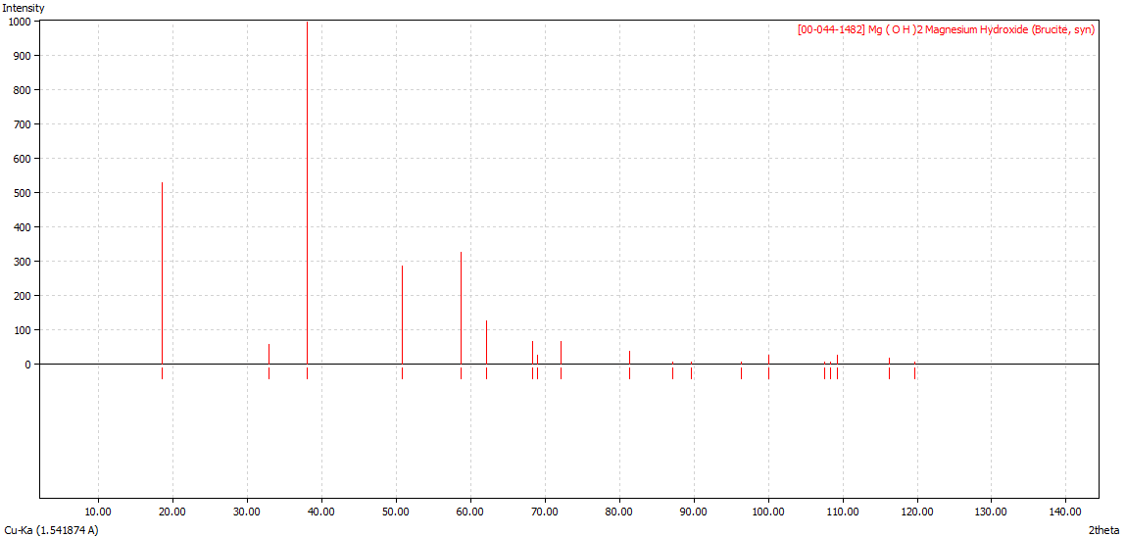
JCPDS card #00-044-1482 – Mg(OH)₂

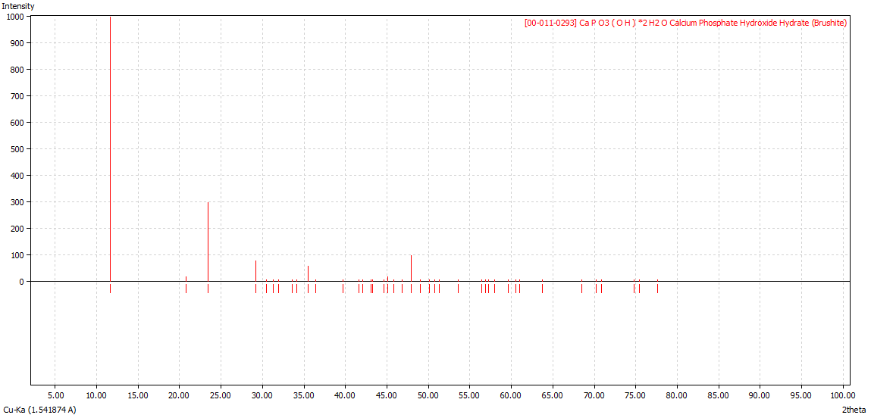
JCPDS card #00-011-0293 – CaHPO₄∙2H₂O
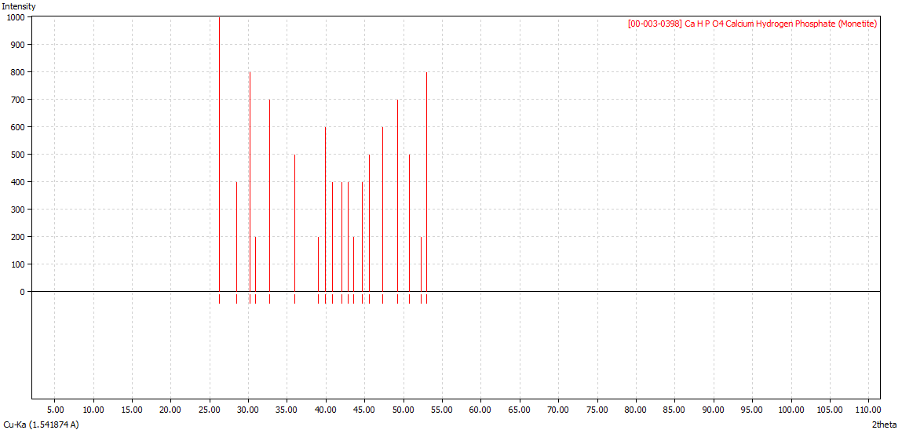
JCPDS card #00-003-0398 – CaHPO₄

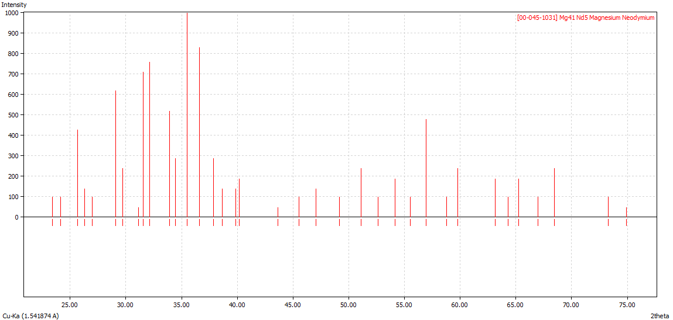
JCPDS card #00-045-1031 – Mg₄₁Nd₅

Adhesion measurements
The adhesion of the obtained coatings to the WE43 alloy substrate was evaluated using a PosiTest AT-A adhesive meter. The separation surface diameter was 20 mm. The results are listed in Table S1 and Fig. S1.
Table S1 – Results of adhesion tests
Sample | Breakout force [MPa]
Sample | Before corrosion | After 14 days of corrosion tests
PLA | 2.03±0.12 | –
CaP-PLA | 1.50±0.25 | 0.57±0.13

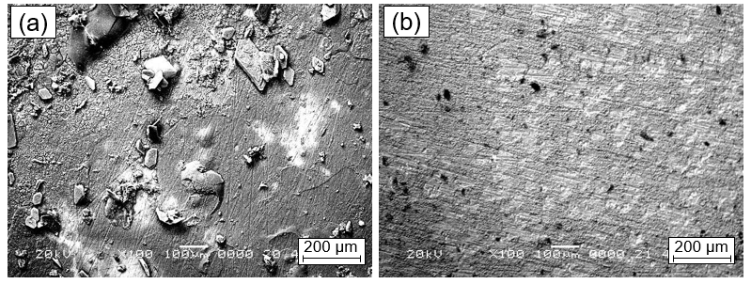
Fig. S1. – SEM images of PLA (a) and CaP-PLA (b) samples after adhesion tests

