Multimode Nonlinear Dynamic Process Monitoring of a Multiphase Flow Facility
Ruomu Tan^{a,*}, Raphael T. Samuelª, Yi Caoª
ªSchool of Water, Energy and Environment, Cranfield University, College Road, Cranfield, MK43 0AL, UK
r.tan@cranfield.ac.uk

Nonlinearity and dynamics exist widely in process industry whilst the process commonly can have more than one normal operating mode. Therefore, the capability of handling nonlinearity and dynamics and the tolerance of multiple operating conditions is a necessity for process monitoring algorithms. As an example, the multiphase flow facility at Cranfield University is investigated as a benchmark for monitoring algorithms. Sketch of the facility is shown in Figure 1. Previous work has been done (1) in linear dynamic monitoring algorithm for manually seeded faults. To further improve the performance, a nonlinear extension (2) is favourable. With historical faulty data sets available, the algorithm can be developed and implemented in real-time for monitoring of real faults instead of seeded ones.
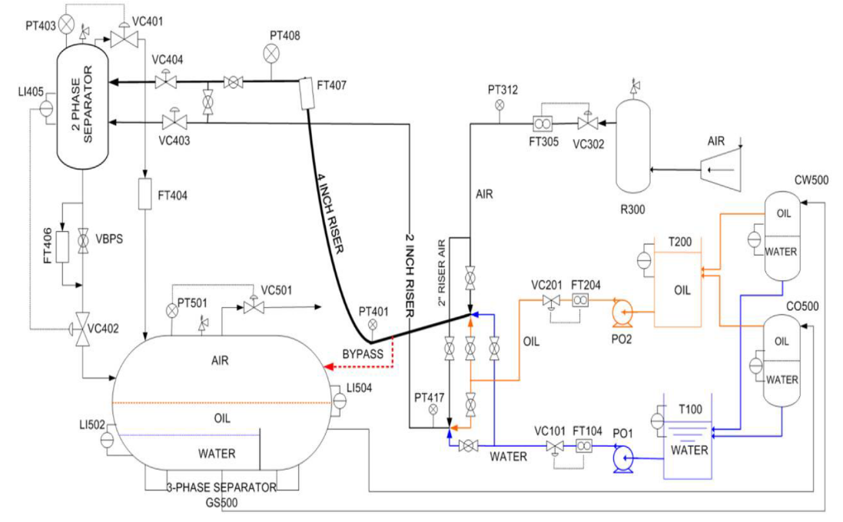
Figure 1. Multiphase Flow Facility
In this work, a multivariate statistical algorithm, mKLV-CVA (multimode Kernel Latent Variable Canonical Variate Analysis), is proposed for the multimode nonlinear dynamic monitoring problem. Kernel-based nonlinear latent space is constructed using data collected from multiple operating modes to address nonlinear and multimode properties. Canonical Variate Analysis is conducted on the kernel matrix to extract the dynamic features. Due to the existence of non-Gaussian noises, testing statistics are calculated accordingly by Kernel Density Estimation approach for a better monitoring performance.
Aforementioned mKLV-CVA algorithm is validated both offline and online on the multiphase flow facility. The data collected from multiple normal operating conditions of the facility is used for training. Corresponding offline validation is conducted on the two historical faulty data sets collected in 2011 and 2016 respectively. Moreover, an online monitoring system with Graphical User Interface (GUI) in Matlab and DeltaV is implemented in the facility to monitor the occurrence of potential faults in real-time.

Ruiz-Cárcel, C., Cao, Y., Mba, D., Lao, L., Samuel, R.T., 2015. Statistical process monitoring of a multiphase flow facility. Control Eng. Pract. 42, 74–88. doi:10.1016/j.conengprac.2015.04.012
Samuel, R.T., Cao, Y., 2015. Kernel canonical variate analysis for nonlinear dynamic process monitoring. IFAC Proc. Vol. 48, 605–610. doi:10.1016/j.ifacol.2015.09.034

