Investigating huntingtin-DNA binding by EMSA and DSLS (2017/05/31)

Previous work:

Plasmid EMSA with full-length HTT Q23/Q46 https://zenodo.org/record/580111:

A band shift of the plasmid DNA is observed for both HTT Q23 and Q46. As plasmid is not a physiologically relevant ligand/binding partner for a human protein, it can be assumed that this is non-specific DNA binding. This property of the protein seems to be independent of the polyQ length. Further experiments are needed to verify if the DNA binding is specific for dsDNA, ssDNA or other types of DNA structures.

16th May 2017

Assessing thermal aggregation of huntingtin HTT¹⁻³¹⁴⁴ samples +/- plasmid DNA to determine if plasmid band shift was caused by huntingtin protein aggregation upon addition of DNA.

All reactions were completed in 20 mM Hepes pH 7.4, 150 mM NaCl, 10 % glycerol. 1 mg/mL HTT₁₋₃₁₄₄ Q23 or Q46 +/- 20 µg/µL plasmid (~12-15 kb) in 45 µL total reaction volume at room temperature for 20 minutes in 384 well clear bottomed black plates (Greiner). Reactions were repeated 2-3 times (dependent on available HTT protein stock). Each reaction then topped with 45 µL mineral oil before being read in Stargazer differential static light scattering (DSLS) machine as plate heated from 25-85 ºC.

There was no significant difference in base level scattering (A1) or thermal aggregation transition temperature (Tagg) between the samples, indicating that the protein does not aggregate upon addition of plasmid DNA in these conditions.

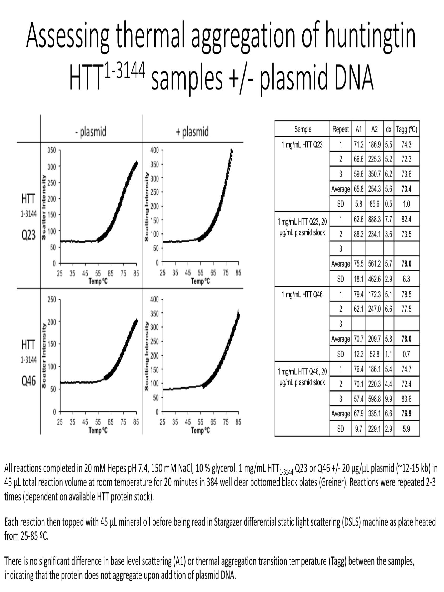

18th May 2017

To further investigate DNA interaction properties of HTT, binding to double stranded cDNA samples was assessed. Unlike plasmid, these are unlikely to have complex coiled or supercoiled structures. All reactions were completed in 20 mM Hepes pH 7.4, 150 mM NaCl, 10 % glycerol.

- 5 µL of cDNA (PCR product - #1 ~800 bp and #2 ~1500 bp) incubated with 14 µL buffer or 4 mg/mL DNAbp (control DNA binding protein ~45 kDa) or 14 µL of 1 mg/mL HTT₁₋₃₁₄₄ Q23 at room temperature for 20 minutes. Each reaction then topped up with 3 µL 6 x loading dye (Fermentas) supplemented with 1:10,000 SybrSafe before being run on a agarose-TAE gel. L – DNA ladder (1 kb – Fermentas). Reactions run in 1.5 % (w/v) agarose-TAE gel in 0.5 % TAE buffer at 135 V for 30 mins before imaging.

A big band shift of cDNA #1 is seen with the control DNAbp whilst more subtle shifts for both cDNAs is observed for HTT Q23. The control DNAbp perhaps binds the DNA at multiple sites, causing the large band shift.

- 5 µL of cDNA (PCR product - #1 ~800 bp) incubated with 14 µL buffer or 1/0.5/0.1/0.05 mg/mL HTT₁₋₃₁₄₄ Q23 at room temperature for 20 minutes. Each reaction then topped up with 3 µL 6 x loading dye (Fermentas) supplemented with 1:10,000 SybrSafe before being run on a agarose-TAE gel. L – DNA ladder (1 kb – Fermentas), D – cDNA alone. Reactions run in 1.5 % (w/v) agarose-TAE gel in 0.5 % TAE buffer at 135 V for 30 mins before imaging.

HTT Q23 hinders the DNA on the gel, generating high molecular weight species with increased concentration, suggesting that at the higher protein concentrations, multiple copies of HTT bind each DNA molecule. This suggests that the DNA binding properties of HTT are not sequence specific.

In experiments A and B, the molar concentration of HTT is in excess of the cDNA (~50 ng PCR product ~0.05 pmol, 60 µg HTT (top concentration) ~ 200 pmol). Therefore, it cannot yet be determined if this interaction is physiologically relevant and perhaps could show non-specific DNA binding. Further experiments are needed to verify if the DNA binding is specific for dsDNA, ssDNA or other types of DNA structures.

NB: cDNA samples kindly provided by Yanjun Li. Cybrsafe causes cDNA to run larger than actual size. cDNA size validated by sequencing in subsequent cloning of samples by Yanjun.

24th May 2017

To further investigate DNA interaction properties of HTT, binding to double stranded and single stranded short (~32 bases or base pair) oligo samples was assessed.

Prior to completing PAGE-EMSA with HTT-oligo DNA samples, ds (double-stranded) and ss (single stranded) oligo samples were assessed for gel migration in order to determine how long to run the PAGE.

Both samples kindly provided by Levon Halabelian.

C8 - ssDNA oligo tagged with 6-FAM, ~8.5 mM stock
5’-FAM-CTCAACACTTAACTACCATCCGGACCAGAAGA

C12 – dsDNA oligo tagged with 6-FAM, ~22 mM stock
5’-FAM-TCTTCTGGTCCGGATGGTAGTTAAGTGTTGAG
5’-FAM-CTCAACACTTAACTACCATCCGGACCAGAAGA

All reactions completed in 20 mM Hepes pH 7.4, 150 mM NaCl, 10 % glycerol. 1 or 0.2 µL of each sample diluted with 19 or 20 µL of reaction buffer respectively and supplemented with 4 µL of 6 x loading dye (Fermentas). All of reaction sample was loaded. Reactions run on 7 % TBE native PAGE for 150 V for 90 mins before imaging.

Oligo concentration far too high – bands visible in dark without stimulation. Gel migration of oligos seems suitable to determine possible band shift.

2 µL of 1:1000 oligo stock (diluted from original mM stock 1:1000 in reaction buffer) was added to 14 µL of

- reaction buffer
- 1 mg/mL HTT Q23
- 1 mg/mL DNAbp
for
- C8 oligo (22 µM)
- C12 oligo (8.5 µM)

After incubating together at room temperature for 20 mins, 3 µL 6 x loading dye before loading on gel. Reactions run on 7 % TBE native PAGE for 150 V for 90 mins.

DNA-protein complexes do not enter the gel and remain stuck in the wells at the top of the gel.
The control DNAbp binds all of the C8 and C12 oligo whereas HTT binds a portion of the oligo. This result may reflect the difference in molar ratio of DNA:protein for these 2 samples (the control DNAbp has a MW of ~40 kDa compared to the 340 kDa of HTT so is ~8-9 times more concentrated in terms of molar ratio).

25th May 2017

All reactions completed in 20 mM Hepes pH 7.4, 150 mM NaCl, 10 % glycerol. 2 µL of 1:1000 oligo stock (diluted from original mM stock 1:1000 in reaction buffer) or PCR product added to 14 µL of

- reaction buffer
- 1 mg/mL DNAbp
- 2 mg/mL HTT Q23
- 0.4 mg/mL HTT Q23
for
- C8 oligo (22 µM)
- C12 oligo (8.5 µM)
- PCR product (unknown concentration ~20 ng per lane)

After incubating together at room temperature for 20 mins, 3 µL 6 x loading dye before loading on gel. Reactions run on 1.5 % (w/v) agarose-TAE gel in 0.5 % TAE buffer at 135 V for 30 mins before imaging.

The control DNAbp binds all of the C8 and C12 oligos as well as the PCR product as seen in lanes 1b, 2b and 3b respectively. DNA-protein complexes do not completely enter the gel and some remain stuck in the wells at the top of the gel. However, some (seen as a smear in these 3 lanes) can be visualized on the gel.

HTT binds a portion of the ds oligo and when at 2 mg/mL this complex can be resolved on the gel as the shifted band seen at a higher molecular weight in lane 2c. Both concentrations of HTT cause a gel shift for the PCR product band in lanes 3c and d.

29th May 2017

All reactions completed in 20 mM Hepes pH 7.4, 150 mM NaCl, 10 % glycerol. 4 µL of 1:1000 oligo stock (diluted from original mM stock 1:1000 in reaction buffer) or PCR product added to 33.5 µL of

- 4 mg/mL HTT Q23
- 2 mg/mL HTT Q23
- 0.5mg/mL HTT Q23
- Reaction buffer
for
- C8 oligo (22 µM)
- C12 oligo (8.5 µM)

After incubating together at room temperature for 20 mins, 7.5 µL 6 x loading dye before loading 20 µL on gel. Reactions run on 1.5 % (w/v) agarose-TAE gel in 0.5 % TAE buffer at 135 V for 30 mins before imaging and on 7 % TBE native PAGE at 150 V for 45 mins.

No band shifts can be observed with the ssDNA (C8 oligo) at any concentration of HTT Q23 tested – lanes 1a-e for both gels. However, at higher concentration of HTT Q23 with ssDNA, some protein-DNA can be seen in the wells of the native PAGE – lanes 1a and 1b.

Band shifts are observed for dsDNA (C12 oligo) in the presence of HTT Q23 by 1.5 % (w/v) agarose-TAE gel – lanes 2a, 2b, 2c. The ratio of the higher molecular weight species (presumably HTT protein-DNA complex) to naked dsDNA, increases with increased HTT concentration. By native PAGE, no band shifts are observed of the dsDNA – lanes 2a-e. However, some protein-DNA can be seen in the wells of the native PAGE – lanes 2a, 2b, 2c and 2d.

C12 – 4 µL of 32bp at 164 ng/µL -> 31 pmol of DNA
HTT Q23 – 33.5 µL of 350 kDa at 4 mg/mL -> 380 pmol of protein
Therefore, at top concentration -> ~ DNA: HTT ~ 1:10 ratio

