Exploring the Financial Health of Nonprofits
in Research and Scholarship

December 2022

Invest in Open Infrastructure

Author
Tania Hernandez Ortiz, Invest in Open Infrastructure, 0000-0002-8046-6024

Table of Contents

Executive Summary 4
Introduction 8
Data and Method 9
Data Sources 9
Financial Ratio Analysis 11
Financial Risk 13
Reliance on a Revenue Type Ratio 14
Details of the Reliance on a Revenue Type Ratio 14
Results and Discussion: Reliance on a Revenue Type Ratio 15
Program Service Reliance Ratio 17
Details of the Program Service Reliance Ratio 17
Results and Discussion: Program Service Reliance Ratio 17
Contributions Reliance Ratio 18
Details of the Contributions Reliance Ratio 18
Results and Discussion: Contributions Reliance Ratio 19
Government Grants Reliance Ratio 20
Details of Government Grants Reliance Ratio 20
Results and Discussion: Government Grants Reliance Ratio 21
Financial Strength 23
Days Cash on Hand 23
Details of Cash on Hand Ratio 23
Results and Discussion: Days Cash on Hand Ratio 24
Leverage Ratio 25
Details of Cash on Leverage Ratio 25
Results and Discussion: Leverage Ratio 26
Resource Allocation 28
Program Expense Ratio 29
Details of Program Expense Ratio 29
Results and Discussion: Program Expense Ratio 29
Administrative Expense Ratio 31
Details of Administrative Expense Ratio 31
Results and Discussion: Administrative Expense Ratio 31
Fundraising Expense Ratio 33
Details of Fundraising Expense Ratio 33
Results and Discussion: Fundraising Expense Ratio 33
Personnel Expense Ratio 35
Details of Personnel Expense Ratio 35
Results and Discussion: Personnel Expense Ratio 36
Takeaways 38
Conclusion 43
Acknowledgments 44
References 45
Appendices 47
Appendix A. List of Entities Under Analysis 47
Appendix B. Availability of Information per Organization 49
Appendix C. Financial Ratios Used and Formulas 52

Executive Summary
The following report presents an initial analysis of the financial health of nonprofit organizations in the open research and scholarship ecosystem, focusing on those organizations reporting their financial information to the U.S. Internal Revenue Service (IRS) via the standard Form 990. The goal of the analysis is to apply standard measures of organizational health and well-being in order to create meaningful baselines for assessing the financial health of organizations in this space. In this report, we lay the foundation for how we intend to begin assessing the organizational and financial performance of nonprofits in the open science and scholarly communication ecosystem to drive more and better-targeted investment into the space, with an emphasis on those nonprofit organizations providing tools and technologies that enable research and scholarly communication.

Three specific goals guide the analysis. First, we assess the health of the organizations by exploring financial indicators using ratio analysis, a method commonly used in the nonprofit financial field. Second, we identify the financial elements that would benefit from reinforcement. Third, we provide financial guidelines for decision makers to consider in order to improve the financial health of the organizations and eventually the ecosystem.

To assess the financial health of the organizations examined in this analysis, we first explore the financial data available. We study 18 U.S.-based organizations that are providers and enablers of open research and scholarship (See Appendix A for the list of entities). We find Form 990 reports to be the most valuable pieces of information for standardized itemized reports on revenues, expenses, and assets. Public reports are available up to 2019 so we restrict our analysis to the period between 2010 and 2019. U.S. IRS Form 990 reports are submitted by organizations classified as generally exempt from the collection of federal taxes under Section 501(c) of the U.S. IRS. Availability of financial statements was the primary reason why we focused on the analysis of these U.S.-based organizations. Our hope is to expand this research to include non-U.S. organizations after we’ve identified the critical financial information required to conduct a meaningful financial assessment of an organization's financial health and well-being.
To analyze the financial information, we use ratio analysis, which is a method that allows us to compare the relationship between two or more data items from the information reported by nonprofits in financial statements to develop comparative measures for organizations of varying sizes. We choose this method for three main reasons: (i) ratios are easy to calculate and replicate by financial and non-financial specialists, (ii) ratio analysis has been used widely in the nonprofit sector to measure the performance of organizations, and (iii) data for ratio analysis is publicly available in Form 990.

The report is based on the analysis of 10 ratios that aim to explore the performance of organizations in three dimensions: financial risk focuses on the extent an organization is vulnerable to external financial conditions, financial strength focuses on the extent an organization can cover its financial obligations, and resource allocation concentrates on the extent to which an organization has invested in programs and managerial capacity.

In the financial risk dimension, we studied the degree to which organizations rely on three distinct revenue types: program service revenue, contributions revenue, and government grants. Program service revenue is the income that comes from the provision of programs and services. This is sometimes referred to as earned income. Contributions revenue is the income that comes from donations, gifts, and grants from the general public, foundations, and other exempt organizations. Government grants revenue is the income that comes from grants and contributions from the government, excluding contracts for services.

Results on the financial risk dimension show that organizations in the ecosystem rely primarily on program revenue (50% of total revenue) and secondarily on contributions revenue (37% of total revenue). Our recommendation is for organizations to explore portfolio diversification among revenue types to best establish reliable and sustainable revenue streams to fund continued operations and to make services sustainable. We also recognize that the diversification of revenue types is contingent on the existing funding available – its diversity, its viability, and the guidelines on the use of such funds.
In the financial strength dimension, most organizations reported an accumulation of liabilities (debts) relative to their total available assets. Organizations with relatively high levels of liabilities have a limited ability to build up operating reserves that are critical for organizations to endure financial stress, unexpected events, and loss of funding (Grizzle et al., 2015). High levels of liabilities may also prevent the organizations from having access to high lines of credit. We recommend organizations create plans to generate operating reserves for reducing their liabilities and debts. This may be achieved by budgeting for annual surpluses and making sure organizations have solid investment plans.

Finally in the resource allocation dimension, most of the expenses reported by organizations go to programs (80% of total expenses). While this is theoretically ideal, meaning that money is being spent on achieving the mission of the organization, underinvestment in managerial and fundraising capacity can be problematic for the long-term sustainability of organizations. Consequences of underinvestment may include limited managerial capacity, increased turnover among staff, and limited capacity to track funding and donations. Therefore, we recommend organizations and funders invest more in managerial, operational, and fundraising activities (commonly known as overhead costs) to improve their organizational capacities. This may include cost management strategies, such as shared resources and shared services with other organizations, as well as investments in capacity-building measures such as staff training, improved internal technology infrastructure, more capable information management systems, improved community engagement strategies, procedures, branding, and other additional capacity-building efforts that will best help these organizations achieve greater long-term viability and sustainability.

In future research, we aim to expand the financial health analysis to include non U.S.-based organizations using similar measures to those used here. Our hope is to use consistent and reliable measures of financial health and well-being across the globe in order to drive investment towards building a reliable, sustainable, and resilient ecosystem of open infrastructure services. This report is the first step in a larger project analyzing financial data of providers of open research and scholarship. We also aim to integrate the presented financial health assessments into the Catalog of Open Infrastructure Services (COIs) and other future research products.

Introduction
Invest in Open Infrastructure (IOI) is dedicated to improving the funding and resourcing for open technologies and systems that support research and scholarship. We do this by shedding light on challenges, conducting research, and working with decision makers to enact change. This report is directly related to our mission. As we analyze financial information, the aim is to provide general guidelines to be considered by decision makers in order to strengthen the ecosystem.

Three specific goals guide the analysis:
- To assess the health of the ecosystem by exploring financial indicators using ratio analysis, a method commonly used in the nonprofit financial field
- To identify the financial elements that would benefit from reinforcement
- To provide general guidelines to be considered for decision makers in order to improve the financial health of organizations analyzed
In order to present an assessment on the financial health of the organizations in the open research and scholarship ecosystem, we followed a three-step process. First, we documented the financial information available and the existing methods to process such information. We selected 18 tax-exempt nonprofits based in the U.S. and we analyzed their financial information reported on Form 990 and Form 990-EZ. We found ratio analysis to be a widely used method to assess the financial performance of nonprofits. The details of data and method are presented in the next section. Second, we present the results of ratio analysis around three financial dimensions: financial risk (the extent to which an organization is vulnerable to financial external conditions), financial strength (the extent to which an organization can cover its financial obligations), and resource allocation (the spending patterns of an organization). Third, based on the results from the financial ratio analysis, in the takeaways section, we present recommendations for providers and funders in the ecosystem.
Lastly, in preparation for this report, we conducted two initial tasks. First, we presented the overview of the project in our blog post, “Assessing the Financial Health of Nonprofits in Research and Scholarship.” The blog post helped us to guide the discussion for the community conversation we hosted on August 9th, 2022. The feedback received from participants of that event was critical to revising an initial proposal to establish benchmark thresholds and identifying the potential effects of the results on decision-making processes.

Data and Method

Data Sources
We selected 18 nonprofit providers that serve the research and scholarly ecosystem via their offerings and services (see the list of entities under analysis in Appendix A). Organizations under study were identified based on an initial exploration of providers of open infrastructure services in an IOI-related project Catalog of Open Infrastructure Services (COIs). While the definition of the boundaries of the research and scholarship ecosystem is still under exploration, this is a snapshot of the space, with providers that are entitled under Sections 501(c)(3) or 501(c)(6) of the U.S. Internal Revenue Code to be exempt from U.S. taxes based on their charitable focus (in the case of Section 501(c)(3) exempt organizations) or membership-based interest focus (in the case of Section 501(c)(6) exempt organizations). While this confines our analysis to only those providers under obligation to report their financial information to taxing authorities in the United States, it provides a useful prototype of analysis that we hope to extend to providers operating in other tax jurisdictions in other legal forms around the world by establishing a baseline of comparison.

To have an overview of the sector’s conditions, we focus the analysis on the period 2010 to 2019. Originally, we aimed at including information from the year 2020. Due to delays in the availability of public records by the U.S. Internal Revenue Service (IRS) associated with the COVID-19 pandemic, 2020 information was not available for most organizations under analysis. Of the 18 organizations, there is complete data for all 10 years for only 8 organizations. The remaining organizations reported financial activities for the first time in 2012 or after, did not report financial data for one or more of the years in the period of analysis, and/or ceased operation as a nonprofit prior to 2019. Figure 1 presents the number of organizations analyzed each year.

Figure 1
Organizations Analyzed per Year
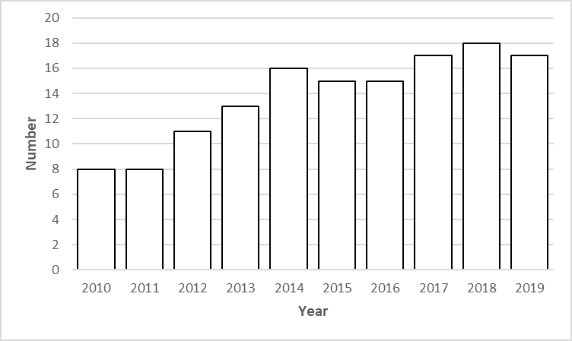

Our primary data source is the financial information reported by nonprofit organizations on the Form 990 and Form 990-EZ. Forms are used for nonprofits to fulfill their reporting requirements as tax-exempt entities under 501(c)3 and 501(c)6 of the U.S. Internal Revenue Code. We primarily use three sections from the Form 990: Part VIII. Statement of Revenue, Part IX. Statement of Functional Expenses, and Part X. Balance Sheet. As legal filings, we assume the financial disclosures on the IRS Form 990s are relatively accurate representations of their financial condition. We identify organizations by Employer Identification Number (EIN) and use digitized aggregated Form 990 data from The Nonprofit Open Data Collective. Some organizations under analysis did not submit their Form 990 electronically, meaning this data was not available in a machine-readable format from the IRS. In such cases, we manually typed the financial information reported by organizations in Form 990 available on Candid/Guidestar records. This data is self-reported and often not subject to verification or validation. Each organization is able to choose how they record their financial information and there are likely cases where revenue and expenses are inadvertently miscategorized. We are unable to independently audit and verify the reported financial data and confine our analysis to what has been reported. While this means our conclusions are possibly inaccurate, we believe the overall trends are representative and the results useful for understanding the financial health and well-being of the organizations we’re reviewing.

To ensure the accuracy of information we’ve collected, we conducted random reviews of information at various points in our internal data collection and analysis processs for review and validation. We verify financial information using Form 990 available at Candid/Guidestar and manually calculate selected ratios of a couple of cases in different years.

Financial Ratio Analysis
Financial ratio analysis is a commonly used method to assess the financial health of organizations (see for example, BBB Wise Giving Alliance, 2022, Searing, 2017). The ratio analysis is based on the comparison between two or more items of financial data from an organization’s financial statements. Ratio analysis is helpful for comparing organizations across time and within and among different fields and industries. Furthermore the calculation of ratios is easy to replicate and communicate.

This study follows commonly used ratios for the nonprofit sector (Ittelson, 2017). For this report, we focus on reporting the results of ten ratios aiming to explore the status of organizations in three areas: financial risk, financial strength, and resource allocation (see Figure 2). In the next three sections, we present the description of the financial ratios used in each dimension and the results for the 10-year analysis. For the aggregated list of financial ratios and formulas see Appendix B.

Figure 2
Dimensions of Ratio Analysis
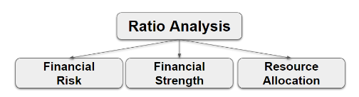
Results of each ratio are reported in two means, a table and a box plot. Tables present basic statistics, including number of organizations analyzed per year, minimum value, maximum value, ratio average, and median. Box plots present the distribution of ratio values. They display the data based on a five-number summary, (minimum, first quartile, median, third quartile, and maximum). They are used to further understand the behaviour of ratios, identify outliers, and tell if the data is symmetrical or skewed (Galarnyk, 2022). The red line in the box plots represents the mean of the ratio under analysis.

Financial Risk
The financial risk dimension relates to the reliance organizations have on different types of funding, including revenue that comes from program service revenue, contributions (e.g. donations), and government grants (Ittelson, 2017). This dimension of the analysis focuses on the extent an organization is vulnerable to external financial conditions by being solely reliant on one type of revenue.

Revenue diversification has been documented to have positive effects on reducing revenue volatility and the overall financial health of nonprofits (Hung & Hager, 2019; Wicker et al., 2015; Mayer et al., 2014; Carroll & Stater, 2009). In this dimension, we are trying to explore the ways in which nonprofits may explore diversification among and within sources. We also recognize that there is a rich discussion on the effects of revenue diversification in nonprofits (see for instance, Mayer et al., 2014, Grasse et al., 2016, and Qu, 2019). In this section, we present the analysis of four ratios. First, reliance on a revenue source ratio aims to assess the dependence of organizations to major revenue types. Second, program service reliance ratio, contributions reliance ratio, and government reliance ratio are useful to have a deeper understanding of major revenue types. The formulas used per each ratio are presented in Table 1.

Table 1
Formulas of Financial Risk Ratios
Ratio Name | Formula
Reliance on a revenue type | The single largest type of income/  Total revenue
Program service reliance | Program service revenue/  Total revenue
Contributions reliance ratio | Contributions revenue/  Total Revenue
Government grants reliance ratio | Government grants revenue/  Total revenue

The results of the four ratios indicate that on average, out of total revenue of organizations under analysis across all years (2010-2019), 50% comes from program service revenue, 37% from contributions, 4% from government grants, and 9% from other types of revenue. The detailed analysis on each type of revenue is presented in the following subsections.
Figure 3
Percentage of Types of Revenue
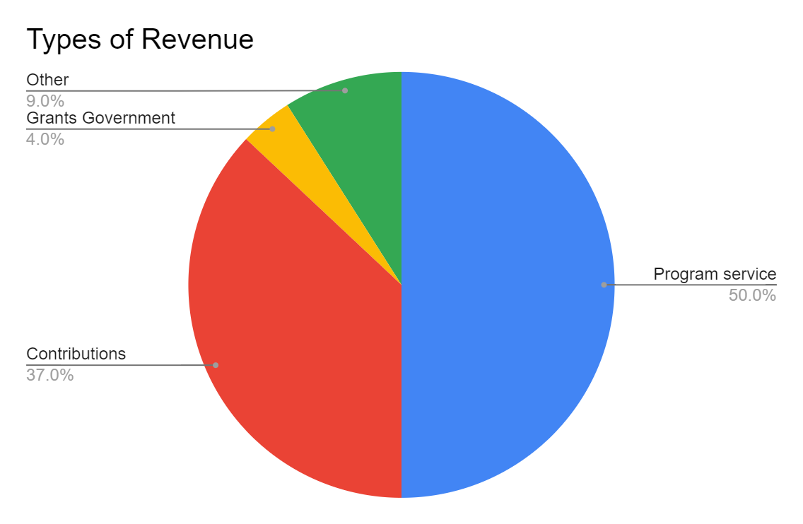

Reliance on a Revenue Type Ratio

Details of the Reliance on a Revenue Type Ratio
Reliance on a revenue source is a central measure of financial risk. As proposed by Ittelson (2017), this measure provides a sense of “how many eggs are being carried in one basket” (p. 180). This measure assumes that relying on a single revenue type is risky because the revenue can be easily disrupted or even disappear altogether. Moreover, as organizations evolve (grow or increase their scope), ideally they also increase their base of supporters by diversifying revenue streams that may include contributions, program services revenue, contracts, and grants (Ittelson, 2017). While it is possible for organizations to continue to rely on the same base of supporters or revenue streams as they grow, the lack of revenue diversification has been associated with limited revenue stability and organizational longevity (Carroll & Stater, 2009).

In preparation for this project, on August 9th, 2022, we hosted a community conversation with representatives of organizations in the ecosystem. This community conversation taught us that some organizations diversify income within revenue types. For instance, this could be the case of an organization that relies primarily on contributions but diversifies its portfolio by expanding its base of supporters through increased sponsorships or even individual donations. Since we are using standardized financial reports (Form 990), we could only compare major revenue types. Following the Candid/Guidestar proposed types of revenue, we analyzed the revenue from seven sources: (i) contributions (not including government grants), (ii) government grants, (iii) programs and services, (iv) investments, (v) special events, (vi) sales, and (vii) other. To calculate the ratio, we identified the largest revenue among the seven types and divided this value by total revenue.

Results and Discussion: Reliance on a Revenue Type Ratio
Results show that singular reliance on a single revenue type could be an area of concern for organizations studied (see Table 2). For any given year, no less than 2/3rds (67%) of organizations were reliant on a single revenue type for 75% or more of their income. As presented in Table 2, there is no apparent change in this area for the period under study (2010-2019). On the contrary, numerous organizations report that most of their income (almost 100%) relies on a single revenue type. Data is concentrated on the higher values of the ratio; see the last column of Table 2 with the median values per year.

Table 2
Results: Reliance on a Revenue Type Ratio 2010-2019
Year | N | Min | Max | Average/  Mean | Median
2010 | 8 | 0.52 | 1 | 0.84 | 0.87
2011 | 8 | 0.59 | 1 | 0.87 | 0.93
2012 | 11 | 0.48 | 1 | 0.89 | 0.98
2013 | 13 | 0.56 | 1 | 0.89 | 0.98
2014 | 16 | 0.52 | 1 | 0.89 | 0.98
2015 | 15 | 0.51 | 1 | 0.87 | 0.92
2016 | 15 | 0.50 | 1 | 0.86 | 0.96
2017 | 17 | 0.52 | 1 | 0.82 | 0.82
2018 | 18 | 0.54 | 1 | 0.85 | 0.91
2019 | 17 | 0.54 | 1 | 0.85 | 0.97
PERIOD 2010-2019 | |18| | 0.48 | 1 | 0.86 | |1|

Figure 4 presents the distribution of the reliance on revenue type ratio values. We can observe almost two groups of organizations. The majority does not diversify and rely heavily on a single revenue type. The other group of organizations is trying to diversify their revenue, but still around half of their income comes from a single revenue type. Our future research will look closely at diversification within major revenue streams to further explore the composition of revenue.

Figure 4
Reliance on a Revenue Type Ratio Values
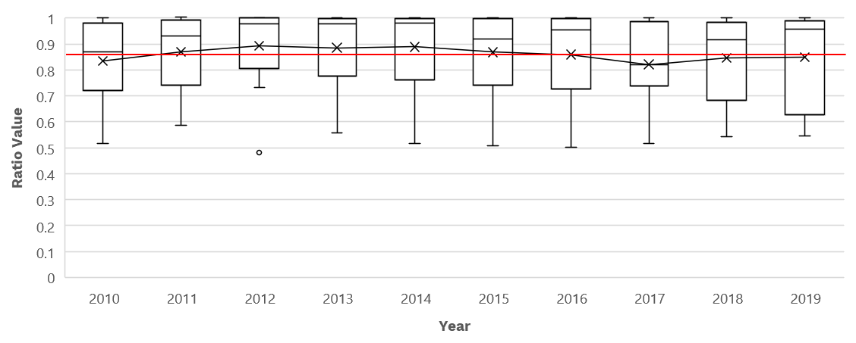

Program Service Reliance Ratio

Details of the Program Service Reliance Ratio
The program service revenue reliance ratio measures the degree to which a nonprofit relies on the revenue from the delivery of programs and services. The two elements to calculate this ratio are program service revenue and total revenue. As defined by the IRS (2021), program services are primarily those that form the basis of an organization’s exemption from tax. Program service revenue includes fees for services provided by nonprofits such as tuition received by a school, revenue from admissions to a concert or to a museum. Program service revenue also includes income earned by an organization for providing a government agency with a service, facility, or product that benefited that government agency directly rather than benefiting the public as a whole.

Results and Discussion: Program Service Reliance Ratio
The organizations in this analysis rely on funding from the delivery of programs and services (see Table 3). On average, 50% of the revenue comes from this source for the organizations in this analysis. There are no clear changes or trends in recent years. The main observation is that a consistent group of organizations (at least five organizations in this analysis) report that more than 90% of their revenue comes from program service revenue over the ten years of analysis. This could be evidence of persistent reliance on this type of income.

Table 3
Results: Program Service Reliance Ratio 2010-2019
Year | N | Min | Max | Average/  Mean | Median
2010 | 9 | 0 | 1 | 0.54 | 0.82
2011 | 8 | 0 | 1 | 0.64 | 0.93
2012 | 12 | 0 | 1 | 0.44 | 0.16
2013 | 13 | 0 | 1 | 0.43 | 0.16
2014 | 16 | 0 | 1 | 0.40 | 0.16
2015 | 16 | 0 | 1 | 0.52 | 0.46
2016 | 16 | 0 | 1 | 0.52 | 0.53
2017 | 18 | 0 | 1 | 0.52 | 0.55
2018 | 18 | 0 | 1 | 0.51 | 0.49
2019 | 17 | 0 | 1 | 0.49 | 0.46
PERIOD 2010-2019 | |18| | 0 | 1 | 0.50 | |0|

Figure 5 presents the distribution of the program service reliance ratio values. Except for years 2012 to 2014 and 2019, more than half of the income of the organizations in the ecosystem comes from program service revenue. This means that the financial viability of most organizations analyzed is mostly explained by the capacity of organizations to deliver programs and services.

Figure 5
Program Service Reliance Ratio Values
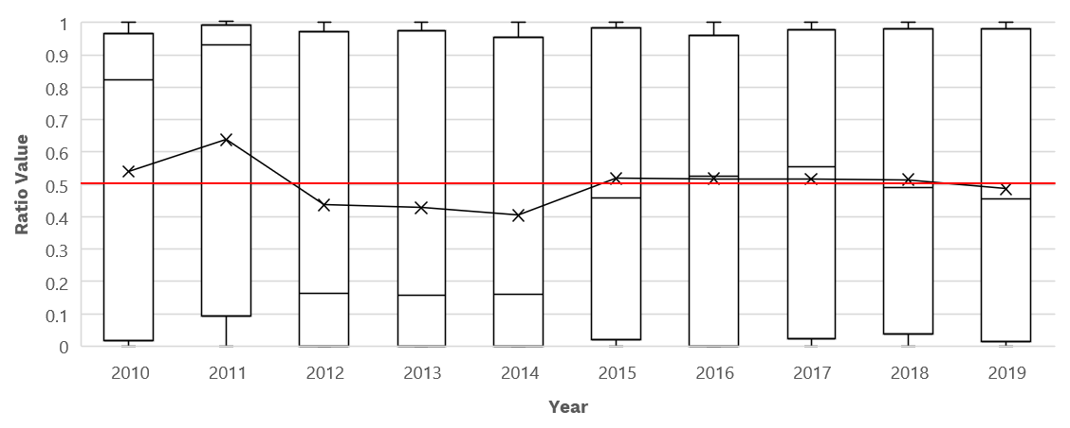

Contributions Reliance Ratio

Details of the Contributions Reliance Ratio
The contributions reliance ratio or contribution revenue reliance measures the reliance of organizations on public and private support (Cashwell et al., 2019). The two elements to calculate this ratio are contributions, gifts, and grants (excluding government grants) and total revenue. Higher values in this ratio indicate that organizations depend upon donations and grants (Cashwell et al., 2019).

We noted that within the nonprofit sector, there are differences regarding contributions revenue over total revenue. For instance, religious organizations are the largest recipients of contributions, with environmental and animal welfare organizations being the lowest (Urban Institute, 2021). In this subsection, we explore the extent to which nonprofits in the open research and scholarship space depend on this revenue type.

Results and Discussion: Contributions Reliance Ratio
On average, 37% of the total revenue comes from contributions for organizations under analysis (see Table 4). This means that most organizations do not rely on this type of revenue, as shown by the relatively low mean of this ratio. Still there is a consistent small number of organizations that rely on this type of revenue.

Table 4
Results: Contributions Reliance Ratio 2010-2019
Year | N | Min | Max | Average/  Mean | Median
2010 | 8 | 0 | 0.80 | 0.17 | 0.04
2011 | 8 | 0 | 0.81 | 0.13 | 0.01
2012 | 11 | 0 | 1 | 0.39 | 0.03
2013 | 13 | 0 | 1 | 0.46 | 0.44
2014 | 16 | 0 | 1 | 0.45 | 0.37
2015 | 15 | 0 | 1 | 0.44 | 0.48
2016 | 15 | 0 | 1 | 0.43 | 0.45
2017 | 17 | 0 | 0.99 | 0.34 | 0.25
2018 | 18 | 0 | 0.99 | 0.42 | 0.43
2019 | 17 | 0 | 0.99 | 0.43 | 0.38
PERIOD 2010-2019 | |18| | 0 | 1 | 0.37 | |0|

Figure 6 presents the distribution of contributions reliance ratio values. Over time, the income that comes from contributions has gained importance for the revenue mix of organizations in this analysis. For organizations operating in 2010 and 2011, contributions revenue did not seem as relevant as for the new organizations entering the space in 2012 and after. We also observe that similar to program service revenue, there is a consistent group of organizations that rely heavily on the revenue that comes from contributions per each year of analysis. Our future work will aim to expand our understanding of revenue diversification within revenue types and how it can help support the long-term viability and sustainability of organizations.

Figure 6
Contributions Reliance Ratio Values
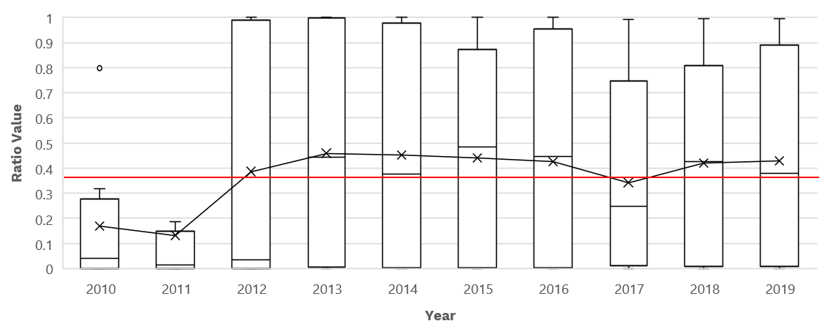

Government Grants Reliance Ratio

Details of Government Grants Reliance Ratio
The government grants reliance ratio measures the degree to which a nonprofit relies on government grants (Sanchez, 2021). The two elements to calculate this ratio are government grants and total revenue. Government funding varies across nonprofit subsectors and depends on organizational characteristics. Some nonprofit hospitals, for example, receive most of the funding from the government. In terms of organizational elements, nonprofits with higher bureaucratic orientation, stronger relationships with the government, and longer funding history have higher chances of receiving government contracts and grants (Lu, 2015). While the overall guideline is for organizations to diversify their revenue, MacIndoe and Sullivan (2014) have suggested that reliance on government funding may increase the likelihood of cross-sector collaborations (collaborations with government agencies and for-profit firms). Given the differences in government grants among nonprofit subsectors, there are no established principles regarding the degree nonprofits rely on government grants.

Results and Discussion: Government Grants Reliance Ratio
Organizations in this analysis do not typically rely on government grants (see Table 5). On the contrary, government grants account for a small percentage of the revenue mix of organizations. Per each of the years of analysis, government grants represent less than 10% of organizations' revenue. There were few exceptions in 2011 and 2013, in which two distinct organizations reported 59% and 99% of their income coming from government grants. On the contrary, several organizations say 0% of funding is from this type of income.

Table 5
Results: Government Grants Reliance Ratio 2010-2019
Year | N | Min | Max | Average/  Mean | Median
2010 | 8 | 0 | 0.52 | 0.09 | 0
2011 | 8 | 0 | 0.59 | 0.09 | 0
2012 | 11 | 0 | 0.48 | 0.04 | 0
2013 | 13 | 0 | 0.32 | 0.03 | 0
2014 | 16 | 0 | 0.99 | 0.07 | 0
2015 | 15 | 0 | 0.05 | 0.01 | 0
2016 | 15 | 0 | 0.11 | 0.01 | 0
2017 | 17 | 0 | 0.52 | 0.04 | 0
2018 | 18 | 0 | 0.17 | 0.01 | 0
2019 | 17 | 0 | 0.38 | 0.03 | 0
PERIOD 2010-2019 | |18| | 0 | 0.99 | 0.04 | |0|

Figure 7 presents the distribution of the government reliance ratio values. We can observe that the mean of the ratio is below 0.10, which means that less than 10% of the income of organizations comes from government grants. There are a couple of outliers (represented with dots), these show cases of organizations that reported government grants income higher than their counterparts.

Figure 7
Government Reliance Ratio Values
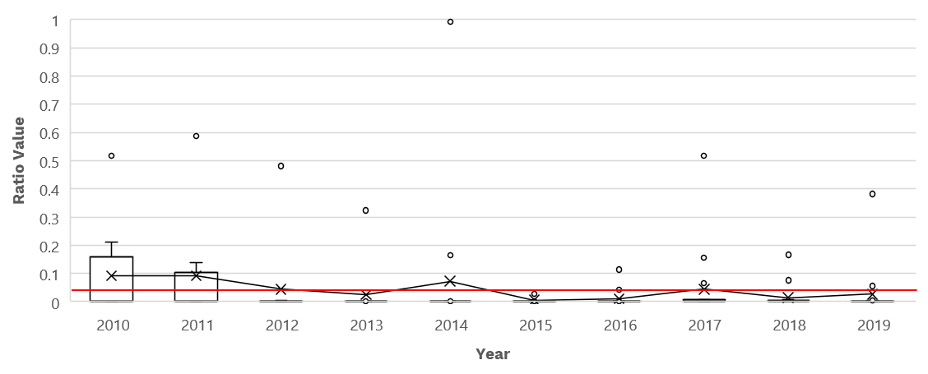

Financial Strength
The financial strength dimension refers to the degree an organization can cover its financial obligations. The dimension is generally measured by looking at cash flows (liquidity) and the balance between liabilities and assets (solvency). To measure this dimension, we selected two ratios: days cash on hand and leverage ratio. The first targets short-term and the second long-term financial strength. The formulas used per each ratio are presented in Table 6.

We recognize that days cash on hand and leverage ratio are not usually paired together. Since this is an exploratory study, we wanted to have a broader understanding on the financial strength of organizations and for that reason we focus on the cash reserves and the accumulation of liabilities. Other ratios useful to understand the financial strength of nonprofits are current ratio and debt ratio. Such measures required detailed financial information that is not available in the source used (Form 990).

Table 6
Formulas of Financial Strength Ratios
Ratio Name | Formula
Days cash on hand ratio | Cash/ (Total expenses/365)
Leverage ratio | Total liabilities / Total assets

Days Cash on Hand

Details of Cash on Hand Ratio
The ratio of days cash on hand is a measure of financial security that helps to assess the ability of an organization to cover its short-term financial obligations. The ratio provides specific information on how many days the cash available to the organization will last at the daily spending rate of the organization (Ittelson, 2017). The two elements to calculate this ratio are cash on hand and total expenses. For both elements, we used the reported information for organizations at the end of each given year. For the calculation of the ratio, we decided to exclusively use cash amounts as opposed to cash AND savings and temporary cash investments. We decided to use only cash in order to stick with the commonly used guidelines to calculate this ratio.

Results and Discussion: Days Cash on Hand Ratio
Table 7 presents the results of the days cash on hand ratio. As the ecosystem has evolved, organizations have emphasized having enough liquidity to cover their short-term financial obligations. For instance, in 2010, the average days of cash on hand was 39 days for the eight organizations reporting financial data for that tax year. In contrast, in recent years (2017-2019), organizations reported cash on hand for three months or more (90 days or more). However, several organizations have zero dollars of cash at the end of the year (see the third column in Table 7).

In this report, we are trying to raise awareness on the importance of cash reserves. Not having them puts organizations in potential debt when faced with some kind of unforeseen financial expense or other emergency funding circumstance. We know that cash reserves are contingent on funding cycles and the maturity of organizations. From our conversations with organizations in the ecosystem, we also know that the amount of cash on hand depends on the funding guidelines of funders and investors. In other words, funders have conservative standards on the amount of cash on hand that an organization should have.

Table 7
Results: Days Cash on Hand Ratio 2010-2019

Year | N | Min | Max | Average days cash on hand | Median
2010 | 8 | 0 | 171 | 39 | 20.00
2011 | 8 | 0 | 280 | 49 | 16.10
2012 | 11 | 0 | 309 | 65 | 4.03
2013 | 13 | 0 | 1158 | 132 | 13.86
2014 | 16 | 0 | 623 | 166 | 131.42
2015 | 15 | 0 | 446 | 94 | 25.86
2016 | 15 | 0 | 389 | 99 | 32.90
2017 | 17 | 0 | 2078 | 210 | 80.63
2018 | 18 | 0 | 1658 | 190 | 32.07
2019 | 17 | 0 | 449 | 114 | 32.72
PERIOD 2010-2019 | |18| | 0 | 2078 | 116 | |39|

Figure 8 presents the distribution of days cash on hand ratio values. As discussed above, the cash reserves of organizations have significantly improved in recent years. This is evidence of the maturity of these organizations and possibly the ecosystem as a whole – an ecosystem that has been able to accumulate cash reserves as time has passed. For the period from 2013 to 2018, the mean of the ratio is above 90 (days). Still, there is a sizeable group of organizations in this analysis that have less than three months of cash reserves.

Figure 8
Days Cash on Hand Ratio Values
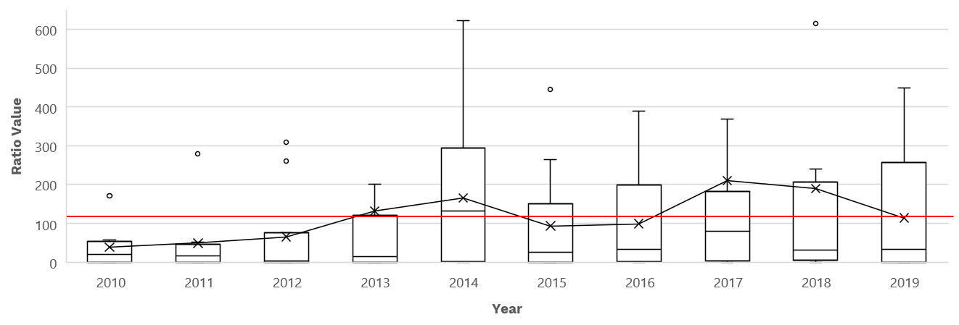

Leverage Ratio

Details of Cash on Leverage Ratio
The leverage ratio is essential to understanding the degree of liabilities (also known as debts) that an organization accumulates relative to its available assets. The two elements to calculate the leverage ratio are total liabilities and total assets. The leverage ratio is commonly used to measure the ability of nonprofits to meet their financial obligations (Skoll Foundation, 2018; Carroll & Stater, 2009). Greater values indicate reduced financial flexibility because assets may be compromised due to debt (Carroll & Stater, 2009). Debt use is negatively related to organizational liquidity (the ability to pay off short-term liabilities). A high leverage ratio is also negatively associated with difficulties for organizations to build up operating reserves (Grizzle et al., 2015). Following the Principles of Open Scholarly Infrastructure (POSI), operational reserves have been noted to be critical for the sustainability of organizations (Bilder et al., 2020).

Results and Discussion: Leverage Ratio
Most organizations studied report a leverage ratio higher than 0.50. Table 8 presents the results of the leverage ratio. While the behaviour of the ratio has improved in recent years, with the lowest mean in 2019, it is still clear that organizations have room for improvement in balancing their financial obligations with the assets they have. As suggested by Grizzle et al. (2015), reliance on debt limits an organization from building up operating reserves which are critical when faced with financial stress, unexpected events, and loss of funding.

Table 8
Results on Leverage Ratio 2010-2019

Year | N | Min | Max | Average/  Mean | Median
2010 | 9 | 0 | 3.01 | 0.61 | 0.30
2011 | 8 | 0.05 | 1.92 | 0.54 | 0.32
2012 | 12 | 0.08 | 1.69 | 0.60 | 0.50
2013 | 13 | 0 | 2.06 | 0.56 | 0.42
2014 | 16 | 0 | 2.04 | 0.52 | 0.34
2015 | 16 | 0 | 1.45 | 0.60 | 0.58
2016 | 16 | 0 | 2.02 | 0.62 | 0.69
2017 | 18 | 0 | 1.96 | 0.60 | 0.64
2018 | 18 | 0 | 1.87 | 0.66 | 0.68
2019 | 16 | 0 | 1.87 | 0.66 | 0.48
PERIOD 2010-2019 | |18| | 0 | 3.01 | 0.58 | |0|

Figure 9 presents the distribution of the leverage ratio values. The mean of the leverage ratio has been above 0.5 for most years of analysis. In recent years (2016-2019), data seems to be skewed to higher values. This may be an indication that some organizations are accumulating more liabilities (debts) in relationships with the assets they have. A deeper understanding of the balance between liabilities and assets may require an analysis of the products and services offered by nonprofits and how they are financing such services.

Figure 9
Leverage Ratio Values
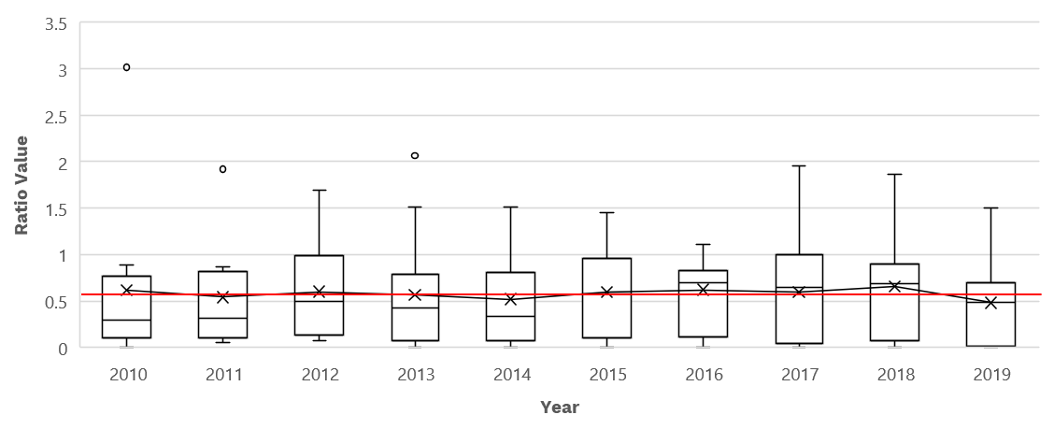

Resource Allocation
The resource allocation dimension refers to the degree to which organizations utilize their resources to advance their mission. To explore the performance of organizations in this dimension, we use four spending ratios, focusing on expenditures in programs, administration, fundraising, and personnel. The formulas used per each ratio are presented in Table 9.

Table 9
Formulas of Resource Allocation Ratios
Ratio Name | Formula
Program expense ratio | Program services expenses/ Total expenses
Administrative expense ratio | Administrative expenses/ Total expenses
Fundraising expense ratio | Fundraising expenses/ Total expenses
Personnel expense ratio | Total salaries, wages, and benefits/ Total revenue

The results of the three first ratios indicate that on average, out of total expenses of organizations under analysis for all years of analysis (2010-2019), 50% goes to programs, 19% to management, and 1% to fundraising expenses. The detailed analysis on each type of expenses is presented in the following subsections.

Figure 10
Percentage of Types of Expenses
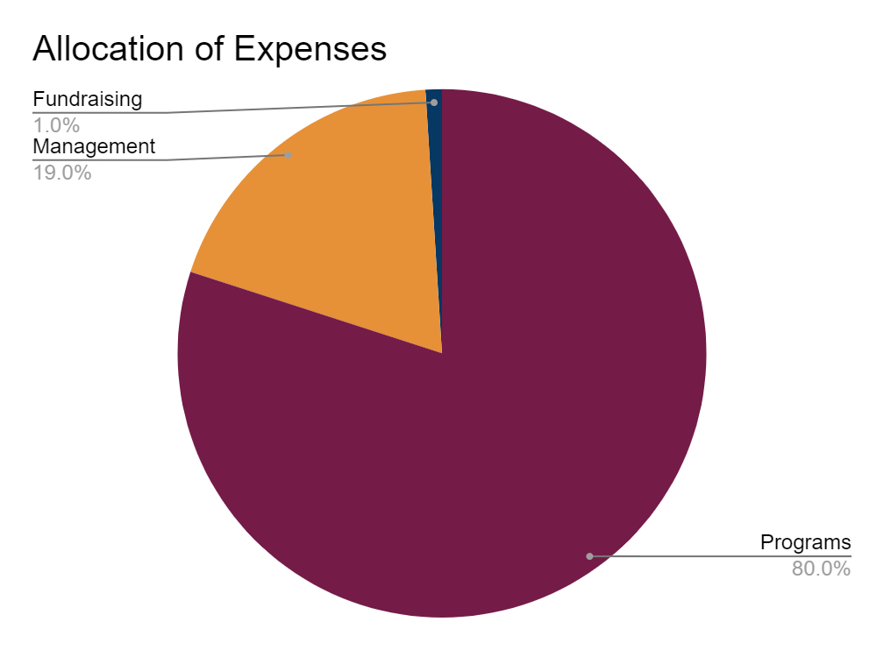

Program Expense Ratio

Details of Program Expense Ratio
The program expense ratio measures the percentage of total expenses devoted to expenses in programs and services (Ittelson, 2017). The two elements to calculate the ratio are expenses used for programs and total expenses. This ratio also has been seen as the degree to which a nonprofit is spending on its core mission (Sanchez, 2021). For most nonprofits, program ratio expenses are the highest percentage of total expenses (Audithow, 2022).

Results and Discussion: Program Expense Ratio
On average, the organizations reviewed in this analysis spend 80% of their expenses on program-related costs (see results in Table 10). There are few exceptions, with some organizations reporting no expenses on program-related services, which is common in new and small nonprofits that have not started programs. Apart from these cases, the ecosystem reports a clear service delivery focus as demonstrated by the large share of expenses devoted to program-related costs.

Table 10
Results: Program Expense Ratio 2010-2019

Year | N | Min | Max | Average/  Mean | Median
2010 | 8 | 0.52 | 0.96 | 0.80 | 0.85
2011 | 8 | 0.57 | 0.97 | 0.81 | 0.82
2012 | 11 | 0.45 | 0.98 | 0.75 | 0.80
2013 | 13 | 0.45 | 0.98 | 0.79 | 0.81
2014 | 16 | 0.40 | 1 | 0.82 | 0.82
2015 | 15 | 0.41 | 0.98 | 0.80 | 0.85
2016 | 15 | 0.38 | 0.99 | 0.78 | 0.81
2017 | 17 | 0 | 1 | 0.78 | 0.84
2018 | 18 | 0.44 | 1 | 0.82 | 0.85
2019 | 17 | 0.45 | 1 | 0.82 | 0.84
PERIOD 2010-2019 | |18| | 0 | 1 | 0.80 | |1|

Figure 10 presents the distribution of the program expense ratio values. It is clear that per each year of analysis, more than 75% of the organizations’s expenses go to programs. This has been a constant for the ten years of analysis. The only extreme outlier was the case of an organization that in 2017 reported no expenditures in programs.

Figure 10
Program Expense Ratio Values
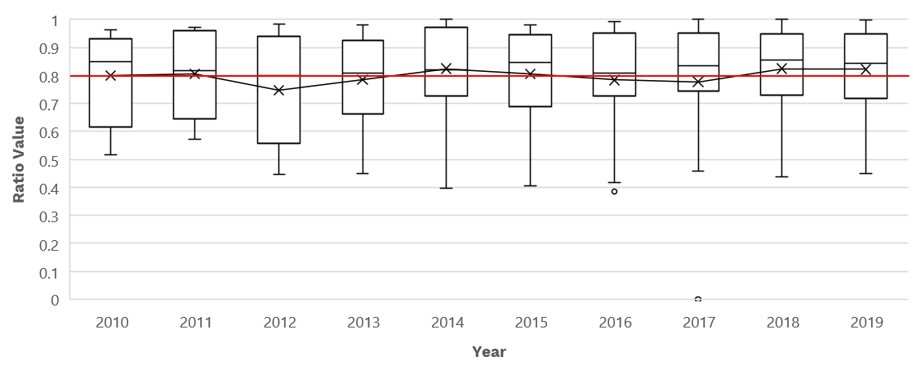

Administrative Expense Ratio

Details of Administrative Expense Ratio
The administrative expense ratio provides a sense of the extent organizations spend on their managerial activities. It measures the relationship between administrative expenses and total expenses. Ittelson (2017) suggests that there is no right threshold here because organizations have different operating strategies. He also proposes that, while theoretically, most expenses of nonprofits should go to programs, the side effect of this is that underinvestment in administrative expenses may lead to deficient or diminished capacity in areas such as governance, strategic planning, risk management, and staff training (Ittelson, 2017). Chronic underinvestment in management and general expenses has been framed as the starvation cycle (Lecy & Searing, 2015). Lecy and Searing have proposed that such a vicious cycle may lead nonprofits to mislead financial reporting to meet growing expectations of donors to maintain lower overhead expenses.

Results and Discussion: Administrative Expense Ratio
Organizations under analysis report an adequate investment in administrative expenses (see results in Table 11). On average, organizations studied spend 19% of their total expenses on management and general expenses. Still, it is surprising that many organizations report 0% to 5% of their expenses in this area. As presented above, underinvestment in this area may lead to a diminished organizational capacity that eventually could reduce long-term sustainability (Ittelson, 2017; Lecy & Searing, 2015).

Table 11
Results: Administrative Expense Ratio 2010-2019

Year | N | Min | Max | Average/  Mean | Median
2010 | 8 | 0.04 | 0.48 | 0.20 | 0.15
2011 | 8 | 0.03 | 0.43 | 0.19 | 0.18
2012 | 11 | 0.02 | 0.51 | 0.24 | 0.20
2013 | 13 | 0.02 | 0.55 | 0.20 | 0.19
2014 | 16 | 0 | 0.60 | 0.17 | 0.17
2015 | 15 | 0.02 | 0.59 | 0.19 | 0.15
2016 | 15 | 0.01 | 0.58 | 0.20 | 0.19
2017 | 17 | 0 | 0.84 | 0.19 | 0.14
2018 | 18 | 0 | 0.56 | 0.16 | 0.14
2019 | 17 | 0 | 0.55 | 0.16 | 0.16
PERIOD 2010-2019 | |18| | 0 | 0.84 | 0.19 | |0|
Figure 11 presents the distribution of the administrative expense ratio values. While there are outliers that represent cases of organizations that spend more than 50% of their expenses on administrative expenses, it is also clear that the ecosystem has steadily spent conservatively on administrative capacity.

Figure 11
Administrative Expense Ratio Values
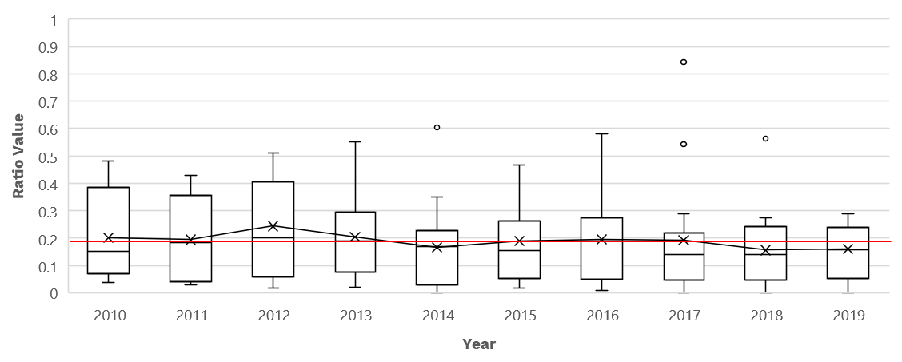

Fundraising Expense Ratio

Details of Fundraising Expense Ratio
The fundraising expense ratio measures the degree of total expenditure designated for fundraising activities. The two elements to calculate this ratio are fundraising expenses and total expenses. Fundraising expenses include any direct or indirect costs associated with fundraising events. Examples of such expenses include marketing for events, public relations costs, and salaries and wages of employees that dedicate time to fundraising activities (Wikiaccounting, 2022).

Results and Discussion: Fundraising Expense Ratio
Nonprofits in this analysis report minimum expenditures on fundraising activities. The highest value in fundraising activities was 27% (reported in 2017). Indeed, most organizations report an average expenditure of 1% on fundraising expenses compared to total expenses. This value is surprisingly low, particularly for organizations that primarily rely on contributions as a source of revenue. It’s possible organizations conduct fundraising activities but do not allocate those costs specifically to this category, either because these costs are unintentionally misidentified or they are intentionally not allocating costs into this category in order to maintain low overhead percentages to be more attractive to funders and donors.

For those organizations intending to leverage contributions as a significant source of revenue to fund their operations, fundraising is an important expense used to build and sustain a reliable source of income from a large and diverse set of donors. Failure to invest in this area can be a concern for the long-term viability of providers intending to rely heavily on contributions. We also recognize that further exploration is needed to determine the extent of those investments and their effectiveness to attract donations.

Table 12
Results: Fundraising Expense Ratio 2010-2019

Year | N | Min | Max | Average/  Mean | Median
2010 | 8 | 0 | 0 | 0 | 0
2011 | 8 | 0 | 0 | 0 | 0
2012 | 11 | 0 | 0.05 | 0.01 | 0
2013 | 13 | 0 | 0.07 | 0.01 | 0
2014 | 16 | 0 | 0.09 | 0.01 | 0
2015 | 15 | 0 | 0.05 | 0.01 | 0
2016 | 15 | 0 | 0.23 | 0.02 | 0
2017 | 17 | 0 | 0.27 | 0.03 | 0
2018 | 18 | 0 | 0.24 | 0.02 | 0
2019 | 17 | 0 | 0.21 | 0.02 | 0
PERIOD 2010-2019 | |18| | 0 | 0.27 | 0.01 | |0|

Figure 12 presents the distribution of the fundraising expense ratio values. The box plot helps to show the skewed distribution of values that in most cases are close to zero. This means that most organizations under study report no expenses on fundraising activities. A couple of exceptions are represented in the box plot as outliers (marked with dots), which are cases of organizations that spend 5% or more in fundraising expenses.

Figure 12
Fundraising Expense Ratio Values
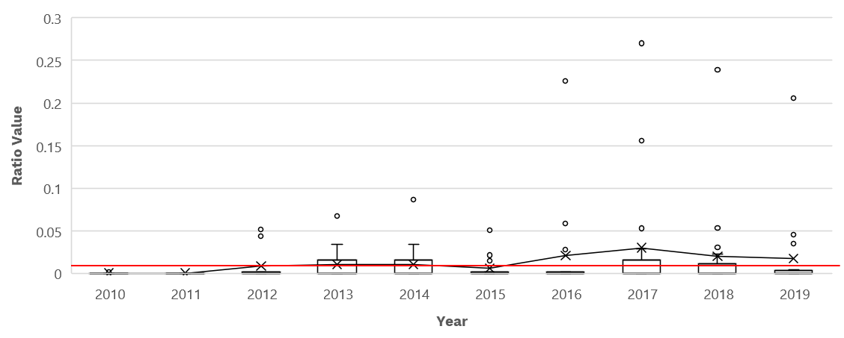

Personnel Expense Ratio

Details of Personnel Expense Ratio
The personnel expense ratio measures the human resource costs of producing revenue (Sanchez, 2021). The two elements to calculate the ratio are the total salaries, wages, and benefits divided by the total revenue. Instead of total expenditures, total revenue is used as the denominator as proposed in practitioner sources (e.g., Sanchez, 2021). The calculation aims to observe the relationship between human resource investments and the efficiency in attracting revenue to the organization. The assumption is that if personnel expenses are costing more than the revenue being generated, this could be an indication that there are inefficiencies in operations.

The personnel expense ratio will vary depending on how labour-intensive an organization is compared to other organizations in the ecosystem. Normally, personnel is the largest expense for an organization. Based on the Form 990 reporting requirements, organizations can allocate personnel expenses in a combination of program service expenses, management and general expenses, and fundraising expenses. For instance, the salary of an employee can be distributed between program service and fundraising activities (if the employee contributes to both).

Results and Discussion: Personnel Expense Ratio
Organizations in this analysis present inconsistent reporting regarding their expenses on salaries and wages (see results in Table 13). On the one hand, especially in recent years (2017-2019), organizations have increased their expenditures on salaries. This may be explained due to formalization processes in organizations (Searing & Lecy, 2022). For instance, organizations that used to rely on volunteer work (allocating zero dollars to salaries) are now transitioning to hiring part-time or full-time staff. On the other hand, during the ten-year analysis, several organizations reported no salary expenditures. This may be due to persistent reliance on volunteer work or that most work is being conducted by contracts (hiring for services). While there is nothing inherently wrong with having volunteers and contractors, studies have shown that underinvestment in human resources may prevent organizations from formalizing the organizational structures and processes that enable them to eventually grow (Searing & Lecy, 2022). Underinvestment in permanent staff can undermine the long-term sustainability and viability of organizations.

Table 13
Results: Personnel Expense Ratio 2010-2019

Year | N | Min | Max | Average/  Mean | Median
2010 | 8 | 0 | 0.63 | 0.39 | 0.45
2011 | 8 | 0 | 0.68 | 0.38 | 0.44
2012 | 11 | 0 | 0.81 | 0.44 | 0.48
2013 | 13 | 0 | 1.45 | 0.43 | 0.39
2014 | 16 | 0 | 0.78 | 0.39 | 0.44
2015 | 15 | 0 | 1 | 0.48 | 0.51
2016 | 15 | 0 | 0.75 | 0.45 | 0.54
2017 | 17 | 0 | 1.67 | 0.50 | 0.54
2018 | 18 | 0 | 1.47 | 0.47 | 0.53
2019 | 17 | 0 | 4.58 | 0.67 | 0.49
PERIOD 2010-2019 | |18| | 0 | 4.58 | 0.46 | |0|

Figure 13 presents the distribution of the personnel expense ratio values. While there is a minor trend of increased expenditures on personnel in recent years (2017-2019), there are still numerous organizations not allocating any expenses to personnel costs.

Figure 13
Personnel Expense Ratio Values
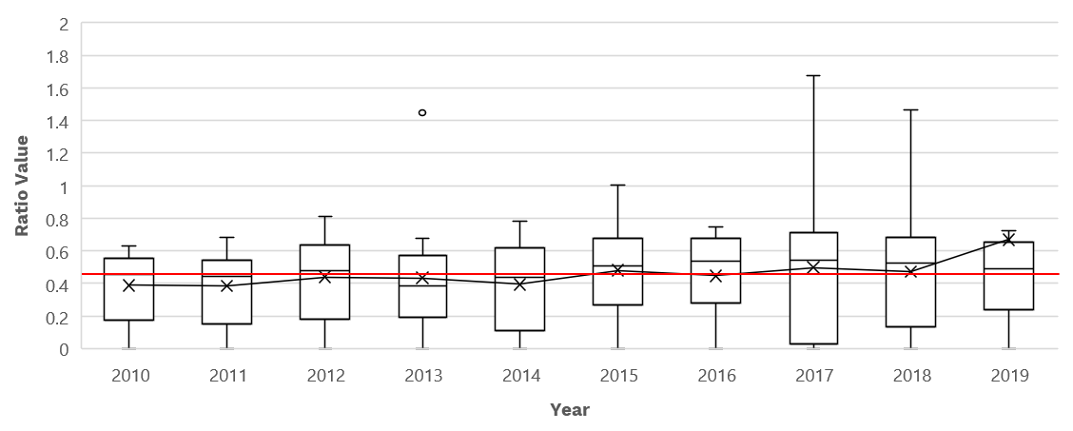

Takeaways
This report explored the financial health of selected nonprofits in open research and scholarship. We conducted financial ratio analysis using financial statements reported by organizations on the U.S. Internal Revenue Service Form 990 and Form 990-EZ. In addition to the results presented above, we found clear trends in the ecosystem around the three dimensions studied: financial risk, financial strength, and resource allocation. While there are likely cases where the financial information reported is inaccurate due to the inadvertent miscategorization of revenue or expenses, we feel confident in our findings while also hoping to improve the accuracy of reported financial data for future analysis.

First, in the financial risk dimension, we studied the degree organizations in this study rely on distinct revenue types (e.g., programs and services, contributions, and government grants). Results show that for the ten-year analysis most organizations are primarily supported by program service revenue. This stream represents 50% of the total revenue of organizations analyzed. Secondarily, organizations rely on contributions revenue. Contributions represent about 37% of the revenue mix of organizations. While some organizations report government grants, there is not a persistent reliance on this type of funding, accounting for only about 4% of the total revenue. Organizations also reported changes in the revenue portfolio during the 10 years of analysis. For instance, an organization may rely on government grants, then change towards contributions, and later change to program service revenue. The recommendation for organizations is to be mindful of their revenue sources and intentional with how they finance their operations. To ensure their long-term financial sustainability, organizations may assess their revenue streams by evaluating the stability of these and by exploring portfolio diversification among revenue types.

Second, in the financial strength dimension, organizations accumulate liabilities. For the ten-year analysis, 58% of organizations report liabilities greater than their assets. Organizations that rely on debt present limited ability to build up operating reserves which are critical for facing financial stress, unexpected events, and loss of funding (Grizzle et al., 2015). For this reason, we recommend organizations create plans to reduce their liabilities so they can invest and diversify their assets in line with the Principles of Open Scholarly Infrastructure (Bilder et al., 2020).

Third, in the resource allocation dimension, most expenses reported by organizations in this analysis went to programs (80% of total expenses). While this is theoretically ideal, meaning that money is being spent on programs and services, underinvestments in management and fundraising capacity can be problematic for the long-term sustainability of organizations providing an enduring service over the long term. Consequences of underinvestment may include limited managerial capacity, increased turnover among staff, and limited capacity to track funding and donations. While this area of analysis may be where the miscategorization of expenses is most prevalent, we recommend organizations review their investments in managerial and fundraising activities (commonly known as overhead costs) in order to better secure their long term organizational capacity. We encourage greater transparency about these costs by clearly delineating these from program costs. Given the constraints of current funding arrangements, organizations may find it useful to explore opportunities to share resources in order to better manage overhead costs, though this would require further study and coordination.

Based on this analysis, we propose recommendations for providers and funders within the ecosystem (see Table 14). By providers, we mean nonprofits that provide open infrastructure services and by funders, we mean organizations that fund open infrastructure services, including primarily private philanthropies, government agencies, and academic institutions, but also other organizations who make monetary and non-monetary contributions to support providers. The recommendations below are broad guidelines for each organization to adapt to their specific needs based on their particular funding models. These aim to provide general guidelines for the overall health of the ecosystem and we offer them as contributions to the ongoing conversation on how to provide stable and consistent financing in the space. We look forward to developing these recommendations in concert with others similarly interested in a viable and robust ecosystem of open infrastructure services.

Table 14
Opportunities for Providers and Funders of Nonprofits in Open Research and Scholarship

Dimensions | Opportunities for providers | Opportunities for funders
Financial Risk | - Be more intentional with financial planning to ensure the costs and benefits of revenue sources are aligned with the strategic plan of the organization and minimize the risk of overdependence on any one source of revenue  - Explore portfolio diversification within program service revenue and contributions to ensure a variety of funders and funding sources are available to the organization to better ensure the long term financial stability of the organization | - Review internal policies and procedures to ensure grantees are able to allocate available resources to address areas of financial risk and build the capacity to manage these risks  - Develop resources (templates, training, mentoring, etc.) for grantees to identify financial risks, particularly around revenue diversification, and build the capacity to address these risks and better identify opportunities for long-term viability and financial success  - Work explicitly with grantees to identify funding and partnership targets with an aim to provide additional sustainability and planning support towards long term sustainability through revenue diversity
Financial Strength | - Quantify the regular operating expenses of the organization and ensure the organization has sufficient liquidity to fund at least 90 days of regular operating expenses in the event of unforeseen financial issues  - Explore opportunities for additional unrestricted funds to address current liabilities and build a meaningful reserve in line with nonprofit management best practices and the Principles of Open Scholarly Infrastructure (POSI)  - Develop and implement plans to pay liabilities, ensuring these plans are communicated to internal staff and external stakeholders, with regular updates to meet current and anticipated future obligations | - Ensure funding policies and procedures allow organizations to accumulate cash reserves to support operational needs and unforeseen contingencies while still ensuring project objectives are met  - Better assess the financial strength of potential grantees and develop useful resources (budget planning templates, training sessions, mentoring, etc.) to improve the internal capacity for strategic financial planning and debt management of grantees at various levels of financial and operational maturity
Resource Allocation | - Ensure management and fundraising activities are properly resourced in order to put in place managerial mechanisms to grow and expand existing capacity to meet current and future challenges  - Ensure labor and human resources activities are properly planned and resourced (especially for organizations currently allocating little to no money in this area) to formalize the structure and processes of the organization in order to ensure long-term sustainability and viability of the organization | - Ensure funding guidelines allow organizations, particularly infrastructure service providing organizations, to have higher levels of indirect costs in order for them to use available funds for management investments and organizational capacity building  - Ensure funding guidelines allow organizations to use funding for labor and human resources investments to formalize their organizational structures and processes in support of long term staffing plans and strategic objectives  - Develop resources (templates, training, mentoring, etc.) for grantees to expand their capacity to better allocate available resources to meet long-term objectives and strategic goals

Conclusion

This report visualizes key financial challenges for the organizations under our analysis and likely for the ecosystem as a whole. There are important limitations to the available data for studying the financial health of organizations. While the Form 990 data is readily available for those obligated to report as US-based nonprofit organizations, this rich source is still limited, not having key details in important areas such as revenue diversification among main revenue types, including program service revenue.

Moreover, while most organizations under analysis report activities using the electronic Form 990, some of the organizations didn’t submit electronic Form 990s, limiting the accessibility of their data that instead needs to be manually captured for analysis. Additionally, some organizations submitted their data via Form 990-EZ, which has slight but significant differences in the detail and type of data reporting. Different reporting requirements of nonprofits present challenges integrating the data with the standard Form 990 data, including detailed information on important elements such as functional expenses.

Despite these challenges, ratio analysis helps to identify three areas of concern for open infrastructure organizations: reliance on a single type of revenue (particularly fee-for-service), challenges to managing liabilities and building cash reserves, and low levels of investment for management and fundraising cost.

While it’s possible to blame the individual organizations for these choices, it’s much more likely these are systemic problems in how we finance and otherwise resource open infrastructure services. These services can’t be financed in the same way as short duration research projects, having structural costs that are part of running an enduring organization and needing additional support to be viable and sustainable in the long term.

Given the complexity of open infrastructure services that need regular, reliable, and consistent funding in order to develop, grow, and continue to mature over time, we advocate for robust funding mechanisms for nonprofits. We support funding models that allow organizations to make their organizational structures and their services sustainable for the long-term. We hope that this study contributes to identifying those funding needs in order for the organizations in this study and the ecosystem to flourish and to continue providing non-for-profit services.

Acknowledgments
Our special thanks to those who’ve helped make this work possible, especially the participants of the community discussion we hosted on August 9th, 2022. Their feedback was critical for early revisions on the benchmark thresholds for ratios and foreseen effects of this information on decision-making processes.

We would also like to thank Elizabeth Searing, ChiaKo Hung, Laurie Mook, Katrina Pugh, Rupert Gatti, and Lucy Ofiesh for providing feedback to the complete draft of this report. Lastly, we would like to thank Jesse Lecy, a member of the Nonprofit Open Data Collective for facilitating the databases with Form 990 and Form 990-EZ electronic filers.

Funding for this research was provided by the Mellon Foundation and Arcadia, a charitable fund of Lisbet Rausing & Peter Baldwin.

This report is made available under a Creative Commons Attribution 4.0 International License. Users are free to share, remix, and adapt this work. (Please attribute Invest in Open Infrastructure in any derivative work.)

References
Audithow. (2022). What is Program Expense Ratio? Definition, Example Calculation? Audithow, https://audithow.com/program-expense-ratio/
Better Business Bureau (BBB) Wise Giving Alliance (2022). BBB Standards for Charity Accountability. https://give.org/donor-landing-page/bbb-standards-for-charity-accountability.
Bilder G, Lin J, Neylon C (2020), The Principles of Open Scholarly Infrastructure, retrieved 2022-10-04, https://doi.org/10.24343/C34W2H
Carroll, D. A., & Stater, K. (2009). Revenue Diversification in Nonprofit Organizations: Does It Lead to Financial Stability? Journal of Public Administration Research & Theory, 19(4): 947- 966. https://doi.org/10.1093/jopart/mun025
Cashwell, K., Copley, P., & Dugan, M. (2019, May). Using Ratio Analysis to Manage Not-for-Profit Organizations. CPA Journal, https://www.cpajournal.com/2019/06/05/using-ratio-analysis-to-manage-not-for-profit-organizations/
Enkhbayar, Asura, & Dunks, Richard. (2022). Funding Open Infrastructure as a Public Utility: A Preliminary Investigation in Water Utility Funding. Invest in Open Infrastructure. https://doi.org/10.5281/zenodo.7076159
Galarnyk, M. (2019). Understanding Boxplots. https://www.kdnuggets.com/2019/11/understanding-boxplots.html
Grasse, N. J., Whaley, K. M., & Ihrke, D. M. (2016). Modern portfolio theory and nonprofit arts organizations: Identifying the efficient frontier. Nonprofit and Voluntary Sector Quarterly, 45(4), 825-843.
Grizzle, C., Sloan, M. F., & Kim, M. (2015). Financial factors that influence the size of nonprofit operating reserves. Journal of Public Budgeting, Accounting & Financial Management, 27(1), 67-97.
Hung, C., & Hager, M. A. (2019). The impact of revenue diversification on nonprofit financial health: A meta-analysis. Nonprofit and Voluntary Sector Quarterly, 48(1), 5-27.
Internal Revenue Service (IRS) (2021, December 2021) Instructions for Form 990 Return of Organization Exempt From Income Tax. https://www.irs.gov/pub/irs-pdf/i990.pdf
Ittelson, T. R. (2017). Nonprofit accounting & financial statements: Overview for board, management, and staff. Mercury Group Press.
Lecy, J. D., & Searing, E. A. (2015). Anatomy of the nonprofit starvation cycle: An analysis of falling overhead ratios in the nonprofit sector. Nonprofit and Voluntary Sector Quarterly, 44(3), 539-563.
Lu, J. (2015). Which nonprofit gets more government funding? Nonprofits’ organizational attributes and their receipts of government funding. Nonprofit Management and Leadership, 25(3), 297-312.
MacIndoe, H., & Sullivan, F. (2014). Nonprofit response to financial uncertainty: How does financial vulnerability shape nonprofit collaboration. Journal of Management and Sustainability, 4(3), 1-15.
Mayer, W. J., Wang, H. C., Egginton, J. F., & Flint, H. S. (2014). The impact of revenue diversification on expected revenue and volatility for nonprofit organizations. Nonprofit and Voluntary Sector Quarterly, 43(2), 374-392.
Qu, H. (2019). Risk and diversification of nonprofit revenue portfolios: Applying modern portfolio theory to nonprofit revenue management. Nonprofit management and leadership, 30(2), 193-212.
Sanchez, M. (2021, May 12). Nonprofit Ratios: How to Use Them and What They Measure for Your Organization. Warren Averett. https://warrenaverett.com/insights/nonprofit-ratios/
Searing, E.A. (2017). Determinants of the recovery of financially distressed nonprofits. Nonprofit Management & Leadership, 28(3), 313-328.
Searing, E. A., & Lecy, J. D. (2022). Growing Up Nonprofit: Predictors of Early-Stage Nonprofit Formalization. Nonprofit and Voluntary Sector Quarterly, 51(3), 680-698.
Skoll Foundation (2018, March). Assessing an Organization’s Financial Health: A Step-by-Step Guide to Decode the Numbers. http://skoll.org/wp-content/uploads/2018/03/Decoding-the-Numbers-How-Skoll-Assesses-an-Orgs-Financial-Health.3.21.18.pdf
Urban Institute (2021). Nonprofit Trends and Impacts 2021. Urban Institute. https://www.urban.org/sites/default/files/publication/104889/nonprofit-trends-and-impacts-2021_2.pdf
Wicker, P., Longley, N., & Breuer, C. (2015). Revenue volatility in German nonprofit sports clubs. Nonprofit and Voluntary Sector Quarterly, 44(1), 5-24.
Wikiaccounting (2022). Accounting for Fundraising Expenses (Explained). https://www.wikiaccounting.com/accounting-fundraising-expenses/

Appendices

Appendix A. List of Entities Under Analysis
Table A.1

List of Entities Analyzed

Number | EIN | Legal Name | Also known as | Type
1 | 941156476 | Annual Reviews |  | 501(c)(3)
2 | 461496217 | Center for Open Science |  | 501(c)(3)
3 | 043502255 | Publishers International Linking Association | Crossref | 501(c)(6)
4 | 453588477 | Elife Sciences Publications | eLife | 501(c)(3)
5 | 260389639 | Fedora Commons | Duraspace | 501(c)(3)
6 | 452677817 | Hypothes Is Project | Hypothesis | 501(c)(3)
7 | 522065453 | International Doi Foundation |  | 501(c)(6)
8 | 461599252 | Impactstory | Our Research | 501(c)(3)
9 | 133857105 | Ithaka Harbors | ITHAKA | 501(c)(3)
10 | 231365979 | LYRASIS |  | 501(c)(3)
11 | 454547709 | NumFOCUS |  | 501(c)(3)
12 | 275142743 | Orcid | ORCID | 501(c)(3)
13 | 680492065 | PUBLIC LIBRARY OF SCIENCE | PLOS | 501(c)(3)
14 | 461685419 | Dryad |  | 501(c)(3)
15 | 463871312 | CHOR | CHORUS | 501(c)(3)
16 | 814921243 | Asapbio | ASAPbio | 501(c)(3)
17 | 521447747 | Corporation for National Research Initiatives |  | 501(c)(3)
18 | 814396672 | Open Library Foundation |  | 501(c)(3)

Appendix B. Availability of Information per Organization
Table B.1
Type of Form 990 for the Period Under Study
No. | EIN | Legal Name | Form 990 years | Other type of Form 990 | Tax Year Type
1 | 941156476 | Annual Reviews | 2010-2019 | NA | January to December
2 | 461496217 | Center for Open Science | 2013-2019 | NA | January to December
3 | 043502255 | Publishers International Linking Association | 2010-2019 | NA | January to December
4 | 453588477 | Elife Sciences Publications | 2012-2019 | NA | January to December
5 | 260389639 | Fedora Commons | 2010-2019 | NA | January to December
6 | 452677817 | Hypothes Is Project | 2012-2019 | NA | July to June
7 | 522065453 | International Doi Foundation | 2010-2019 | NA | January to December
8 | 461599252 | Impactstory | 2014, 2018, 2019 | Form 990EZ for 2015 - 2017 | July to June
9 | 133857105 | Ithaka Harbors | 2010-2019 | NA | January to December
10 | 231365979 | LYRASIS | 2010-2019 | NA | July to June
11 | 454547709 | NumFOCUS | 2013-2019 | Form 990EZ for 2012 | January to December
12 | 275142743 | Orcid | 2012-2019 | Form 990 EZ for 2010 | January to December
13 | 680492065 | PUBLIC LIBRARY OF SCIENCE | 2010-2019 | NA | January to December
14 | 461685419 | Dryad | 2014-2018 | Form 990-N for 2012 | July to June
15 | 463871312 | CHOR | 2013-2019 | NA | Unsure
16 | 814921243 | Asapbio | 2017-2019 | NA | January to December
17 | 521447747 | Corporation for National Research Initiatives | 2010-2019 | NA | January to December
18 | 814396672 | Open Library Foundation | 2017-2019 | NA | January to December

Appendix C. Financial Ratios Used and Formulas
Table C.1
List of Financial Ratios Used and Formulas
Ratio | Formula
Reliance on a revenue type ratio | The single largest type of income/ Total revenue
Program service revenue reliance | Program service revenue/  Total revenue
Contributions reliance ratio | Contributions revenue/  Total revenue
Government reliance ratio | Government revenue/  Total revenue
Days cash on hand | Cash/ (Total expenses/365)
Leverage ratio | Total liabilities/Total assets
Program expense ratio | Program services expenses/Total expenses
Administrative expense ratio | Administrative expenses/Total expenses
Fundraising expense ratio | Fundraising expenses/Total expenses
Personnel expense ratio | Total salaries, wages, and benefits/ Total revenue

IOI is working on defining the boundaries of the open infrastructure field as well as the characteristics of organizations within this space. For more information on these efforts please look at our blog post “Preliminary investigation: Defining Open Scholarly Infrastructure” and the Catalog of Open Infrastructure Services (COIs).
Due to delays in availability of public records by the U.S. IRS associated with the COVID-19 pandemic, 2020 information was not available for most organizations under analysis.
We recognize that revenue diversification can be achieved in multiple ways. We advocate for reducing the reliance of organizations on single revenue types based on the available research in this area.
The recommendation is for organizations to explore different types of capital investment and operating costs in line with a strategic financial management approach widely used to fund water infrastructure services. For more on this topic, see Enkhbayar, Asura, & Dunks, Richard. (2022). Funding Open Infrastructure as a Public Utility: A Preliminary Investigation in Water Utility Funding. Zenodo. https://doi.org/10.5281/zenodo.7076159
See for example the Principles of Open Scholarly Infrastructure, which include a goal to generate a surplus, stating “organisations which define sustainability based merely on recovering costs are brittle and stagnant. It is not enough to merely survive, it has to be able to adapt and change. To weather economic, social and technological volatility, they need financial resources beyond immediate operating costs.” For the full list of principles, see Bilder G, Lin J, Neylon C (2020), The Principles of Open Scholarly Infrastructure, retrieved 14 Sept 2022, https://doi.org/10.24343/C34W2H
This is mostly based on availability of Form 990. We also use information from Form 990-EZ but only found sufficient information to calculate Leverage ratio and Program service reliance ratio. We calculate these ratios for different organizations in years 2015 to 2017 and 2019. These are not counted in the total number of organizations analyzed.
Form 990 is used to report activities by organizations with gross receipts ≥ $200,000, or total assets ≥ $500,000.
Form 990-EZ is used to report activities by organizations with gross receipts <$200,000, and total assets < $500,000.
Effective for tax years beginning after July 1, 2019, the Taxpayer First Act, Pub. L. No. 116-25 Section 2301, requires organizations exempt from taxation under section 501(a) to file their annual Form 990 and Form 990-PF returns electronically, unless covered by one of the exceptions listed in the form instructions. Form 990-EZ filers are required to file electronically for tax years ending July 31, 2021, and later, see https://www.irs.gov/charities-non-profits/annual-filing-and-forms.
Please note that government funding may be present on program service revenue since nonprofits may have contracts with governments to provide services.
Please note that the mix of government grants revenue may be different in different countries. Depending on the regulations of the country, nonprofits have regulatory limits on earned revenues and therefore may rely more on contributions and government grants. Results presented in this report are based on the financial information of nonprofits based in the U.S.
For days cash on hand, we use the information on Form 990, Part X Balance Sheet, line 1 that includes restricted and unrestricted cash.
In this report, we present a broad measure of solvency using the leverage ratio. We also recognize the existence of complex measures to assess short-term and long-term liabilities as well as the various interpretations of such measures. In this report, we present baseline measures to provide insights for future analysis using complex indicators to assess liabilities and debts.
For administrative expenses, we used the total of management and general expenses reported in Column C, line 25 of Part IX Statement of Functional Expenses in Form 990.
To calculate the total of salaries, wages, and benefits, we summed lines 5 to 10 (column A) in the Statement of Functional Expenses in Form 990. The lines refer to personnel expenses in: (line 5) Compensation of current officers, directors, trustees, and key employees, (line 6) Compensation not included above to disqualified persons (as defined under section 4958(f)(1)) and persons described in section 4958(c)(3)(B), (line 7) Other salaries and wages, (line 8) Pension plan accruals and contributions (include section 401(k) and 403(b) employer contributions), (line 9) Other employee benefits, and (line 10) Payroll taxes.
Since, for this ratio, we are using total revenue in the denominator, personnel expense ratio is technically not an expense ratio. In this study, we present an exploration of ratios with the hope to provide insight into the financial conditions of nonprofits.
For presentation purposes, Figure 8, in the year 2019, omits an outlier with a ratio value of 4.58. It was the case of a single organization that reported high personnel expenses. The specific causes of this case require further exploration.
This might be because of the way Form 990 categorizes government funding. The actual share of government funding could be larger. For instance, the government can contract nonprofits to deliver programs. In that case, government funding is labeled as program service revenue.
We recognize that debts are not always bad as long as nonprofits can leverage them and pay off on time. Our hope in this work is to highlight these issues and help sensitize decision-makers to the need for organizations to have more flexible funding options to service debt to be on a more sustainable foundation going forward.
We know that grants usually have particular requirements that limit how the available money can be spent by organizations in doing the work specified by the grant. Our intention is to sensitize providers and funders to the need for early investments in the managerial and funding capacity to ensure long-term viability. Our hope is they will modify funding and spending patterns accordingly to meet these needs.
Please note that for the year 2018, line A of Form 990 reads “For the 2019, calendar year, or tax year beginning” However, the year stated seems to be incorrect and should read “2019.”
Final return of the organization was 2019 in which they reported activities from 01/01/2019 to 06/30/2019. For this reason, data for calculation of 2019 ratios was insufficient in most cases.
For this organization, the tax year goes from July to June. For instance, the report presented to the IRS for 2018 goes from 07/01/2017 to 06/30/2018.
Information presented on Form 990EZ only allowed for the calculation of leverage ratio and program service reliance ratio.
For this organization, the tax year goes from July to June. For instance, the report presented to the IRS for 2018 goes from 07/01/2017 to 06/30/2018.
For this organization, the tax year goes from July to June. For instance, the report presented to the IRS for 2018 goes from 07/01/2017 to 06/30/2018.
Information presented on Form 990EZ only allowed for the calculation of leverage ratio and program service reliance ratio.
For 2011, Form 990 of Orcid was not able to be allocated on public records.
Information presented on Form 990EZ only allowed for the calculation of leverage ratio and program service reliance ratio.
For 2019, Form 990 of Dryad was not able to be allocated on public records.
For this organization, the tax year goes from July to June. For instance, the report presented to the IRS for 2018 goes from 07/01/2017 to 06/30/2018.
For 2013, CHOR reported activities from 07/01/2013 to 12/31/2013. This was its first Form 990 filing submitted.
Line A of Form 990 has information on the Tax Year Type. CHOR did not complete such Line A for most of the years of interest 2014-2019. It is until year 2020 (out of the scope of this work) that the organization reports tax year beginning on January and ending December.
For 2017, Asapbio reported activities from 01/09/2017 to 12/31/2017. This was its first Form 990 filing.
For 2019, Open Library Foundation submitted an amended return. This last report was the one used for analysis.
Starting 2020, Open Library Foundation changed its accounting period to July to June.
This ratio was calculated for Form 990 and From 990-EZ fillers.
This ratio was calculated for Form 990 and Form 990-EZ fillers.

