SUPPLEMENTARY FIGURES
Figs. S1-S7 Concatenation-based trees of Castanea from RAD-seq datasets. These figures show the phylogenetic trees derived from analyses of M20 to M80 datasets, respectively, using IQ-Tree. Quercus castaneifolia was used as an outgroup. All topologies are identical, showing two monophyletic groups, EA clade and ENA clade. Numbers on branches indicate values of UFBS.

Fig. S1
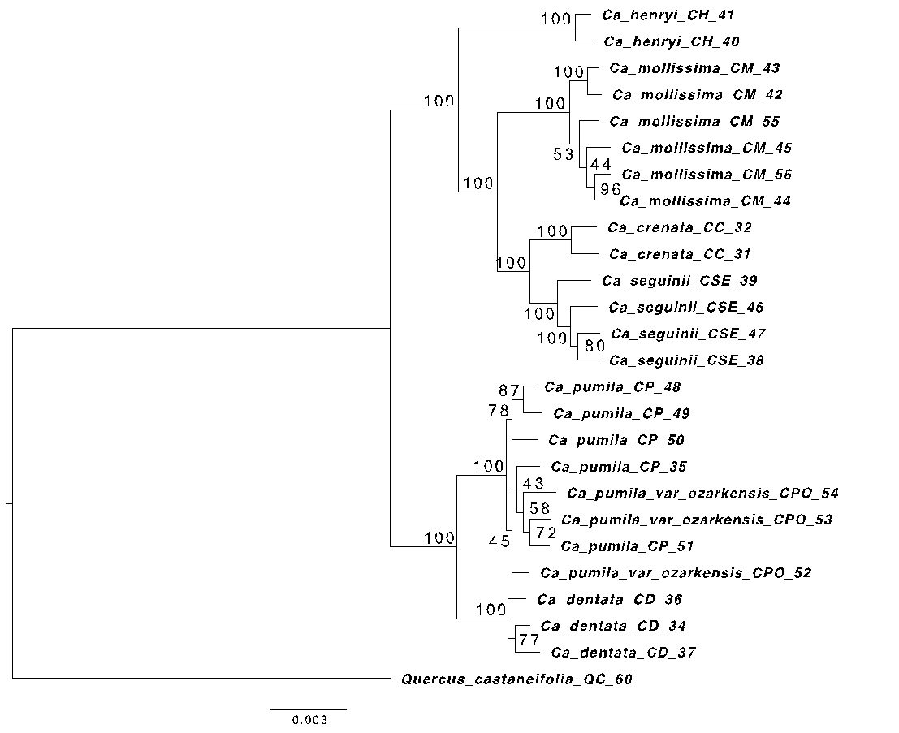

Fig. S2
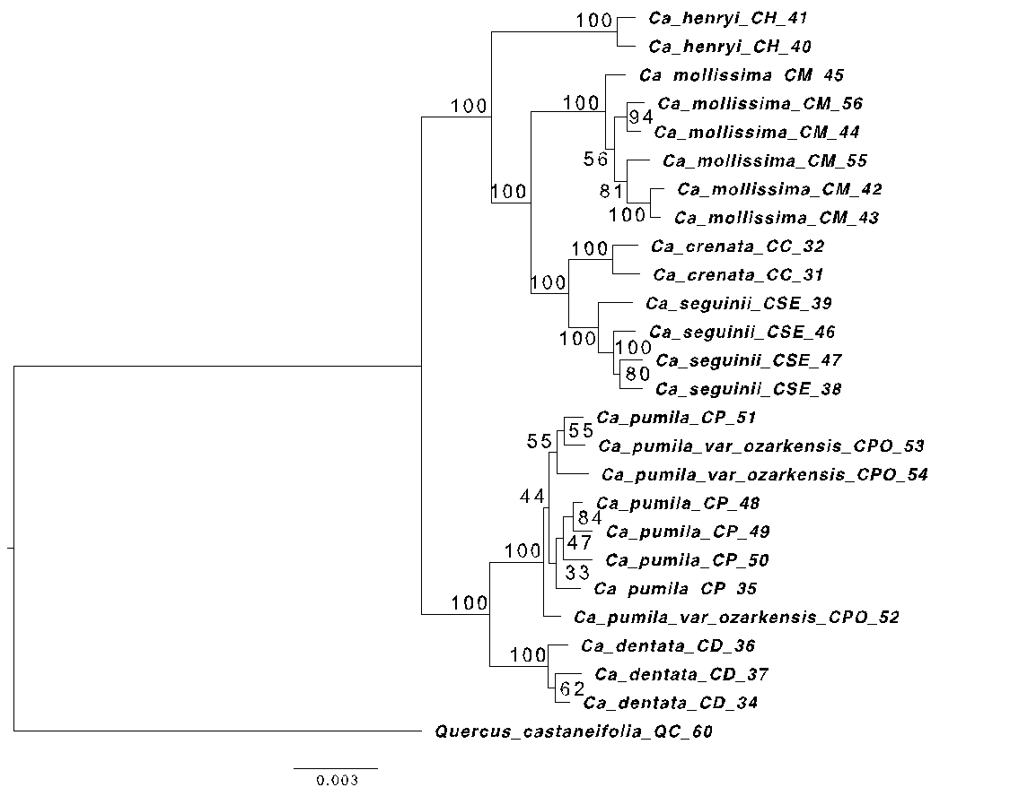

Fig. S3
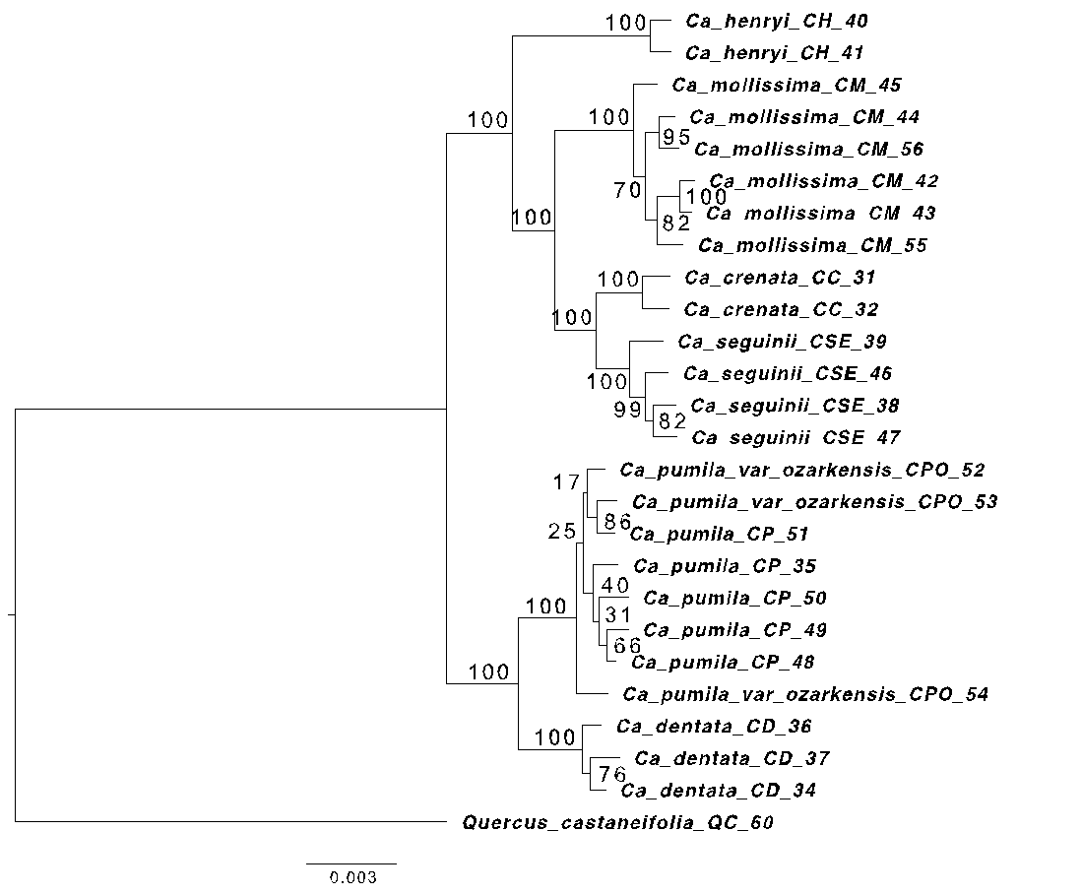

Fig. S4

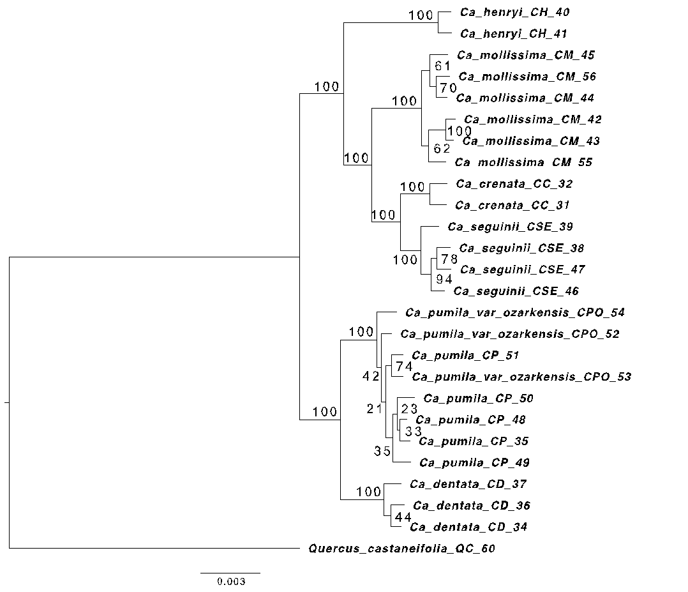

Fig. S5
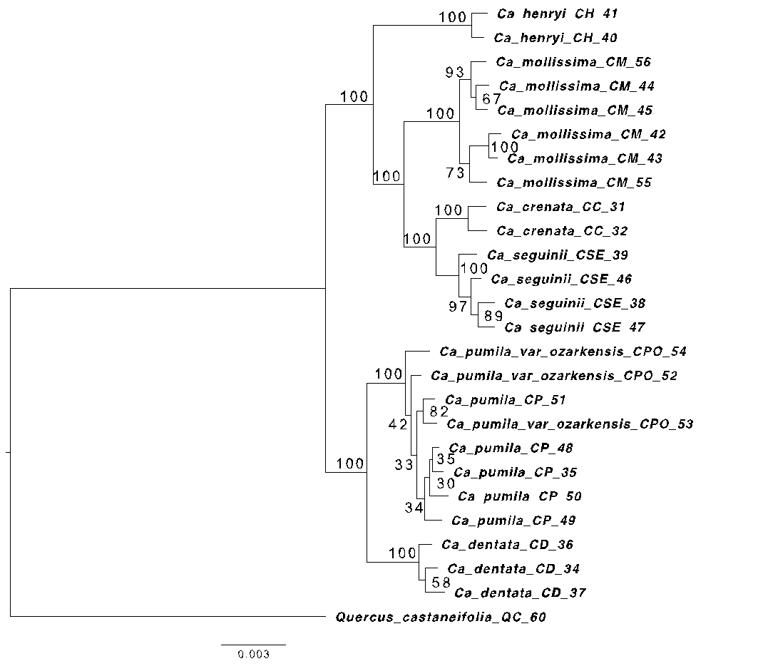

Fig. S6
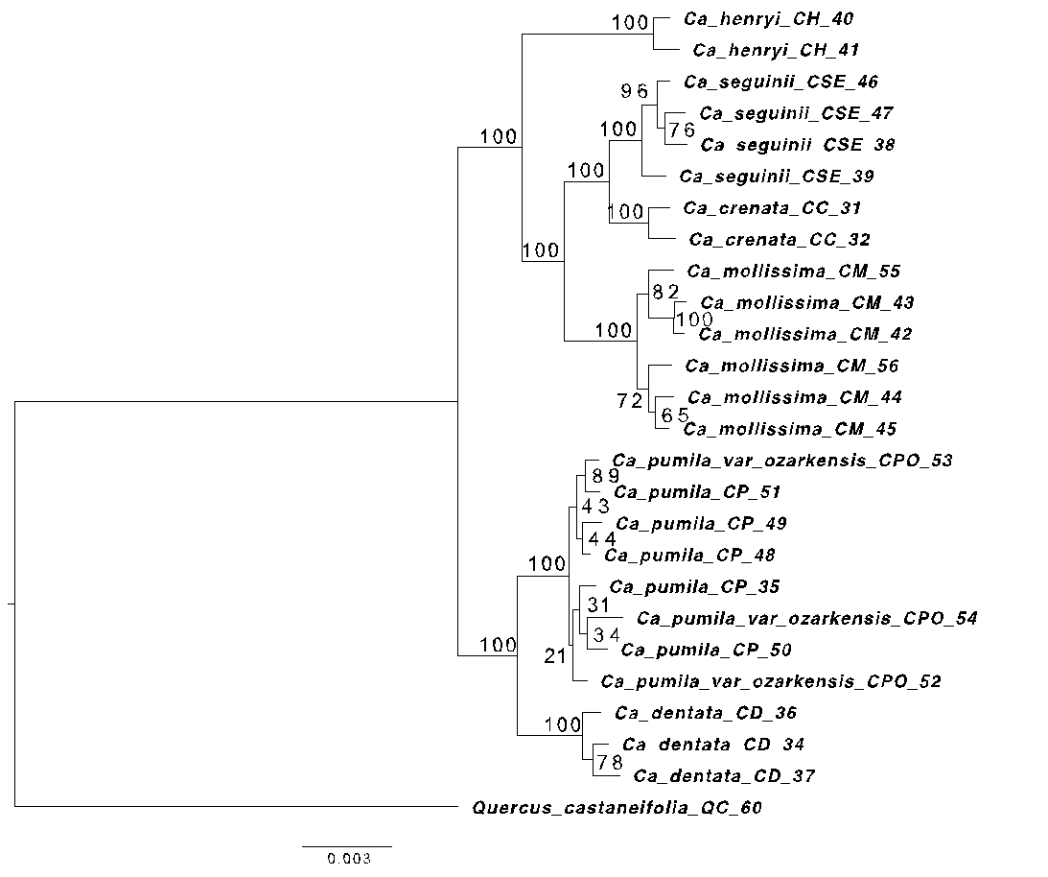

Fig.S7
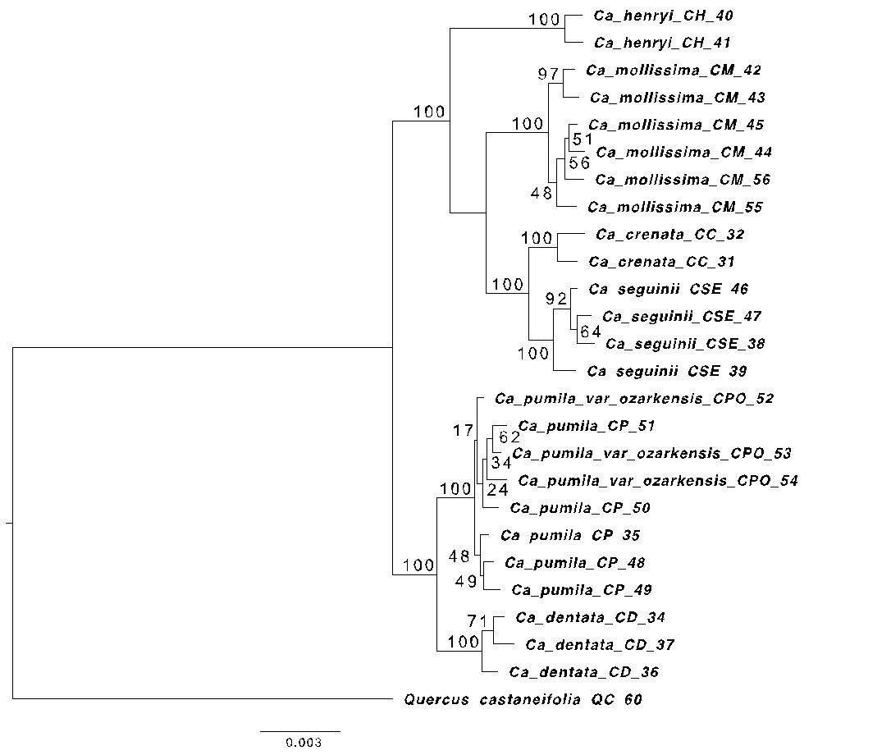

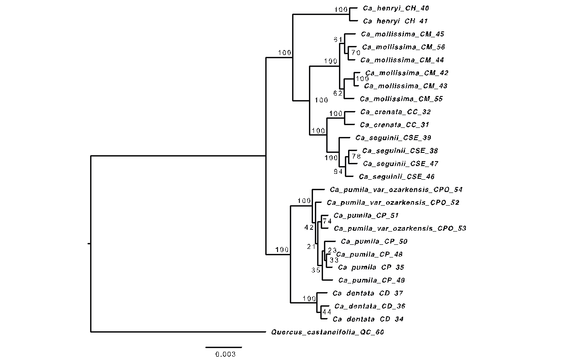

Fig. S8 Concatenation-based tree of Castanea from analysis of a) RAD-seq M50 and b) primary Hyb-Seq-PPD data using RAxML. Quercus castaneifolia was used as an outgroup. Numbers on branches are values of bootstrap support.

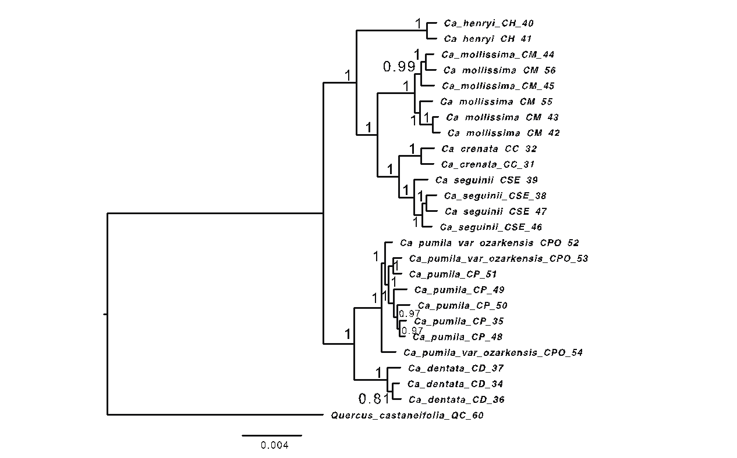
Fig. S9 Concatenation-based tree of Castanea from analysis of a) RAD-seq M50 and b) primary Hyb-Seq-PPD data using MrBayes. Quercus castaneifolia was used as an outgroup. Numbers on branches are values of posterior probability.

Figs. S10-S16 Concatenation-based trees of Hamamelis from analysis of RAD-seq data. These figures show the phylogenetic results from analyses of M20 to M80 datasets, respectively, using IQ-Tree. Parrotiopsis jacquemontiana and Fothergilla major were used as outgroups, but the trees were rerooted by the bybrid Hamamelis x intermedia. Numbers on branches are values of UF bootstrap support.

Fig. S10
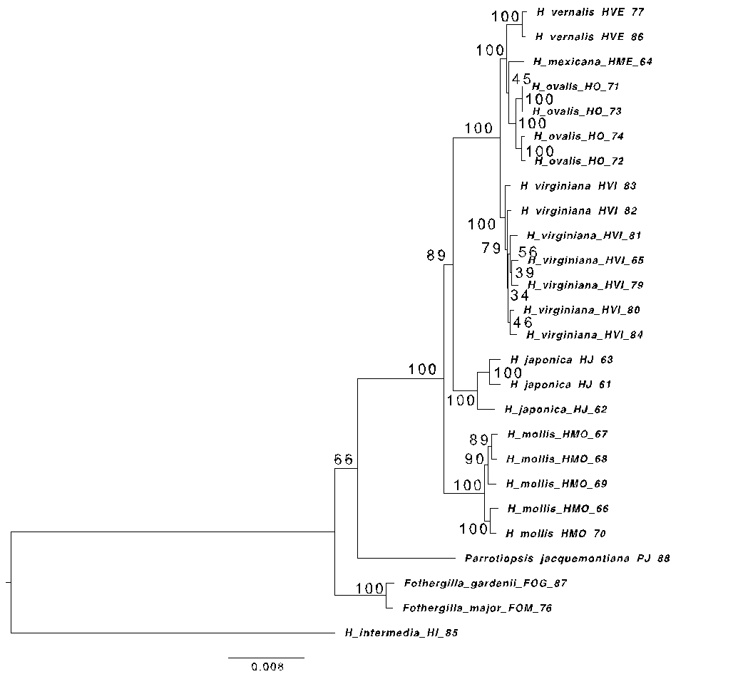

Fig. S11
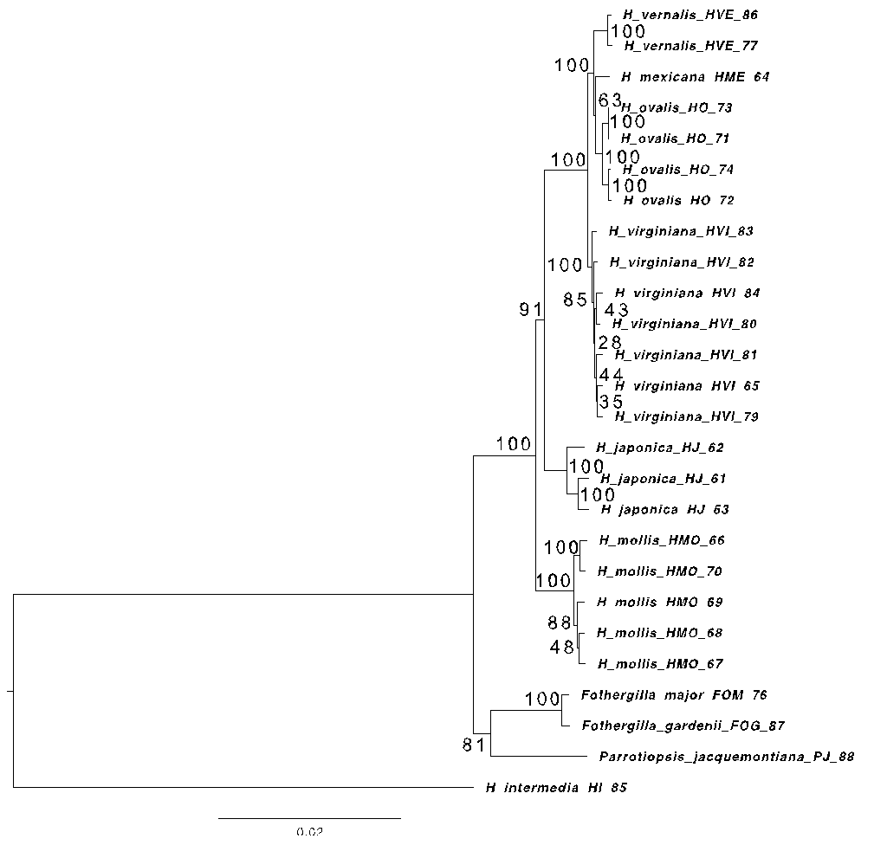

Fig. S12
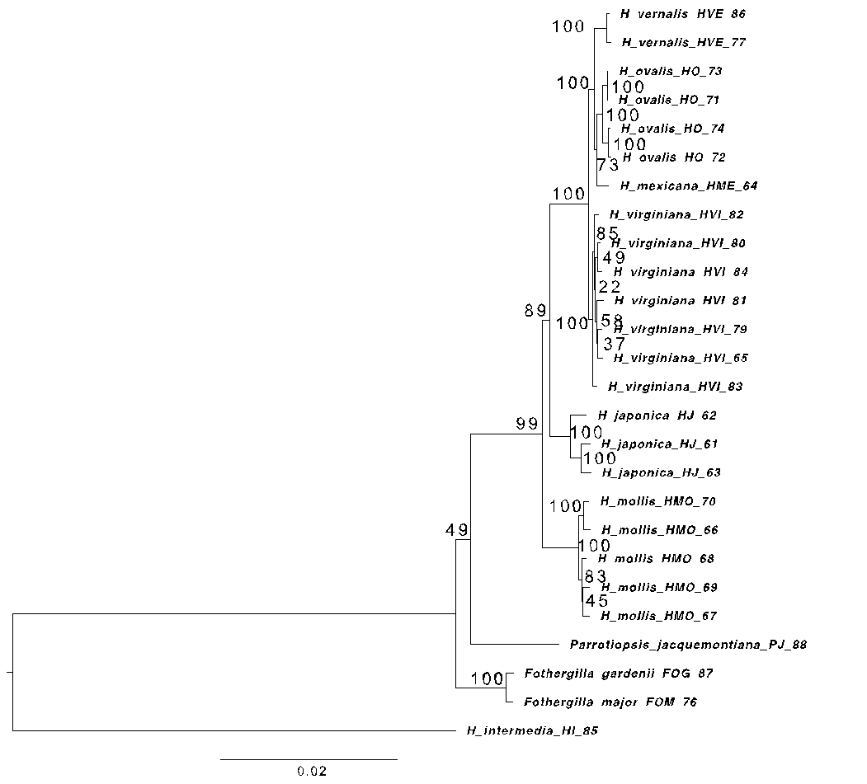

Fig. S13
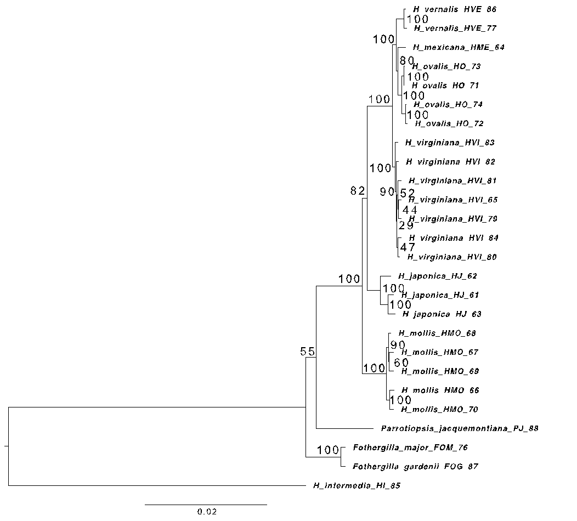

Fig. S14
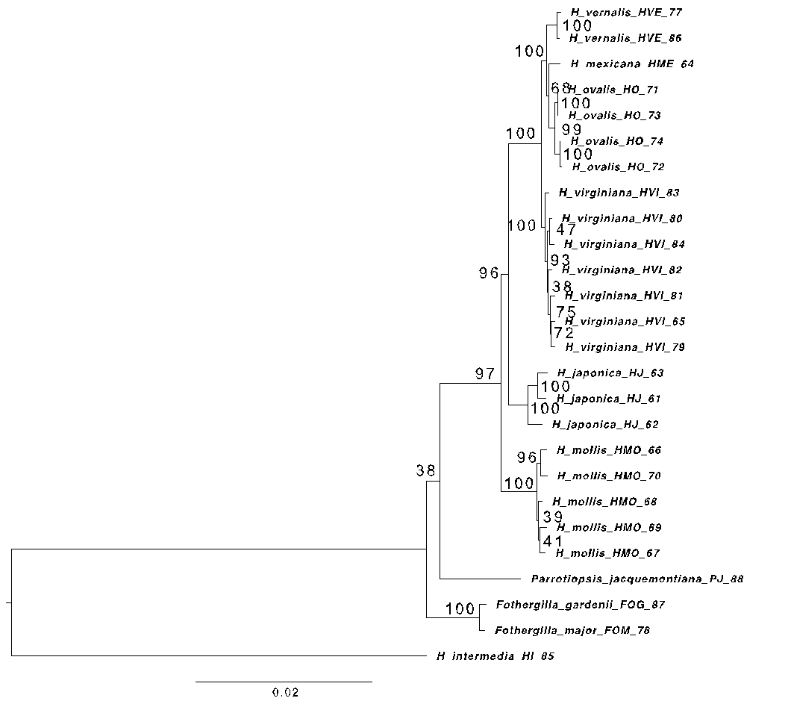

Fig. S15
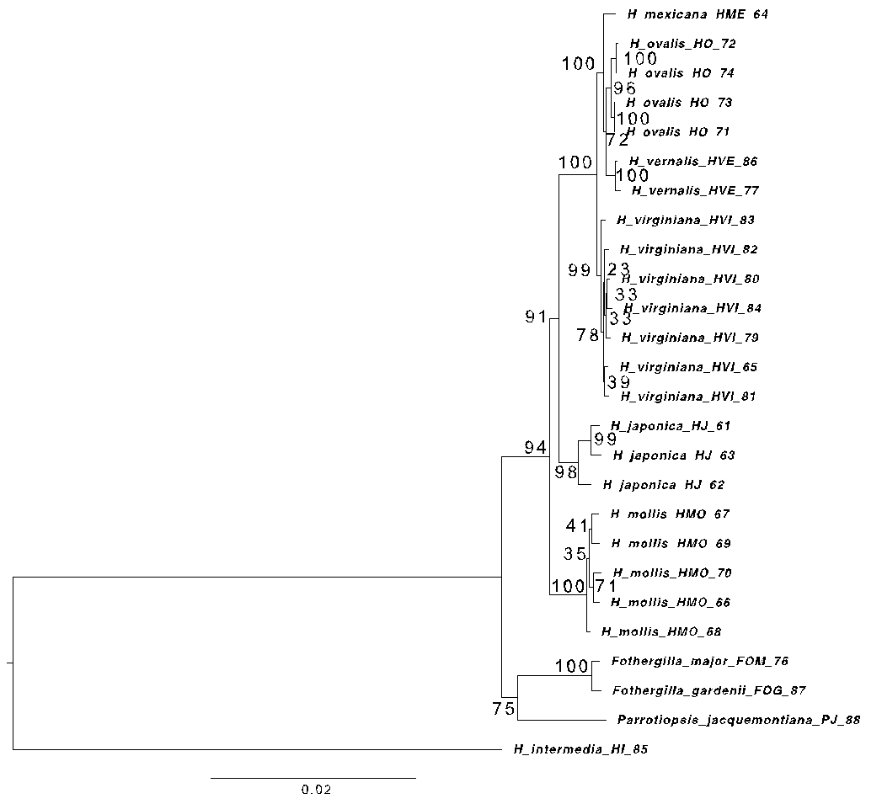

Fig. S16
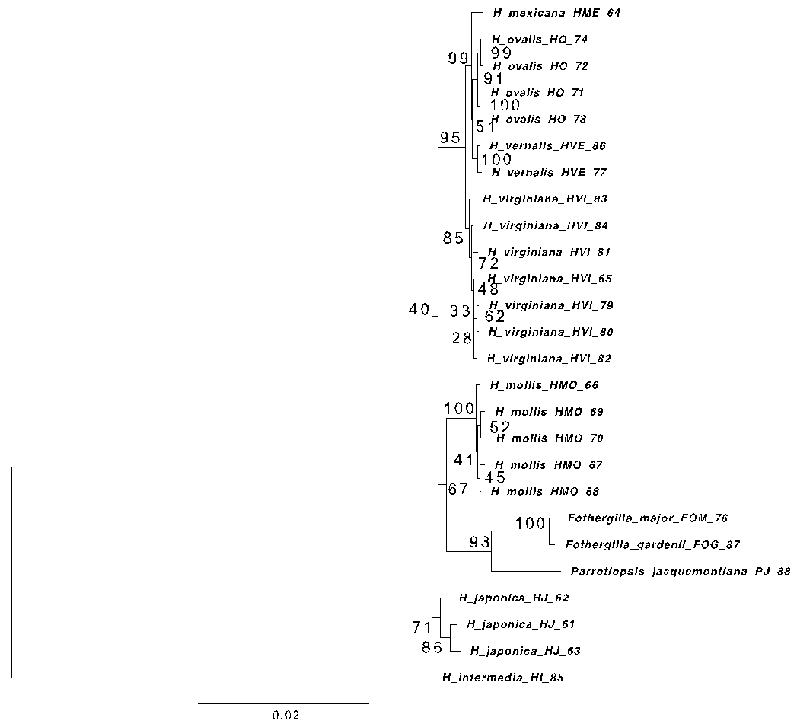

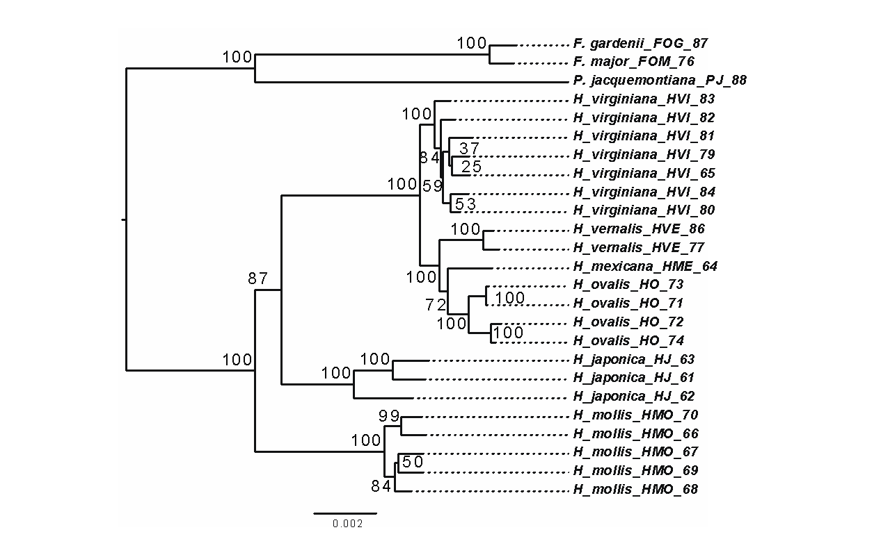
Fig. S17 Concatenation-based tree of Hamamelis from analysis of a) RAD-seq M50 and b) primary Hyb-Seq-PPD data using RAxML. Parrotiopsis jacquemontiana and Fothergilla major were used as outgroups. Numbers on branches are values of bootstrap support.

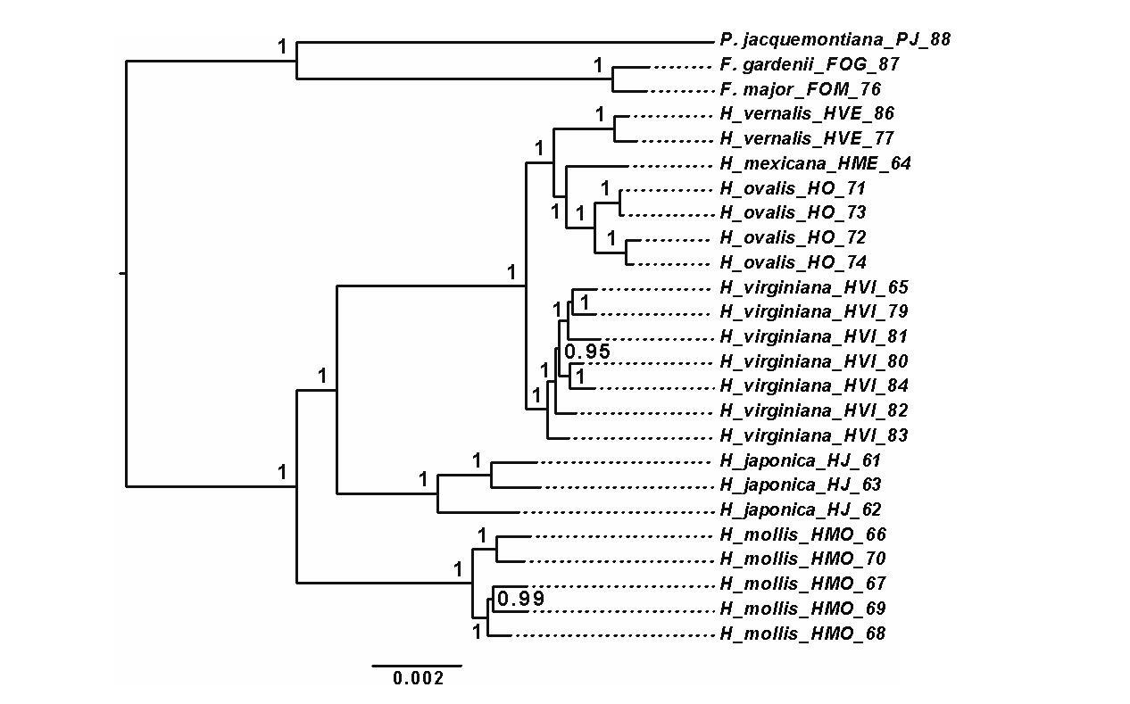
Fig. S18 Concatenation-based tree of Hamamelis from analysis of a) RAD-seq M50 and b) primary Hyb-Seq-PPD data using MrBayes. Parrotiopsis jacquemontiana and Fothergilla major were used as outgroups. Numbers on branches are values of posterior probability.

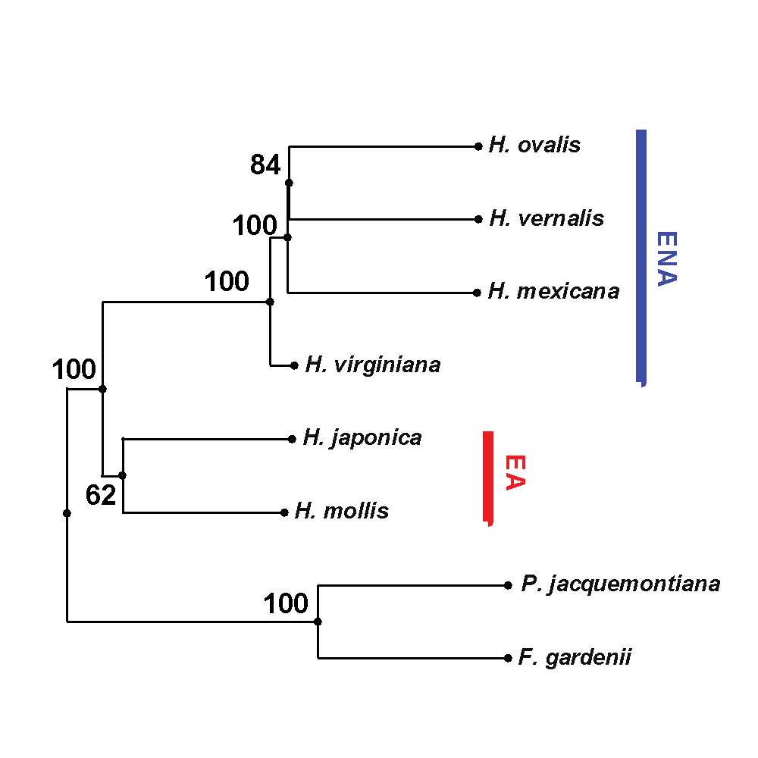
Fig. S19 The species tree of Hamamelis from analysis of RAD-seq M50 data using SVDQuartets. Parrotiopsis jacquemontiana and Fothergilla major were used as outgroups. The result shows that EA clade is a monophyly with relatively low support value 62.

