SMARTCULTOUR - WP3 - CASE STUDY DATA COLLECTION
Intervention: Bistrot de Pays
Destination/site: France- Rural communities of less than 2000 inhabitants
Country: France
Conducted by (name and institution): Mylene van der Donk (Breda University of Applied Sciences)
List of interviewees:
Interviewee 1: Entrepreneur (interview)
Interviewee 2: Network coordinator (interview)
Interviewee 3: Representative of the regional Tourism Office (email correspondence)
Interviewee 4: Representative of the regional Tourism Office (email correspondence)

Context and background information
Facilities labelled with the Bistrot de Pays label can be found in 23 departments in 7 regions (See map). The labelled facilities are located in rural communities with fewer than 2,000 inhabitants. In these villages they are often the only local service points still present in the villages. Unfortunately, for too many years, bistros have been closing their doors. However, these multiservice café restaurants are an integral part of the living heritage of the regions. Rural bistros are unique places for meeting, socializing, discovery and local activity.
The ‘Bistrot de Pays’ label was created in 1993 to support independent bistros in small rural communities and to improve the liveability in small communities. Visitors may be attracted by the quality label (Bistrot de Pays, 2020). In rural areas, tourism and agriculture are essential (Interviewee 1, 2021).

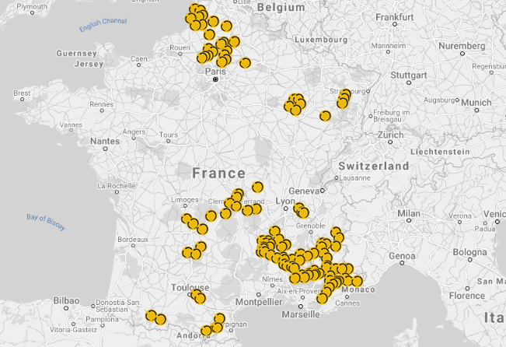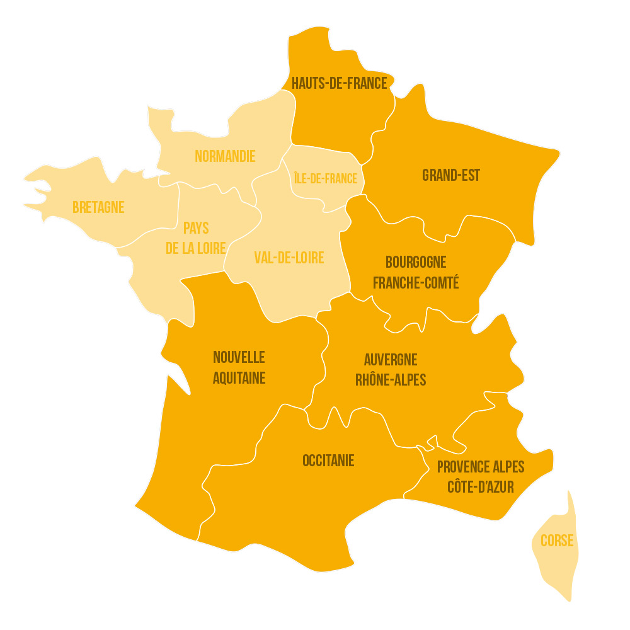
Bistros cafes and taverns can be labelled. The Bistrot de Pays Federation assigns the label to the owner of the facility. This label is awarded at personal basis to the owner/manager. In case the owner/manager leaves, a new application procedure starts. The Bistrot de Pays label is not a Franchise organisation. It is a network organisation for private companies.
The bistrots are all located in different communities with their own challenges and chances. Overall, all these small villages deal with the challenge to keep a bistro profitable and thus open as a multi-service point in small rural communities (Interviewee 2, 2021). The concept benefits the bistrot owners, the people in the community and the quality of the offer. The chances and the objectives of the intervention clearly overlap. See therefore also section 2.
Chances: Stimulating use of local products, stimulating creation of quality products, stimulating use of authentic recipes, organising (cultural) events, work together with other public and private organisations (Interviewee 1, 2021).

The “reason why” of the intervention
The objectives of the label:
“Having a country bistro in your village is a major asset in terms of social and economic life. This revives certain villages which thus see their population increase due to the installation of a bistro, not to mention all the benefits that this brings at the same time” (Interviewee 4, 2021).
In short it can be summarised as ‘In every village a place for social time’ (Iinterviewee 2, 2021). Maintain local life and traditions in small rural areas by keeping at least one (multi-functional) small shop open. The website of the Federation of Bistrot de Pays lists three business related arguments to join the label (Bistrot de Pays, n.d.):
- Create an authentic customer experience that can attract visitors: Customers come to find the strong values of the rural world: friendliness, authenticity, fair value for money. The network's communication actions are there to increase and diversify the flow of customers.
- Increase the quality of the products: Adhering to a charter also means taking advantage of a progress process. You thus benefit from personalized local support at the time of application and after certification.
- Connections and networks: Maintain its uniqueness while integrating a group of professionals on the same "wavelength”.
The above mentioned objectives apply to both the entrepreneurs and the organisation of Bistrot de Pays. Additionally, it can be mentioned as a further specification that the entrepreneurs labelled by Bistrot de Pays are supported with communication tools (for example a nice design for menus for Valentine) and with other communication materials. This saves them time and money. Besides, the label supports them to gain funding for organising events (Interviewee 1, 2021)
The tourism office also specifies that having a bistro revives certain villages and that the population grows after a bistro is installed (Interviewee 4, 2021).

The intervention
Jean Maurizot, an elected official from Lardiers (Alpes de Haute-Provence) seizes the idea, proposes it to the Intercommunal Syndicate which receives some subsidies from Europe (Leader), the State, the Provence-Alpes-Côte d 'Regional Council. Azur and the General Council of the Alpes de Haute-Provence (Bistrot de Pays, n.d.). During the annual meeting all registered Bistros are invited to discuss the project and the plans (interviewee 2, 2021).
The most important success factor of the project is the involvement of the different levels of the public system (departments, regions, tourism offices). It is a multi-partnership organisation. In each region or department this is organized in a different way. They support the implementation of the label financially. Support is offered through funding the audit, supporting the organisation of events, designing and printing leaflets and communication materials, and dedicating a person to manage the Bistrot de Pays in the department (region). Part of that job is to make an inventory of the needs of the businesses. If there is a need for training this can be organised. The project is dependent on the engagement of the local parties and the way things are organised at regional level. This also defines the budget available (Interviewee 2, 2021).
- 1993 – 1998: The label was designed and piloted in the region of Pays de Forcalquer - Montagne de Lure dans les Alpes-de-Haute-Provence.
- 1999 – 2003: The concept was expanded to other regions in France
- 2003 : La fédération nationale des Bistrots de Pays was created.
- 2020 : 130 bistrots are labelled (Bistrot de Pays, 2020)

Resources and tools
With the Leadership programme, the concept was worked out and tested. The federation Bistrot de Pays now does not get EU subsidy, however, in the Ardeche for example a Leadership programme runs and within that programme they included Bistrot de Pays related activities that are funded.
In each county (department in French) the finances are organized in a different way. The different levels of the public system are involved. How this is organised varies per department in France. At county level, at regional level and with tourism offices budgets are differently organised. The project is dependent on the engagement of the local municipal parties, that also define the budget allocated to the Bistrot de Pays.
Support to businesses is offered through funding the audit, events, leaflets, communication, dedicating a person to manage it in the department (region), inventorying the needs of the local businesses (e.g. training) and contribution to the Bistrot de Pays. The total costs for the region are around 80,000 to 100,000 euros. (Interviewee 2, 2021).
The website (Bistrot de Pays, n.d.) lists the following financial partners (directly for the organisation):
Les Conseils régionaux :
- Conseil Régional Région Sud: www.maregionsud.fr
- Conseil Régional Grand-Est: www.grandest.fr
- Conseil Régional Occitanie: www.laregion.fr
Les Conseils départementaux :
- Conseil départemental du Var: www.var.fr
- Conseil départemental de la Somme: www.somme.fr
- Conseil départemental de l'Oise: www.oise.fr
- Conseil départemental du Puy-de-Dôme: www.puy-de-dome.fr
L'Union Européenne via le programme Leader:
- Leader France: http://leaderfrance.fr/
The organization currently exists of one director, one person for the communication and one for maintaining the network (interviewee 2, 2021).
Digital technologies are key to establish and communicate with the network. It is impossible for the organisation of Bistrot de Pays to visit all bistros individually by car. The members of the label, the owners of the Bistros, are not so much digital minded. There would be more possible in communication and networking, but this is hard to realise (Interviewee 2, 2021). However, there is a group of people very active on the Facebook page and the communication manager of the Bistrot de Pays federation maintains the site. (Interviewee 2, 2021). See https://www.facebook.com/BistrotdePays.
The Federation of Bistros de Pays maintains the label and checks whether the businesses comply with the set of guidelines. In each region the budgets are organised differently between the governments, the tourism organisations and the businesses. It very much depends on the structure of the region and the needs of the businesses.

Impact of the intervention
Economic impact
Many impacts are described below. However, not all benefits can be assigned to visitors that are only attracted by Bistrot de Pays.
Country bistros are sometimes one of the last shops in the village. They offer certain essential and sometimes missing services in the villages: tobacco shops, bread, groceries, gas, stamps, cash withdrawal, etc. (Interviewee 3, 2021). This virtuous circle allows other economic players to expand their activities in rural areas. They also create work for the local producers whose products are found on the menus of the bistros: farmers, breeders, bakers, wine makers, market gardeners, etc. (Interviewee 4, 2021). Bistrot de Pays encourages people to develop activities and to attract tourists and to increase the quality. More tourists mean more benefits. Because of an increase in tourists there is an increase in local food consumption and more wine and more accommodation. Some farmers even change the products they produce to cater better to tourists and visitors. A farmer started producing cheese as that sell better then milk to tourists. Because of the events and expositions indirect benefits also occur; Artists are positively affected by their exhibitions and the selling of their artwork. There are more little shops and even the hairdresser benefits. (Interviewee 1, 2021).
Interviewee 2 adds to this those local seasonal workers are hired in the little villages in the bistrots. And that the bistrots are supported in their business through being in the network. (Interviewee 1, 2021).
Social impact
The bistros are animators of the social and cultural life of the village. They offer or host activities throughout the year and contribute to the promotion of their village and access to the culture of the inhabitants. (Interviewee 3, 2021).
Having an active bistro in the village can revive villages and lead to population growth (Interviewee 4, 2021). It does not become more expensive because of Bistrot de Pays, the location close to the mountains and to the city makes it popular to live. More and more people want to live there, out from the city. It is a trend it does not come from the labelling. There are many people with children and good salaries living in our village” illustrates Interviewee 1 (2021).
The level of social impact depends also on the activities of the entrepreneur. Bistrot de Pays requests regular events, at least 3 a year. Inhabitants and visitors can also participate in actions organized by the Bistrot de Pays like Rando’Bistrot, Ciné’Bistrot, etc. (Interviewee 3, 2021). However, some bistros organise many more and very diverse events. Interviewee 2, for example, organised an evening for immigrants to make them feel welcome and to make them taste real French cuisine.
Environmental impact
Environmental impacts have not been at the core of the development of the Bistrot de Pays concept. Use of local food is promoted and that means less transport and less packaging (Interviewee 2, 2021).
The rural areas are gaining popularity. Too many people might be coming (not only because of Bistrot de Pays) we should not build big hotels but provide local mall facilities of high standard (Interviewee 1, 2021).
Cultural impact
Possibly the most important impact of the concept is the facilitation of the cultural habits of the local life of the community. The cultural traditions of getting a chat and cup of coffee in the bistros before going to work are facilitated when the bistros remain open. (This is clearly reflected in the main objective of the intervention).
Cultural development is part of the concept. Organised events are intended to bring culture to the people as there are often scarce possibilities in these little villages. Events organised are book presentations, expositions, music events, etc. The ‘Rando Bistrot’ is also an idea to link local cultural experiences with the bistros. To make this happen, linkages to other structures are required. E.g. with the owner of the nearby castle (Interviewee 1, 2021) or the other organisations and businesses in the network (Interviewee 2, 2021). Some visitors make tours and visit the villages especially for the Bistrot de Pays certified locations.
An important element mentioned by both interviewees 1 and 2 are the use of local recipes. This is part of the intangible heritage that remains preserved. The tendency in Bistros is to serve easy unhealthy meals (Interviewee 1, 2021).

(Perceived) success conditions and factors
A survey amongst bistros owners in 2019 indicated that the label is a real lever for attendance (75%), Familiarity (85%) and diversification of the clientele (76%). In the same study 92% of all interviewees state that they are globally satisfied with the label (Bistrot de Pays, 2020).
Interviewee 1 is very satisfied with the concept for all the reasons mentioned before. The network doesn’t work optimal yet but that is not the fault of the organisation. It has to do with the mindset of the entrepreneurs. This is also what was said by Interviewee 2 (2021) who indicated that the interest to be on-line active is not so high amongst all bistro owners. The fact that different levels of the public system are involved and committed and can organise in a way that matches with their public sector structure is an important success factor.
The bistro is the nerve centre in the village that encourages people to stop, get to know, talk and share. It is for this reason that it is vital for both locals and visitors. The bistro keeps visitors a little longer in the village, so they can visit and run the local business. It is an important actor for the social, cultural and economic life of the territory (Interviewee 3, 2021).
The concept is developed in such a way that everything that needs to done (organising events, local cooking, etc.) results in better quality, returning guests, etc.. There is no work that needs to be done by the owners of the Bistrots that is not benefitting them directly (Interview 2, 2021). However, according to Interviewee 3 (2021) some bistros have given up on the label because of the obligations and the cost of the label. This contradicts with the experience of the costs of Interviewee 1 (2021), who states that they pay a fair – even low – price for the label.
Some bistros do not really play the game, the quality is not always there, the prices are high, the welcome not necessarily pleasant (personal opinion), while others offer menus simple, home cooking for an affordable price. It also requires having opening days and hours which may seem restrictive for some, sometimes creating turnover (Interviewee 3).
One trend that is positively influencing the type of customers that are coming to the bistros is mentioned by Interviewee 1 (2021). She states that in earlier days men (male) came to the bistros to drink wine and to talk. Now all kinds of people come to the bistros for different reasons. To socialize and also for events. That is something that is changing all over France and that is affecting the visitation of the bistros positively.
Concerns are expressed by the tourism office: The places where the country bistros are located are very often places of the municipality that the bistros rent. If the rent has to increase it can create cash flow problems for the managers (Interviewee 4, 2021).
The current health crisis risks impacting some bistros that are already weakened (economic crisis, drop in attendance, etc.) (Interviewee 4, 2021).
For the organisation of Bistrot de Pays it is a challenge to be not dependent on public money. Partnerships at national and regional level have to be built. Without commitment things do not happen. It depends on the people involved. An elected person (village major) who supports the project and sets this as a priority brings the organization much further. In the past the focus was on developing the cities. Nowadays the focus is much more on the rural areas. That offers opportunities. There is an increasing interest of governments (Interviewee 2, 2021).

Appendix 1: Bibliography
Bistrot de pays, nd ; https://www.bistrotdepays.com
Bistrot de Pays, 2020. Dossier de presentation, https://bistrotscama.s3.eu-central-1.amazonaws.com/DP_National_2020.pdf
Interviewee 1 (2021, February 19), Personal communication (interview)
Interviewee 2 (2021, February 22), Personal communication (Interview)
Interviewee 3 (2021, March 4), Personal communication (Email)
Interviewee 4 (2021, March 4), Personal communication (Email)

Appendix 2: Summary of each interview
Interview 1:
1. The region
Tourists come to the region for experiencing nature and landscapes. The region is rich in volcanos and has been declared as a monument de France. Once tourists arrive in the region they are also interested in the Roman Churches and the Castle of the 11th century.
Tourism is essential for the region. Just like agriculture; Farming accommodations are highly appreciated at the moment.
Public and private parties are involved. The owner of the castle is involved, For cultural tourism to develop the churches and the castle need to be renovated. Different projects exist. A crowd sourcing project generated funds for the renovation of a tower. Funds came mostly from local people and businesses not from tourists.

1. Cultural tourism offer
In the Bistro is information available about the cultural highlights. Cultural events are organized (music, writers, art, immigrant welcoming evenings). Walks combining nature and culture: visit the site and the castle, have local quality food in the restaurant.
Local food and products are used for the restaurant.
The challenge for the region is the offer of accommodation. And then specifically of a certain standard. More quality is needed.
2. Objective
We wanted our place to be a place to socialize and meet locals and tourists. Socialising is important in these little villages. The number of bistros are decreasing. People come for the terrace and meet new and other people.
We want to bring culture to the people in these areas; music writers… each month we organize an activity for the people in our village and also for the people in the other villages nearby where the bistros are already closed.
Bistrot de Pays helps us to
- gain funding for events
- they support us with advice
- Communication tools and materials: we lack time and they provide us with well-designed and printed menus for valentine for example.
- The network of the organisation (could be better functioning)

3. Organisation and 4. Resources
When we opened the bistro we found this information about Bistrot de Pays and it corresponded exactly to our ideas. (see2)
We had to wait one year before we could have the logo. The process takes about 1 year (mystery guests and documents).
There is a strong cooperation with the public agencies. The different local government within the department and the tourism office. They pay for organizing and funding certain events. It is not always organized like this. Not all departments are supporting the Bistrot de Pays in the same way. Not in all regions there are Bistrot de Pays. Bistrot de Pays stands for quality of food and of tours.
We pay a small amount to Bistrot de Pays. 50 Euro? I do not know

5 Impacts
Economic:
Bistrot de Pays encourages to develop activities and to attract tourists and to increase the quality.
Possibly more tourists are attracted but not only because of Bistrot de Pays.
Because of an increase in tourists there is an increase in local food consumption and more wine and more accommodation.
Farmers start producing cheese as that sells better then milk to tourists.
Artists are positively effected by their exhibitions and the selling of their art work.
There are more little shops and even the hairdresser benefits.
Ecologic:
Too many people might be coming (not only because of Bistrot de Pays) we should not build big hotels but provide local mall facilities of high standard.
Due to increased visitation to the Vovic mountain the trail has been closed for some time. Water and energy.
Social:
The importance of having a bistro in the village where you can meet and socialize; that organizes events and that supports local products.
It does not become more expensive because of Bistrot de Pays; the location close to the mountains and to Clemont Ferant makes it popular to live,
More and more people live here; with children and good salaries.
We organized an evening for immigrants to make them feel welcome and to make them taste real French cuisine.

Cultural impacts:
Cooperation with the owner of the castle to develop and maintain the castle
Organising the events
Some people come for the Bistrot de Pays; they then visit the attractions in the region.
Resilience:
Corona; Bistrot de Pays comes with a concept (information and communication materials) for take away.
We share names of artist for the exposition
We talk to each other via the website
Networks are created with other bistros and public agencies.
6. Success:
Yes, Bistrot de Pays is perceived as a very successful concept.
For all the reasons mentioned already
The network doesn’t work optimal yet but that is not the fault of the organization. That has to do with the entrepreneurs and their mind set.
Trend: Before men came to the bistro to drink wine. Now all kinds of people come to the bistro to for different reasons. To socialize and for events. That is something that is changing all over France.
Interview 2:
- Context
Bistrot de Pays focusses on 3 target groups:
- The local customer: they come for a drink and social life. (use the bistrot also as a parcel delivery pick up point)
- The visitors from cities nearby: They come for a weekend get away and want a happy time and authentic food.
- The Visitors from further away: They come for the local speciality and the local products and recipes.
All the guest are the same; there is no preference or ideal balance; it depends the village. Together they can keep the bistro financially viable. Guest are coming thanks to the label from a little further; and they return. Some make a tour of Bistrot de Payss.
Objective: In every village a place for social time
- The intervention/ 3. Resources and tools
1993 the project started regionally. The objective was to support the local communities where facilties were decreasing rapidly. The little villages became less pleasant to live in. The created of the project wanted to halt this process. We want to support entrepreneurs to maintain their business and not to close. With a leader subsidy the project was set up and worked out.
In 2000 other areas got involved.
The organization currently exists of one director and one person for the communication and one for maintaining the network (Marian).
The most important success factor of the project is the involvement of the different levels of the public system. In each department this is organized in a different way. At department level, at regional level and with tourism offices. The project is dependent on the engagement of the local parties, that also defined the budget allocated to the Bistrot de Pays.
They support the implementation of the label with 80.00 to 100.000 euros. Support is offered through funding the audit, events, leaflets, communication, dedicating a person to manage it in the department (region) (inventory: what are the needs? Eg training? and contribution to the Bistrot de Pays.
There existed little cooperative structures amongst small villages and bistros: No trade unions or federations.
Single bistrots are sometimes not accepted although they might meet the criteria; local support and a network is a precondition.
The bistrot remain independent.
All we do is to support entrepreneurs to maintain their business and not to close.
Bistrot de Pays does not get EU subsidy however, in the Ardeche for example a Leadership programme runs and within that programme they included Bistrot de Pays related activities to be funded.
In an annual meeting the entrepreneurs can discuss the project and the plans. Otherwise they can directly contact the president. Each three years we do a query and people are satisfied.
5. Impacts:
Econominc
Local products
Hire local seasonal workers
Support entrepreneurs
Being in the network
Social
In the village the café is often the last place to meet.
Closely linked to morning habits: café in the morning (intangible culture)
Bistrot de Pays is not only for the touristic areas.
Following the charter is respecting the guests so they do not get bored – make efforts to attract them.
Ecologic impacts
Not the main objective of Bistrot de Pays
By buying local less transport and less packaging
Cultural impacts
Bring the culture to the local people (events)
Tours
Authentic recepes
Link to other structures (cooperation)
Negative impacts? Bistrot de Pays is so small that effects cannot be assigned to the label only. It does not attract crowds.
Resilience
Entrepreneurs have to be resilient nowadays and they turn out to be very resilient.
Food from local partners and local markets
6. Challenges and succesfactors:
Overcoming the crisis is the current challenge:
It is a challenge to be not dependent on public money.
Be able to build partnerships at national level. Without commitment things to do happen. It depends on the people involved. The elected person (village major) who supports the project and sets this as a priority brings the organization much further.
Trend: In the past the focus was on developing cities. Nowadays the focus is much more on the rural areas. That offers opportunities. There is an increasing interest of governments.
Success factors see point 2

Interview 3 and 4 (by email)
- In what way is Bistrot de Pays important for your region?
- What are the most important challenges that Bistrot de Pays addresses according to you?
- What effects of Bistrot de Pays do you see on:
- Economy of the region
- Culture of the region
- Social aspects in the region
- The environmental aspects of the region?
- Who are the most important stakeholders affected by the Bistrot de Pays?
- Who are the most important stakeholders involved in the implementation of the Bistrot de Pays?
- What do you consider to be the main challenges for further implementation of the Bistrot de Pays?
- What do you consider to be important success factors for the implementation of the Bistrot de Pays?
Re-Bonjour,
dans l'intervalle mon collègue Dominique Lagenèbre a complété les réponses, je vous envoie donc une deuxième version. Amicalement
Suite à votre demande, voici quelques éléments de réponse qui, nous l'espérons, serviront votre étude.
1. En quoi le Bistrot de Pays est-il important pour votre région?
Le concept des bistrots de pays est né sur notre territoire, le premier bistrot fut celui de Lardiers. Il s'est ensuite développé dans toute la région et maintenant dans une bonne partie de la France.
Le fait d’avoir un bistrot de pays dans son village est un atout majeur en terme de vie sociale et économique. Cela fait revivre certains villages qui voient ainsi leur population augmenter du fait de l’installation d’un bistrot sans compter tous les bénéfices que cela apporte en parallèle.
Google translate:
The concept of country bistros was born on our territory, the first bistro was that of Lardiers. It then developed throughout the region and now in a good part of France.
Having a country bistro in your village is a major asset in terms of social and economic life. This revives certain villages which thus see their population increase due to the installation of a bistro, not to mention all the benefits that this brings at the same time.
2. Quels sont les défis les plus importants que le Bistrot de Pays relève selon vous?
Les bistrots de pays sont parfois l'un des derniers commerces du village. Ils doivent respecter une charte qui les oblige à proposer certains services indispensables et manquants parfois dans les villages : débit de tabac, pain, épicerie, gaz, timbres, retrait d'argent, etc.
Ils doivent travailler les produits du terroir, animer la vie sociale et culturelle du village en proposant des animations tout au long de l'année.
Le label est perçu pour beaucoup comme un gage de qualité.
« The place to be ! »
Les lieux où se trouvent les bistrots de pays sont bien souvent des biens de la commune que les bistrotiers louent. Si le loyer doit augmenter cela peut engendrer des problèmes de trésorerie pour les gérants.
La crise sanitaire actuelle risque d’impacter certains bistrots déjà fragilisés (crise économique, baisse de fréquentation…)
Google translate:
Country bistros are sometimes one of the last shops in the village. They must respect a charter which obliges them to offer certain essential and sometimes missing services in the villages: tobacco shops, bread, groceries, gas, stamps, cash withdrawal, etc.
They must work with local products, animate the social and cultural life of the village by offering activities throughout the year.
The label is seen by many as a guarantee of quality.
“The place to be! "
The places where the country bistros are located are very often goods of the municipality that the bistros rent out. If the rent has to increase it can create cash flow problems for the managers.
The current health crisis risks impacting some bistros that are already weakened (economic crisis, drop in attendance, etc.)
3. Quels effets du Bistrot de Pays voyez-vous sur:
Économie de la région
Les bistrots de pays sont parfois l'un des derniers commerces du village. Ils proposent certains services indispensables et manquants parfois dans les villages : débit de tabac, pain, épicerie, gaz, timbres, retrait d'argent, etc. Ce cercle vertueux permet à d'autres acteurs économiques d'étendre leurs activités en zone rurale.
Ils font aussi travailler les producteurs locaux dont les produits se retrouvent sur les cartes des bistrots : agriculteurs, éleveurs, boulangers, viticulteurs, maraichers, etc.
Google translate: Country bistros are sometimes one of the last shops in the village. They offer certain essential and sometimes missing services in the villages: tobacco shops, bread, groceries, gas, stamps, cash withdrawal, etc. This virtuous circle allows other economic players to expand their activities in rural areas.
They also make work the local producers whose products are found on the menus of the bistros: farmers, breeders, bakers, wine growers, market gardeners, etc.
Culture de la région
Les bistrots de pays sont animateurs de la vie sociale et culturelle du village. Ils proposent ou accueillent des animations tout au long de l'année et contribuent à la promotion de leur village et à l'accès à la culture des habitants. Ils peuvent aussi participer à des actions organisées par la fédération des bistrots de pays : Rando’Bistrot, Ciné’Bistrot…
Google translate : The country bistros are animators of the social and cultural life of the village. They offer or host activities throughout the year and contribute to the promotion of their village and access to the culture of the inhabitants. They can also participate in actions organized by the federation of country bistros: Rando’Bistrot, Ciné’Bistrot ...
4. Quels sont les principaux acteurs concernés par le Bistrot de Pays?
Le bistrot est le point névralgique qui incite à s'arrêter, à connaître, à échanger, à partager. C'est pour cette raison qu'il est indispensable à la fois pour les habitants et les visiteurs.
Google translate: The bistro is the nerve center that encourages people to stop, get to know, talk and share. It is for this reason that it is indispensable for both locals and visitors.
6. Quels sont selon vous les principaux défis pour la poursuite de la mise en œuvre du Bistrot de Pays?
- Avant d'obtenir ce label, le restaurateur est soumis à un audit où l'on vérifie qu'il répond bien aux critères de la charte. Certains, notamment sur notre territoire, ont renoncé au label en raison des obligations et du coût du label.
- Certains bistrots de pays ne jouent pas vraiment le jeu, la qualité n'est pas toujours au rendez-vous, les tarifs sont élevés, l'accueil pas forcément agréable (avis personnel)... tandis que d'autres proposent des menus simples, une cuisine familiale pour un prix abordable.
Google translate:
- Before obtaining this label, the restaurateur is subject to an audit where it is verified that he meets the criteria of the charter. Some, especially in our territory, have given up on the label because of the obligations and the cost of the label.
Some country bistros do not really play the game, the quality is not always there, the prices are high, the welcome not necessarily pleasant (personal opinion) ... while others offer menus simple, home cooking for an affordable price.
7. Selon vous, quels sont les facteurs de succès importants pour la mise en œuvre du Bistrot de Pays?
Le bistrot permet de garder un peu plus longtemps les visiteurs dans le village qu'ils peuvent ainsi visiter et faire marcher le commerce local.
Cela nécessite aussi d'avoir des jours et horaires d'ouverture qui peuvent sembler contraignant pour certains, créant parfois du turn-over.
C'est un acteur important pour la vie sociale, culturelle et économique du territoire.
Google Translate: The bistro keeps visitors a little longer in the village, so they can visit and run the local business.
It also requires having opening days and hours which may seem restrictive for some, sometimes creating turnover.
It is an important actor for the social, cultural and economic life of the territory.
Amicalement

The interviewee was located in the French Department of Puy-de-Dôme, so likely the ‘region’ that the interviewee mentions is related to this area, or alternatively (but less likely) the larger French region of Auvergne-Rhône-Alpes. Although the words cannot be interpreted in a very precise way, since local people might colloquially refer to ‘a region’ that is not necessarily linked to precise administrative boundaries.
The interviewee is like referring to the “Chaîne des Puys – Limage fault tectonic area” which has been inscribed on the World Heritage List since 2018.

