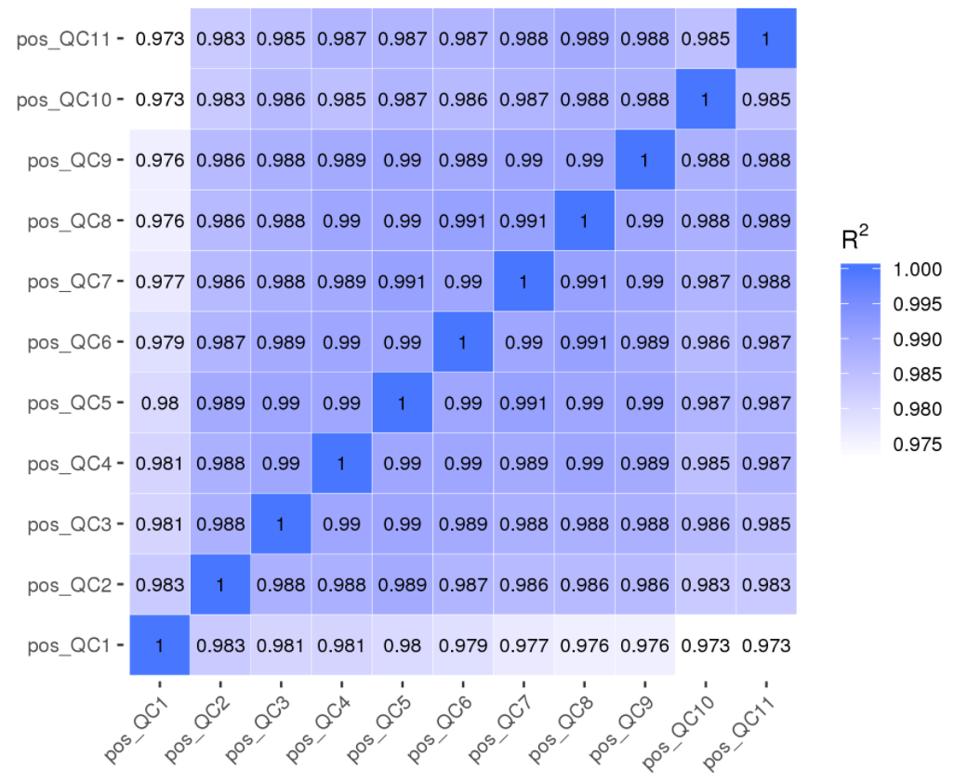

Figure S1 Pearson correlation between pos QC samples.

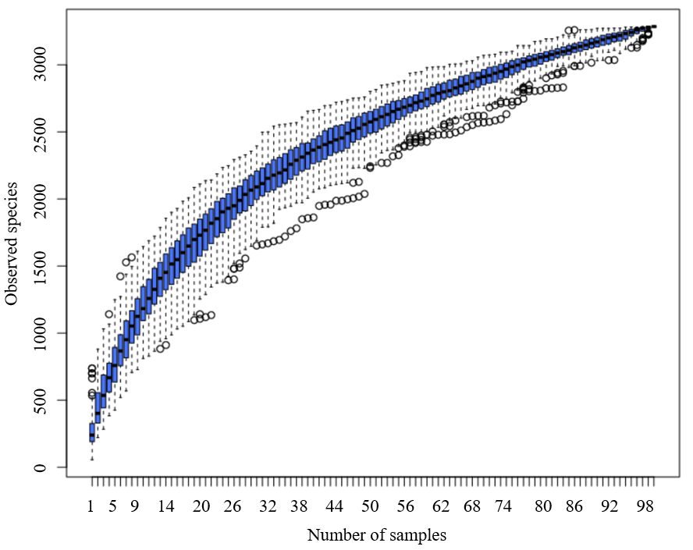

Figure S2 Species accumulation boxplot.

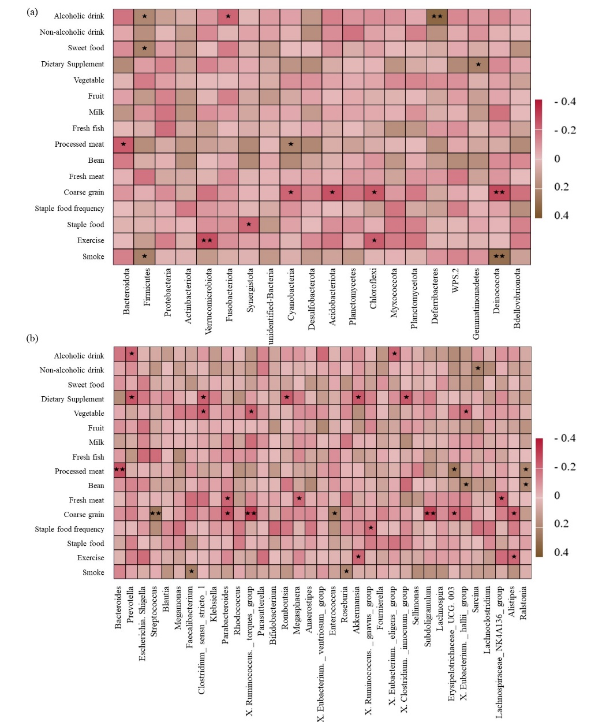

Figure S3 The correlation between environmental factors and gut microbiota. (a) Spearman correlation coefficient between environmental factors and the top 20 species with the greatest abundance at the phylum level. (b) Spearman correlation coefficient between environmental factors and the top 35 species with the greatest abundance at the genus level. ★: P value<0.05; ★★: P value<0.01.

Life style and simplified food frequency questionnaire
(The following content is only used for scientific research and is completely confidential.)
Name: 在 Gender: Age: 在 Phone number： 。
Since after renal transplantation: 3 months 3-6 months 6-12 months 1-3 year over 3 year
- Medication：
  - Immunosuppressive treatment
Cyclosporine (CsA, etc.) Tacrolimus
Mofetil Glucocorticoid (prednisone, methylprednisolone, etc.) Other 。
1.2 Other medication
- Antibiotics No Yes, ： 丁
- Antihypertensive Agent No Yes, ： 丁
- Hypoglycemic drug No Yes, ： 丁
- Other No Yes, ： 丁
- Life style
Smoking habits： No Yes
Drinking habits： No Yes
Sport or exercise：No 1-3 times per week 4-6 times per week every day
The time of sport or exercise per week: hours
- simplified food frequency
How often do you eat the following types of foods?  （ for the circle, for the space on the right） | every day | 5-6 days a week | 3-4 days a week | 1-2 days a week | never
Staple food
○Mainly rice
○Mainly pasta
○Both rice and pasta
Coarse grains (oats, corn, potatoes, mung beans, etc.)
Fresh meat (pork, beef, chicken, etc.)
Beans (tofu, peas, etc.)
Processed meat (ham, bacon, luncheon meat, etc.)
Fresh fish (shrimp, fish, crab, etc.)
Milk (pure milk, yogurt, cheese, etc.)
Fresh fruits (grapes, cantaloupe, apples, etc.)
Vegetables (cabbage, pumpkin, etc.)
Dietary supplements (vitamin A, calcium tablets, etc.)
Sweets (cake, ice cream, chocolate, etc.)
Non-alcoholic drinks (cola, soda, etc.)
Alcoholic drinks (beer, etc.)

