Supporting information related to:
Effect of Mastiha supplementation on NAFLD: The MAST4HEALTH randomised, controlled trial
Charalampia Amerikanou^{1*}, Stavroula Kanoni^{2*}, Andriana C. Kaliora^{1*}, Angela Barone³, Mladen Bjelan⁴, Giuseppe D'Auria^{5,6}, Aristea Gioxari¹, María José Gosalbes^{6,7}, Sofia Mouchti³, Maria G. Stathopoulou⁸, Beatriz Soriano⁹, Stefan Stojanoski^{4,10}, Rajarshi Banerjee³, Maria Halabalaki¹¹, Eleni V. Mikropoulou¹¹, Aimo Kannt^{12,13,14}, John Lamont¹⁵, Carlos Llorens⁹, Fernando Marascio¹⁶, Miriam Marascio¹⁶, Francisco J. Roig^{9,17}, Ilias Smyrnioudis¹⁸, Iraklis Varlamis¹⁹, Sophie Visvikis-Siest⁸, Milan Vukic²⁰, Natasa Milic⁴, Milica Medic-Stojanoska⁴,²¹, Lucia Cesarini²², Jonica Campolo²³, Amalia Gastaldelli²⁴, Panos Deloukas^{2,25}, Maria Giovanna Trivella^{23,24}, M. Pilar Francino^{6,7}, George V. Dedoussis¹ on behalf of MAST4HEALTH consortium
Table of contents
 | Page
Materials and Methods | 2
Randomization | 2
Details on sample collection, genotyping, other outcomes and scores | 2
Plasma quantification of metabolites | 3
Identification of Mastiha derived metabolite | 3
Power calculations | 4
Statistical Analysis of microbiota markers | 5
Statistical Analysis of metabolites | 6
SFig. 1. Principal Component Analysis (PCA) including all 65 metabolites measured | 7
SFig. 2. Volcano plot of metabolites levels post treatment, between the Mastiha and Placebo groups | 8
SFig. 3. Pearson’s pairwise correlation coefficients among the 58 outcomes analysed | 9
SFig. 4 CONSORT 2010 Flow diagram | 10
SFig. 5 (A) Suggested structure of the tentatively identified triterpenic acid metabolite detected in the Mastiha group. (B) HRMS/MS spectrum of the detected triterpenic acids metabolite in negative mode | 11
SFig. 6. Sensitivity analysis for the differences in all outcomes assessed post treatment between the Mastiha and Placebo groups | 12
SFig. 7. Violin plots for the MRI parameters showing the values at baseline and post-treatment for the Mastiha and Placebo group, by BMI category | 13
SFig. 8. Differences of the outcomes means between the two treatment groups at 80% power | 14
References | 15

Materials and Methods
Randomization
The randomization algorithm was designed to balance the size of each group per country and per sex, by picking a pseudo-random number from 0 to 1 (using Javascript's "random" method)¹. The trial was blinded to treatment allocation for both researchers and patients.
Details on sample collection, genotyping, other outcomes and scores
Blood (25 ml) was drawn after an overnight fast at baseline and post-treatment (for plasma isolation whole blood was collected in EDTA whole blood tubes and was kept on ice until further processing, for serum isolation whole blood was collected into serum vacutainers, was mixed 5 times and allowed to clot at room temperature for about 20 min). Then, whole blood was centrifuged for 10 min at a speed of 3000 rpm in order to isolate serum and plasma.
DNA was also isolated and genotyping was performed with the Infinium Global Screening Array (Illumina). The PNPLA3 rs738409 variant was extracted from the genotypic data of all samples and was used for the calculation of the NASH score.
Fecal samples were collected with the Omnigen-Gut system, following manufacturer instructions (http://www.dnagenotek.com/US/support/ciOMR200.html) and were shipped to FISABIO for 16S rRNA amplicon sequencing.
Other outcomes analysed in more details are: changes over baseline of other MRI parameters (PDFF and hepatic iron content), BMI, total diabetes risk, liver function enzymes (g-GT, ALT, and AST), lipid profile (total cholesterol, high-density lipoprotein (HDL), low-density lipoprotein (LDL) and triglycerides (TG)), insulin, homeostasis model assessment (HOMA-IR), 75-g, 2 hour Oral Glucose Tolerance Test (OGTT), NFS, NASH score, plasma metabolites and gut microbiota composition. Individuals on statin medication had their pre-medication levels approximated by dividing the LDL value by 0.7 and the TC value by 0.8, both at baseline and post-trial. Insulin resistance was evaluated by the Homeostasis model assessment (HOMA-IR)².
NFS³ was calculated as: -1.675 + 0.037 × age (years) + 0.094 × BMI (kg/m²) + 1.13 × IFG (impaired fasting glycaemia) /diabetes (yes = 1, no = 0) + 0.99 × AST/ALT ratio – 0.013 × platelet (×10⁹/l) – 0.66 × albumin (g/dl) and NASH score using the formula -3.05 + 0.562 × PNPLA3 rs738409 genotype (CC = 1/GC = 2/GG = 3) – 0.0092 × fasting-insulin (mU/L) + 0.0023 × AST (IU/L) + 0.0019 × (fasting -insulin × AST)⁴.
Plasma quantification of metabolites
Plasma samples were treated as described by Lemonakis et al.⁵ using cold acetonitrile for protein precipitation. For the metabolomic analysis, high-purity water was provided by a Millipore Direct-Q® 3 UV purification system (Merck Millipore Sigma, Burlington, MA, USA), while Optima™ LC-MS grade acetonitrile and formic acid were obtained from Thermo Fisher Scientific (Waltham, MA, USA). For the Liquid Chromatography-High Resolution Mass Spectrometry (LC-HRMS) based metabolomics, liquid chromatography analysis was performed using an Acquity® UPLC System (Waters). Detection was carried out on an LTQ-Orbitrap® XL hybrid mass spectrometer equipped with an ESI source (Thermo Scientific). Separation was achieved on an Acquity® HSS T3 (Waters) column (100 x 2.1 mm, 1.8 μm) using a standard gradient of water containing 0.1% (v/v) formic acid (A) and acetonitrile (B). MS data were acquired in negative mode, in the full scan range of m/z 115–1000, with a resolution of 30000.
Identification of Mastiha derived metabolite: Following an untargeted metabolic profiling approach, a compound with a pseudomolecular ion at m/z 551.3037 with a suggested molecular formula of C30H47O7S (RDBeq 7.5) was detected only in plasma samples of the Mastiha group. Based on full scan HRMS and HRMS/MS information a tentative identification could be proposed. As it is shown at the HRMS/MS (SFig.5B), a fragment ion at m/z 507.3130 corresponding to C29H47O5S (RDBeq. 6.5, Delta -3.959 ppm) is detected consistent with a neutral loss of a carboxyl group (acid decarboxylation) a typical pattern of triterpenic acids. It could be hypothesised that the detected compound is a metabolite of major triterpenic acids of Mastiha after oxidation (phase I) and sulphation (phase II – conjugation) reactions (SFig.5A). During the first step, the ketone group is reduced at C-3 accommodating sulphation while an oxidation reaction takes place either at C-11 or C-21 which are more prone to hydroxylation, according to the Biotransformer platform¹⁷ and previously published data on the metabolization of other naturally occurring triterpenic acids¹⁸. However, given that hydroxylation has been reported in several other sites of the steroidal skeleton¹⁹, other positions cannot be excluded.
Power calculations
A priory power calculations to calculate the optimal sample-size were based on the SD of the fold-change of liver fat content. A pooled SD of 0.68 was found for the fold-change in liver fat content measured by MR spectroscopy during a lifestyle intervention⁶. With a sample size of 45 evaluable subjects per group and the given SD of 0.68 for the fold-change, the entire 95-% confidence interval for a treatment difference in the fold-change of liver fat content is thought to entirely be within a range from ± 0.35 of the true (but unknown) fold-change with a probability of at least 80% (= estimation power). Most recently this approach proved effective to find a 14% difference of the change of liver fat content in a multicenter, randomized, placebo-controlled clinical trial⁷. Enrolled in each arm will be 50-55 patients (to allow for a 10% drop out). This is a conservative estimate as the sensitivity of the LiverMultiScan platform will allow to detect even small changes from the Mastiha treatment i.e. LIF score changes from 3.0 to 2.3 (cT1 950ms → 900ms), with 90% power in 26 patients per arm allowing for a potentially higher dropout rate.
For the current analysis, we estimated that we had 80% statistical power to detect a minimum effect size difference (effect size=difference in means/pooled SD), between the two treatment groups at the end of the trial, of 0.55 with a maximum of 52 samples per group. Power calculations are illustrated in SFig.8.
Statistical Analysis of microbiota markers
We selected the relative abundances of eleven taxa (Flavonifractor, Bacteroides, Faecalibacterium, Dorea, Enterobacteriaceae, Rikenellaceae, Prevotella 9, Coprobacter, Ruminococcaceae UCG-014, Veillonella and Fusobacterium) to include in our main analysis. Faecalibacterium, Prevotella 9, Coprobacter, Ruminococcaceae UCG-014, Veillonella and Fusobacterium were significantly associated with liver MRI outcomes at baseline (Table 2), while changes in the abundance of Flavonifractor, Bacteroides, Faecalibacterium, Dorea, Enterobacteriaceae, Rikenellaceae and Coprobacter have been previously associated with dysbiosis in NAFLD^{8,9}. The relative abundances of these taxa were obtained by total-sum scaling of the taxon count contingency tables obtained with the DADA2 pipeline in the R package¹⁰. We also computed three microbiota parameters, namely the Chao1 richness estimator¹¹, the Shannon diversity index¹² and the Bray-Curtis dissimilarity index¹³ to evaluate the overall change in gut microbiota composition and diversity. The Chao1 estimator and Shannon index are measures of within sample diversity and were determined at ASV level using the vegan library from the R package. The Bray-Curtis dissimilarity is a well-established non-Euclidian measure of the distance between two bacterial communities (beta-diversity), which takes into account the differences in abundance for all bacterial taxa that are shared between two samples. We employed this index to quantify the compositional dissimilarity between the gut microbiota at baseline and post-treatment.
The potential associations between gut microbiota composition and NAFLD-related variables were analyzed with the gneiss software¹⁴ within the qiime2 platform¹⁵. Gneiss performs differential abundance analysis using balances to identify differentially abundant taxa in a compositionally coherent way. Rather than focusing on individual taxa abundances, gneiss focuses on the ratios between taxa or groups of taxa, which facilitates the identification of the actual microbes that are changing. In brief, taxa were first clustered based on how often they co-occur with each other via Ward’s hierarchical clustering¹⁶. Then, for each sample, a balance was obtained at each node of the clustering dendrogram by computing the log abundance ratio for the two clusters of taxa underneath that node. Statistical procedures were then performed using the obtained balances rather than crude taxon abundances or proportions. Multivariate response linear regression models were built to predict the matrix of abundance balances depending on the different MRI covariates measured at baseline.
Statistical Analysis of metabolites
In order to prioritize metabolites for further statistical analysis, we calculated the log2fold change in the levels of metabolites post-treatment between the Mastiha and Placebo group and we also performed t-tests for the comparisons, adjusting for the multiple comparisons with the Benjamini-Hochberg correction. Only one metabolite (triterpenic acid sulfate) had a significant adjusted p-value for the comparison between the two groups post-treatment. We did however select all metabolites with a log2fold change greater than 1.5 for downstream analysis. These included 24 metabolites, as shown in SFig. 2.

A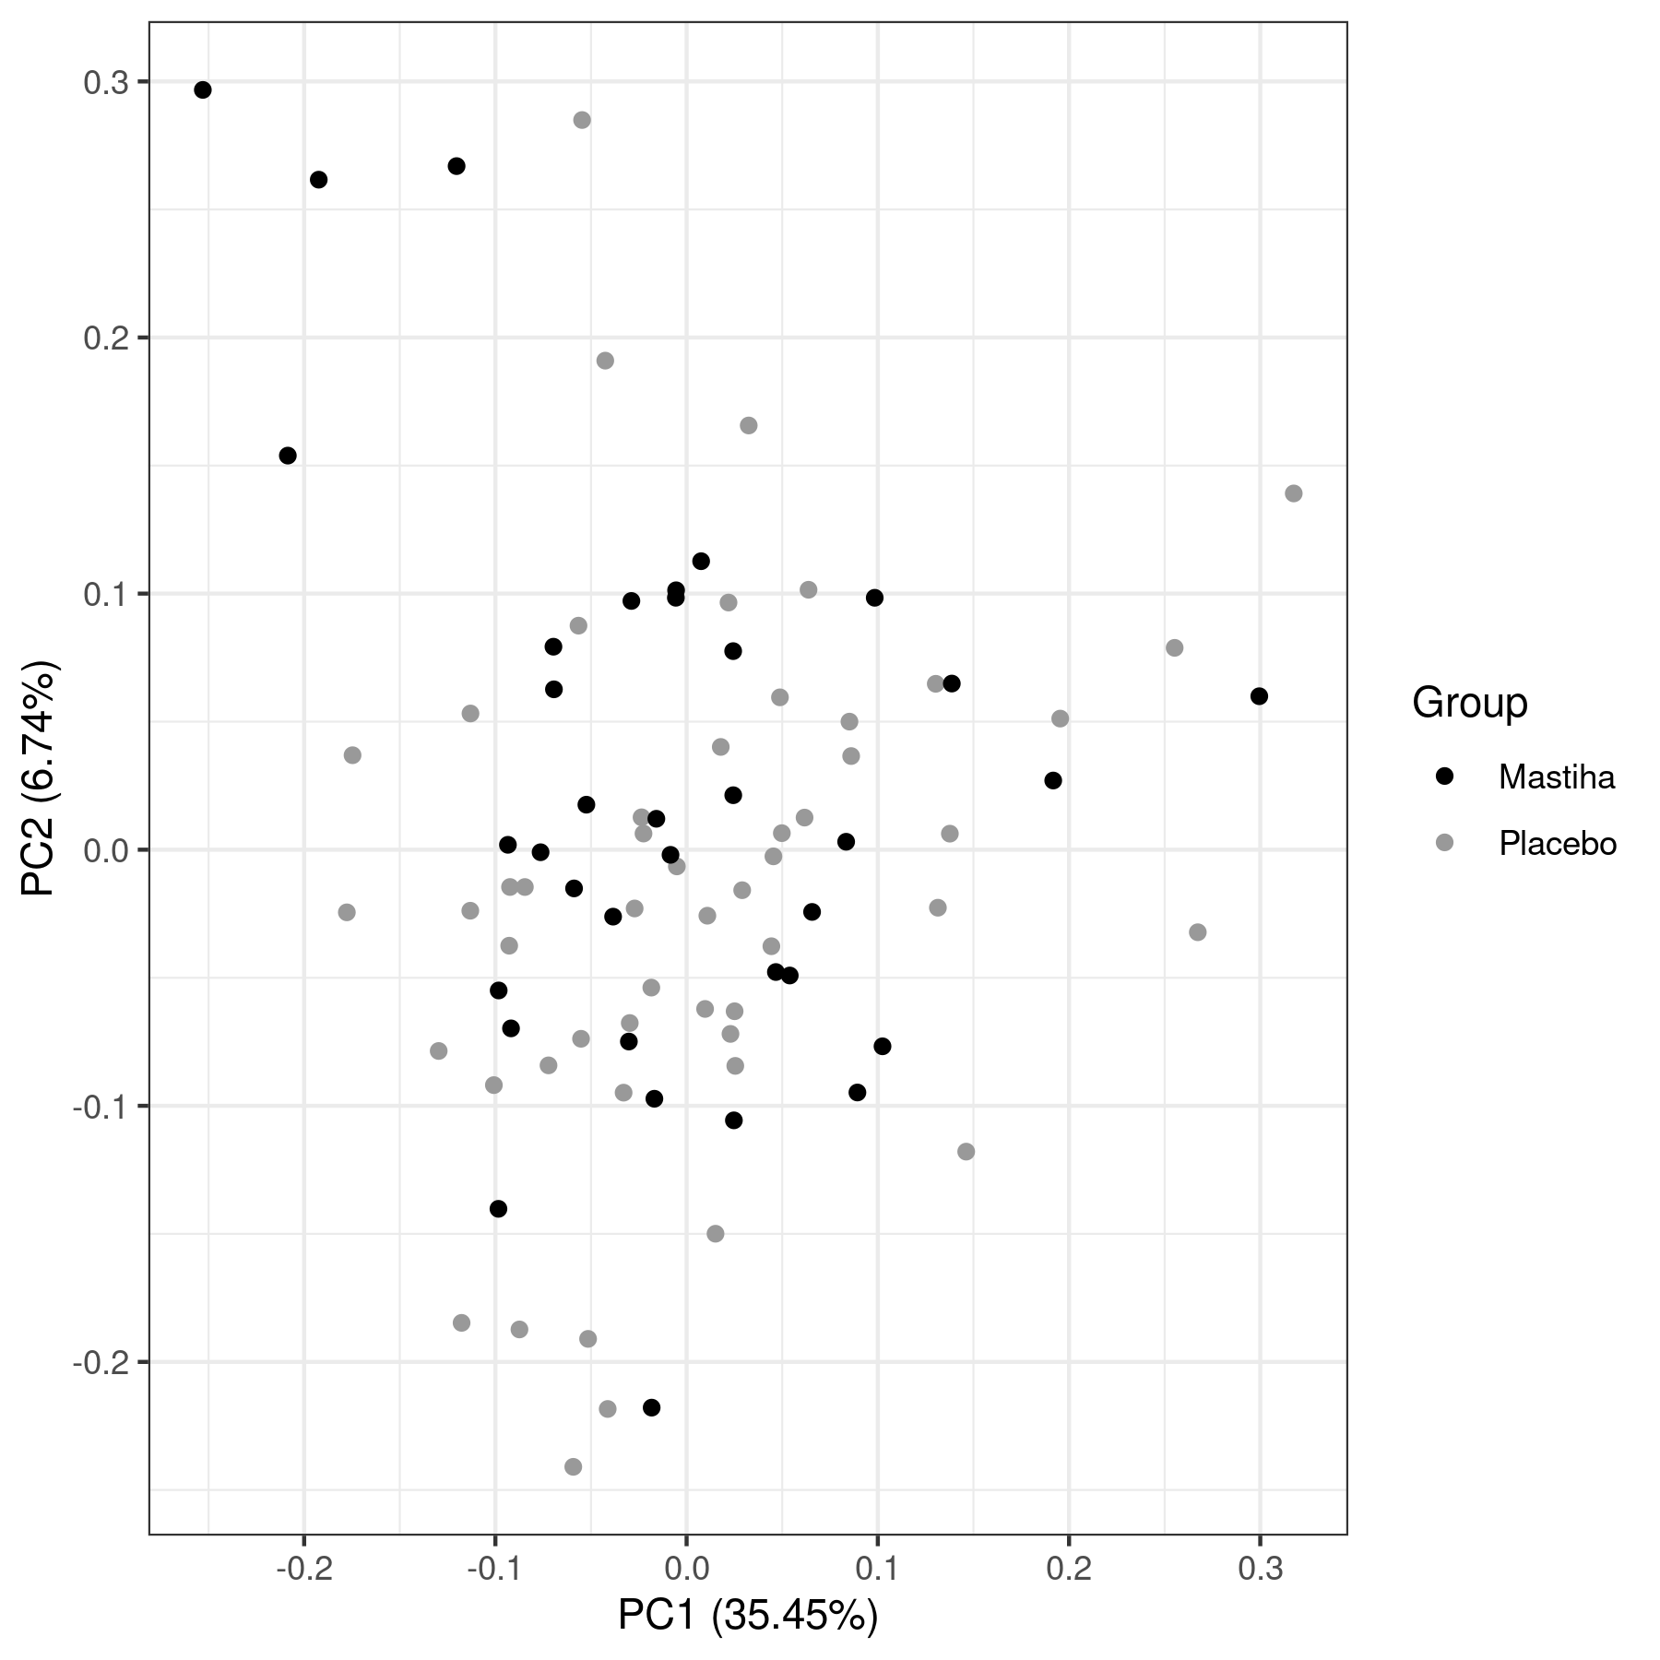B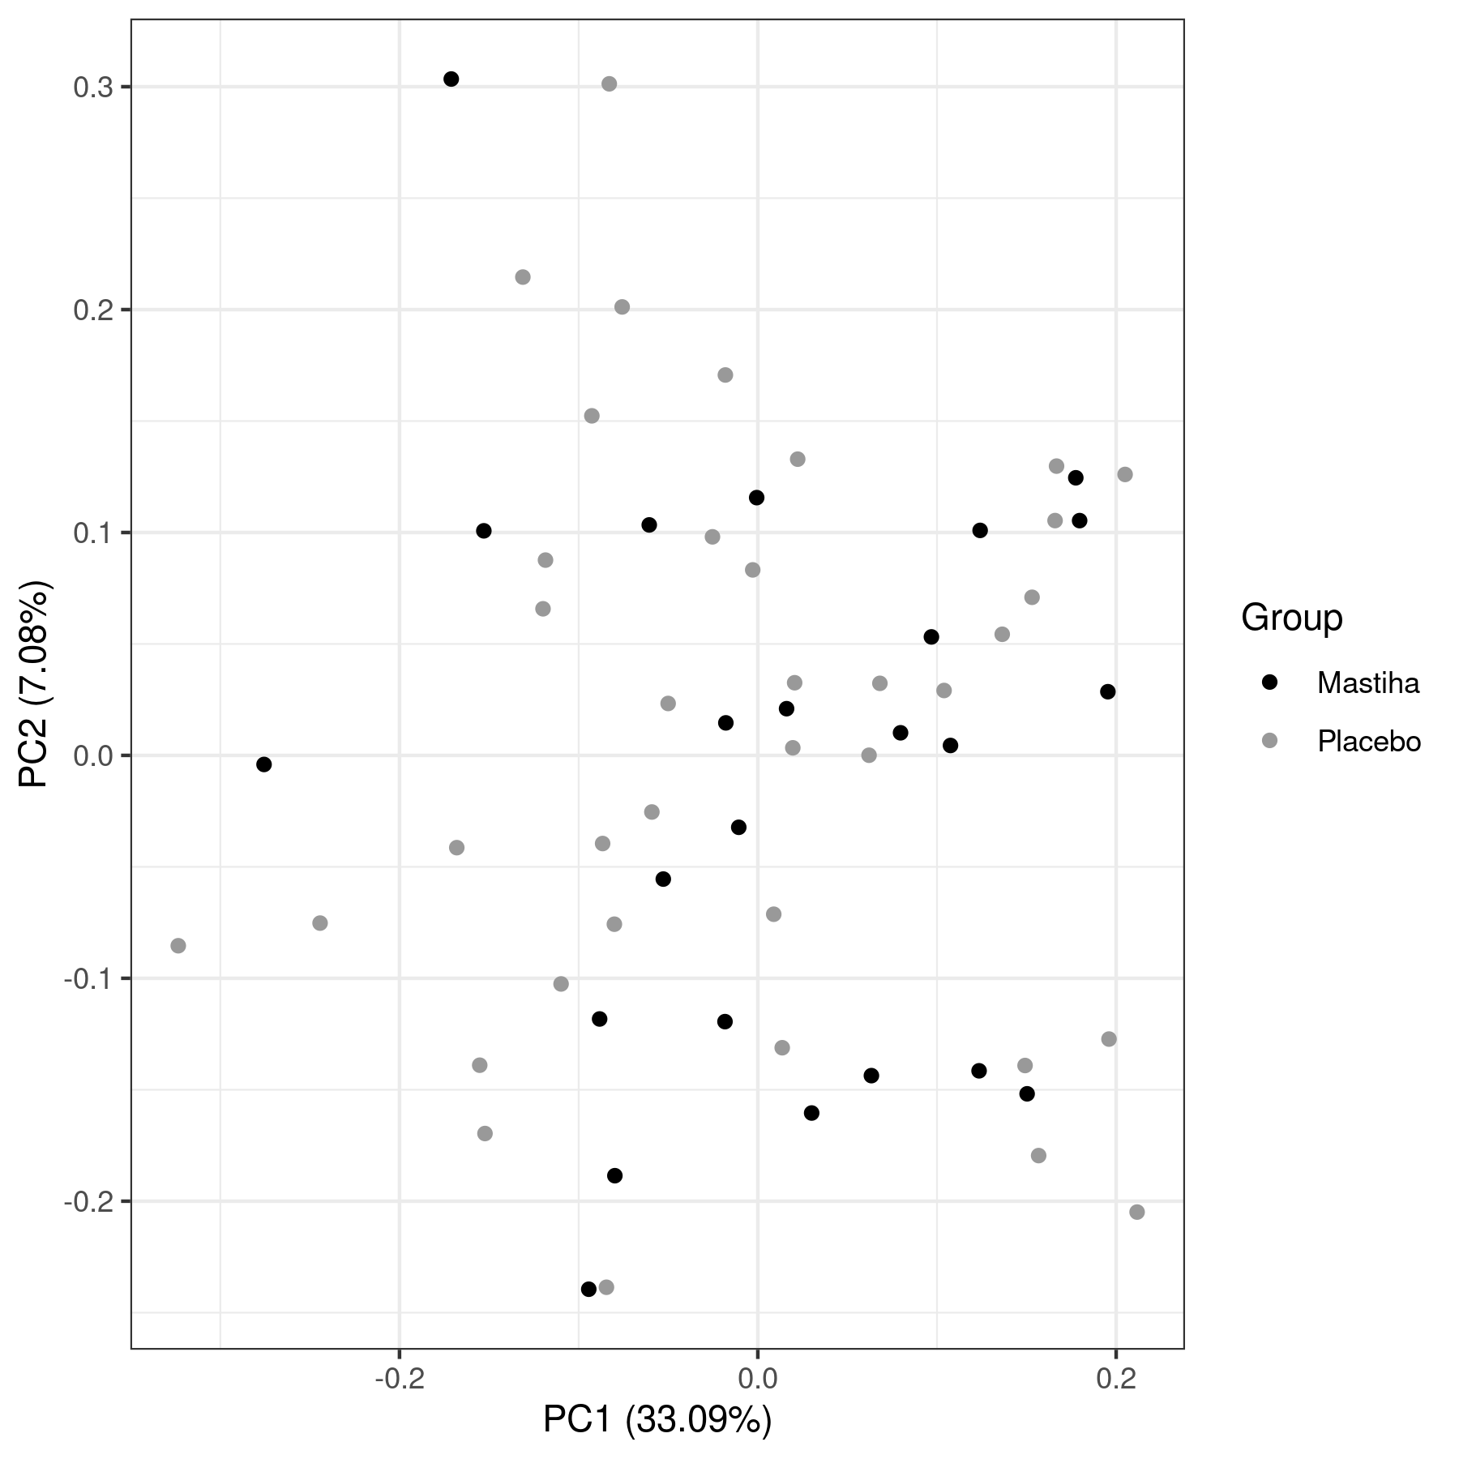
SFig. 1. Principal Component Analysis (PCA) including all 65 metabolites measured. (A) At baseline, (B) Post-treatment.

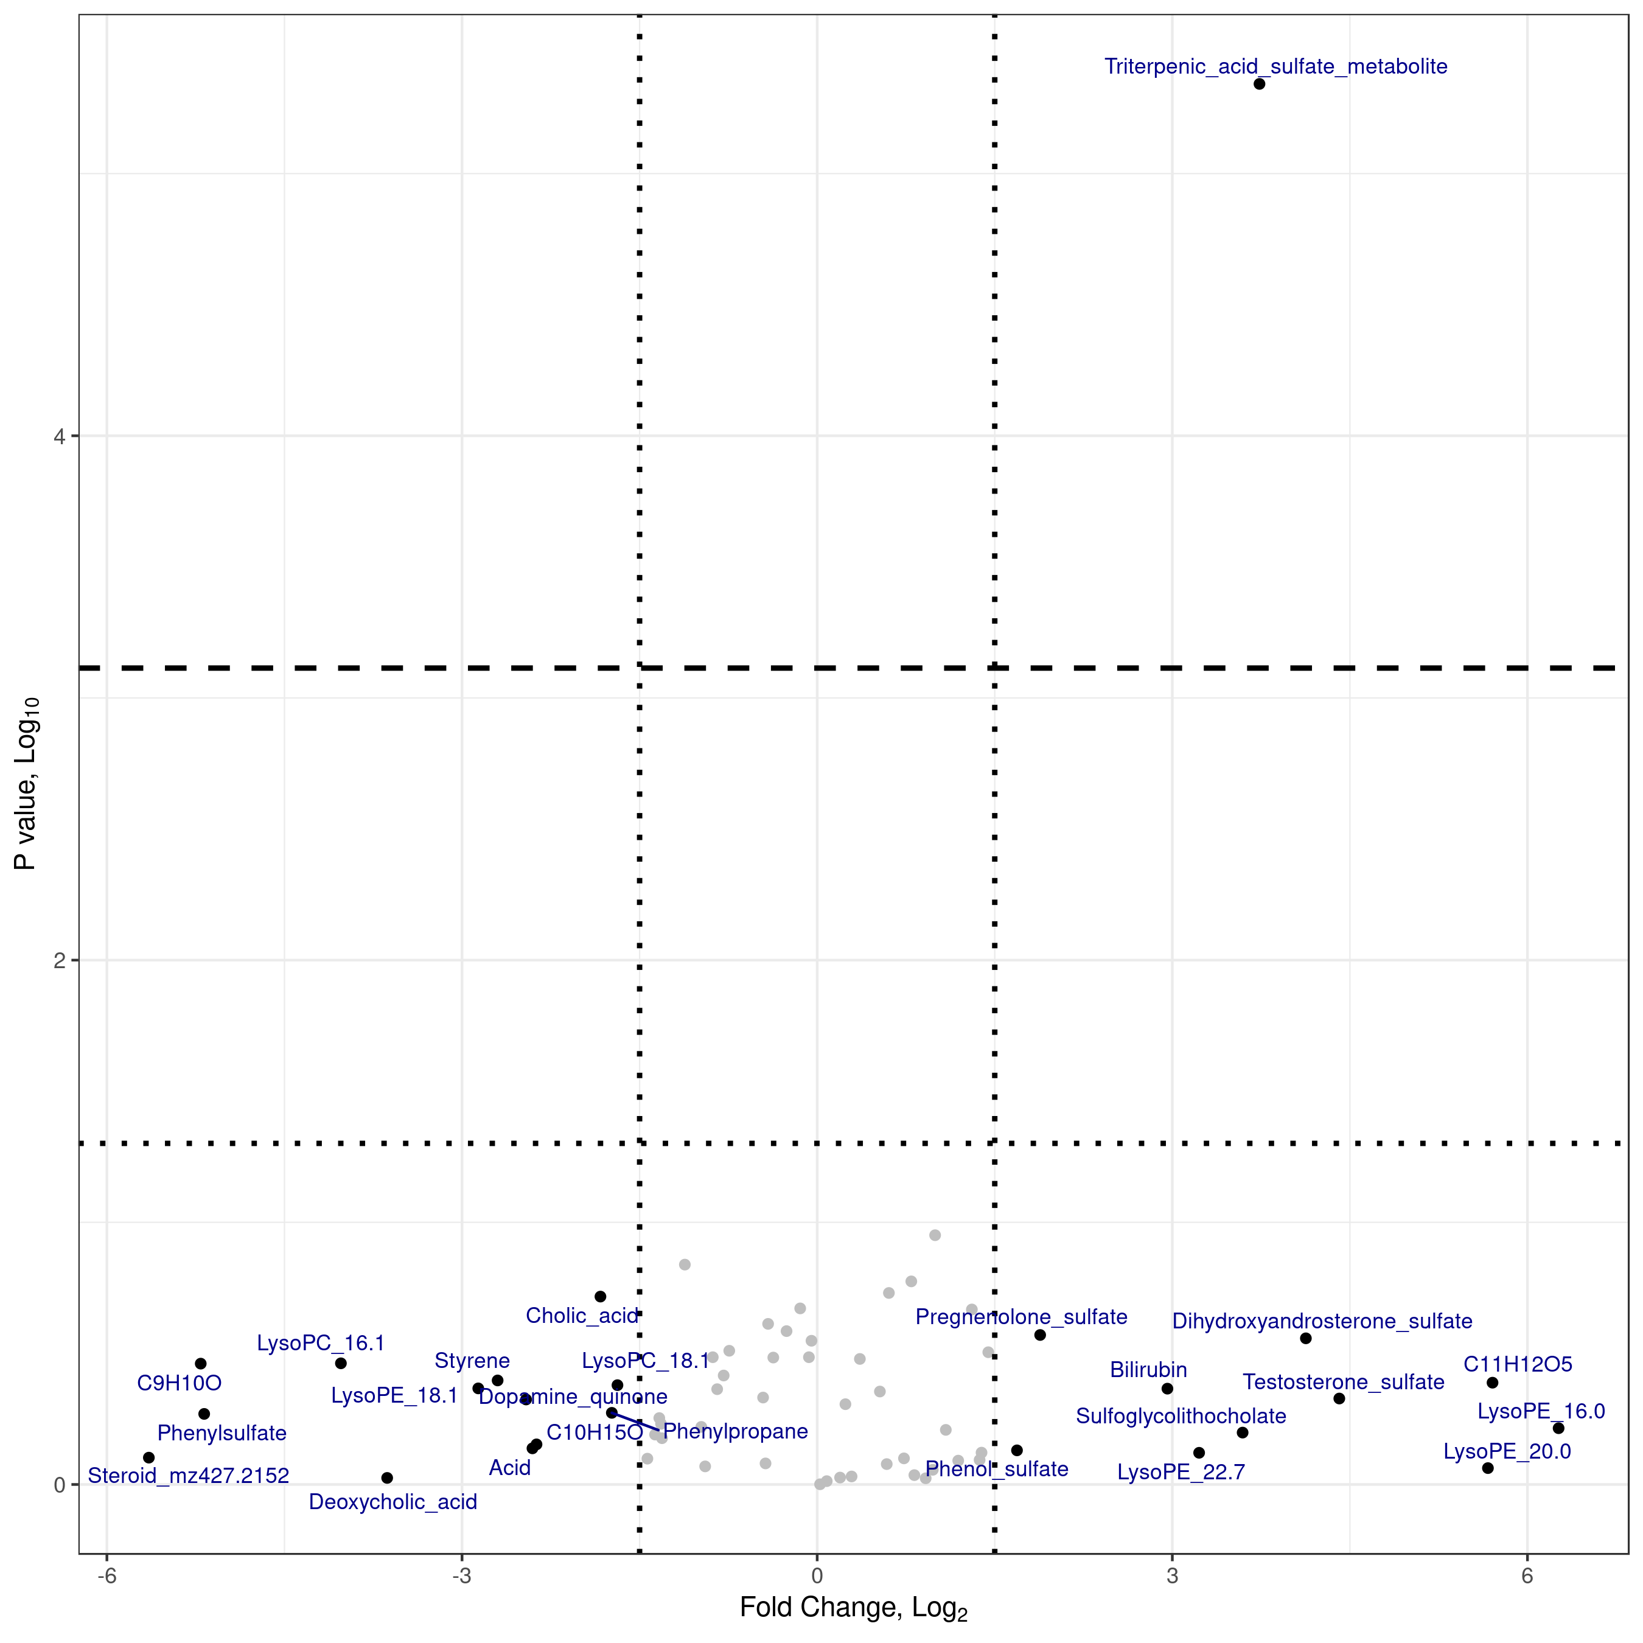
SFig. 2. Volcano plot of metabolites levels post treatment, between the Mastiha and Placebo groups. Vertical dotted lines highlight log2 fold-change less than -1.5 and greater than 1.5; metabolites passing these threshold appear labelled. The horizontal dotted line highlighted nominal significance level, while the dashed one Benjamini-Hochberg corrected significance level.

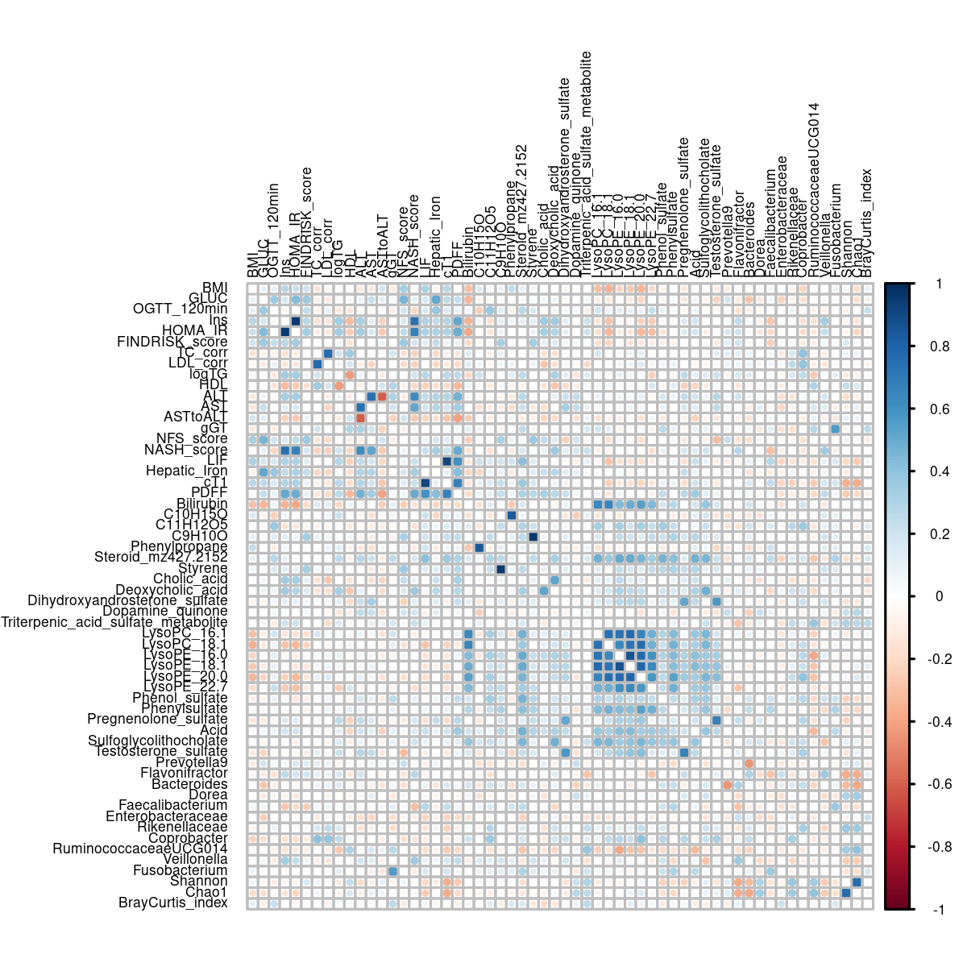
SFig. 3. Pearson’s pairwise correlation coefficients among the 58 outcomes analysed

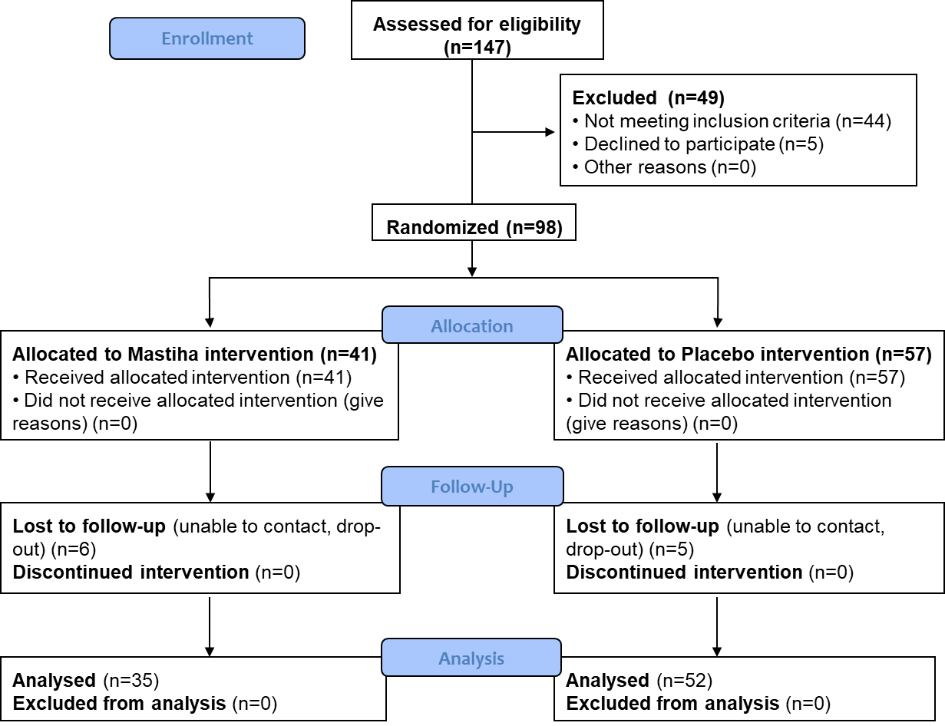

SFig. 4 CONSORT 2010 Flow diagram
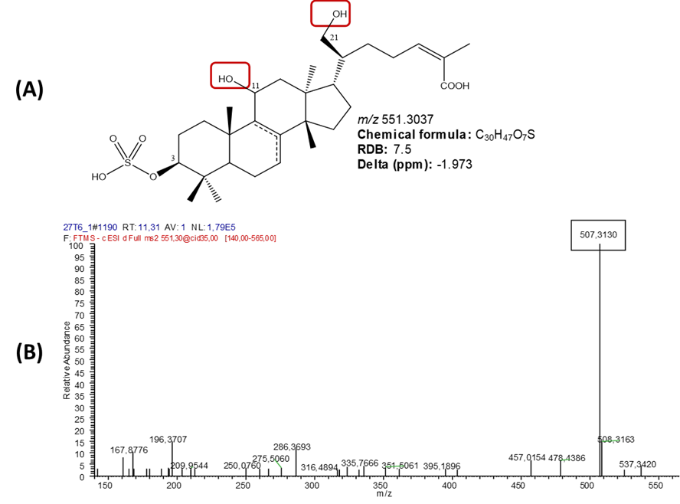
SFig. 5 (A) Suggested structure of the tentatively identified triterpenic acid metabolite detected in the Mastiha group. (B) HRMS/MS spectrum of the detected triterpenic acids metabolite in negative mode.

.

A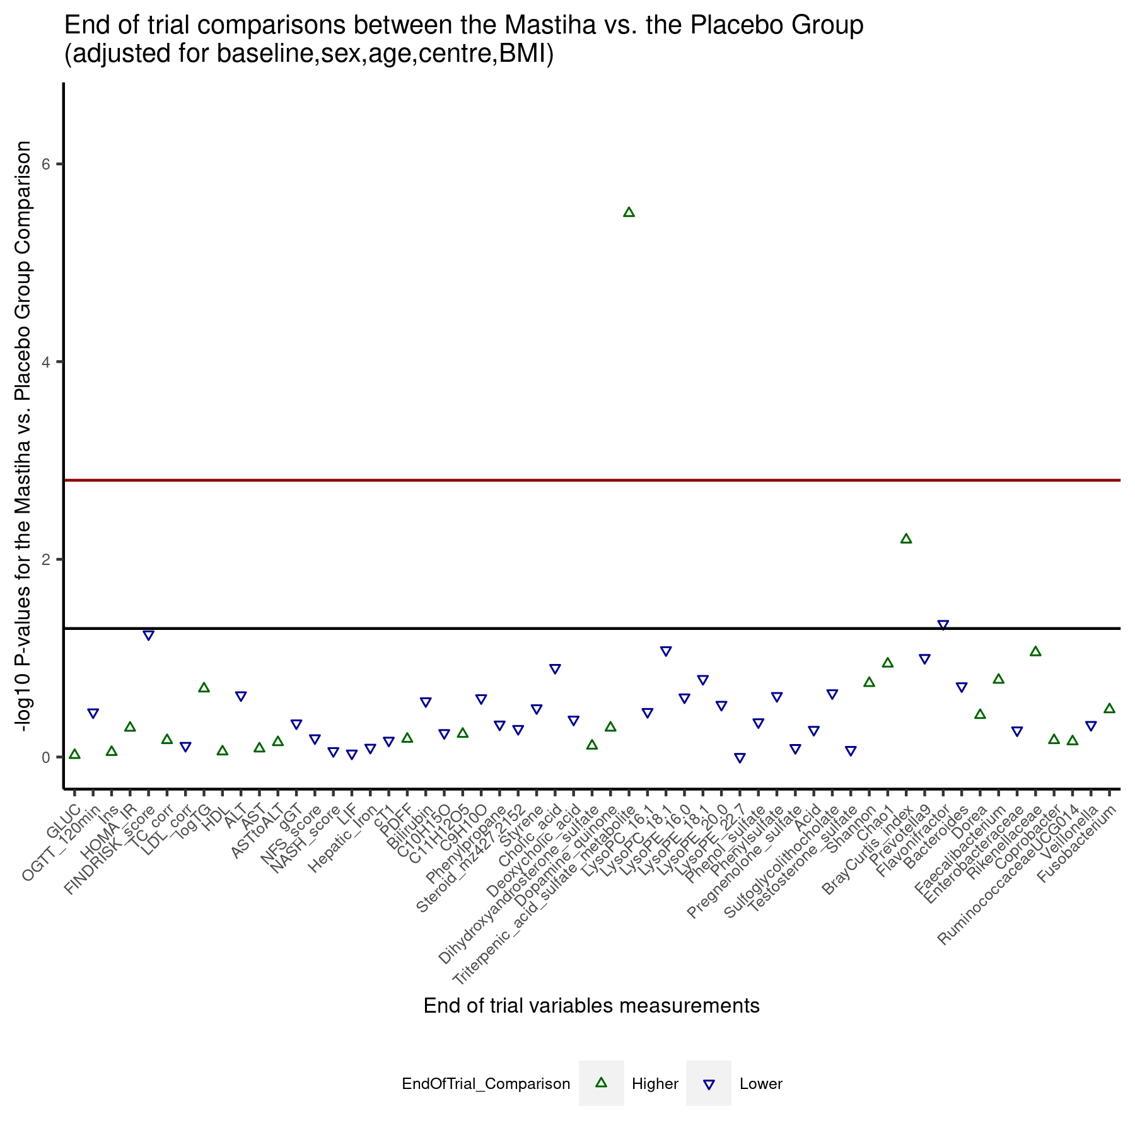B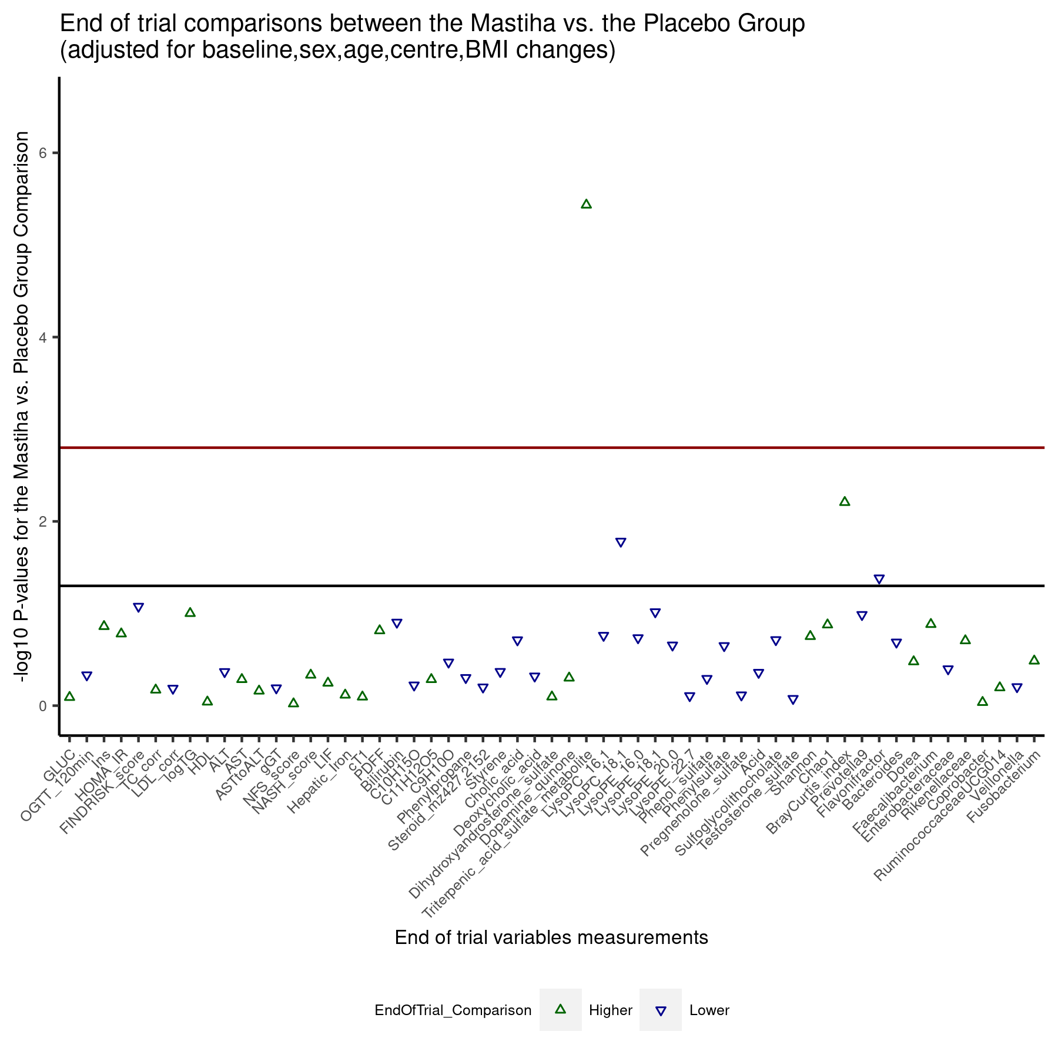 C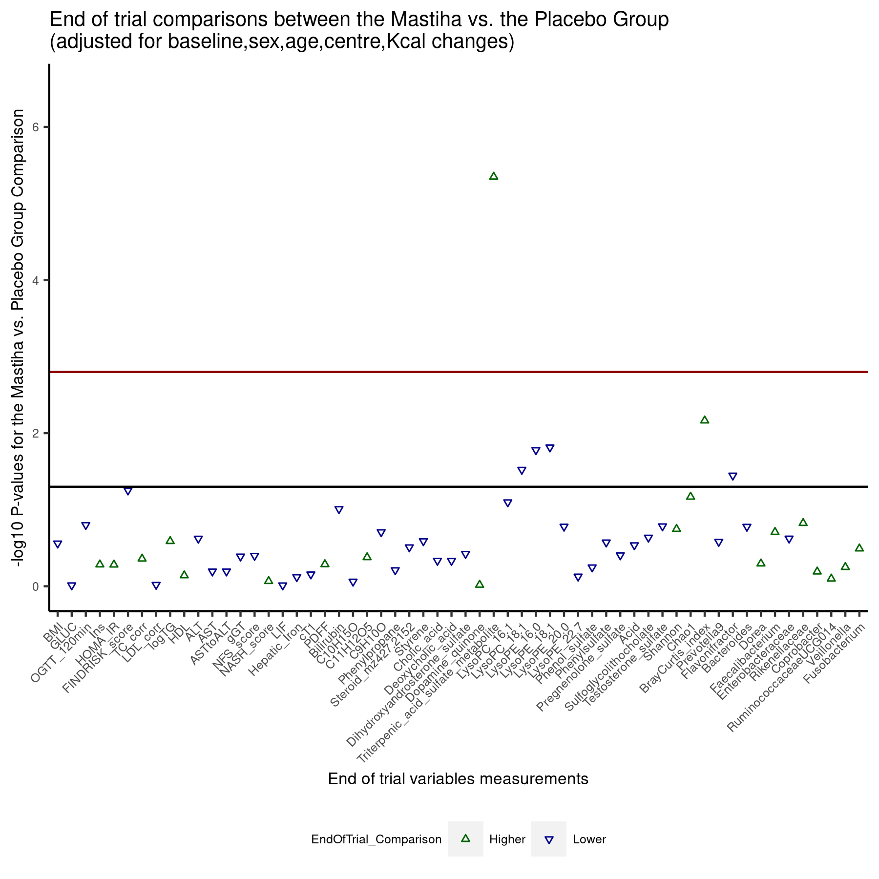D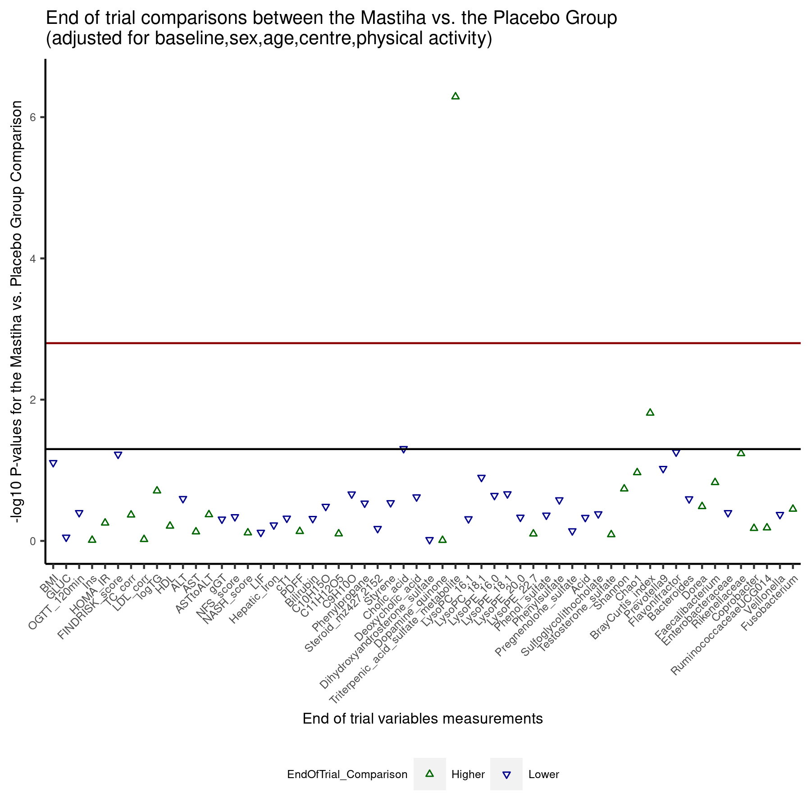 SFig. 6. Sensitivity analysis for the differences in all outcomes assessed post treatment between the Mastiha and Placebo groups. Comparisons were performed using ANOVA and adjusted for (A) The corresponding baseline levels for each outcome, age, gender, centre and BMI at baseline, (B) The corresponding baseline levels for each outcome, age, gender, centre and the BMI difference between post-treatment and baseline, (C) The corresponding baseline levels for each outcome, age, gender, centre and the caloric intake difference between post-treatment and baseline, (D) The corresponding baseline levels for each outcome, age, gender, centre and the level of physical activity at baseline. Triangles indicate the P value (-log10 transformed) for the comparison. Blue descending triangles indicate lower mean values in the Mastiha group compared to the Placebo; while green ascending triangles indicate the opposite. The black horizontal line marks nominal significance level (P value=0.05) and the red line the multiple testing significance level (P value=0.0015).

A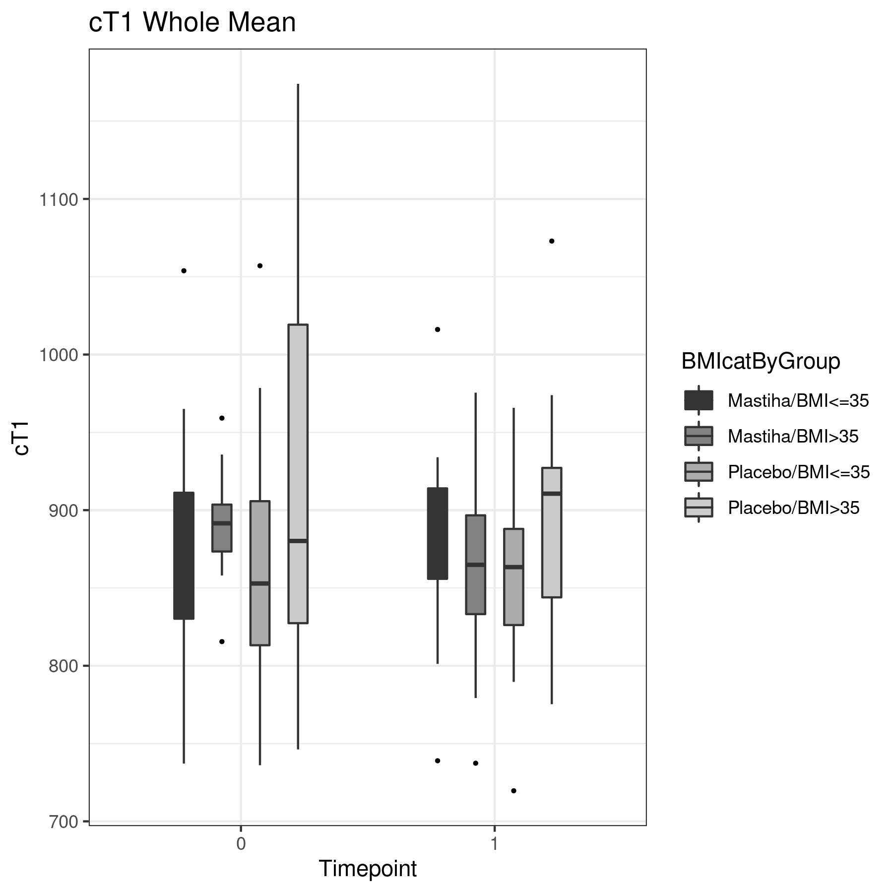B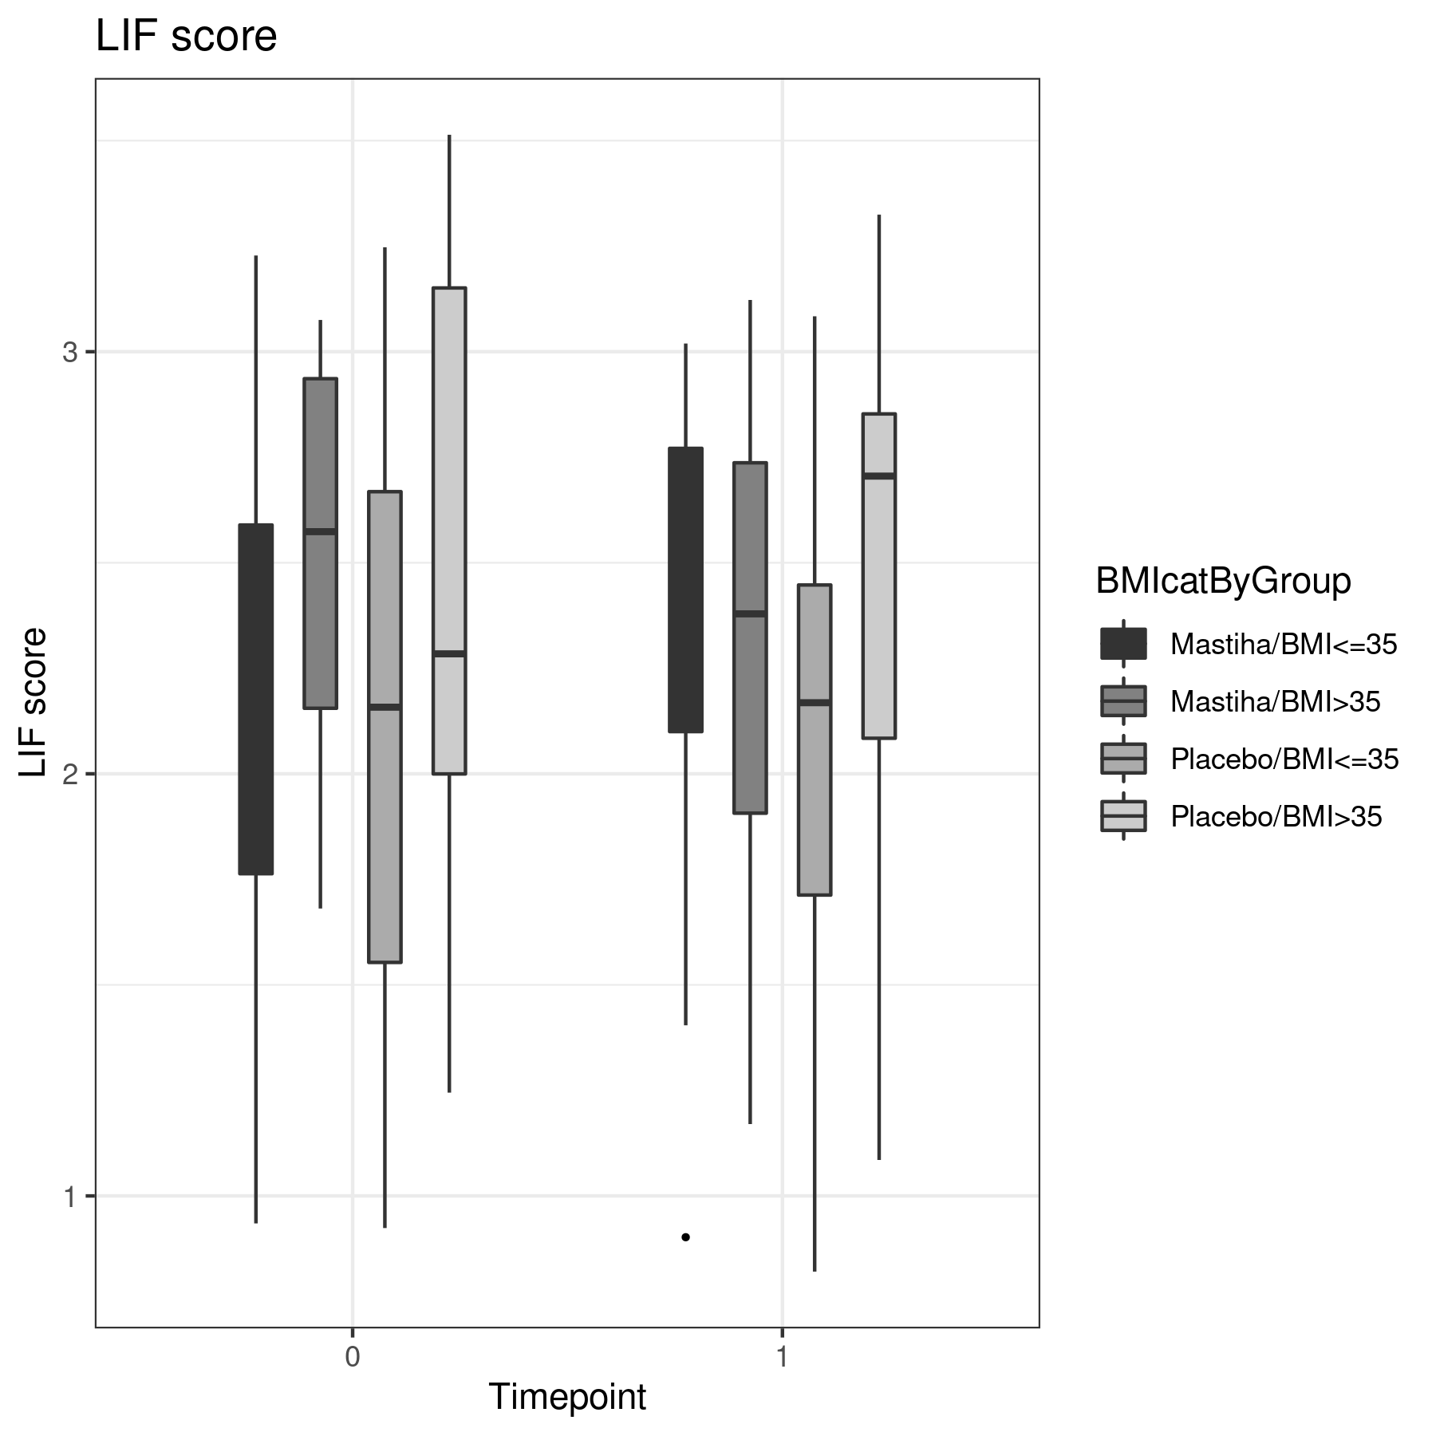C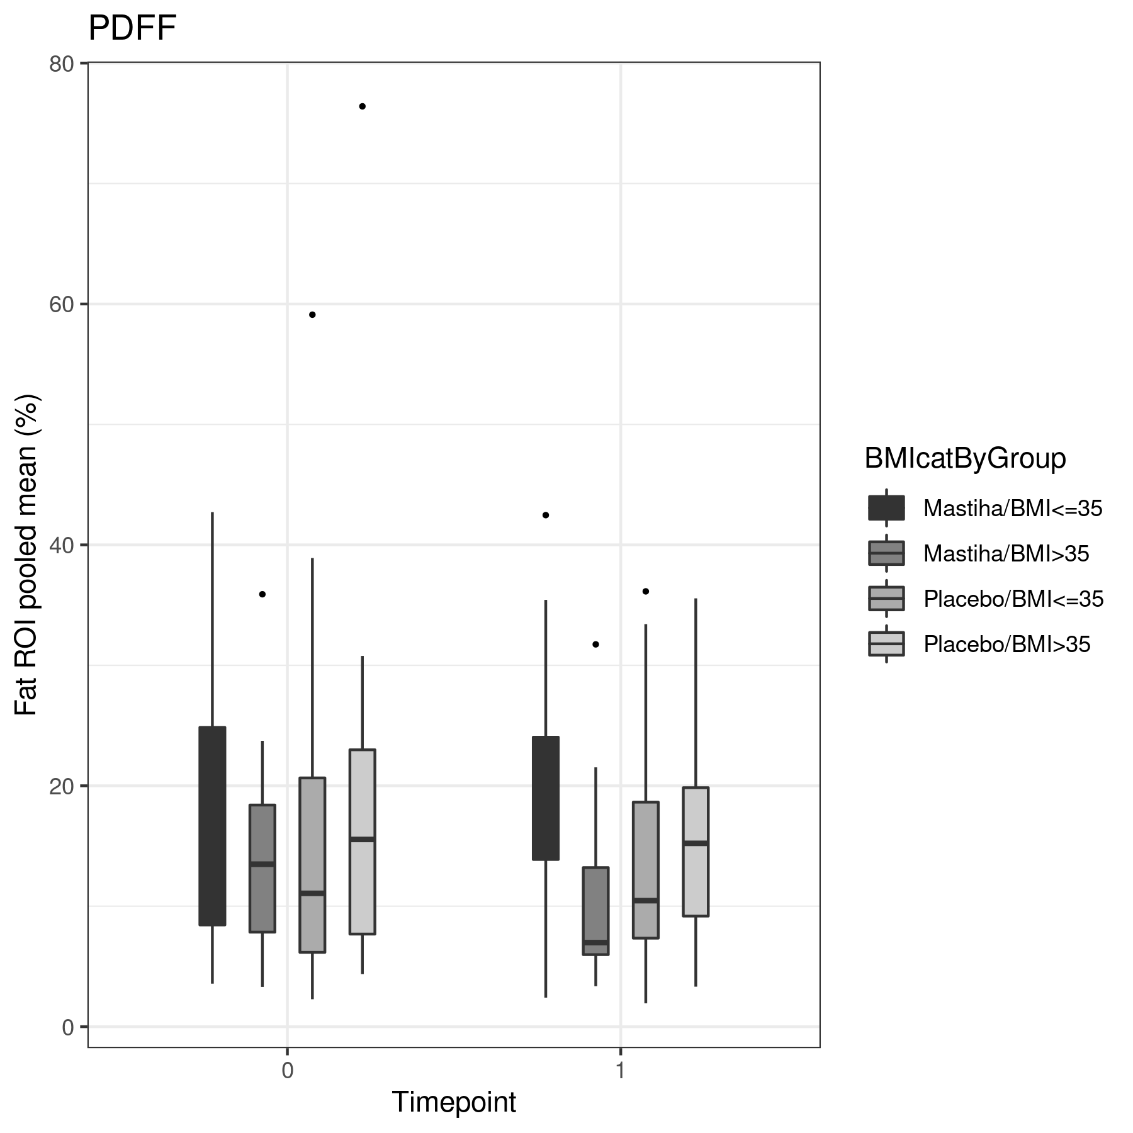D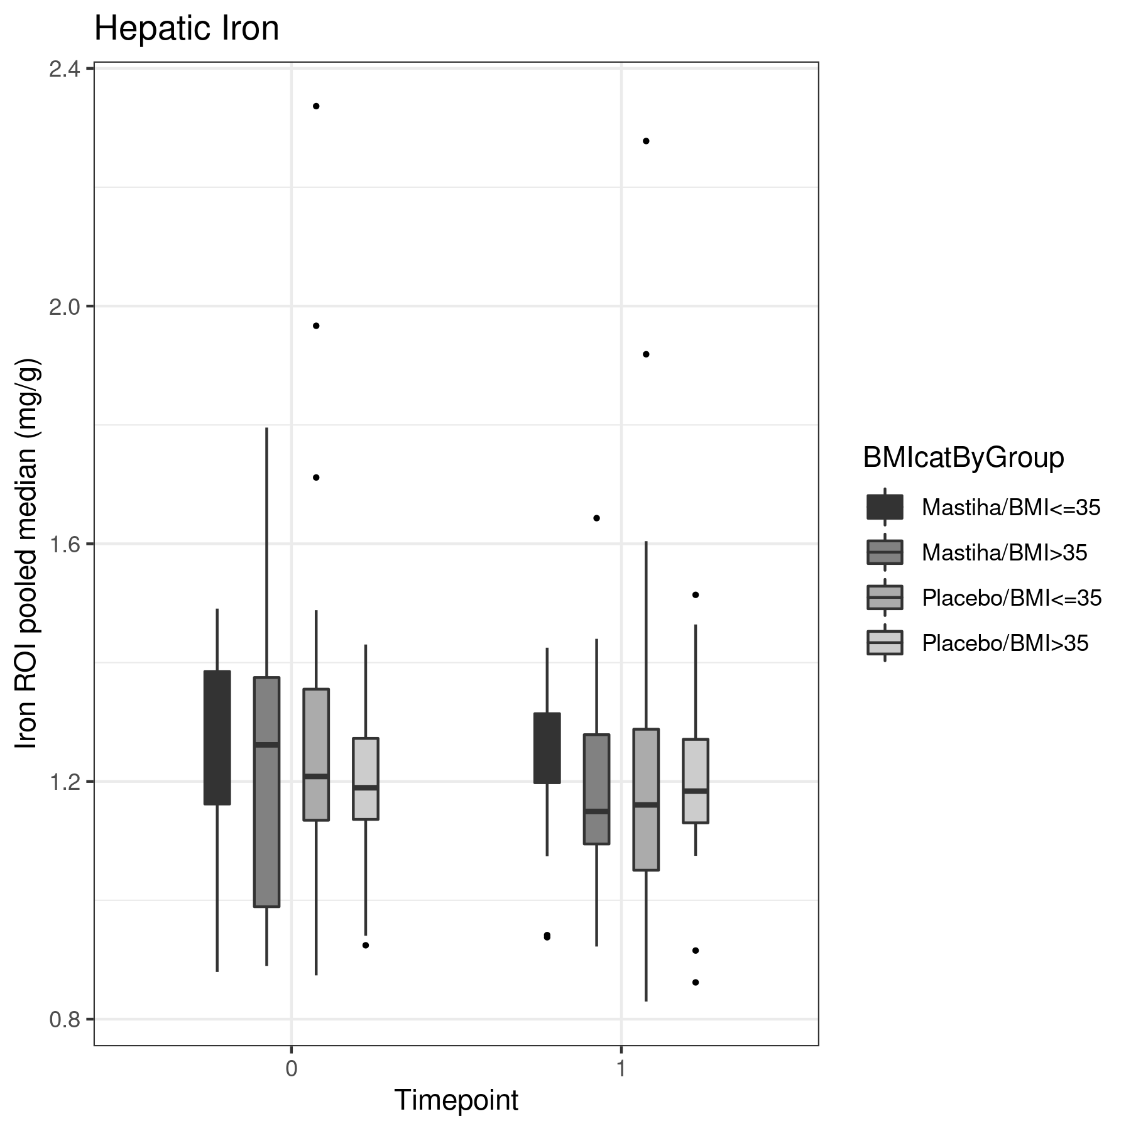 SFig. 7. Box plots for the MRI parameters showing the values at baseline and post-treatment for the Mastiha and Placebo group, by BMI category. (A) cT1 levels, (B) LIF, (C) PDFF, (D) Hepatic iron.

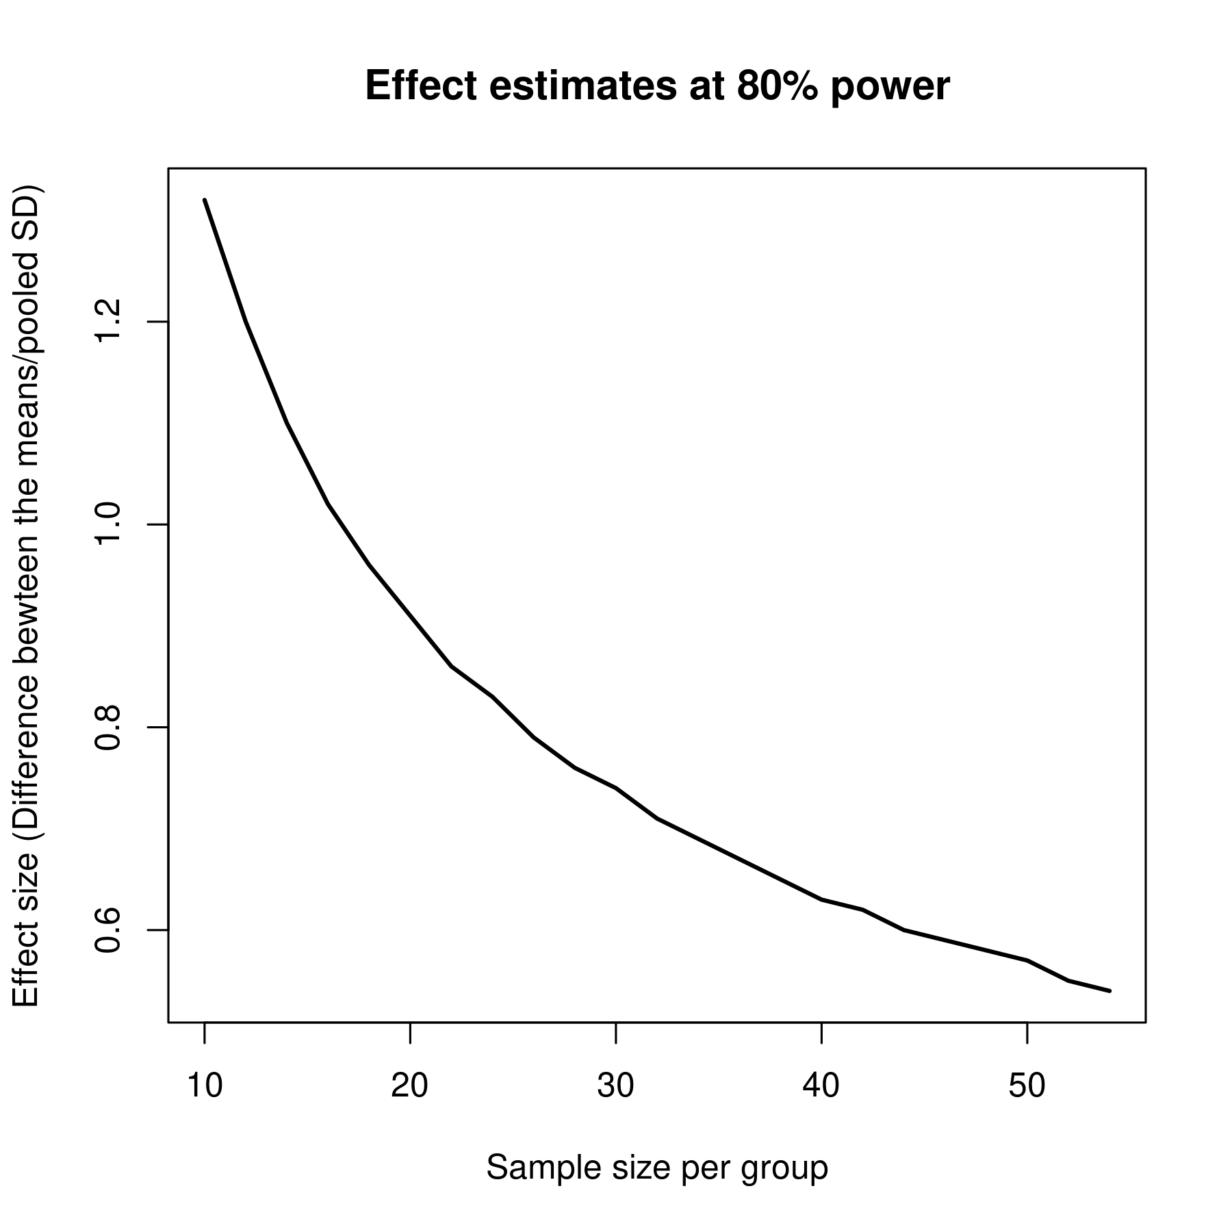
SFig. 8. Differences of the outcomes means between the two treatment groups at 80% power.

References
- Trochim WMK. Random selection & assignment. Web Centre for Social Research Methods 2006, Retrieved from http://www.socialresearchmethods.net/kb/random.htm
- Isokuortti E, Zhou Y, Peltonen M, Bugianesi E, Clement K, Bonnefont-Rousselot D, et al. Use of HOMA-IR to diagnose non-alcoholic fatty liver disease: a population-based and inter-laboratory study. Diabetologia. 2017;60(10):1873-1882. doi:10.1007/s00125-017-4340-1
- Angulo P, Hui JM, Marchesini G, Bugianesi E, George J, Farrell GC, et al. The NAFLD fibrosis score: a noninvasive system that identifies liver fibrosis in patients with NAFLD. Hepatology. 2007;45(4):846-854. doi:10.1002/hep.21496
- Hyysalo J, Männistö VT, Zhou Y, Arola J, Kärjä V, Leivonen M, et al. A population-based study on the prevalence of NASH using scores validated against liver histology. J Hepatol. 2014;60(4):839-846. doi:10.1016/j.jhep.2013.12.009
- Lemonakis N, Magiatis P, Kostomitsopoulos N, Skaltsounis AL, Tamvakopoulos C. Oral administration of chios mastic gum or extracts in mice: quantification of triterpenic acids by liquid chromatography-tandem mass spectrometry. Planta Med. 2011;77(17):1916-1923. doi:10.1055/s-0031-1279996
- Kantartzis K, Thamer C, Peter A, Machann J, Schick F, Schraml C, et al. High cardiorespiratory fitness is an independent predictor of the reduction in liver fat during a lifestyle intervention in non-alcoholic fatty liver disease. Gut. 2009 Sep;58(9):1281-8. doi: 10.1136/gut.2008.151977
- Stefan N, Ramsauer M, Jordan P, Nowotny B, Kantartzis K, Machann J, et al. Inhibition of 11β-HSD1 with RO5093151 for non-alcoholic fatty liver disease: a multicentre, randomised, double-blind, placebo-controlled trial. Lancet Diabetes Endocrinol. 2014;2(5):406-16
- Quesada-Vázquez S, Aragonès G, Del Bas JM, Escoté X. Diet, Gut Microbiota and Non-Alcoholic Fatty Liver Disease: Three Parts of the Same Axis. Cells. 2020;9(1):176. Published 2020 Jan 10. doi:10.3390/cells9010176
- Aron-Wisnewsky J, Vigliotti C, Witjes J, Le P, Holleboom AG, Verheij J, et al. Gut microbiota and human NAFLD: disentangling microbial signatures from metabolic disorders. Nat Rev Gastroenterol Hepatol. 2020;17(5):279-297. doi:10.1038/s41575-020-0269-9
- Callahan BJ, McMurdie PJ, Rosen MJ, Han AW, Johnson AJ, Holmes SP. DADA2: High-resolution sample inference from Illumina amplicon data. Nat Methods. 2016;13(7):581-583. doi:10.1038/nmeth.3869
- Chao A. Nonparametric estimation of the number of classes in a population. Scandinavian Journal of Statistics. 1984;11: 256-270
- Shannon CE. A mathematical theory of communication. Bell System Technical Journal. 1948;27: 379-656
- Bray JR, Curtis JT. An ordination of upland forest communities of southern Wisconsin. Ecological Monographs. 1957;27: 325-349
- Morton JT, Sanders J, Quinn RA, McDonald D, Gonzalez A, Vázquez-Baeza Y, et al. Balance Trees Reveal Microbial Niche Differentiation. mSystems. 2017;2(1):e00162-16. Published 2017 Jan 17. doi:10.1128/mSystems.00162-16
- Bolyen E, Rideout JR, Dillon MR, Bokulich NA, Abnet CC, Al-Ghalith GA, et al. Reproducible, interactive, scalable and extensible microbiome data science using QIIME 2. Nat Biotechnol. 2019 Aug;37(8):852-857. doi: 10.1038/s41587-019-0209-9
- JH. Hierarchical Grouping to Optimize an Objective Function. Journal of the American Statistical Association 1963;58(301):236-244. doi: 10.1080/01621459.1963.10500845
- Djoumbou-Feunang Y, Fiamoncini J, Gil-de-la-Fuente A, Greiner R, Manach C, Wishart DS. BioTransformer: a comprehensive computational tool for small molecule metabolism prediction and metabolite identification. J Cheminform. 2019 Jan 5;11(1):2. doi: 10.1186/s13321-018-0324-5. PMID: 30612223; PMCID: PMC6689873.
- Guo XY, Liu D, Ye M, Han J, Deng S, Ma XC, et al. Structural characterization of minor metabolites and pharmacokinetics of ganoderic acid C2 in rat plasma by HPLC coupled with electrospray ionization tandem mass spectrometry. J Pharm Biomed Anal. 2013 Mar 5;75:64-73. doi: 10.1016/j.jpba.2012.11.024. Epub 2012 Nov 23. PMID: 23312386.
- Krüger P, Daneshfar R, Eckert GP, Klein J, Volmer DA, Bahr U, et al. Metabolism of boswellic acids in vitro and in vivo. Drug Metab Dispos. 2008 Jun;36(6):1135-42. doi: 10.1124/dmd.107.018424. Epub 2008 Mar 20. PMID: 18356270.

