Project: PAR dysregulation in HD

Experiment: Phospho-N17-huntingtin immunofluorescence in PARG inhibitor-treated cells

Authors: Tamara Maiuri and Ray Truant

Date: 2021-02-11

Experiment 1

Seeding
2020-12-19

Seeded RPE1s (p10) in drilled glass-bottom 6-well plate: 500 uL/10 mL from a 95% confluent 10-cm plate per well.
2020-12-20

Treated cells with either 1 uM talazoparib or 10 uM PARG inhibitor (PDD00017273 from AdipoGen Lifesciences) for approximately 1 h. As this was originally part of a micro-irradiation assay, treatment was done in growth media with NucBlue for the first 20 minutes followed by inhibitor only in HBSS.

Fixation and staining
- Fixed in cold methanol 10 min at -20
- Blocked in 10% FBS/PBS for 15 min at room temp
- Incubated with anti-P-N17 (1:500 dilution in blocking buffer 45 min at room temp)
- Washed twice with PBS
- Incubated with donkey anti-rabbit-594 (1:500 20 min at room temp)
- Washed twice with PBS
- Incubated with mouse anti-PARP1 (BD Biosciences, 1:500 1h at room temp)
- Washed twice with PBS
- Incubated with donkey anti-mouse-488 (1:500 20 min at room temp)
- Washed twice with PBS
- Incubated with 0.2 ug/mL Hoechst for 5 min
- Washed once with PBS and imaged in PBS on the Nikon A1 confocal microscope (60X objective)

Results
In PARG inhibitor-treated cells, mitotic cells had very striking staining pattern in which the huntingtin seemed to “coat” the condensed chromosomes. Staining in PARP inhibitor-treated cells resembled what is usually seen in untreated cells [1].

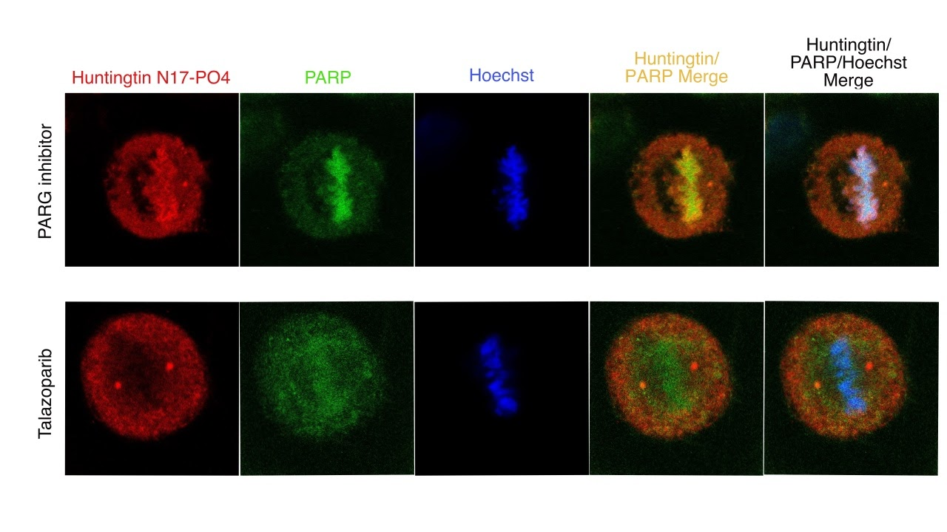

Experiment 2

2020-12-28

Seeded RPE1s in 8-well Ibidi dish for rather dense confluence to increase chances of finding mitotic cells:
- WT: brought 0.75 mL/10 mL from 95% 10-cm plate (p13) to 10 mL, plated 300 uL per well x 4 wells
- PARP1/PARP2 KO: brought 1.5 mL/10 mL from 95% 10-cm plate (p8) to 10 mL, plated 300 uL per well x 4 wells

2020-12-29

Next day, cells were not overly dense (~90%), but there were a few mitotic cells in the middle of each well (detected as rounded, healthy cells).

Treatment
- Added 10 uM PARG inhibitor in fresh growth media to each well for 20 min
- Replaced with 10 uM PARG inhibitor in fresh growth media containing NucBlue (one drop into 2 mL media) for 20 min
- Stress conditions:
  - No stress: HBSS + PARG inhibitor approx 20 min
  - KBrO3: PBS/Ca2+/Mg2+ containing 100 mM KBrO3 and PARG inhibitor approx 20 min
  - H2O2: PBS/Ca2+/Mg2+ containing 400 uM H2O2 and PARG inhibitor approx 20 min
  - UV: HBSS + PARG inhibitor 10 min followed by irradiation of 10 ROIs at 4 points (2 points in WT, 2 points in PKOs), which took approx 10 min

Fixation and staining
- Fixed in cold methanol 10 min at -20
- Blocked in 10% FBS/PBS for 15 min at room temp
- Incubated with anti-P-N17 (1:1000 dilution in blocking buffer) overnight

2020-12-30

- Washed twice with PBS
- Incubated with goat anti-rabbit-488 (1:1000 dilution in blocking buffer) for 15 min at room temp
- Washed twice with PBS
- Incubated with 0.2 ug/mL Hoechst for 5 min
- Washed once with PBS and imaged in PBS on the Nikon A1 confocal microscope (60X objective)

Results
No mitotic cells could be found in any of the stress conditions, but found 2 mitotic cells in the no stress condition, which displayed the huntingtin-coating-chromosomes pattern:

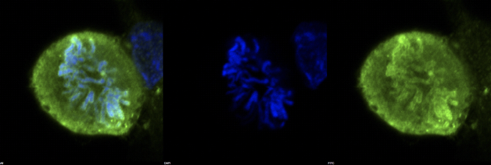
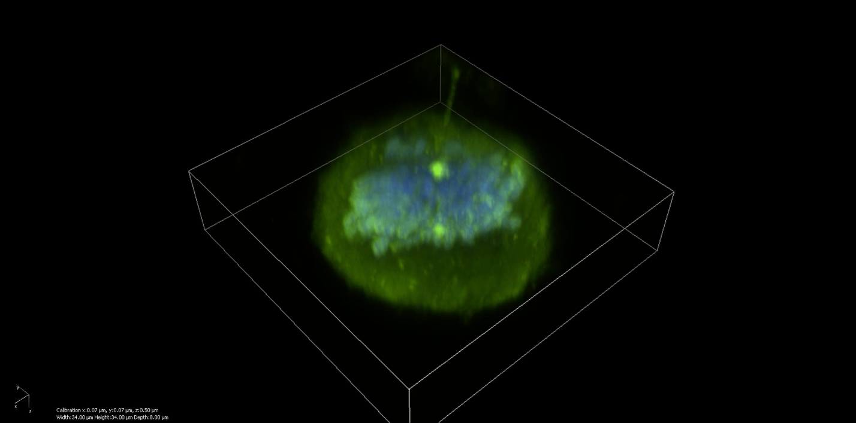
Double click to start movie: 3D reconstruction of Z-stack

Conclusions
- Huntingtin localizes to condensed chromosomes upon PARG inhibition
- Evidence that huntingtin binds PAR in vivo
- Can act as a readout for the PAR binding motif mutant, once CRISPR edited
- To do: try co-staining with PAR
- Using BenchSci, found these two images of IF against PAR in mitotic cells. Looks a lot like huntingtin in PARG inhibitor-treated cells:

https://www.ncbi.nlm.nih.gov/pmc/articles/PMC5114291/figure/fig03/:

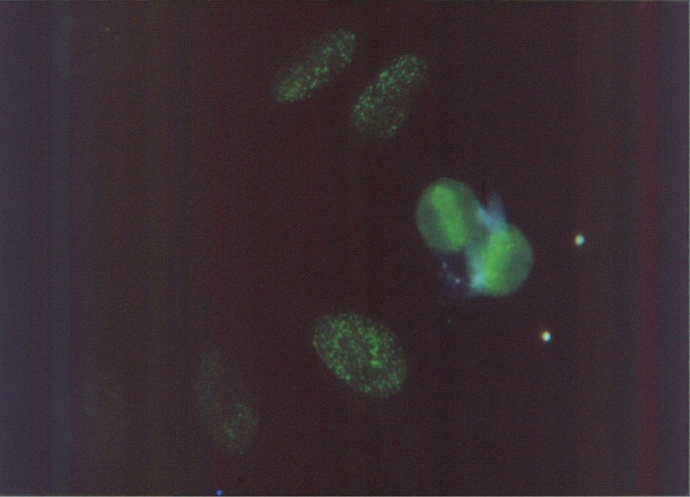

https://www.ncbi.nlm.nih.gov/pmc/articles/PMC319445/figure/F3/:
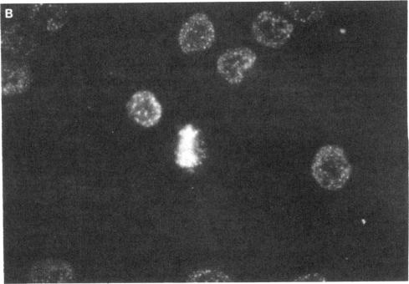

References

- Atwal RS, Desmond CR, Caron N, Maiuri T, Xia J, Sipione S, et al. Kinase inhibitors modulate huntingtin cell localization and toxicity. Nat Chem Biol. 2011;7: 453–460.

