PRMT5 cellular assay
Magdalena Szewczyk
Methods
MCF7 cells were grown in 12-well plates in DMEM supplemented with 10% FBS, penicillin (100 units/mL) and streptomycin (100 µg/mL). For knock-down (KD) experiments 40% confluent cells were transfected with 15 nM of either control siRNA or siRNA against PRMT1, 3, 4, 5, 6, and 7 (Dharmacon) using Lipofectamine™ RNAiMAX, following manufacturer instructions. Cells were harvested after 3 days or transfected again after 3 days for 6 day KD experiment. For the inhibition experiment 40% confluent cells were treated with different concentrations of GSK591 or DMSO control for 48 h.
Cells were lysed in 100 µL of total lysis buffer (20 mM Tris-HCl pH 8, 150 mM NaCl, 1 mM EDTA, 10 mM MgCl₂, 0.5% TritonX-100, 12.5 U/mL benzonase (Sigma), complete EDTA-free protease inhibitor cocktail (Roche)). After 3 min incubation at RT, SDS was added to the final 1% concentration. Total cell lysates were resolved in 4-12% Bis-Tris Protein Gels (Invitrogen) with MOPS buffer (Invitrogen) and transferred in for 1.5h (80 V) onto PVDF membrane (GE Healthcare Amersham™ Hybond™ 0.2 µm, Fisher Scientific, #45-004-021) in Tris-Glycine transfer buffer containing 20% MeOH and 0.05% SDS. Blots were blocked for 1 h in blocking buffer (5% milk in TBST: 0.1% Tween 20 PBS) and incubated with primary antibodies: anti-smBB’ (1:200, Santa Cruz, #sc-130670), anti-Rme2s (1:2000, Cell Signalling #13222), anti-PRMT7 (1:1000, Abcam, #ab179822), anti-PRMT1 (1:5000, Millipore, #07-404), anti-PRMT3 (1:5000, Abcam, #ab191562), anti-PRMT4 (1:2000, Bethyl, #A300-421A), anti-PTMT5 (1:5000, Abcam, #ab109451), anti-PRMT6 (1:2000, Abcam, #ab47244), anti-β-actin (#ab3280,Abcam, 1:3000) in blocking buffer overnight at 4 ºC. After five washes with 0.1% TBST, the blots were incubated with goat anti-rabbit (IR800 conjugated, LiCor #926-32211) and donkey anti-mouse (IR 680, LiCor #926-68072) antibodies (1:5000) in Odyssey Blocking Buffer (LiCor) for 30 min at RT and washed five times with TBST. The signal was read on an Odyssey scanner (LiCor) at 800 nm and 700 nm.

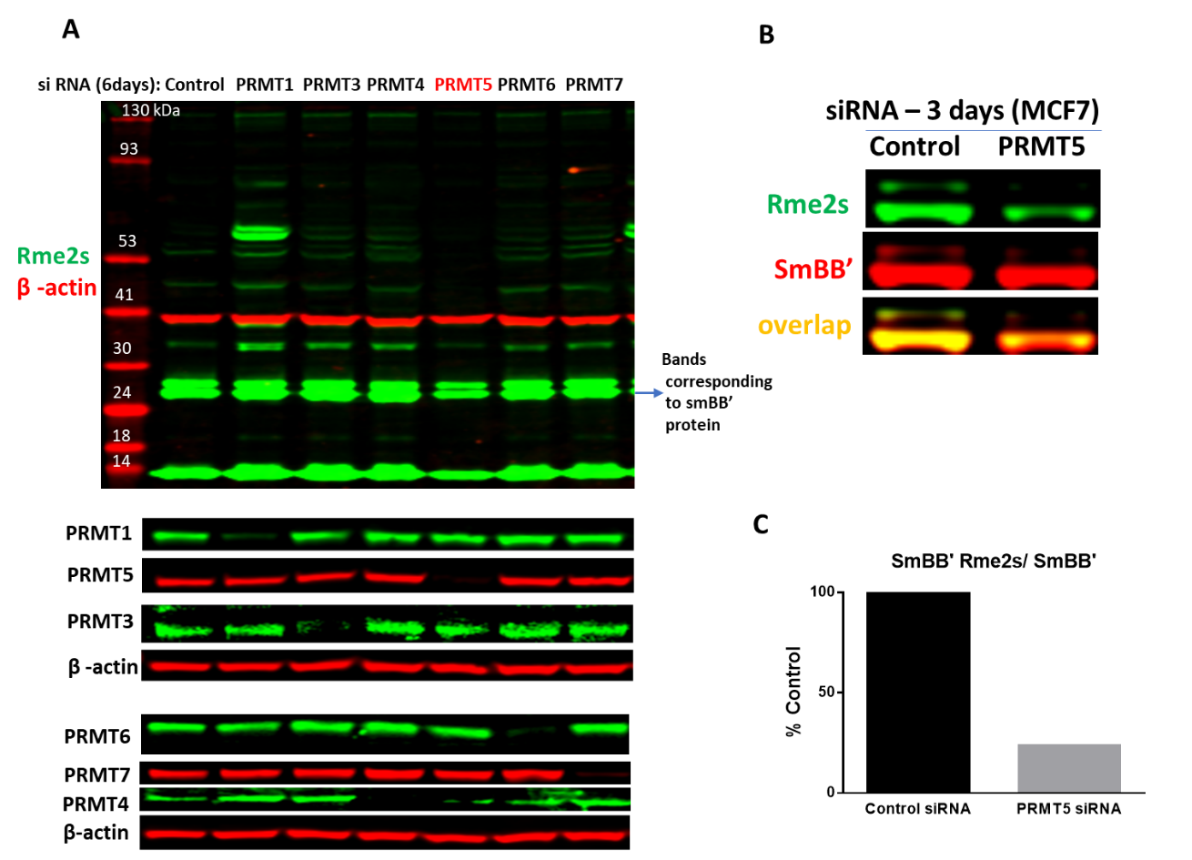
Fig.2. PRMT5 knock-down results in decrease in SmBB’-Rme2s levels. MCF7 cells were treated with siRNA targeted for different PRMTs and control siRNA for 6 (A) and 3 (B) days. A. Western blot analysis with an antibody recognizing symmetric arginine methylation (Rme2s) of various proteins. PRMTs expression after knock-down (KD) and β-actin controls are shown. Note that the loss of PTMT1 leads to decrease of Rme2a modification and the shared substrates become targets for PRMT5 leading to increase in Rme2s levels.B. Western blot analysis of the SmBB’-Rme2s levels after PRMT5 KD. C. Quantification of signal intensities of SmBB’-Rme2s normalized to total SmBB’ (n=1).
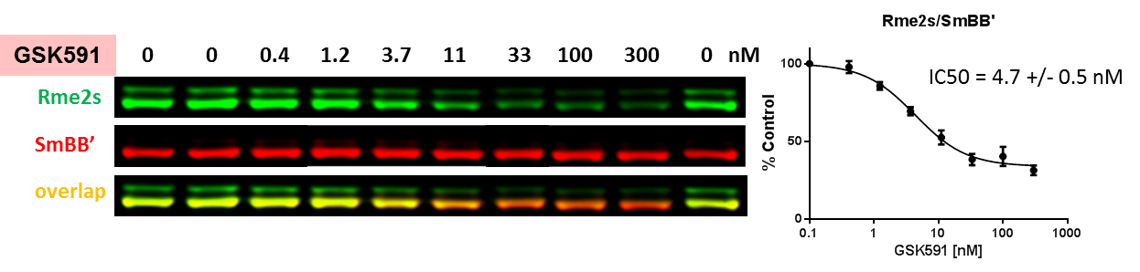
Fig.3. PRMT5 chemical probe, GSK591, decreases SmBB’ symmetric dimethylation in a dose-dependent manner. MCF7 cells were treated with inhibitor at indicated concentrations for 48 h and SmBB’-Rme2s and total SmBB’ levels were determined by Western blot. The graph represents nonlinear fits of SmBB’-Rme2s signal intensities normalized to total SmBB’. The results are mean +/- SEM of 3 replicates. The Z factor for the assay equals 0.67 (n=3).

