Project: ROS-specific Huntingtin Interactions

Experiment: Comparing nuclear PAR levels in wild type and HD (TruHD) fibroblasts in response to a PARP inhibitor concentration gradient (as a measure of PARP activity).

Authors: Tamara Maiuri and Ray Truant

Date: 2019-11-06

Purpose: To determine whether PARP activity differs in HD and wild type cells.

PARP activity expt 1
Seeding
- Q21s: 2.8 mL/10 mL from a 75% confluent 10-cm plate + 1.2 mL media; plated 200 uL per well
- Q43s: 1.4 mL/10 mL from a 50% confluent 10-cm plate + 2.6 mL media; plated 200 uL per well
- Q50s: 2.8 mL/10 mL from a 50% confluent 10-cm plate + 1.2 mL media; plated 200 uL per well

Next day, cells are:
- Q21s: 95% confluent at centre of well
- Q43s: 60% confluent at centre of well
- Q50s: 75% confluent at centre of well
Lunch meeting with potential donor. Let cells grow another day.

After 2 days, cells are 95-100%.

Treatment
Included 5 uM PARG inhibitor in all conditions.
Pre-treated cells with veliparib diluted in fresh growth media (+PARG inhibitor) for one hour. Dilution series:
- 10 uM: 1 uL of the 10 mM stock + 1 mL GM (+PARG inhibitor)
- 5 uM: 0.5 uL of the 10 mM stock + 1 mL GM (+PARG inhibitor)
- 1 uM: 100 uL of the 10 uM solution + 900 uL GM (+PARG inhibitor)
- 0.5 uM: 100 uL of the 5 uM solution + 900 uL GM (+PARG inhibitor)
- 0.1 uM: 100 uL of the 1 uM solution + 900 uL GM (+PARG inhibitor)
- 0.05 uM: 100 uL of the 0.5 uM solution + 900 uL GM (+PARG inhibitor)
- 0.01 uM: 100 uL of the 0.1 uM solution + 900 uL GM (+PARG inhibitor)
- 0 uM: 1 mL GM (+PARG inhibitor)

Plated 100 uL per well.

Prepared a 100 uM KBrO3 solution in PBS containing calcium and magnesium and added 5 uM PARG inhibitor. Diluted veliparib in KBrO3 solution as above. Removed pre-treatment and replaced with KBrO3 containing veliparib dose series for 30 min.

Fixation and staining
- Fixed in cold methanol at -20℃ for 10 min
- Washed twice with PBS
- Blocked in 10% FBS/PBS for 15 min at room temp
- Incubated with MABE1016 (1:750 dilution in blocking buffer) for 30 min at room temp using 50 uL per well
- Washed twice with PBS
- Incubated with donkey anti-rabbit-488 (1:1000 dilution in blocking buffer) for 15 min at room temp using 100 uL per well
- Washed twice with PBS
- Incubated with 0.2 ug/mL Hoechst for 5 min
- Washed once with PBS and plated 100 uL PBS for imaging

Imaging and analysis
Imaged six fields per well using the 10X objective on the EVOS FL Auto 2 widefield microscope (1000-2000 cells per condition). Identified nuclei using Hoechst stain in CellProfiler then measured the PAR signal intensity within nuclei (mean for each field).

Results
- Both Q43s and Q50s have higher PAR levels than Q21s at lower concentrations of veliparib
- By 5-10 uM veliparib, the differences are lost

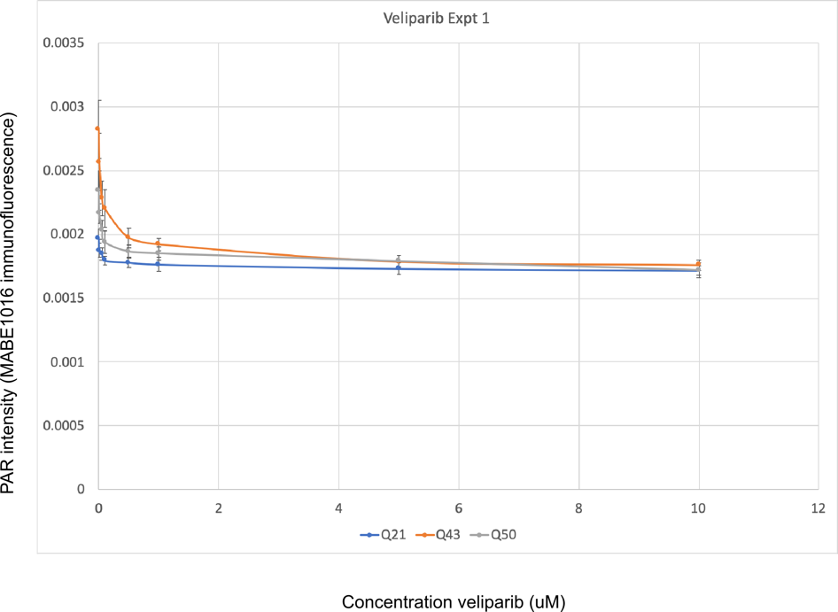
IC50 analysis expt 1
Used the IC50 calculator at https://www.aatbio.com/tools/ic50-calculator. Scaled the PAR signal intensities for each cell line such that the lowest value = 0% PAR signal, and the highest value = 100% PAR signal.

Q21 veliparib IC50 = 0.367 uM
Q43 veliparib IC50 = 0.065 uM
Q50 veliparib IC50 = 0.048 uM

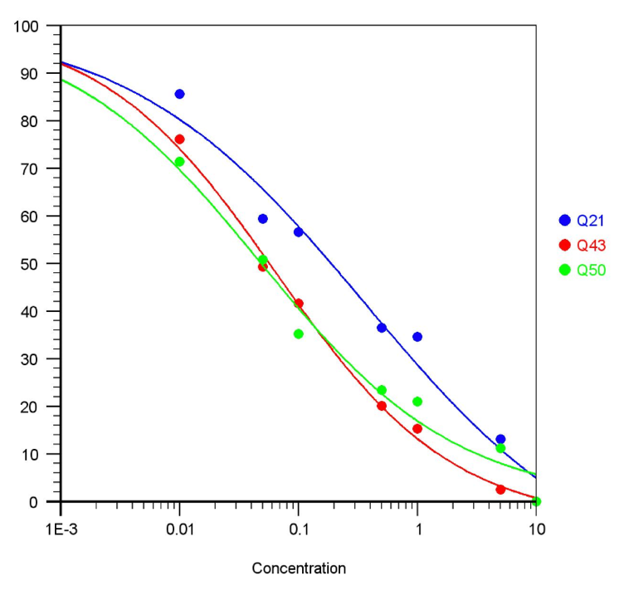

This is interesting. Despite higher overall levels of PAR in HD cells, it takes 5-10X as much veliparib to reduce the PAR response by half in WT cells.

PARP activity expt 2
Seeding
- Q21s: 1.5 mL/10 mL from a 90% confluent 10-cm plate + 2.5 mL media; plated 200 uL per well
- Q43s: 0.7 mL/10 mL from an 80% confluent 10-cm plate + 3.3 mL media; plated 200 uL per well
- Q50s: 2 mL/10 mL from an 80% confluent 10-cm plate + 2 mL media; plated 200 uL per well

Next day, cells are:
- Q21s: 60% confluent at centre of well
- Q43s: 50% confluent at centre of well
- Q50s: 75% confluent at centre of well

Treatment, fixation/staining, imaging/analysis
Exactly as in experiment 1, EXCEPT: used 2 uM PARG inhibitor instead of 5 uM.

Results
This time, Q50s did not differ much from Q21s in terms of PAR levels. Q43 PAR levels were elevated as usual.

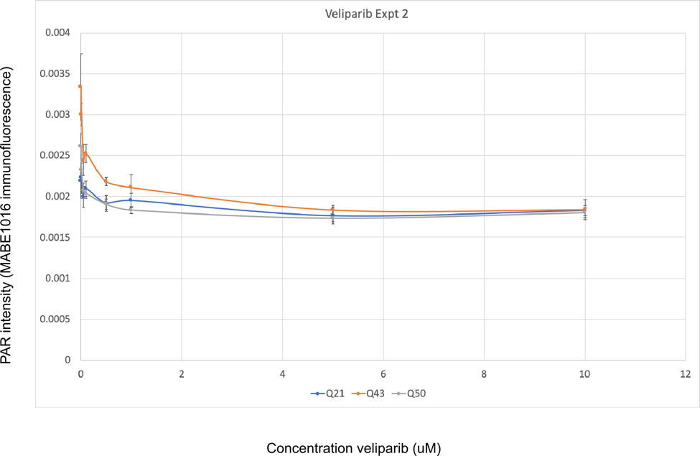

IC50 analysis expt 2
As in experiment 1.

Q21 veliparib IC50 = 0.244 uM
Q43 veliparib IC50 = 0.073 uM
Q50 veliparib IC50 = 0.048 uM

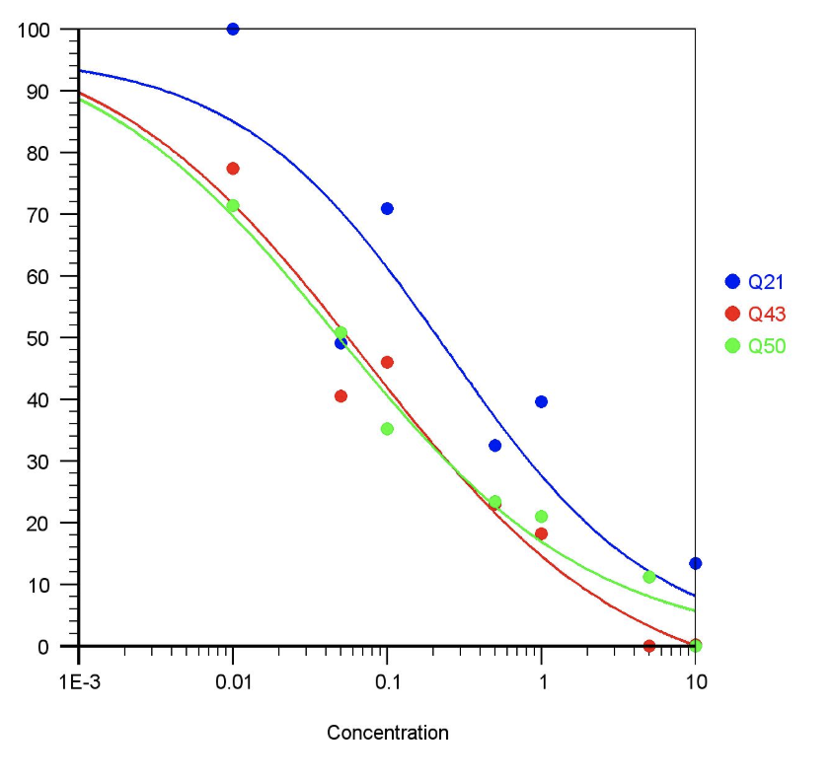

Similar to experiment 1, it takes more veliparib to reduce the PAR response by half in WT cells than it does in HD cells.

PARP activity expt 3
Seeding
- Q21s: 2 mL/10 mL from an 80% confluent 10-cm plate + 2 mL media; plated 200 uL per well
- Q43s: 0.7 mL/10 mL from an 85% confluent 10-cm plate + 3.3 mL media; plated 200 uL per well
- Q50s: 2 mL/10 mL from a 75% confluent 10-cm plate + 2 mL media; plated 200 uL per well

Next day cells are 75% confluent at centre of well.

Treatment, fixation/staining, imaging/analysis
Exactly as in experiment 2.

Results
Similar to expt 2.
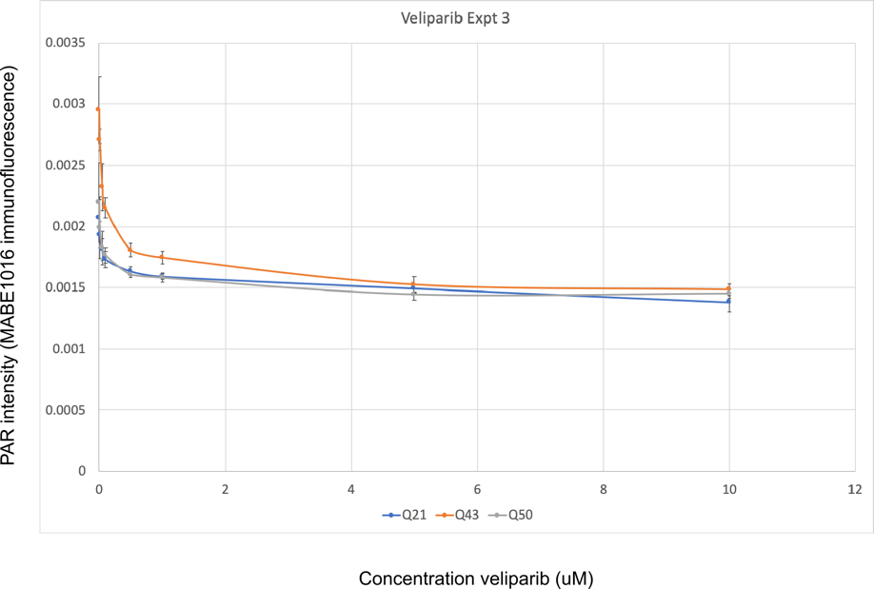

IC50 analysis expt 3
As in experiments 1 and 2.

Q21 veliparib IC50 = 0.258 uM
Q43 veliparib IC50 = 0.090 uM
Q50 veliparib IC50 = 0.082 uM
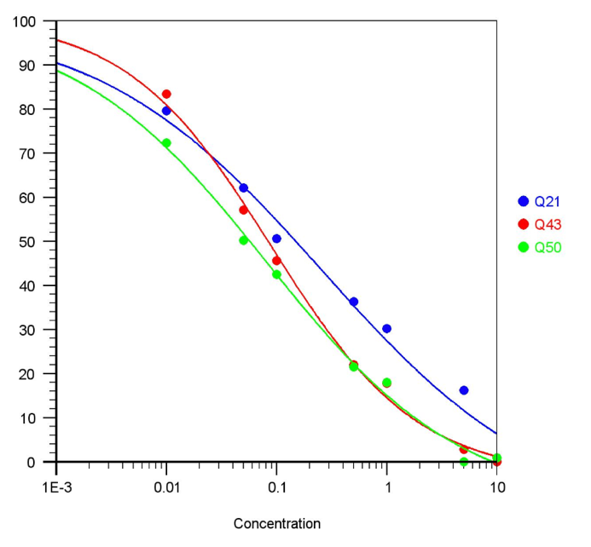

Results from three trials
Normalized the values for each experiment to the average 0 uM Q21 value. Q43s have higher levels of PAR than Q21s.
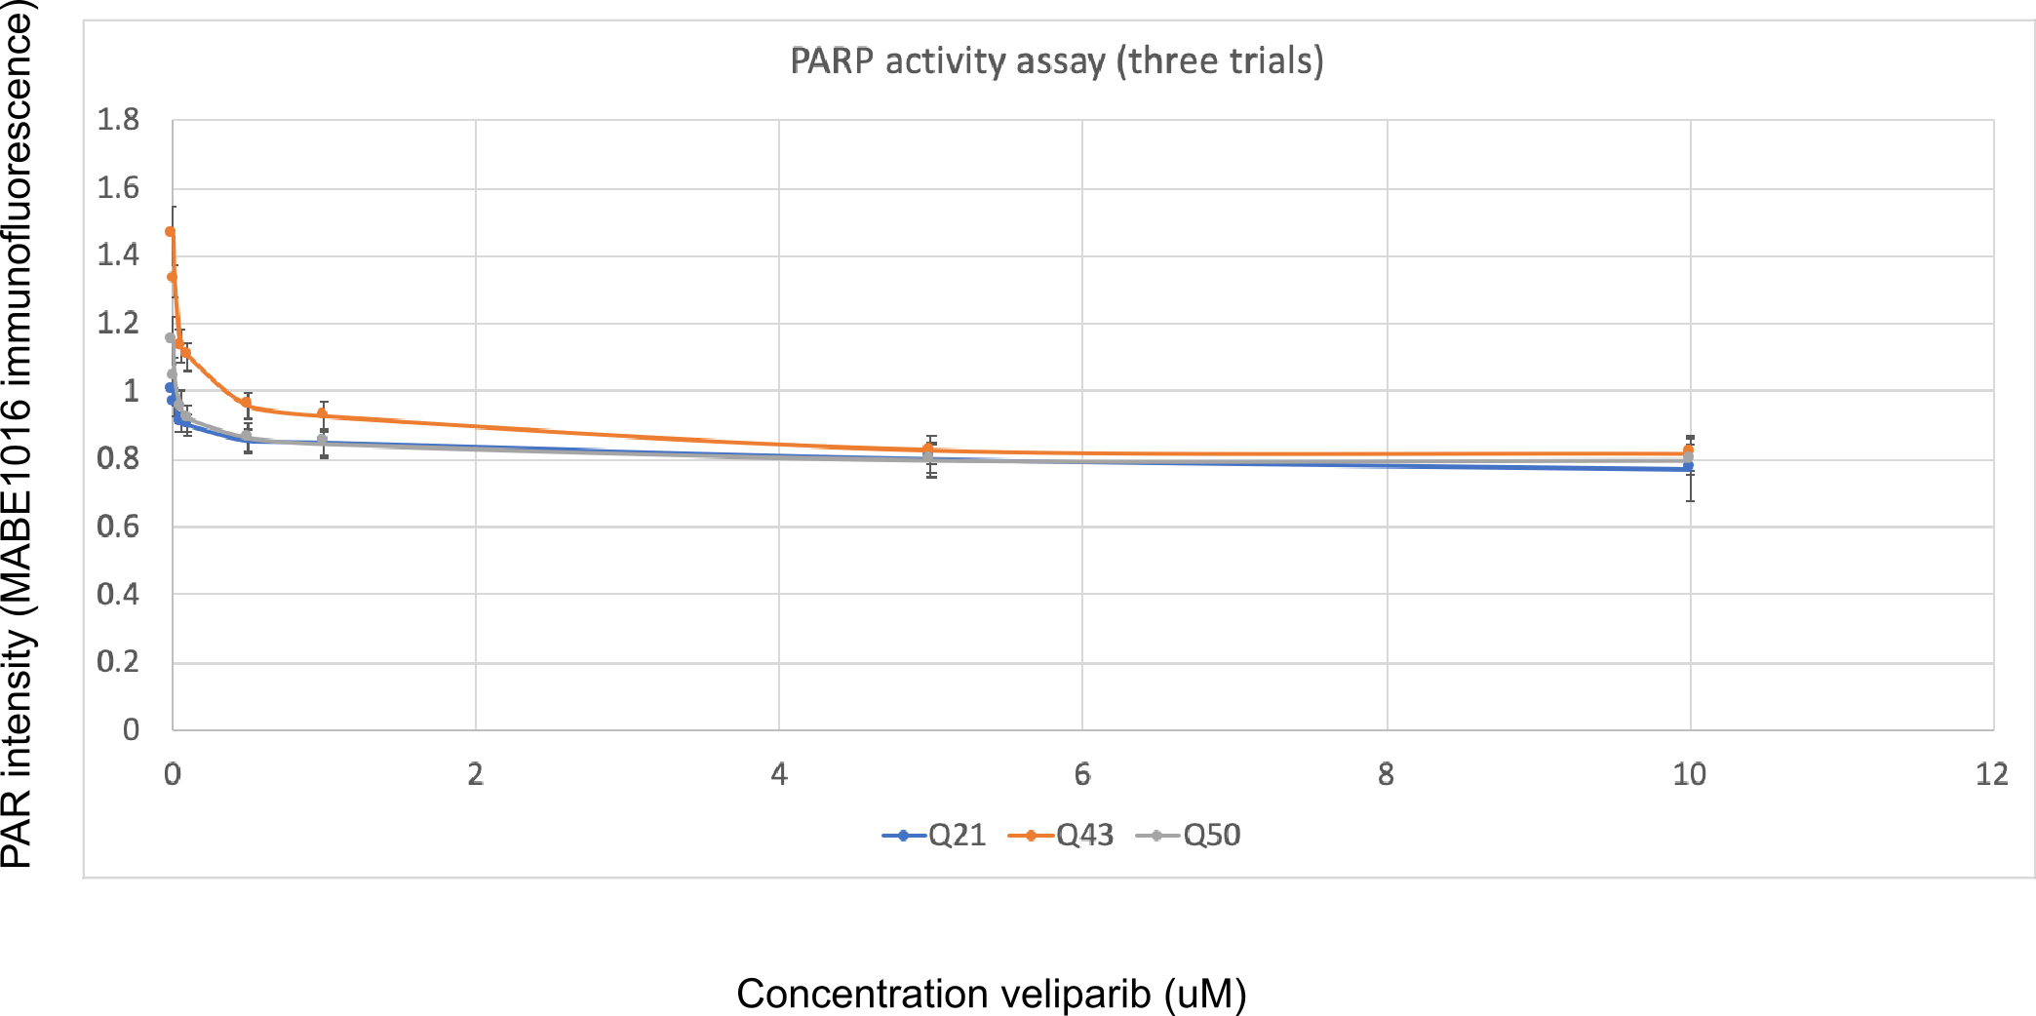
Q50s have higher PARP activity than Q21s at lower concentrations of veliparib.

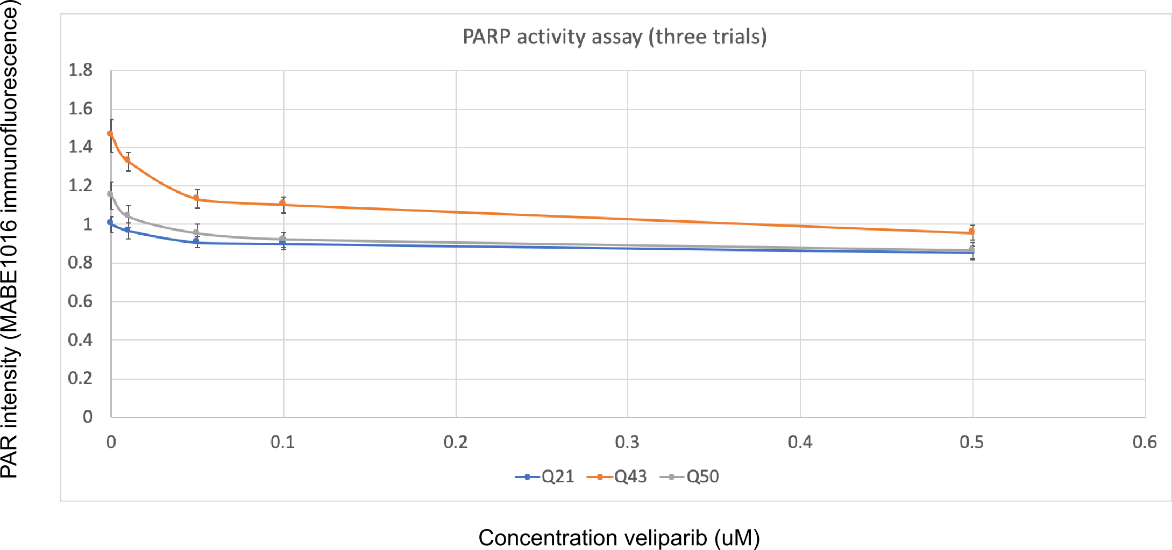

IC50 analysis on three trials
As above.

Q21 veliparib IC50 = 0.329 uM. Equation for the best fit line:
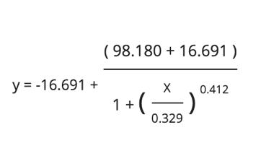
Q43 veliparib IC50 = 0.067 uM. Equation for the best fit line:
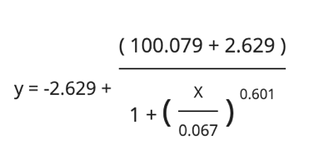
Q50 veliparib IC50 = 0.048 uM. Equation for the best fit line:
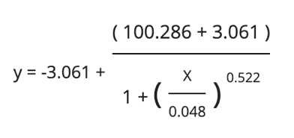

These values were calculated using the website at https://www.aatbio.com/tools/ic50-calculator, citation: "Quest Graph™ IC50 Calculator." AAT Bioquest, Inc, 25 Nov. 2019, https://www.aatbio.com/tools/ic50-calculator.

Error bars: SEM.
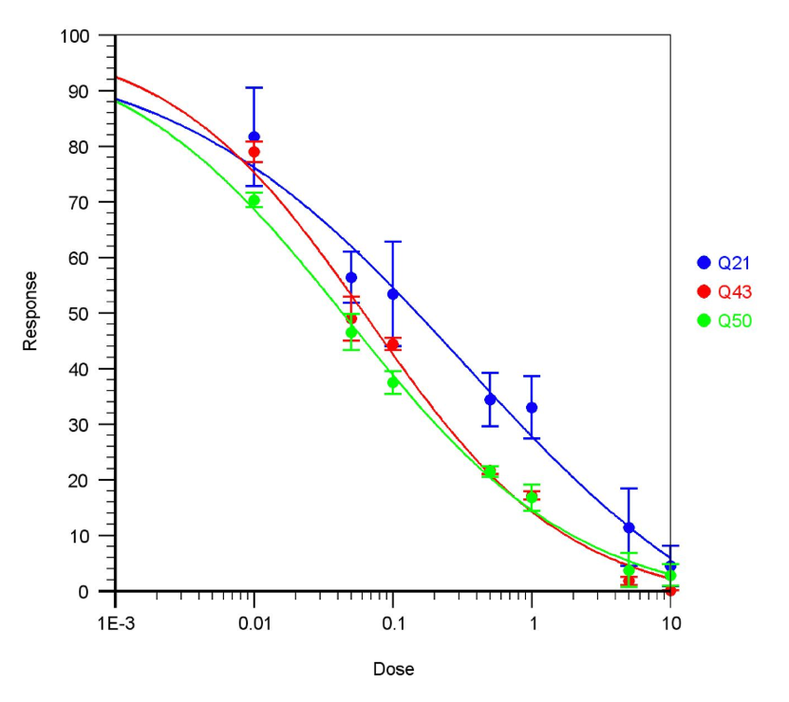

Conclusion
While HD cells have higher PAR levels than WT, it appears there is less PARP activity in HD cells, since it takes less veliparib to reduce the response. The levels of PARP in all three cell lines are very similar, if anything they are slightly higher in HD cells (see Zenodo entry: https://zenodo.org/record/3560227#.XeVjVpNKh-U). So it is not likely to be a matter of PARP expression levels.
Previous experiments suggest that huntingtin and PARP interact, and that this interaction is stronger in the presence of veliparib. Maybe mutant huntingtin interacts more strongly with PARP than wild type huntingtin does, and inhibits it activity? It must be noted that these experiments are done in the presence of PARG inhibitor (to allow detection of PAR before its degradation by PARG), which may confound interpretation of the results.

