Project: ROS-specific Huntingtin Interactions

Experiment: Comparing nuclear PAR levels in wild type and HD (TruHD) fibroblasts in response to a PARG inhibitor concentration gradient (as a measure of PARG activity).

Authors: Tamara Maiuri and Ray Truant

Date: 2019-10-31

Purpose: To determine whether PARG activity differs in HD and wild type cells.

PARG activity assay set-up
This method for measuring PARG activity was reported by James et al [1].

Seeding
Seeded TruHD [2] fibroblasts in a glass-bottom, black 96-well plate. Surface area of well in 96-well plate is 28X smaller than that of a 6-well plate, therefore used the usual amounts for a 6-well, divided by 28 and multiplied by the number of wells (need 16 wells for each cell line):
- Q21: 2 mL/10 mL from a 90% 10-cm plate would be used for each well of a 6-well plate
  - 2 mL / 28 = 71 uL per well times 20 wells: 1.4 mL cells plus 1.6 mL media, plate 150 uL per well
- Q43: 1 mL/10 mL from a 90% 10-cm plate would be used for each well of a 6-well plate
  - 1 mL / 28 = 35.7 uL per well times 20 wells: 0.7 mL cells plus 2.3 mL media, plate 150 uL per well
- Q50: 2.5 mL/10 mL from a 75% 10-cm plate would be used for each well of a 6-well plate
  - 2.5 mL / 28 = 89 uL per well times 20 wells: 1.8 mL cells plus 1.2 mL media, plate 150 uL per well

Next day, cells were 100% confluent around the edges of the well, 90-100% confluent in the centre.
Set up an 8-point dose response with 2 replicates per point: 0, 0.1, 0.5, 1, 2, 10, and 20 uM PARG inhibitor.

Treatment
Pre-treated cells with PARG inhibitor (PDD00017273 from AdipoGen Lifesciences) diluted in fresh growth media for one hour. Dilution series:
- 20 uM: 2 uL of the 10 mM stock into 1 mL GM
- 10 uM: 1 uL of the 10 mM stock into 1 mL GM
- 5 uM: 0.5 uL of the 10 mM stock into 1 mL GM
- 2 uM: 100 uL of the 20 uM solution + 900 uL GM
- 1 uM: 100 uL of the 10 uM solution + 900 uL GM
- 0.5 uM: 100 uL of the 5 uM solution + 900 uL GM
- 0.1 uM: 100 uL of the 1 uM solution + 900 uL GM
- 0 uM: 1 mL GM

Plated 100 uL per well.

Prepared a 100 uM KBrO3 solution in PBS containing calcium and magnesium and diluted PARG inhibitor in KBrO3 solution as above. Removed pre-treatment and replaced with KBrO3 containing PARG inhibitor dose series for 30 min.

Fixation and staining
- Fixed in cold methanol at -20℃ for 10 min
- Washed twice with PBS
- Blocked in 10% FBS/PBS for 15 min at room temp
- Incubated with MABE1016 (1:500 dilution in blocking buffer) for 30 min at room temp using 30 uL per well (prepared 1.75 mL blocking buffer + 2.62 uL MABE1016)
- Washed twice with PBS
- Incubated with donkey anti-rabbit-488 (1:1000 dilution in blocking buffer) for 15 min at room temp using 100 uL per well (prepared 6 mL blocking buffer + 6 uL secondary)
- Washed twice with PBS
- Incubated with 0.2 ug/mL Hoechst for 5 min
- Washed once with PBS and plated 100 uL PBS for imaging

Imaging and analysis
Imaged six fields per well using the 10X objective on the EVOS FL Auto 2 widefield microscope (1000-2000 cells per condition). Identified nuclei using Hoechst stain in CellProfiler then measured the PAR signal intensity within nuclei (mean for each field).

Results
The dose response was evident for all three cell lines, with max PARG inhibitor effect at approximately 2 uM. Q43 and Q50 cells had higher PAR levels than than Q21s, as usual. The PAR levels in Q43s was higher than Q50s, as usual.

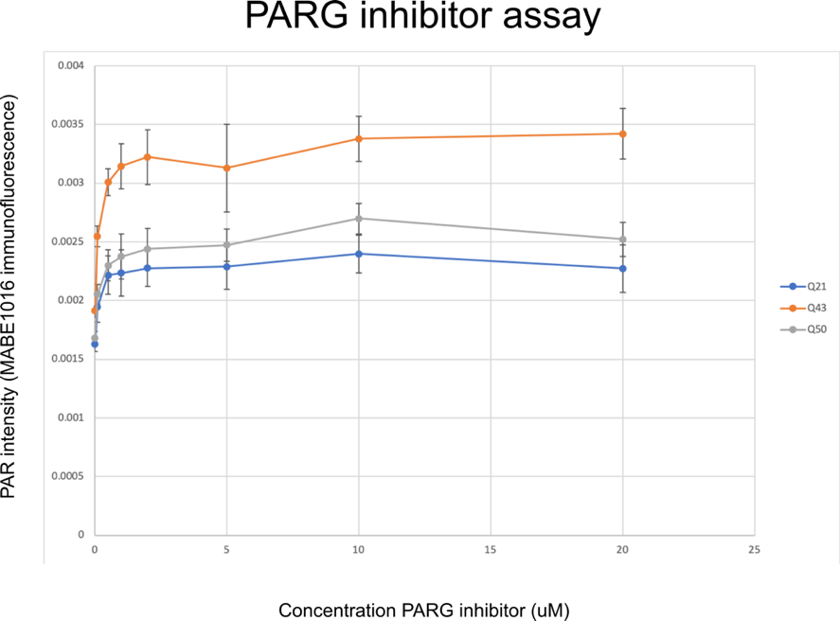

EC50 analysis
Since the readout for PARG inhibitor is an increase in signal, need to calculate the EC50 instead of the IC50. The EC50 will tell us the concentration of a drug that gives half-maximal response. Used the EC50 calculator at https://www.aatbio.com/tools/ec50-calculator. Scaled the PAR signal intensities for each cell line such that the lowest value = 0% PAR signal, and the highest value = 100% PAR signal.

Q21 PARG inhibitor EC50 = 0.116 uM
Q43 PARG inhibitor EC50 = 0.138 uM
Q50 PARG inhibitor EC50 = 0.212 uM

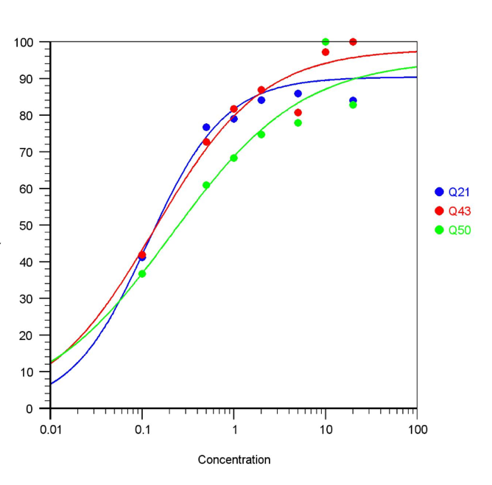

The PAR levels are higher in HD cells, which would suggest that PARG isn’t working as well in HD cells as in WT cells. However, it takes more PARG inhibitor to get to the half-maximal response in HD cells, suggesting there is more PARG activity.

Next Time
Bring the dose range down to max out at 2 uM.

PARG activity assay expt 1

Seeding
Seeded cells as above but plated 200 uL cells instead of 150 uL to avoid meniscus effects.
- Q21: 2 mL/10 mL from a 100% 10-cm plate would be used for each well of a 6-well plate
  - 2 mL / 28 = 71 uL per well times 20 wells: 1.4 mL cells plus 2.6 mL media, plate 200 uL per well
- Q43: 1 mL/10 mL from a 90% 10-cm plate would be used for each well of a 6-well plate
  - 1 mL / 28 = 35.7 uL per well times 20 wells: 0.7 mL cells plus 3.3 mL media, plate 200 uL per well
- Q50: 2 mL/10 mL from a 95% 10-cm plate would be used for each well of a 6-well plate
  - 2 mL / 28 = 71 uL per well times 20 wells: 1.4 mL cells plus 2.6 mL media, plate 200 uL per well

Next day, cells are 100% confluent around edges and 85-90% in centre.

Treatment
This time, set up an 8-point dose response with 2 replicates per point: 0, 0.01, 0.025, 0.05, 0.1, 0.5, 1, and 2 uM PARG inhibitor.

Pre-treated cells with PARG inhibitor diluted in fresh growth media for one hour. Dilution series:
- First made a 20 uM solution by adding 2 uL of the 10 mM stock to 1 mL of GM
- 2 uM: 100 uL of the 20 uM solution + 900 uL GM
- 1 uM: 50 uL of the 20 uM solution + 950 uL GM
- 0.5 uM: 25 uL of the 20 uM solution + 975 uL GM
- 0.1 uM: 100 uL of the 1 uM solution + 900 uL GM
- 0.05 uM: 100 uL of the 0.5 uM solution + 900 uL GM
- 0.025 uM: 50 uL of the 0.5 uM solution + 950 uL GM
- 0.01 uM: 100 uL of the 0.1 uM solution + 900 uL GM
- 0 uM: 1 mL GM

Plated 100 uL per well.

Prepared a 100 uM KBrO3 solution in PBS containing calcium and magnesium and diluted PARG inhibitor in KBrO3 solution as above. Removed pre-treatment and replaced with KBrO3 containing PARG inhibitor dose series for 30 min.

Fixation, staining, imaging, analysis
Exactly as in assay set-up experiment.

Results
This time, PAR levels were similar for Q50s and Q21s, while Q43s had higher levels as usual.

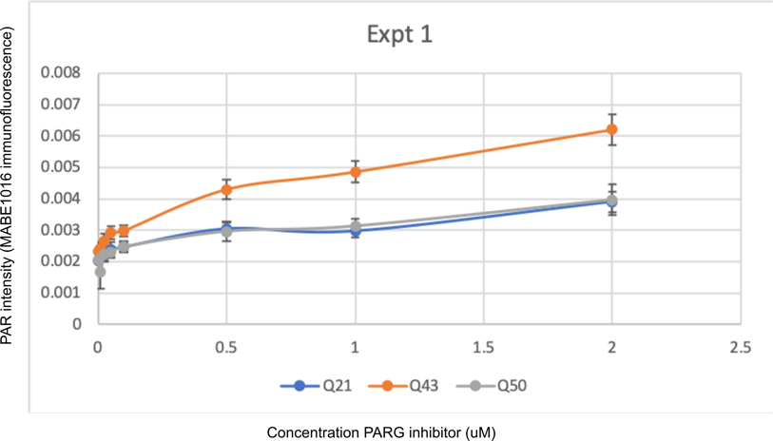

EC50 analysis
Unfortunately, with the max concentration at 2 uM, can’t see the plateau of the concentration curve. This makes it impossible to calculate the EC50:

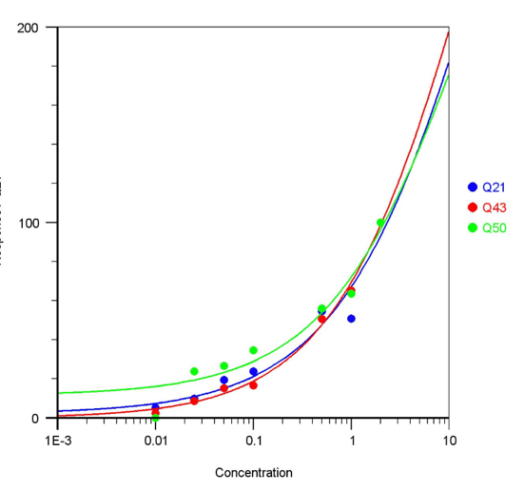
PARG activity assay expt 2

Seeding
- Q21s: 1.4 mL/10 mL from a 100% confluent 10-cm plate + 2.6 mL media; plated 200 uL per well
- Q43s: 0.7 mL/10 mL from a 90% confluent 10-cm plate + 3.3 mL media; plated 200 uL per well
- Q50s: 1.4 mL/10 mL from a 90% confluent 10-cm plate + 2.6 mL media; plated 200 uL per well

Next day, cells are 80% confluent at centre of well.

Treatment, fixation, staining, image analysis
Exactly as in experiment 1, except:
- Used 50 uL of primary antibody instead of 30 uL
- After primary, washed with PBS and stored in fridge until Monday (kids’ after school pick-up was cancelled), then finished staining

Results
Once again, Q43s had the highest levels of PAR. This time, unlike expt 1, Q50s also had higher PAR levels than Q21s. Could not calculate EC50.

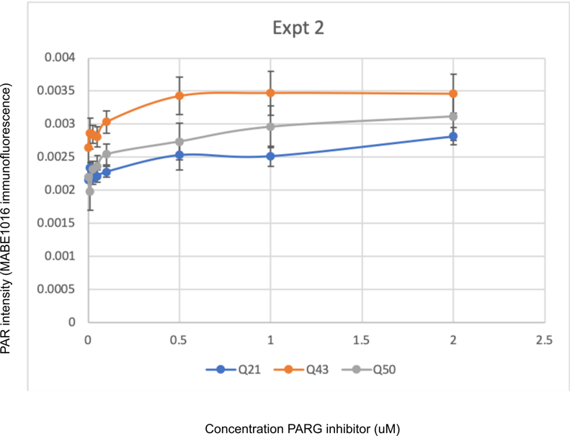

PARG activity assay expt 3
Seeding
Seeded cells to be ready in two days:
- Q21s: 0.7 mL/10 mL from a 100% confluent 10-cm plate + 3.3 mL media; plated 200 uL per well
- Q43s: 0.35 mL/10 mL from a 100% confluent 10-cm plate + 3.65 mL media; plated 200 uL per well
- Q50s: 0.7 mL/10 mL from a 100% confluent 10-cm plate + 3.3 mL media; plated 200 uL per well

After 2 days, cells are 85% confluent at centre of well.

Treatment, fixation, staining, image analysis
Exactly as in experiment 1, except:
- Used 50 uL of primary antibody instead of 30 uL
- After primary, washed with PBS and stored in fridge overnight

Results
Once again, Q43s had the highest levels of PAR. The Q50s results are somewhere between what happened in expts 1 and 2. Could not calculate EC50s.

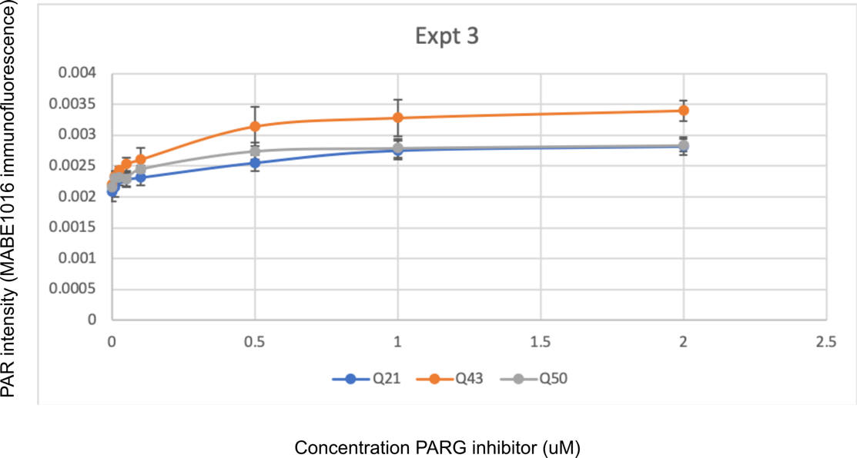

Results from three trials
Normalized the values for each experiment to the average Q21 0uM PARG inhibitor value. Q43s have higher PAR levels than Q21s. Q50s also have higher levels, but it is very close to Q21s. Error bars = SEM for three trials.

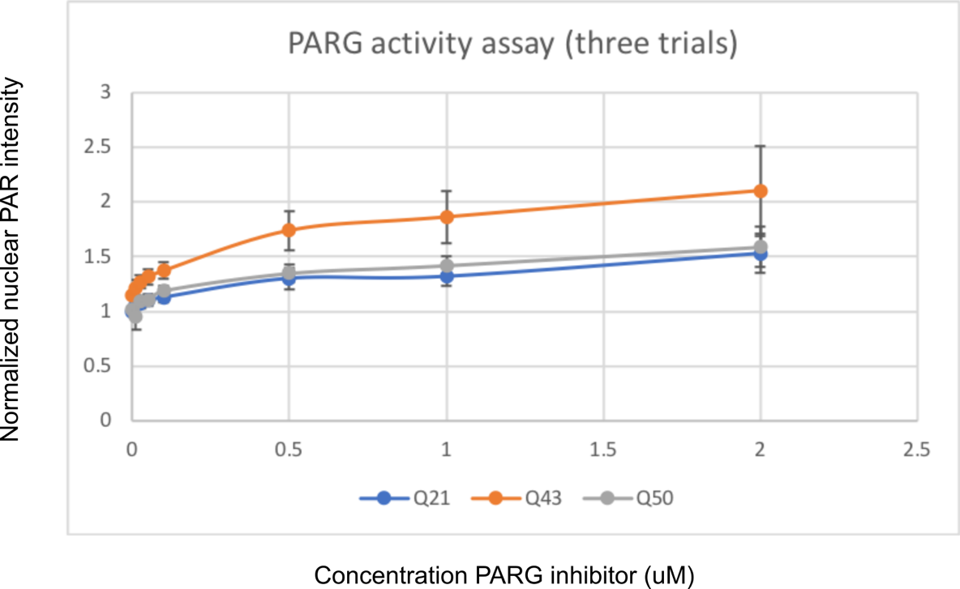

Conclusions
Unfortunately couldn’t calculate EC50s from these experiments, so they will have to be repeated with a larger range of doses.

PARP levels
Probed the plate from expt 1 with a mouse anti-PARP antibody (BD Biosciences) to see if there are any differences in total nuclear PARP between wild type and HD cells under conditions of PARG inhibition. Stained using the same protocol as for MABE1016 but with chicken anti-mouse-594 secondary.

Results
Staining was quite faint. No difference in PARP levels between the three cell lines.

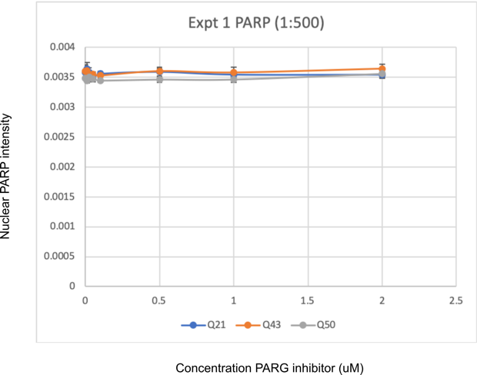

Repeated the staining on the expt 2 plate, using 1:100 dilution of anti-PARP antibody instead of 1:500.

Results
Staining was still quite faint, although a bit brighter than 1:500 condition. Still no major difference in PARP levels between the three cell lines. HD cells may have slightly higher levels, did not test for significance.

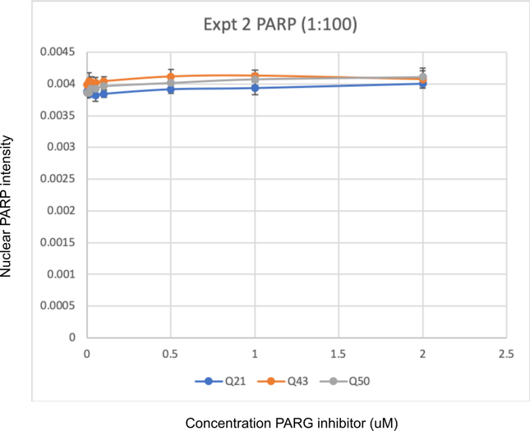

References

- James DI, Durant S, Eckersley K, Fairweather E, Griffiths LA, Hamilton N, et al. An assay to measure poly(ADP ribose) glycohydrolase (PARG) activity in cells. F1000Res. 2016;5: 736.
- Hung CL-K, Maiuri T, Bowie LE, Gotesman R, Son S, Falcone M, et al. A Patient-Derived Cellular Model for Huntington’s Disease Reveals Phenotypes at Clinically Relevant CAG Lengths. Mol Biol Cell. 2018; mbcE18090590.

