**Project:**

Biophysical investigation of purified HTT protein samples

**Experiment:**

Mass spectrometry analysis of contaminating band in HTT samples

**Date completed:­**

2019/10/31

**Rationale:**

To determine the identity of ~100 kDa band seen on SDS-PAGE in HTT preps – see <https://zenodo.org/record/3555378>

**Experimental approach:**

A contaminating band in HTT purifications was identified in previous experiments e.g. <https://zenodo.org/record/3555378>

 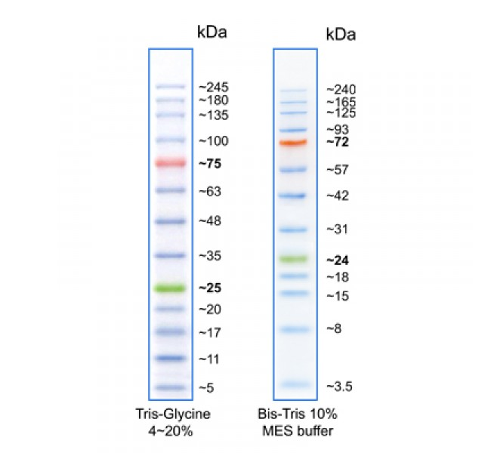

Both the excised band and solution protein sample from this purification were processed for bottom up proteomics using the procedure described in Harding et al. [doi: 10.1074/jbc.RA118.007204].

Two peptides corresponding to NVL (Nuclear Valosin-containing protein-like) were identified (<https://www.uniprot.org/uniprot/O15381>) with high confidence (and mass accuracy < 10 ppm). However, the confidence in identifying this protein is low due to the poor sequence coverage. An overview of the protein family may be found here[1],[2].

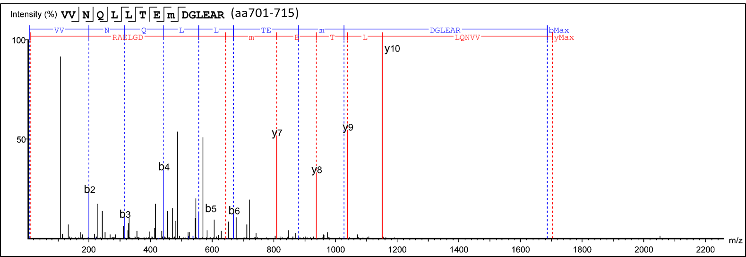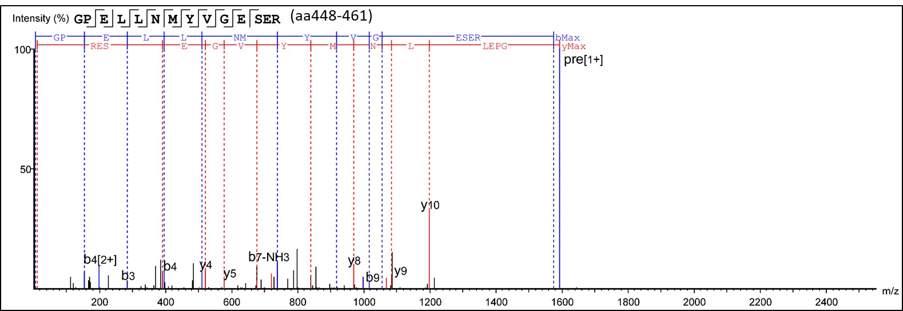

1. <http://www.jbc.org/content/early/2019/04/21/jbc.RA119.007585.full.pdf>
2. <https://jcs.biologists.org/content/joces/early/2014/08/18/jcs.093831.full.pdf>