Supporting Information
Strong habitat and weak genetic effects shape the lifetime reproductive success in a wild clownfish population
Océane C. Salles, Glenn R. Almany, Michael L. Berumen, Geoffrey P. Jones, Pablo Saenz-Agudelo, Maya Srinivasan, Simon R. Thorrold, Benoit Pujol*, and Serge Planes*

*Both authors share senior authorship of this article
Correspondence: Océane Salles and Benoit Pujol; Emails: oceane.salles@gmail.com and benoit.pujol@univ-perp.fr

This file contains:
- Table S1. Previous estimates of fitness heritability and maternal effects on fitness in 15 wild populations.
- Figure S1. Pedigree data and power analysis for the Kimbe Island orange clownfish population.
- Supplementary methods, results and discussion on De-lifing measures.

Table S1. Previous estimates of fitness heritability and maternal effects on fitness in wild populations. Different fitness measures are denoted as lifetime reproductive success (LRS), De-lifing or relative RS (LRS/mean of LRS in the population). ♀ corresponds to female, ♂ corresponds to male and ⚥ corresponds to female and male confounded. NA indicates that maternal effects were not estimated or dropped from the quantitative genetic models.
Study organism | Location | Years  of monitoring | Heritability estimate  ± SE or 95%SI | Maternal effects estimate | Fitness measure | Reference
Collared flycatcher | Gotland Is. | 1980 to 1984 | ♀ 0.01 ± 0.16  ♂ 0.01 ± 0.13 | NA  NA | LRS | (Gustafsson 1986)
Red deer | Isle of Rum | 1971 to 1999 | ♀ 0.00 ± 0.05 | 0.16 ± 0.041 | LRS | (Kruuk et al. 2000)
 |  |  | ♂ 0.02 ± 0.06 | NA
 |  | 1971 to 2005 | ♀ 0.21 ± 0.06  ♂ 0.07 ± 0.06 | 0.0021  0.0045 | De-lifing | (Foerster et al. 2007)
Collared flycatcher | Gotland Is. | 1980 to 1997 | ♀ 0.21 ± 0.06 | NA | LRS | (Merila & Sheldon 2000)
 |  |  | ♂ 0.07 ± 0.06 | NA
Bighorn sheep | Ram Mountain  Sheep River | 1973 to 1998  1981 to 1998 | ♀ 0.66 ± 0.32  ♀ 0.19 ± (0.50) | NA  NA | LRS  LRS | (Réale & Festa-Bianchet 2000)
Cheetahs | Serengeti park | 1970 to 1994 | ♀ 0.88 ± ? | NA | LRS | (Kelly 2001)
Great tit | Wytham Wood | 1960 to 1998 | ♀ 0.00 ± 0.04  ♂ 0.02 ± 0.04 | NA  NA | LRS | (McCleery et al. 2004)
Bighorn sheep | Ram Mountain | 1971 to 2003 | ♀ 0.00 ± 0.00  ♂ 0.00 ± 0.00 | NA  NA | LRS | (Coltman et al. 2005)
Red billed gulls | Kaikoura | 1958 to 2004 | ♀ 0.36 ± 0.29  ♂ 0.00 ± 0.00 | NA  NA | LRS | (Teplitsky et al. 2009)
Rhesus macaques | Cayo Is. | 1959 to 1990 | ♀ 0.36 ± 0.081 | NA | LRS | (Blomquist 2010)
House sparrow | Lundy Is. | 2000 to 2011 | ⚥ 0.09 (0.03 to 0.18) | 0.33 (0.14 to 0.51) | De-lifing | (Schroeder et al. 2012)
Soay sheep | St Kilda | 1985 to 2002 | ⚥ 0.03 ± 0.01 | NA | Relative RS | (Morrissey et al. 2012)
Red squirrels | Yukon | 1987 to 2011 | ⚥ 4.90x10⁻⁰⁴ (3.0x10⁻⁰⁸ to 0.07)  ♀ 6.80 x10⁻⁰⁴ (8.5x10⁻¹¹ to 0.10)  ♂ 4.90 x10⁻⁰⁴ (1.1x10⁻⁰³ to 0.39) | 0.07 (0.02 to 0.14)  0.08 (0.01 to 0.14)  0.10 (0.10 to 0.37) | LRS | (McFarlane et al. 2014)
Savannah sparrow | Kent Is. | 1987 to 2005 | ♀ 0.002 ± 0.036  ♂ 0.000 ± 0.036 | NA  NA | LRS  LRS | (Wheelwright et al. 2014)
Brown anole lizard | Kidd Cay | 2005 to 2008 | ⚥ 1.40 (8.0x10⁻¹⁰ to 0.023) | NA | RS | (Calsbeek et al. 2015)
Song sparrow | Mandarte Island | 1993-2015 | ♀ 0.5 ± 0.21  ♂ 0.44 ± 0.74 | NA  NA | LRS | (Wolak et al. 2018)

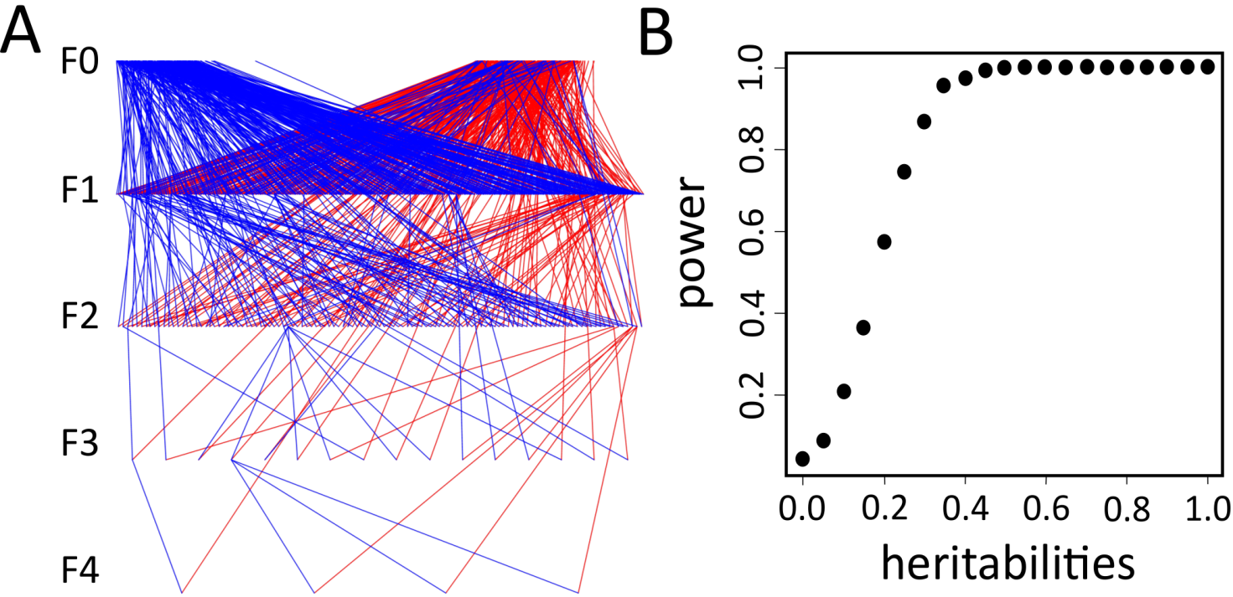
Figure S1. Pedigree data of the Kimbe Island orange clownfish population. (A) Pedigree representation of the orange clownfish Amphiprion percula in Kimbe Island (n= 1735, excluding new-recruits). Each line connects a parent with one of its offspring (blue and red lines represent respectively paternal and maternal links). It is important to note that an individual can be father then mother. The generation is indicated on the left from first generation (F0, n=502) to fifth generation (F4). (B) Power analysis of the pedigree.
SUPPLEMENTARY METHODS
Individual's contribution to biennial population growth rate
We estimated the De-lifing (DL), which is the individual's contribution to the biennial population growth rate. DL was calculated following Coulson et al. (2006). This index can be considered as the realized fitness of an individual over the given period of time (here two years) by including survival and success to local recruitment. This index offers great opportunities to empirically study ecological and evolutionary changes in stochastic environments (Dupont et al. 2017).
According to Coulson et al. (2006), an individual's biennial fitness is measured by its contribution ${DL}_{ti}$ to the growth rate of the population between $t$ and $t+1$.
${DL}_{ti}=\frac{s_{ti}-{\overline{s}}_{t} }{N_{t}-1 }$ + $\frac{F_{ti}-{\overline{F}}_{t} }{N_{t}-1 }$ (1)
where $N_{t}$is the population size at time$t$; $s_{ti}$is the survival of individual $i$ between $t$ and $t+1$ (1 if it survived and 0 otherwise);${\overline{S}}_{t}$is the mean survival rate in the population between $t$ and $t+1$; $F_{ti}$ is the fecundity of the individual $i$ defined as the number of offspring born between $t$ and $t+1$ and still alive at $t+1$ and ${\overline{F}}_{t}$is the mean individual fecundity in the population. A negative value of DL represents an individual that performed worse than the population mean while a positive value represents one that performed better. (Coulson et al. 2006)
Quantitative genetic generalized linear model approach
As for the IIRS variance, the DL variance was partitioned into six random effects: Additive genetic (V_{A}), Maternal (V_{M}), Natal Habitat (V_{NH}), Resident Habitat (V_{RH}), Permanent Environment (V_{PE}) and Residual (V_{R}) variances by using the ‘animal model’ quantitative genetic approach (Kruuk 2004).
The DL variance is the sum of six variance components:
V_{DL} = $V_{A_{DL}}$+ $V_{M_{DL}}$+ $V_{{NH}_{DL}}$+ $V_{{RH}_{DL}}$+ $V_{{PE}_{DL}}$ + $V_{R_{DL}}$ (2)
We used a quantitative genetics model as univariate GLMMs using the 'MCMCglmm' package (Hadfield 2010) in R version 3.5.1 (R Core Team 2018), with DL as a Gaussian response variable. We used parameter expanded priors for all analyses (V=1, nu=0.02), which are often referred to as ‘non informative’ priors although such denomination can be debated, as we wanted posterior estimates to be determined from the data and not from the priors (Morrissey et al. 2014). We ran model MCMC chains over 1,000,000 iterations with initial burning of 10,000 iterations and a thinning of 1,000 iterations.
Variance components were estimated as the mean of the posterior distributions (the mean of the MCMC sample). and we reported the lower and the upper limits of the 95% credible interval. For the six variance components, we calculated their relative contribution to the sum of all variance components, thereby expressing their effects as percentages of the total phenotypic variance (V_{DL}). As a result, we obtained standard heritability estimates for DL (h²_{DL}) by applying the basic formula (h² = $V_{A}$ / $V_{P}$, see Falconer & McKay 1996), and similarly maternal effects by estimating the proportion of total phenotypic variance explained by the maternal variance (m² = $V_{M}$ / $V_{P}$). Because DL is Gaussian variable, we reported a standard heritability and a standard maternal effects. We calculated the 95% credibility intervals from the posterior distributions of observed parameters for all the variance components and other estimates expressed on their basis by using the ‘HDInterval’ package (Meredith & Kruschke 2016).
SUPPLEMENTARY RESULTS
Habitats dominantly shape the De-lifing in the clownfish population.
De-lifing (DL) varied from -2.56 ×10⁻³ to 1.81 ×10⁻² (Figure S2, histogram), which illustrates that there is variation in the individual contribution to the population demographic growth through reproduction and survival. Its average value at the population level was 2.16×10⁻⁵ ± 8.04×10⁻⁵ units. When considering DL, 43.1% of its variance was explained by Natal Habitat (Figure S2, pie chart) and 55.3% by Resident Habitat, again with minor contributions from Additive genetic effects (0.3%) and Maternal effects (1.0%).
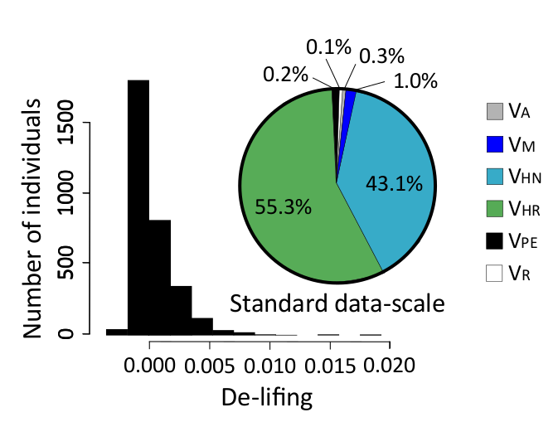
Figure S2. Sources of variation in De-lifing (DL) variance of the the Kimbe Island orange clownfish. Distribution (histograms) and variance components on standard data-scale (pie chart) for biennial DL explained by Additive genetic (V_{A}), Maternal (V_{M}), Natal Habitat (V_{NH}), Resident Habitat (V_{RH}), Permanent Environment (V_{PE}) and Residual (V_{R}) variances. These proportions were calculated from the values of the posterior mode of a quantitative genetics generalized linear mixed model analysis.
We found that Additive genetic variance was extremely low: V_{A,DL}=3.151 × 10⁻⁵ (CI_{95%} 2.897×10⁻⁵ to 3.470×10⁻⁵, Table S2). Consequently, heritability estimates expressed on the standard data-scale was h²_{DL} =0.003 (CI_{95%} 2.432 × 10⁻³ to 0.0261, Table S2) for DL. We also found that maternal was extremely small, to the extent that it might be considered as null: V_{M,DL}=1.190×10⁻⁴ (CI_{95%} 9.974×10⁻⁵ to 1.434×10⁻⁴, Table S2). While our analysis detected maternal variance, it made very little contribution to the total variance in DL estimate (m²_{DL}=1.0%, Figure S2). The relative contribution of individuals to the population replenishment was indeed influenced by the Natal Habitat to an extent of 43.1% for DL.
Table S2. Sources of variation in De-lifing (DL) for the Kimbe Island orange clownfish. Here we reported variance component estimates quantified by using the animal model approach: Additive genetic effect (V_{A}), Maternal effect (V_{M}), Natal Habitat (V_{NH}) and Resident Habitat (V_{RH}) effects, Permanent Environmental (V_{PE}) effect and Residual Variance (V_{R}) and heritability (h²) and maternal effects (m²) for biennial DL. 95% credible intervals (CI) are reported for each estimate.
Components | DL  Standard scale
V_{A}  (CI) | 3.151×10⁻⁵  (2.897×10⁻⁵ to 3.470×10⁻⁵)
V_{M}  (CI) | 1.190×10⁻⁴  (9.974×10⁻⁵ to 1.434×10⁻⁴)
V_{NH}  (CI) | 5.022×10⁻³  (9.972×10⁻⁴ to 0.012)
V_{RH}  (CI) | 6.443×10⁻³  (1.13×10-3 to 0.017)
V_{PE}  (CI) | 3.016×10⁻⁵  (2.72× 10⁻⁵ to 3.25×10⁻⁵)
V_{R}  (CI) | 2.978×10⁻⁵  (1.15×10⁻⁵ to 1.29×10⁻⁵)
h²  (CI) | 0.003  (6.506×10⁻⁴ to 6.712×10⁻³)
m²  (CI) | 0.010  (2.432×10⁻³ to 0.0261)

SUPPLEMENTARY DISCUSSION
Because of the different proprieties of the two measures of individual reproductive success (i.e., IIRS, which is the Intra-population Individual Reproductive Success, and DL), the results obtained on the DL highlights that the residual variance of SLR can be implicitly explained by annual environmental variation. The model decomposing the variance in DL measured a larger effect of the habitat, which is likely due to the fact that DL has different statistical properties. DL accounts for reproductive success, survival and population size. DL is expected to smooth out changes in demographic population growth and to account for the individuals that did not produce offspring but contributed to the population stability or growth by their own survival. Recruitment and population size vary through time in this population (Salles et al. 2015), which might explain why more variance in DL was explained by the model. This difference in outcomes among these two estimators of the individual contribution to the local replenishment of the population supports the hypothesis that a part of the self-recruitment variation explained by the habitat is confounded with temporal heterogeneity in population growth and survival.
SUPPLEMENTARY REFERENCES
Blomquist, G.E. (2010). Heritability of individual fitness in female macaques. Evol Ecol, 24, 657-669.
Calsbeek, R., Duryea, M.C., Goedert, D., Bergeron, P. & Cox, R.M. (2015). Intralocus sexual conflict, adaptive sex allocation, and the heritability of fitness. Journal Evolution. Biol., 28, 1975-1985.
Coltman, D.W., O'Donoghue, P., Hogg, J.T. & Festa-Bianchet, M. (2005). Selection and genetic (CO)variance in bighorn sheep. Evolution, 59, 1372-1382.
Coulson, T., Benton, T.G., Lundberg, P., Dall, S.R.X., Kendall, B.E. & Gaillard, J.M. (2006). Estimating individual contributions to population growth: evolutionary fitness in ecological time. Proc R Soc B, 273, 547-555.
Dupont, P., Cohas, A., Allainé, D. & Pradel, R. (2017). Testing determinants of the annual individual fitness: An overall mean mixture model for de-lifing data. MEE, doi: 10.1111/2041-210X.12908.
Falconer, D.S. & Mackay, T.F.C. (1996). Introduction to Quantitative Genetics. Longman, New York.
Foerster, K., Coulson, T., Sheldon, B.C., Pemberton, J.M., Clutton-Brock, T.H. & Kruuk, L.E.B. (2007). Sexually antagonistic genetic variation for fitness in red deer. Nature, 447, 1107-U1109.
Gustafsson, L. (1986). Lifetime reproductive success and heritability - empirical support for fisher fundamental theorem. Amer. Nat., 128, 761-764.
Hadfield, J.D. (2010). MCMC methods for multi-response generalized linear mixed models: The MCMCglmm R Package. J. Stat. Softw., 33, 1-22.
Kelly, M.J. (2001). Lineage loss in Serengeti cheetahs: Consequences of high reproductive variance and heritability of fitness on effective population size. Cons Biol, 15, 137-147.
Kruuk, L.E.B. (2004). Estimating genetic parameters in natural populations using the 'animal model'. Philos Trans R Soc Lond B Biol Sci, 359, 873-890.
Kruuk, L.E.B., Clutton-Brock, T.H., Slate, J., Pemberton, J.M., Brotherstone, S. & Guinness, F.E. (2000). Heritability of fitness in a wild mammal population. Proc. Natl. Acad. Sci. USA, 97, 698-703.
McCleery, R.H., Pettifor, R.A., Armbruster, P., Meyer, K., Sheldon, B.C. & Perrins, C.M. (2004). Components of variance underlying fitness in a natural population of the great tit Parus major. Amer. Nat., 164, E62-E72.
McFarlane, S.E., Gorrell, J.C., Coltman, D.W., Humphries, M.M., Boutin, S. & McAdam, A.G. (2014). Very low levels of direct additive genetic variance in fitness and fitness components in a red squirrel population. Ecol. and Evol., 4, 1729-1738.
Meredith, M., & J. Kruschke (2016) HDInterval: highest (posterior) density intervals. R package version 0.1.3. https://CRAN.R-project.org/package=HDInterval. Accessed 3 Mar 2017.
Merila, J. & Sheldon, B.C. (2000). Lifetime reproductive success and heritability in nature. Amer Nat, 155, 301-310.
Morrissey, M.B., de Villemereuil, P., Doligez, B. & Gimenez, O. (2014). Bayesian approaches to the
Morrissey, M.B., Parker, D.J., Korsten, P., Pemberton, J.M., Kruuk, L.E.B. & Wilson, A.J. (2012). The prediction of adaptive evolution: Empirical application of the secondary theorem of selection and comparison to the breeder's equation. Evolution, 66, 2399-2410.
R.Core.Team (2018). R: A language and environment for statistical computing. R Foundation for Statistical Computing, Vienna, Austria. ISBN 3-900051-07-0, URL http://www.R-project.org/.
Réale, D. & Festa-Bianchet, M. (2000). Quantitative genetics of life-history traits in a long-lived wild mammal. Heredity, 85, 593-603.
Schroeder, J., Burke, T., Mannarelli, M.E., Dawson, D.A. & Nakagawa, S. (2012). Maternal effects and heritability of annual productivity. J. Evol. Biol., 25, 149-156.
Teplitsky, C., Mills, J.A., Yarrall, J.W. & Merila, J. (2009). Heritability of fitness components in a wild bird population. Evolution, 63, 716-726.
Wheelwright, N.T., Keller, L.F. & Postma, E. (2014). The effect of trait type an strength of selection on heritability and evolvability in an island bird population. Evolution, 68, 3325-3336.
Wolak, M.E., Arcese, P., Keller, L.F., Nietlisbach, P. & Reid, J.M. (2018). Sex‐specific additive genetic variances and correlations for fitness in a song sparrow (Melospiza melodia) population subject to natural immigration and inbreeding. Evolution doi.org/10.1111/evo.13575.

