Project: ROS-specific Huntingtin Interactions

Experiment: Chromatin retention assay with huntingtin fragments containing putative PAR binding motif PBM3.

Authors: Tamara Maiuri and Ray Truant

Date: 2019-09-13

Purpose: To test whether huntingtin fragments that contain the potential PAR binding motif PBM3 are retained on chromatin in response to oxidative stress.

2019-09-10

Seeded 6-well plate with coverslips: 1 mL/10 mL from a 95% confluent 10-cm plate of RPE1s (p9) per well.

2019-09-11

Next day, cells are 95% confluent. Replaced with fresh media before transfection.

Transfection
- Mixed 200 uL serum-free media with 2 ug H2B-mCherry and 2 ug of either YFP-1-586, YFP-1208-1810, or YFP-1775-2413
- Added 8 uL Turbofect to each and vortexed, incubated 15 min
- Plated 100 uL per well
- Replaced media after several hours

2019-09-12

Cells look very healthy with good transfection efficiency of H2B-mCherry. 1-586 fragment has excellent expression while 1208-1810 and 1775-2413 are much fainter.

Treatment
Treated with HBSS or HBSS + 100 mM KBrO3 for 30 min.

Extraction and fixation
- Extracted soluble proteins with ice-cold 0.2% triton X-100 in PBS for 2 min on ice before fixation with PFA (15 min at room temp), washed 2X PBS
- Incubated with 0.2 ug/mL Hoechst for 5 min at room temp
- Mounted in Prolong anti-fade

Imaging and analysis
- Imaged on the Nikon A1 confocal using the 20X objective
- Used Hoechst images to define nuclei in CellProfiler, then measured mean image intensity for YFP and for H2B-mCherry
- Divided YFP values by the H2B-mCherry values to account for transfection efficiency
- Normalized to average untreated control for each huntingtin fragment

Results

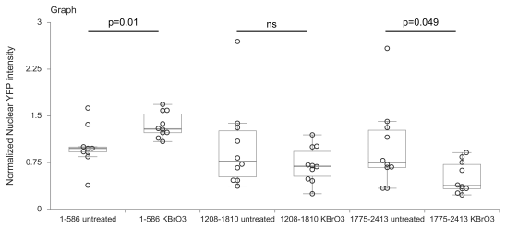

- KBrO3 treatment worked since 1-586 responded by sticking to chromatin
- The other fragments actually had decreased chromatin retention in response to KBrO3 (did not reach significance for 1208-1810)

Conclusion
The huntingtin 1208-1810 and 1775-2413 fragments may actually bind chromatin under untreated conditions and release upon KBrO3 treatment. This is difficult to interpret since endogenous full length huntingtin tends to chromatin retention upon oxidative stress. If the potential PAR binding motif PBM3 plays any role in this behaviour, it will be revealed upon its mutation.

To Do
- Repeat to confirm
- Make PBM3 mutants in these fragments and test in the chromatin retention assay

