Project: ROS-specific Huntingtin Interactions

Experiment: Chromatin retention assay set-up

Purpose: To test control conditions for the huntingtin chromatin retention assay and establish quantification method.

Date: 2018-04-17

Control conditions

2018-04-14

Seeded an 8-well Ibidi slide with RPE1 (p11) cells: 1 mL/10 mL from a 100% confluent 10-cm + 4 mL media; plated 300 uL per well.

2018-04-15

Next day, cells were ~60% confluent, less than is optimal to avoid transfection related stress. Replaced media 2 hours before transfection, then replaced with fresh media one hour after transfection to reduce chance of stressing cells.

Transfection
- 200 uL serum-free media + 2 ug YFP + 2 ug H2B-mCherry + 8 uL Turbofect
- 200 uL serum-free media + 2 ug nucHCB2 + 2 ug H2B-mCherry + 8 uL Turbofect

Incubated transfection mixtures 15 min. Added 2.3 mL media to each, plated 300 uL per well.

2018-04-16

Cells have good expression of constructs. They are 100% confluent and look very healthy--extra media changes seem to have helped.

Treatment
Treated with HBSS or HBSS containing 100 mM KBrO3 for 30 min, washed with PBS or PBS + 0.2% Triton X-100 for 2 min on ice, washed with cold PBS, then fixed in 4% PFA for 15 min at room temperature.

Results
Slides were imaged with the Nikon A1+ confocal microscope/NIS Elements software. As expected, YFP alone was not retained at chromatin upon detergent wash either with or without KBrO3 treatment. Nor did KBrO3 treatment have a visible effect on YFP localization in PBS-washed cells. NucHCB2 was washed away in untreated cells but retained at chromatin in KBrO3-treated cells.
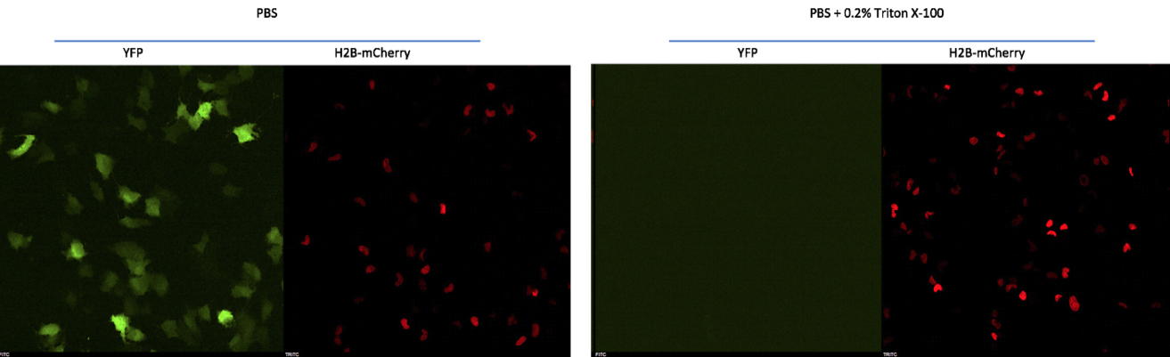

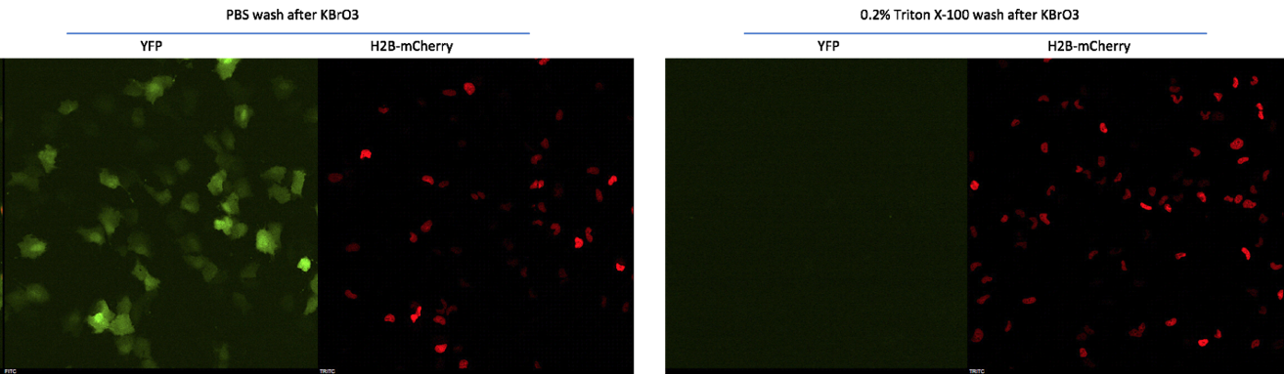

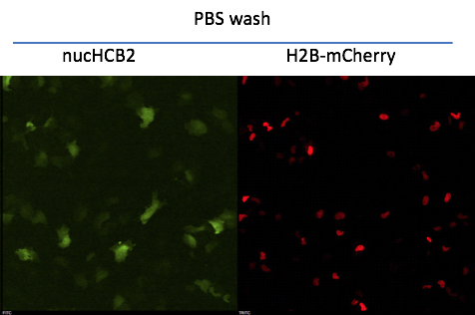

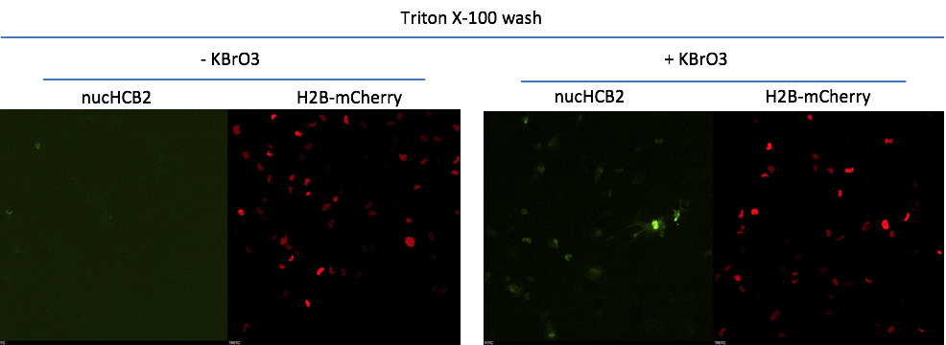

Quantification
H2B-mCherry was used as a control for transfection efficiency and to delineate nuclei. Ten fields of view were captured for nucHCB2 -/+ KBrO3 conditions with Triton X-100 wash. Images were analyzed by CellProfiler as follows:

- Used the H2B-mCherry image to identify nuclei as a primary object
- Measured the mean green intensity within nuclei from the nucHCB2 image
- Measured the mean red intensity within nuclei from the H2B-mCherry image
- For each image, calculated: mean nucHCB2 nuclear intensity / mean H2B-mCherry nuclear intensity

Example CellProfiler Analysis
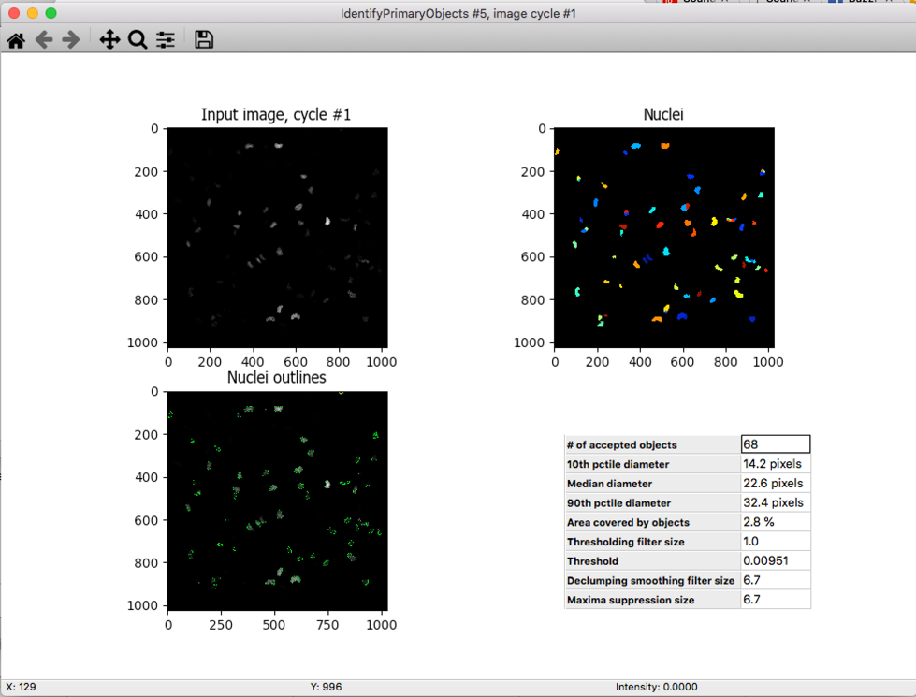

Results
Data points were graphed using Interactive Dotplot (http://statistika.mfub.bg.ac.rs/interactive-dotplot/)

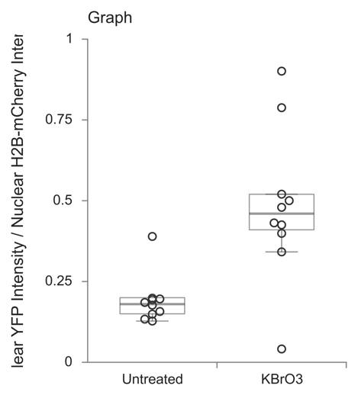

Conclusion
These conditions can be used for further analysis of huntingtin chromatin retention in response to ROS stress.

