TNIK (TRAF2 and NCK Interacting Kinase) purification for coarse screening with M4K2009
Aim: to purify TNIK (residues I24-E295) for crystallisation in complex with M4K2009.
The purification protocol is basically the same as that for ACVR1.

Expression: I was given 10 ml of overnight culture of Mach1 cells containing this construct by Alejandra Fernandez-Cid in the biotech team. Did a mini-prep and transformed BL21(DE3)-R3-pRARE2 (Rosetta) cells with the DNA. Picked colonies the next day for overnight starter cultures and then inoculated 6 L of TB containing chloramphenicol and kanamycin with the starters the next day (10 ml/L). Cells were grown at 37 °C for about 3.5 hours (internal seminar happened while they were growing), by which time they had overshot and gone to OD₆₀₀ = 1. Nevertheless, I induced with 0.4 mM IPTG and left to grow overnight at 18 °C. The cells were harvested at 7000 g the next morning and stored at -20 °C.

Buffers (all filtered 0.2 µm):
Nickel buffers
Binding buffer: 50 mM HEPES, pH 7.5, 500 mM NaCl, 5 % glycerol, 5 mM imidazole, 1 mM TCEP
Wash buffer: 50 mM HEPES, pH 7.5, 500 mM NaCl, 5 % glycerol, 30 mM imidazole, 1 mM TCEP
Elution buffer 1: 50 mM HEPES, pH 7.5, 500 mM NaCl, 5 % glycerol, 50 mM imidazole, 1 mM TCEP
Elution buffer 4: 50 mM HEPES, pH 7.5, 500 mM NaCl, 5 % glycerol, 250 mM imidazole, 1 mM TCEP
Gel filtration buffer
50 mM HEPES, pH 7.5, 300 mM NaCl, 1 mM TCEP

Ni purification
Standard Nickel column: thawed 2 L pellet on the bench in cool water topped up to 40 ml with binding buffer. Added 40 ul SET III protease inhibitors. Sonicated 5 s on 10 s off for 3 min x 2. Added 1 ml PEI and spun at 50 000 g for 1 hour.
Filtered the supernatant 1.2 um, then applied to 3 ml nickel resin in batch (equilibrated in binding buffer) and rotated in cold room for an hour.
Poured back on column and washed with about 50-60 ml wash buffer. Eluted with 10 ml Elution buffer 1 and 4 x 10 ml elution buffer 4. Kept fraction 2, concentrated through 10 K MWCO to 5 ml and loaded on 16/60 Superdex 200 gel filtration column. TEV cleavage was unnecessary as the tag is not cleavable.

Nickel gel
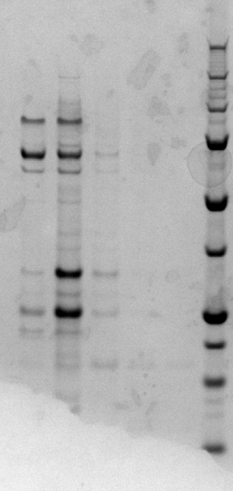
250 kDa
150
100
75

50

37

25
20

15

10
TNIK (~32 kDa)

Superdex S200 gel filtration profile

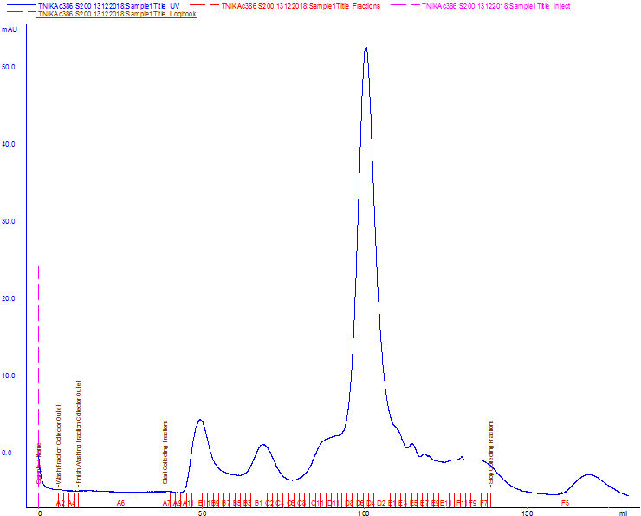

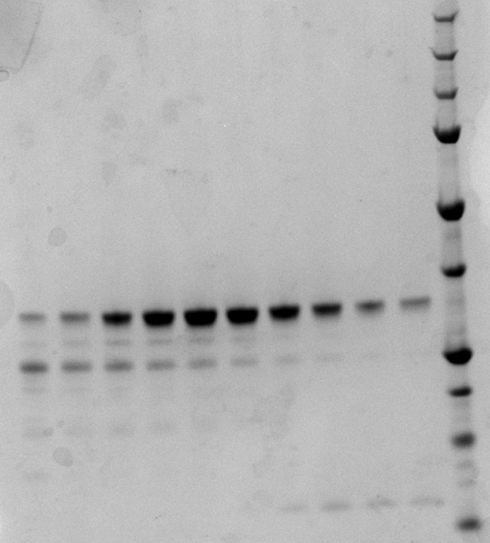
Gel filtration gel
250 kDa
150
100
75

50

37

25
20
15

10
TNIK (~32 kDa)
Pooled

Pooled the fractions shown and concentrated through 10 000 MWCO membrane to 11.7 mg/ml). Added 1 mM M4K2009 and left to incubate on ice while I prepared the plates. Spin-filtered the solution, then set up two plates (that’s all I had enough for), with 150 nl drops, in what I thought was my composite screen, but it turned out later after I saw my mass spec results that actually I’d mixed up the ACVR1 and TNIK tubes, so in fact this sample went into a fine screen intended for ACVR1, with ACVR1 seeds. Unremarkably, there are no hits for this, but I did get some hits for ACVR1 with M4K3003 from the other plates! So it wasn’t all bad in the end.

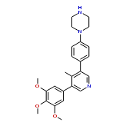

M4K2009

