Collaborative Communication: Updates on cryo-electron microscopy experiments conducted by Prof. Susan Lea

Susan collected another 72hrs worth of data of the optimized huntingtin full-length Q23 grids. This was completed on the Talos Arctica using the Falcon III in electron counting mode.

The 2D is a little better than the non-electron counting mode, but still not equivalent to data collected on a K2 detector.

The next step is to calculated a 3D envelope of the huntingtin particle, with the current data quality, it is not anticipated that secondary structure features will be resolved.

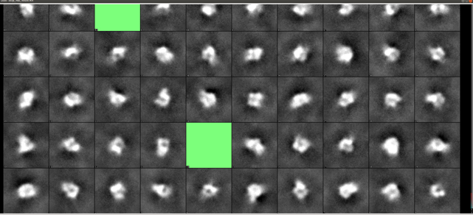
Examples of 2D averages calculated from data collection.

