**Expression and purification of huntingtin domain constructs spanning aa. P80-G428 – 2016/12/15**

**Aim:** to purify mg quantities of soluble huntingtin domain constructs

**Rationale:** purifying large amounts of protein would allow next phase experiments characterizing the protein samples to be completed i.e. crystallization experiments for X-ray crystallography, antibody production, biophysical analysis etc.

**Expression system:** all proteins were expressed in a baculovirus expression system (BVES) as detailed in previous uploads: <https://zenodo.org/record/57172>

NB: all cell culture experiments were completed by Dr. Alma Seitova, head of the Eukaryotic Expression Platform team at SGC Toronto. Cell culture conditions are as described in accompanying document BVES_protocols.docx.

**Previous experiments:** test expression experiments (<https://zenodo.org/record/57172>) show that constructs A4, A5, B2 and B3 express well in BVES and may be purified using cobalt affinity chromatography to ~90% purity.

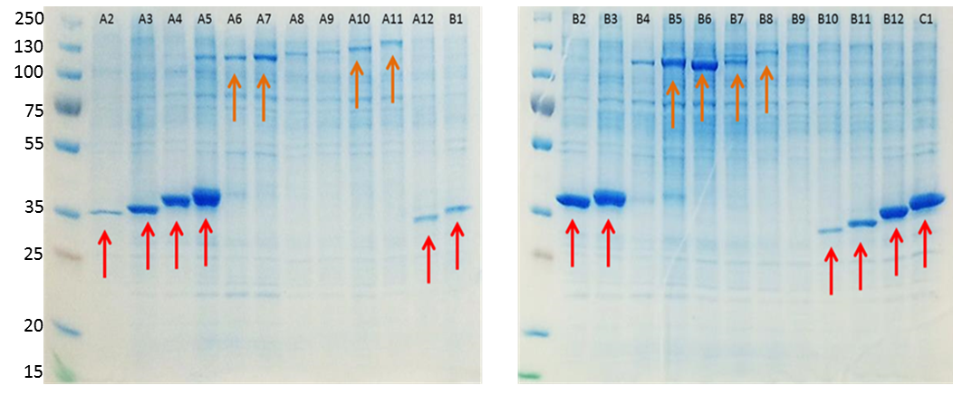

|  |  |  |  |  |  |
| --- | --- | --- | --- | --- | --- |
| **Construct** | **Start** | **End** | **Length** | **MW (kDa) - insert** | **MW (kDa) – insert + tag** |
| TOC004-A04 | 80 | 419 | 340 | 37.9 | 40.1 |
| TOC004-A05 | 80 | 428 | 349 | 38.7 | 40.9 |
| TOC004-B02 | 85 | 419 | 335 | 37.4 | 39.6 |
| TOC004-B03 | 85 | 428 | 344 | 38.3 | 40.5 |

Preliminary expression scale ups showed good overexpression of the constructs but larger quantities of protein are needed for affinity agent preparation.

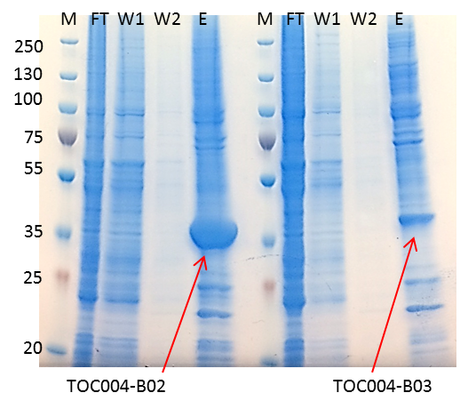

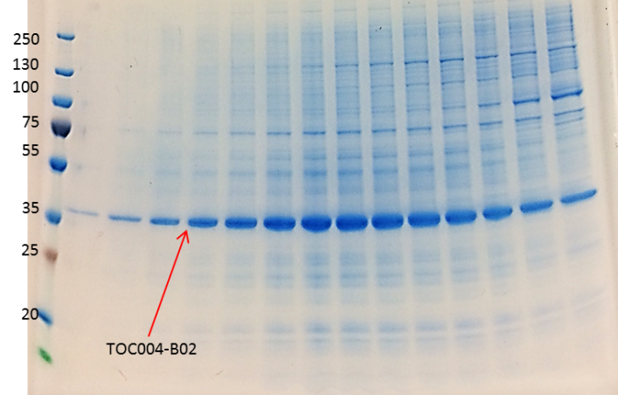

**1st December 2016:**

16 L Sf9 culture of TOC004-B02 was harvested by centrifugation. Cell pellets were washed in PBS and then each resuspended in 400 ml resuspension buffer (50 mM Tris-HCl pH 8, 500 mM NaCl, 2 mM TCEP, 5 % glycerol) before being flash frozen in liquid nitrogen and stored at -80 °C prior to subsequent purification steps.

**21st November 2016:**

Cell suspensions were thawed and rocked at 4 °C for 30 mins with 0.4 % NP-40, 10 U/ml benzonase and 1x protease inhibitor mix (0.1 mg/ml Aprotinin, 0.1 mg/ml Leupeptin, 0.2 mg/ml Pepstatin A, 0.1 mg/ml E-64). Suspensions were then diluted to 4 x 250 ml with resuspension buffer before cell lysis by sonication. Cell lysates were clarified by centrifugation at 20,000 xg for 1 hour.

Clarified lysate was rocked with 5 ml TALON (cobalt-beads) slurry at 4 °C for 1 hour (FT). Beads were washed with 500 ml resuspension buffer (W1) and then 500 ml resuspension buffer supplemented with 5 mM imidazole (W2). Protein was eluted with 20 ml resuspension buffer supplemented with 300 mM imidazole (E).

Samples collected throughout the prep were analysed by 4-20 % Tris-Glycine SDS-PAGE.

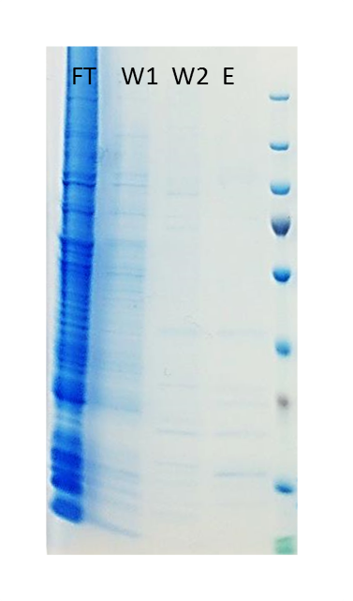

No protein has been purified – no clear bands in the elution (E) gel sample. This implies inconsistent expression of HTT TOC004 domain constructs i.e. compare E in this gel and in that described for previous experiments which shows a clear overexpression band in

Growth from P1 and P2 viral stocks so this could be a factor in differences in expression.

Now repeating test expression from both P1 and P2 – 3mL culture to see if inconsistencies can be determined on small scale.