Exercise – How is research supported in your institution

Introduce yourself to the other participants and give them a brief overview of your role and the scale and scope of the research activity that you require to be supported.

Then, discuss your own specific research data management needs, where you know them.

You may find it useful to use the DCC’s high level service diagram as a guide when discussing local and institutional level support activity.

Try to identify:
- Areas of best practice
- Gaps in provision
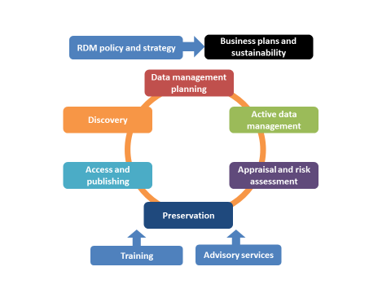
- Where responsibility for support should lie (e.g. with the institution/faculty/research group/etc)

RISE Evaluation

1. RDM policy and strategy | a. Policy development  b. Awareness raising and stakeholder engagement  c. RDM implementation roadmap
2. Business plans and sustainability | a. Staff investment  b. Technology investment  c. Cost modelling
3. Advisory services
4. Training | a. Online training  b. Face to face training
5. Data management planning
6. Active data management | a. Scalability and synchronisation  b. Collaboration support  c. Security management
7. Appraisal and risk assessment | a. Data collection policy  b. Security, legal and ethical risk assessment  c. Metadata collection to inform decision making
8. Preservation | a. Preservation planning and action  b. Continuity support
9. Access and publishing | a. Monitoring locally produced datasets  b. Data publishing mandate  c. Level of data curation
10. Discovery | a. Metadata cataloguing scope

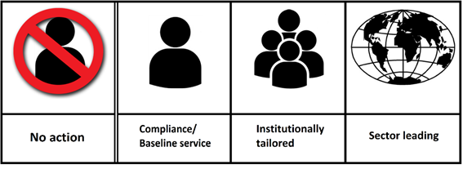

Level 0 Level1 Level 2 Level 3

