Ionosphere Sounding Data Processing Information System (ISDPIS) – basics, potentials and perspective
Jovan Bajčetić  University of Defence in  Belgrade, Military Academy  Telecommunication and Informatics Department,  Gen. Pavla Jurišića Šturma 33,  Belgrade, Serbia | bajce05@gmail.com
Mladen Trikoš  University of Defence in  Belgrade, Military Academy  Telecommunication and Informatics Department,  Gen. Pavla Jurišića Šturma 33,  Belgrade, Serbia | trikosm@gmail.com
Ivan Tot  University of Defence in  Belgrade, Military Academy  Telecommunication and Informatics Department,  Gen. Pavla Jurišića Šturma 33,  Belgrade, Serbia | totivan@gmail.com

Abstract
Big data proper handling drives the possibility for real-time detection and visualization of complicated long-lasting, as well as short, transient events. Among other applications, the one that is rapidly getting in focus latest years is definitely Space weather. The effects on the atmosphere, as well as the ionosphere, as one of its regions, are driven mainly by Sun – the electromagnetic and particle emissions coming from the active regions. This paper gives the overview of the developed set of Python scripts and the MySQL database which as a whole give the complete information system solution for the detection and visualization of the recorded ionosphere sounding radio signal sudden amplitude variation induced by sources of Space weather disturbances.

Keywords: data processing, visualization, ionosphere, disturbance, data acquisition

- Introduction

The main medium parameter concerning radio propagation through the ionosphere (60-800 km above sea level) which reflects its state is electron density. The sudden and intensive variations of this parameter are the reflection of the energy accumulation and release within this part of the atmosphere and can be represented through the variation of the electron density which is very convenient to measure using one of the broadly accepted methods (K. G. Budden, 1984; Martin Füllekrug et al., 2014). It is radio sounding as one of the main measurement methods applied among numerous methods for electron density estimation suitable for different ionosphere sub-region monitoring as a part of the remote sensing Earth observation technics. The valuable data gathered through the VLF/LF (3-300 kHz) radio sounding data measurements (E. D. Schmitter., 2013; A. Nina and V. M. Čadež., 2013) reflect electron density changes of the low latitude ionosphere (60-90 km) and makes possible further, deep analysis. The correlation of those measurements and natural phenomena related to its origin or consequences makes possible to better understand Space weather disturbances and a possible relation between the lower ionosphere and the natural disasters (Aleksandra Nina et.al., 2017).

- ISDPIS (Ionosphere Sounding Data Processing Information System), experiment and data acquiring

In order to adequately collect, store and make easily accessible, we constructed near real-time Ionosphere Sounding Data Processing Information System (ISDPIS) with the purpose to automate data acquisition, alert warning and visualization of detected events (Figure 1). As a challenge which drove to ISDPIS development, a huge amount of data that reflect low ionosphere electron density change, gathered from the frequency power distribution sensor (SA – Spectrum Analyzer) is used. Data processing starts with the Matlab code data acquisition from the programmable broad bandwidth SA tuned to the frequency band from 15 to 35 kHz. Raw data are sequentially stored in .mat files where every such a file is a structure that separately contains I/Q data stream recordings, associated time recordings and generated FFT (Fast Fourier Transformation) digest. Power distribution over the 20 kHz bandwidth with the resolution of 200 kHz is achieved with the sampling frequency of 56 Ms/s. The amount of data gathered in this way is approximately 250 MB per day, 7.5 GB monthly or 90 GB yearly.

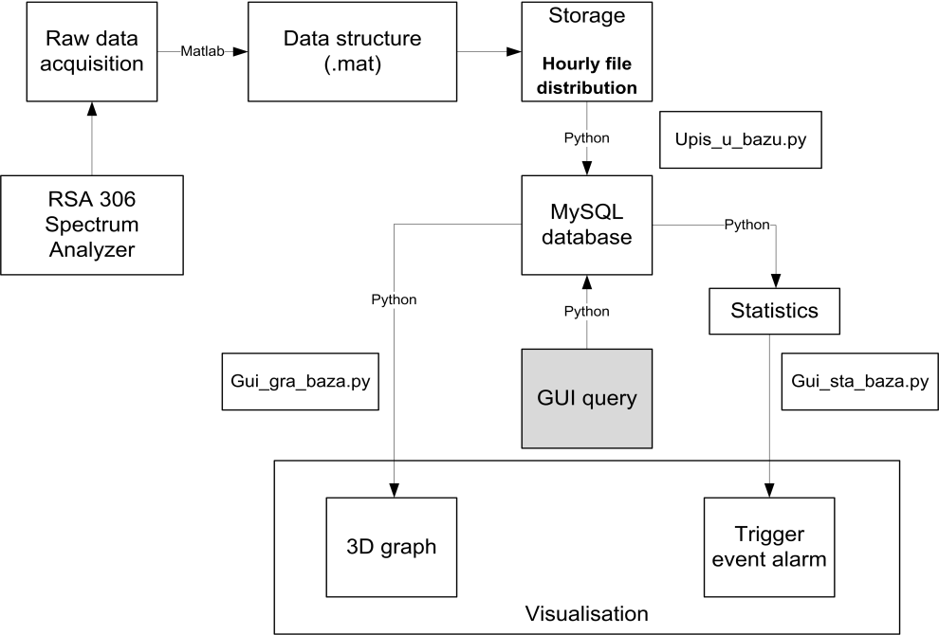
Figure 1: ISDPIS (Ionosphere Sounding Data Processing Information System)

- ISDPIS – description and functionalities

ISDPIS is completely Python based information system with the modules and functions implemented through the scripts that contain codes optimized for the dedicated data processing purposes. From the .mat data files, the system hourly injects data in MySQL database tables which are constructed to support recorded data structures consisted of three matrixes – time (six columns: year, month, day, hour, minute and second), I/Q data (200 columns), as well as produced spectrum data (100 columns) as depicted in Figure 2. All of those matrixes are up to 9000 rows long (m≈9000), while statistical analysis is done in parallel to enable alarm triggering in accordance to given triggering parameters.

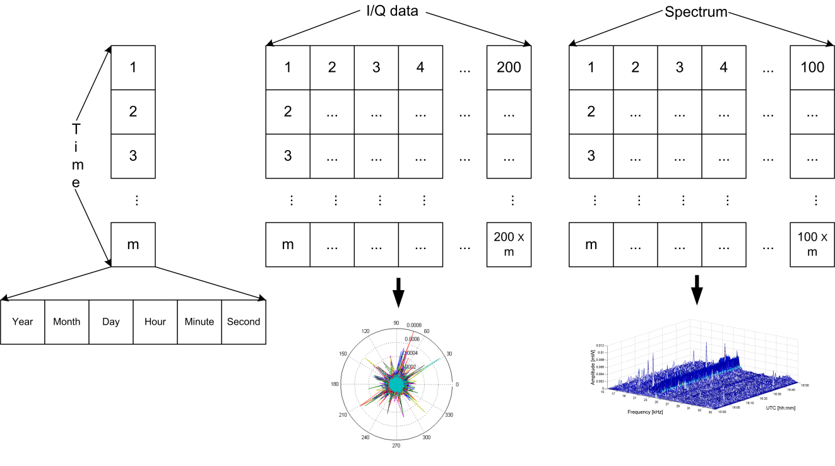
Figure 2: Data structures and visualisation
Triggering parameters are related to a particular event declared with the amplitude change over a designated time. By now, two criteria are determined:
• For transient events, this amplitude change is defined to be at least 10 dB over a time period of 1 second.
• The amplitude variation is ought to be at least 2 dB in continuation for the time period of 1 hour, so the event can be considered to be long-lasting.
Considering the facts that the triggering parameters are changeable, the model is not yet fully operative and is in the testing phase, triggering parameters are in the tuning stage.
After the import, the process of data handling and overview is the next stage of upcoming signal processing which for example can be directed towards the radio signal propagation simulation or whatever modelling related to radio signal propagation through the disturbed ionized medium or to other D-layer parameters (effective recombination coefficient, electron loss and gain rates, electron temperature, etc.) (Jovan Bajčetić et.al., 2015; A. Nina, V. M. Čadež, and J. Bajčetić., 2015). In order to be able to visualize the acquired data at the machines with reasonable performances, data adaptation was introduced within the GUI (Graphic User Interface) script (Figure 3).

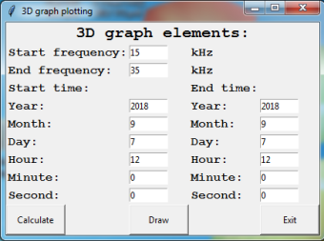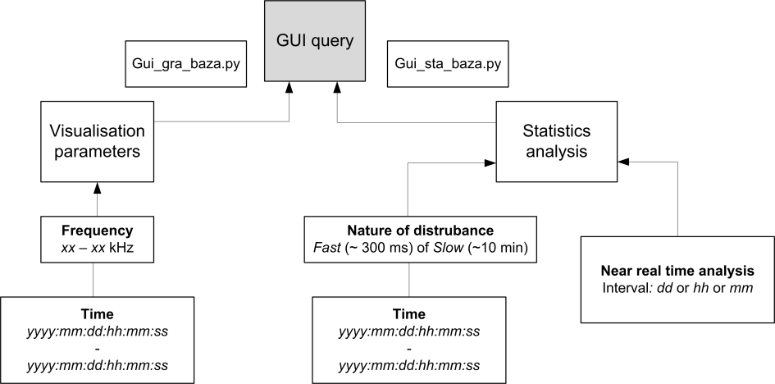
Figure 3: GUI query and its structure

Accordingly to the alarm triggering events, a user can narrow down the visualization parameters to the desired time and frequency domains. It is a quite useful tool for making a decision “at a glance” whether the event is a real electron density disturbance initiated by a natural phenomenon or not. It can be easy to notice the real disturbance at for example 3D waterfall diagram which is generated from raw data (Figure 4) however, sometimes it is necessary to pre-process the visualization parameters accordingly to the already mentioned criteria.

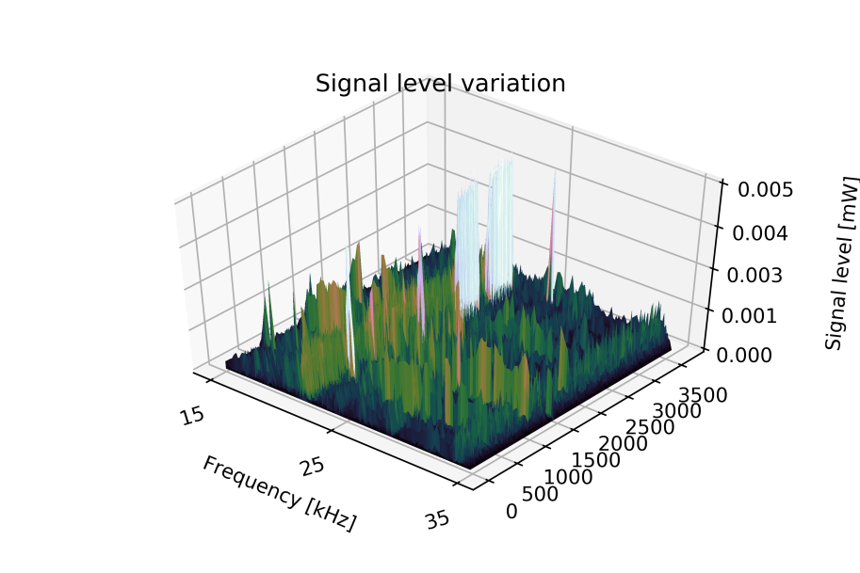
Figure 4: 3D waterfall diagram of acquired signal variation change on 7th of September, 2017 from 12:00 to 13:00

- Conclusion

Several prerequisites are required to be fulfilled in order to make a huge database easily accessible and adequate for proper data analysis. First of all, it is necessary to make the model of a database such to be as better reflection of the acquired data structure as it could be. Next, database import should be automatized in order to effectively make and fill up the database structures, e.g. tables. The process of importing is crucial in order to have data available to analyse in near real-time manner. Adequate GUI puts together functionalities of time and frequency filtering, adaptation in order of easier presentation and 3D visualization of the desired data set. The statistical module has an important role of concrete event detection described through empirically formed prerequisites described as a determined amplitude change over the specific time.

Acknowledgments

This study is made within the COST project TD1403. The authors thank the Ministry of Defence of the Republic of Serbia through the projects VА-TT/3/18-20 i VА-TT/1/17-19. Requests for the recorded data can be directed to the corresponding author.

References

K. G. Budden, The propagation of radio waves. New York: Cambridge University Press, 1984.
Martin Füllekrug et al. Array analysis of electromagnetic radiation from radio transmitters for submarine communication. Geophysical Research Letters, pp. 9143-9149, 2014.
E. D. Schmitter. Modeling solar flare induced lower ionosphere changes using VLF/LF transmitter amplitude and phase observations at a midlatitude site. Annales Geophysicae, pp. 765-773, 2013.
A. Nina and V. M. Čadež. Detection of acoustic-gravity waves in lower ionosphere by VLF radio waves. Geophysical Research Letters, pp. 4803–4807, 2013.
Aleksandra Nina, Milan Radovanović, Boško Milovanović, Andjelka Kovačević, Jovan Bajčetić, Luka Č. Popović. Low ionospheric reactions on tropical depressions prior hurricanes. Advances in Space Research, pp. 1866-1877, Volume 60, Issue 8, 2017.
Jovan Bajčetić, Aleksandra Nina, Vladimir M. Čadež, and Branislav M. Todorović. Ionospheric D-region temperature relaxation and its influences on radio signal propagation after solar X-flares occurrence. Thermal Science, vol. 19, pp. S299-S309, 2015.
A. Nina, V. M. Čadež, and J. Bajčetić. Contribution of Solar Hydrogen Lyα Line Emission in Total Ionization Rate in Ionospheric D-region During the Maximum of Solar X-flare. Serbian Astronomical Journal, pp. 51-57, 2015.

