**Purification of and crystallisation of TGFBR1 short form (ALK5) with ALK2 inhibitors**

**Aim:** to purify TGFBR1 (residues 198-503) for crystallisation in complex with ALK2 inhibitors (check off-target specificity).

**Expression:** TGFBR1 was expressed in Sf9 insect cells by Shubhashish Mukhopadhyay at 27°C for 72 hours in glass shaker flasks.

**Buffers (all filtered 0.2 µm**)**:**

**Nickel buffers**

**Binding buffer:** 50 mM HEPES, pH 7.5, 500 mM NaCl, 5 % glycerol, 5 mM imidazole, 1 mM TCEP

**Wash buffer:** 50 mM HEPES, pH 7.5, 500 mM NaCl, 5 % glycerol, 30 mM imidazole, 1 mM TCEP

**Elution buffer 1:** 50 mM HEPES, pH 7.5, 500 mM NaCl, 5 % glycerol, 50 mM imidazole, 1 mM TCEP

**Elution buffer 4:** 50 mM HEPES, pH 7.5, 500 mM NaCl, 5 % glycerol, 250 mM imidazole, 1 mM TCEP

**Gel filtration buffer**

50 mM HEPES, pH 7.5, 300 mM NaCl, 1 mM TCEP

**Purification:**

* Thawed 4 L pellet in Ni binding buffer with SET III protease inhibitors (1:1000).
* Sonicated for 2 x 3 min, 5 sec on, 10 sec off, 35 % amplitude.
* Added 0.125 % PEI to 40 ml lysate. Centrifuged at 50 000 g in JA 25.5 rotor for 50 min, 4 deg.
* Filtered the supernatant through 1.2 um filter and loaded onto 2 columns with 3 ml Ni resin equilibrated in Binding buffer. Rotated in batch in cold room for 1 hour, then poured back on to the column and washed with ~50-60 ml Wash buffer. Eluted with 10 ml Elution buffer 1, then 4 x 10 ml fractions of Elution buffer 4.

**Nickel gel for TGFBR1**

**250 kDa**

**150**

**100**

**75**

**50**

**37**

**25**

**20**

**15**

**10**

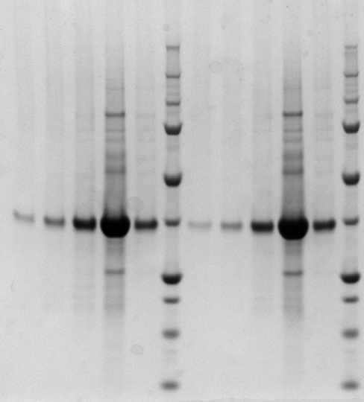

**TGFBR1 (37.7 kDa)**

* Looks like I could have done a couple more elutions with EB4, for future reference.
* Pooled E1-5 of both columns. Added 1 aliquot TEV (around 0.4 mg), to the tubes and left overnight in 4°C fridge. Concentrated the next day in a 10 000 MWCO centrifugal concentrator.
* Loaded 5 ml x 2 concentrated TGFBR1 onto a Superdex S200 16/60 gel filtration column for two runs, then pooled the peak fractions and concentrated through a 10 000 MWCO centrifugal concentrator again.

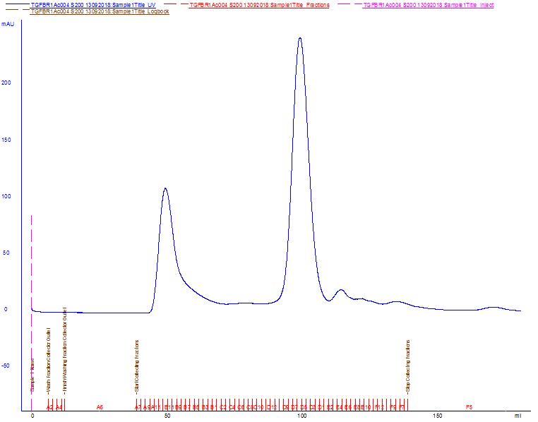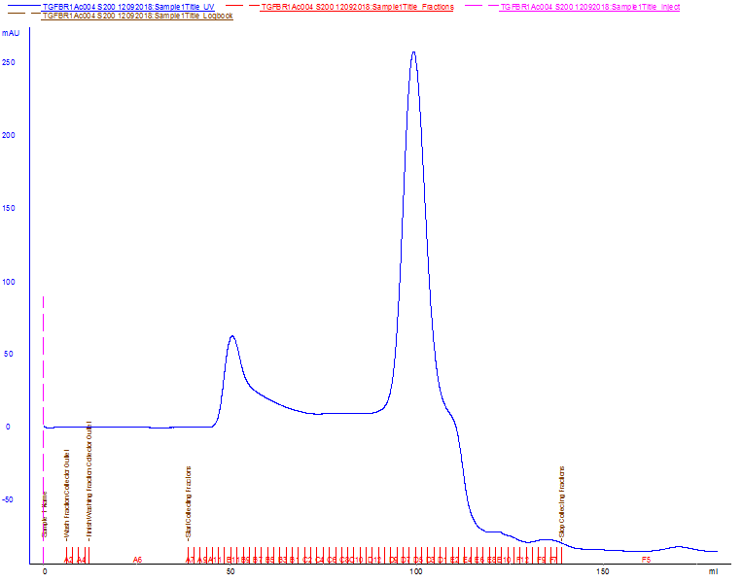**TGFBR1 Gel filtration profiles**

**TGFBR1 Gel filtration gel**

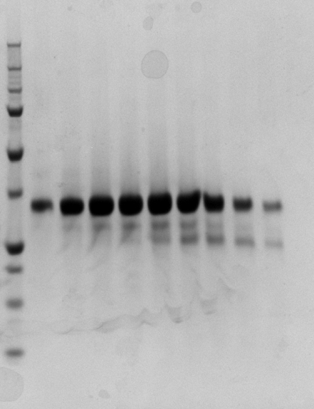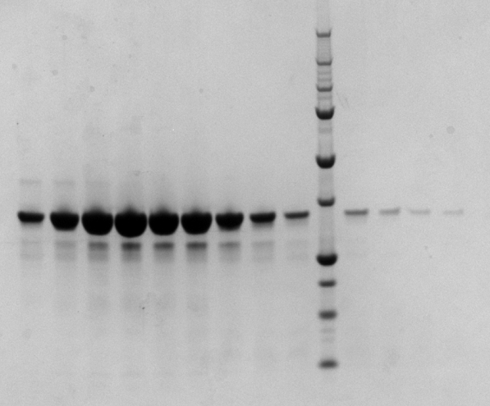

**250 kDa**

**150**

**100**

**75**

**50**

**37**

**25**

**20**

**15**

**10**

**TGFBR1 (35.2 kDa)**

Pooled peak fractions from both runs, concentrated in a 10 000 MWCO centrifugal concentrator to 10 mg/ml and set up 25 crystal plates with 5 different M4K compounds and 5 different coarse screens (JCSG7, LFS6, HIN3, HCS3, BCS6). All 150 nl drops in 2:1, 1:1 and 1:2 protein:reservoir volume ratios in each of the three subwells, with 1 mM compound. Probably should have done a nickel rebind step as the protein doesn’t really look quite clean enough.

**ATP-competitive inhibitors used for co-crystallisation with TGFBR1**

The compounds below were chosen because they have relatively high affinities for TGFBR1 (ALK5):

M4K1046 (40 nM)

M4K1170 (280 nM)

M4K2096 (269 nM)

M4K2053 (554 nM)

M4K2044 (385 nM)

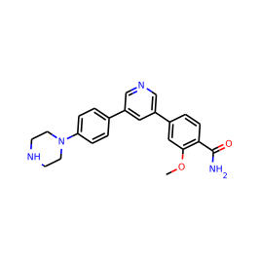

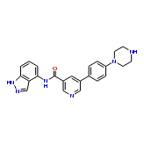

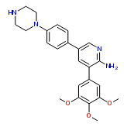

**M4K1046 M4K1170 M4K2096**

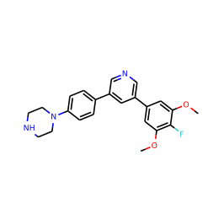



**M4K2053 M4K2044**